OCR GCE A

COMPUTER SCIENCE PROJECT

H446-03

Name : Rui Reis

Candidate Number: 7484

CWLC and Sixth form: 24425

Title of Project: DishOut

H446-03 – Project CONTENTS

Table of Contents

A. Analysis 6

Outline of Project 6

Stakeholders 6

Computational methods 7

Research 8

Stakeholder Research 12

Proposed Solution 16

System Requirements 17

Success Criteria 18

B. Design 18

Systems diagram 19

Project GUI Mockups 19

Login page 20

Waiter/EPOS GUI 20

Kitchen System 24

Manager System 24

Database Diagram 26

Testing for development 27

Algorithms 30

Logging in 30

Table Status 31

Order Taking System 31

Ready Orders 36

Pay 37

Kitchen App 37

Management App 38

Testing data 40

Sign off proposal 43

C. Developing the coded solution (“The development story”) 43

Making the database and Adding Data (V0.1) 43

Making the Login Page (V0.2) 47

Switching to built-in Django user management (V0.3) 48

Adding Permissions To Users and Restricting Page Access (V0.04) 50

Refining UI of login page (V0.5) 53

Stakeholder feedback for login page (V0.6) 59

Testing the Login Page (V0.7) 61

Implementing Waiter selection Screen (v0.8) 62

Waiter selection screen refinement (v0.9) 64

Stakeholder Feedback on the Waiter Selection Screen 70

Implementing Table Status solution Screen (V1.0) 70

Refining the Table Status Screen (V1.1) 76

Stakeholder feedback for Table Status (V1.2) 88

Testing The Table Status Screen 90

Implementing the Structure of the Order Taking System (v1.3) 91

Implementing Search into Order Taking System (v1.4) 95

Implementing the Dish list and selection (V15) 100

Implementing Categories and Dish Filtering (V1.6) 106

Implementing the Current Order List (V1.7) 113

Implementing Order buttons (V1.8) 119

Implementing the Order Submition (V1.9) 129

Testing Ready Dishes (V2.6) 138

Making the mobile GUI for the Order Taking System (V2.0) 140

Stakeholder Feedback for Order Taking System (V2.1) 149

Testing the Order Taking System (V2.3) 151

Implementing Ready Dishes (V2.4) 157

Stakeholder Feedback for Ready Dishes (V2.5) 172

Implementing Pay (V2.7) 172

Stakeholder Feedback for Pay section (V2.8) 182

Testing Pay (v2.9) 184

Making the Kitchen Application (V3.0) 186

Implementing the status buttons for the Kitchen UI (V3.1) 197

Stakeholder Feedback for the Kitchen application (V3.2) 201

Testing Kitchen Application (V3.3) 202

D. Evaluation 203

Final Post Development Testing 203

User Usablity Testing 206

Evaluation of Solution 206

Project Appendixes 207

Code listing 207

Python Screenshots 207

HTML screenshots 216

CSS Screenshots 225

JavaScript 249

References 256

# A. Analysis

## Outline of Project

This project is designed to solve some of the main issues of restaurants. It does this by having multiple systems (Waiter, Kitchen, and Management) all these systems are built separate but can interact with one another by using a shared database and APIs. The name of the project is **DishOut.**

**Waiter application** is focused on taking orders from customers then sending them to the kitchen software, so they know how to prepare it. It will function as an EPOS system and allow waiters to input the order from customers both on a mobile device or a stationary device. They will also have a system that will let them see which dishes have been prepared and are waiting on being brought to the customer, all waiters will be able to see this list of prepared dishes so they will be able to ‘claim’ the dish to ensure that there aren’t multiple waiters trying to grab the same dish as this would be inefficient.

**Kitchen application** will be able to take in the orders that have been processed from the Waiter application and display them to the kitchen staff so that they know what they need to prepare. It will also allow for the kitchen staff to keep track of what point the dish is in the preparation process, it will do this by having checkpoints where the chefs/cooks can check off when they have completed this step. This will ensure that the status of each dish is carefully tracked.

**Management application** this application will be for only the manager and will allow them to keep track of statistics about their staff and how different dishes are performing. It will also allow them to change the role of a staff which can mean that they can change what application they have access to, for example they may want to switch an employee from waiter to kitchen staff which would be done through the management application.

## Stakeholders

The main stakeholders for this project would be restaurant owners as they would be our customers who we would sell this product to. Problems that restaurant owners may face is trying to organise their employees so that they know what needs to be done and at what time, they also may have problems understanding what dishes are doing better than others as well as seeing which dishes should be removed to simplify the restaurant and make it more efficient. This application helps them accomplish all these goals by first adding the modules which tell exactly what each employee should be doing with separate accounts for each employee for individualised and specific tasks which will make their jobs simpler thus easier to perform. The application will also have a management section that will show how much of each dish has been sold per day as well as showing the revenue in real time.

Some indirect stakeholders would be the customers of the restaurant and the employees:

* Employees main problem is not knowing what they are currently required to do and how they are meant to do this, this application will help with that by streamlining the process of giving tasks to employees making it easier for them to perform their jobs.
* Customers main problem is the quality of service and the speed of the service. This application would help both as it would ensure that the service is faster as employees know exactly what they need to be doing and the quality of the service will improve because employees will be able to focus on their task and not think about any other tasks.

## Computational methods

* Thinking Abstractly & Visualisation
  + The program will use abstraction when showing where the tables are. This is so that the user interface is not too complicated and is easy for waiters/waitresses to see which tables need attention at a quick glance while having a brief idea of where they are in the restaurant.
* Thinking Ahead
  + This solution will have various inputs and outputs. Some of the main inputs will be customer orders, preparation of dishes, and login page. It will also out put the current orders that are being worked on, the orders that need to be delivered, how much of each dish has been sold on that day and the revenue for that day. This is all used so that every employee knows at which stage every order is on and what needs to be done to be able to complete it.
* Thinking Procedurally & Decomposition
  + My problem can be easily broken down into smaller problems. I have already structured into separate modules that interact with one another.
  + There are 3 modules:
    - Waiter Application
    - Kitchen Application
    - Management Application
  + These applications are all split into their own groups to represent the users of that application’s needs and to make it easier to tackle the project as I will only have to focus on each one of those modules at a time instead of the program.
  + This will make it easier to code and figure out problems due to the problems being split up into smaller sections which make them easier to code.
* Thinking Logically
  + My program will have branching code when selecting the dish that customers want to order and when orders are complete in each of the stages. This is very important to be able to notify employees of the current status of an order and when checking what should happen depending on the status of a dish/table
  + It will also have looped code to be able to update the orders to the users like waiters and kitchen staff about new orders that came in. This is so that the program can constantly be updating itself and that is important so that orders can be completed as soon as they arrive.
* Thinking Concurrently
  + All the applications will be running simultaneously, and each employee will have access to one of these applications depending on their job role. This means that all the apps will be communicating with each other and running at the same time. They will be able to do this by using a shared database which will store all the data needed.

## Research

Similar Products:

**Example A:** **eatPOS:** eatPOS is a company that makes their own EPOS system for restaurants and retail applications. These are the features that they offer:

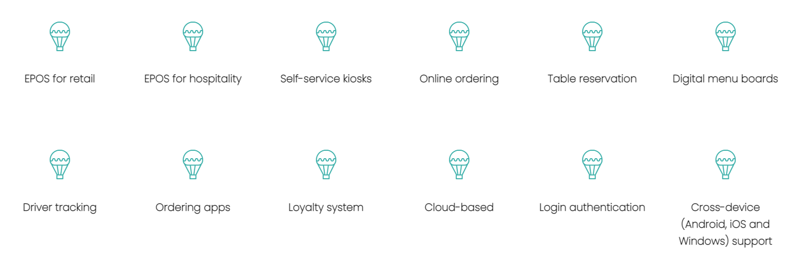

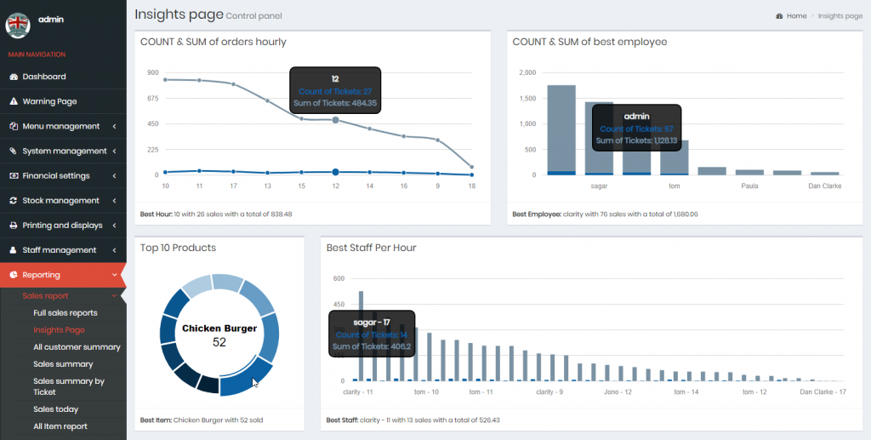This is their current GUI which they offer in landscape and portrait on iOS, Android, and Windows:

Good use of graphs to illustrate sales data and to show which staff has been achieving the most sales

* 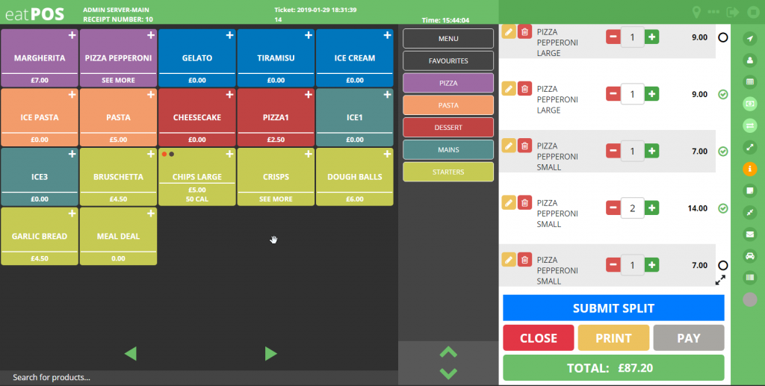For restaurant manager (Has analytics)

Large icons for adding product to the order which is better for usability. Good organisation of different categories of food on the side

Very small icons which can be hard to use on a tablet or whilst moving around the restaurant

* Waiters’ POS system

(eatPOS, 2019)

It is very comprehensive and includes many features, but it does not include a customer ordering system as well as not having a good table management system that shows waiters what tables require attention or delivery of dishes.

The GUI is also modern and is very easy to use but it is quite expensive and adding new employees can be quite complicated due to many parameters that need to be changed.

(Pro software, 2018)

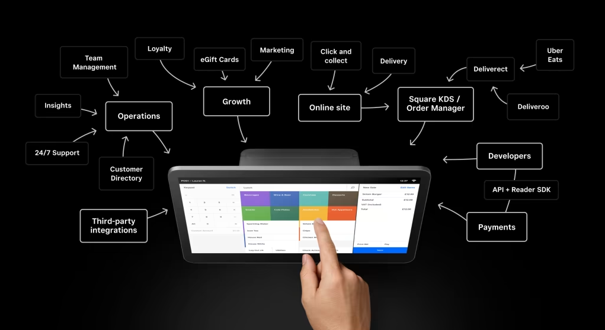**Example B: Square for Restaurants** – This is one of the most popular EPOS systems used in new start-up restaurants to manage their restaurant.

* Demonstrationof the mobile restaurant POS system

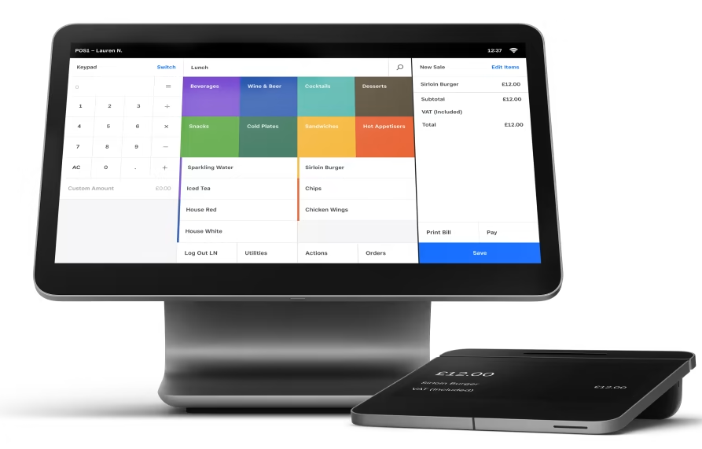

* Demonstration of their non-mobile restaurant POS

(Square, 2022)

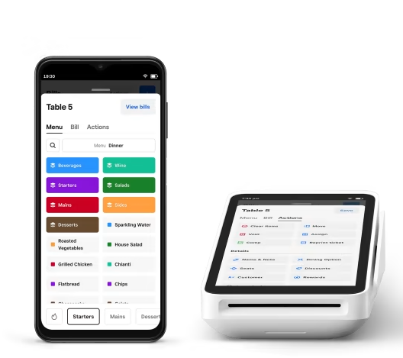Square for restaurants offers many features like online ordering, mobile and stationary ordering for waiters and it has features like saving previous orders for easy reorders if customers request it and an integrated payment system which means that there is no need for a separate card payment machine to take payment. It also has a friends and clean user interface which makes it easier for employees to use.

Good use of space on small devices like a phone. Uses sliding category search at the bottom which saves on space and allows for faster navigation. However, it has the category selection both at the bottom of the screen and separated into individual buttons near the top which is wasting some space.

However, it does lack features like table management and a convenient diagram to show what tables require assistance and it does focus on very small start-up restaurants which means it has low capacity for many orders thus not very scalable.

Market Research:

* 80% of all restaurants are exploring new technologies to make their restaurants more efficient.
* 37% of restaurant operators believed that customer ordering is the future path for restaurants to take.
* 72% of single-location restaurant owners show interest in a mobile EPOS solution.

(Bouncepad, 2022)

In this piece of research conducted by toast they were trying to see the importance of technology in the restaurant market. The key points from this study were that “95% of restaurant owners agree that technology improves restaurant efficiency” and that “75% of restaurant goers say technology improves the dining experience”. This means that EPOS systems should be in quite high demand as restaurants want these new technologies to both improve the efficiency of their restaurant and to give their customers a better experience.

They also found that the most important thing to the customer is self-customer ordering through an online website and loyalty apps. However, they found that customers do not want table tablets and do not want self-service kiosks.

(Toast, 2017)

## Stakeholder Research

I interviewed my stakeholder (Louis Allaway) who currently works in the hospitality industry. I questioned him on what it’s like to use his current EPOS system and how it could be improved from what it currently is. He also was able to give insights on what it’s like being both a waiter and kitchen staff due to his versatility in his job role.

|  |
| --- |
| Question: What do you need in a waiter management system/EPOS? |
| Answer:   * Needs it to be flexible (Able to change ingredients) * Prefers not to write things. * Would prefer customers to order through their own app |
| This question was to give me a general idea of what the stakeholder thinks are the main things he needs in an EPOS system. This informed me that it is important for things like ingredients to be editable and that things shouldn’t be written so that it can be more efficient to exchange information between kitchen staff and waiters |

|  |
| --- |
| Question: Would you prefer a stationary or mobile solution? |
| Answer:   * Would prefer a mobile solution as it allows them to be able to take orders wherever they are in the restaurant |
| This question was to see if the reason that stationary EPOS systems are the most common s because they are very practical or id it is because of cost saving for the restaurant. My stakeholder believes that a mobile solution would be better as it allows them to take orders from anywhere in the restaurant |

|  |
| --- |
| Question: Do you tend to forget orders/need to write them down? |
| Answer:   * Yes, it can be quite time consuming to take notes of the order and can still be hard to use due to low illegibility so I tend to try to remember them but can forget by the time I get to the EPOS system |
| This question was to see if employees struggle remembering the orders from customers. My stakeholder says he does and thus would prefer a mobile solution that just instantly inputs the order into the system which would eliminate having to remember any orders |

|  |
| --- |
| Question: Do you find it difficult to find where orders must go (Which tables)? |
| Answer:   * No, because current solutions allow him to show what table number the order is for but it is a stationary machine so he can forget |
| This question was to see if knowing which tables to check on can be a problem for the employee. What I found is that in their current solution they have some features which help them deal with tables but can forget what table to go to, so it is crucial to have a feature for monitoring tables |

|  |
| --- |
| Question: When working as a kitchen staff do orders reliably get to you? |
| Answer:   * No, sometimes they are given in pieces of paper for with handwritten notes which are hard to read, must go out of kitchen to check for allergies |
| This question is meant to see if there are problems with which orders is transferred between waiters and kitchen staff. My stakeholder believed that there are problems with the transaction of orders and information between these two groups due to some waiters taking note on paper making them hard to read. Therefore, my application will just have different modules for each job type so that information and orders can reliably be sent to each other instantly. He also states that there are problems with taking not of allergies or personal preferences which the application will also solve |

|  |
| --- |
| Question: When working as kitchen staff are you able to easily keep track what orders are being done and which ones are waiting to be cooked? |
| Answer:   * No, he must remember at which point the order is in being made. He would prefer to have a way to keep track of what stage a dish is in being prepared |
| This question to see how the kitchen staff keep track on what stage the order is currently in. I found that for my stakeholder it is quite difficult to keep track due to low communication so it would be better if there was a way to track the state of an order |

|  |
| --- |
| Question: What problems do you have with current GUI? |
| Answer:   * All dark mode which can make things hard to read with visual impairments. * No search function |
| This question was to see what could be improved from current GUI designs for POS systems. I found that they need to be bright and easy to see/read. They should also have a search feature for quick finding of items |

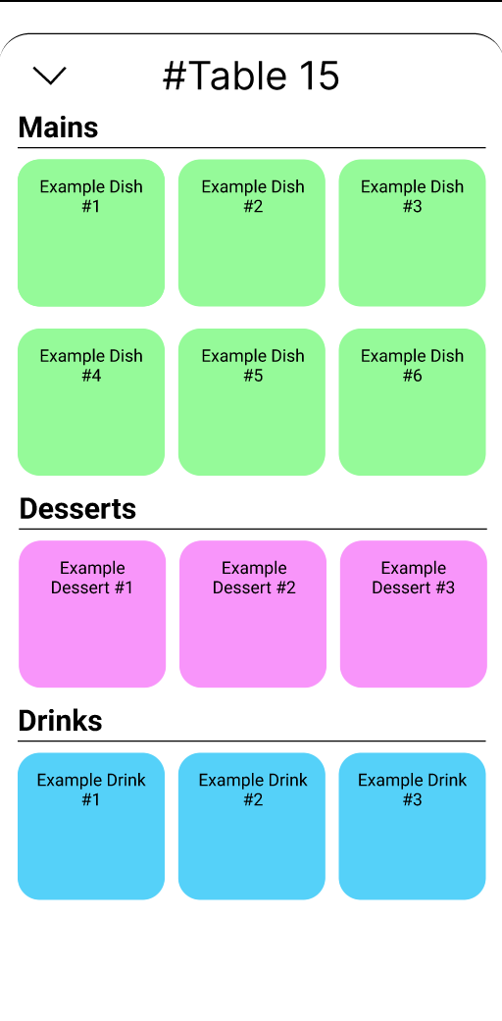

|  |
| --- |
| Question: What do you like and what would like to be seen improved about this GUI? |
| Answer:   * I like that it has colour coded buttons but would prefer to see images of the dishes. * I would also like for there to be a search function to search for specific dishes. * GUI needs to be fast to use |
| This question was to see what is currently good about the GUI design and how it can be improved. I found that the colour coded buttons are good but if they had images, it would make it easier to identify correct dishes. Also found that he would prefer a search function to find dishes and it needs to be fast so that orders can be taken quickly |

|  |  |
| --- | --- |
| Features | Limitations |
| * 3 separate modules that can interact with each other (Waiter, Kitchen, and Manager applications) This is so that employees don’t get distracted with other people’s tasks and can focus on their own work and can have their own dedicated app which makes it easier for them to keep track of work. * Visual based task manager for waiters. This is going to be a very abstracted diagram of the tables in the restaurant, and it will have a colour-based system to show if a table requires service and if they haven’t been checked on in a while. * Mobile and Stationary application. This is because from my research with my stakeholder I have found that remembering orders and using stationary machines can become a problem so both a mobile and stationary solution for the waiter/EPOS system will be useful to them. * Tracking system for which stage an order is in. This is used for the kitchen staff to keep track on what stage each order is in in the kitchen. This was requested by the stakeholder as an important feature. * Order taking. This will be one of the main features as this is how waiters will add orders into the system from the customers. They will also be able to add additional information like allergies | * **No payment method built into the application** This means that waiters will have to carry a card machine to be able to take payment as their application will not have this feature built in * **No inventory management system**. Although it will have a counter for how much of each product/dish has been sold it will not have an inventory management system. Most other EPOS systems do, however. * **No integration with delivery apps.** Unlike competitors like Square this application will not have easy connections to apps like Uber Eats which are very popular now as seen by the statistics. * **No training mode**. From my research I found that many restaurants want a training mode on their EPOS system but due to time limitations I will not be able to implement this feature |

## Proposed Solution

## System Requirements

Server Requirements:

|  |  |
| --- | --- |
| Operating System | * Raspberry Pi OS (Debian Linux) |
| CPU | * Quad Core 1.2GHz Broadcom BCM2837 64bit CPU |
| RAM | * 1GB |
| Storage | * 5 GB free space |

These are the required specifications for both python and the libraries that will be needed to run the server. I am planning to use a raspberry pi to run the server which is supported by both Django and Python so these will be my server specifications.

User/Front end requirements:

|  |  |
| --- | --- |
| Operating System | * Windows 10 or later * macOS High Sierra 10.13 or later * Android 7.0 Nougat * iOS 14 or later * 64-bit Ubuntu 18.04+ * Debian 10+, * openSUSE 15.2+ * Fedora Linux 32+ |
| CPU | * Intel Pentium 4 processor or later that's SSE3 capable. |
| RAM | * 2GB |
| Storage | * 3 GB free space |

These are the hardware and software requirements of chrome which is where the front end will be accessed and used.

## Success Criteria

1. **Program must be able to update the kitchen staff to do orders within 5 seconds of taking the order.** This is to prove that the application updates quickly.
2. **Must be able to add exception to order ingredients or for informing the chefs**. This is so that it can meet the requirements of the stakeholder.
3. **Program must be very easy to use so user should be able to make an order with a main, drink and desert in one minute.** This is so that they can quickly take orders and not leave customers waiting for too long while taking their orders.
4. **Program must be responsive; buttons should activate within one second.** When clicking a button or selecting something it should change or at least give the user feedback in at least one second.
5. **Waiter section must be usable on devices that are considered phones and tablets.** This is to ensure that portable devices are supported which will allow staff to take the system to the tables and input orders directly into DishOut.

# B. Design

## Systems diagram

I decided to break down my project into this diagram to show what key components will be needed for each module to complete and solve its own problems. I used decomposition to break down the problems of each of the 3 modules of DishOut to make it easier to understand what will be needed to develop and predict which problems link together and will be harder to implement, the problems are broken down into the main components of each program/subprogram needed to complete their task, this means that each problem cascades into another problem until all problems have been solved.

I also used the process of abstraction so that I can focus on the overall problem instead of having to put all the detail and code needed to complete each problem on the diagram as that would make the diagram very confusion to use and develop with. Due to having made a diagram it allows me to use the process of visualization to see any shortcomings in the solution before I start coding which will save time in the process.

## Project GUI Mockups

All mockups are designed at one of these two resolutions:

1440px X 900px for the desktop version

412px X 833px for the mobile/small device version

### Graphical user interface, application Description automatically generatedChart Description automatically generatedLogin page

This is the login page where employees and managers will be able to enter the DishOut system and acess the functions they need for their roles. It is very simple as it does not need to be complicated and is very intuative for the user. Having a login page also makes the system more secure to hackers and other attacks.

### Waiter/EPOS GUI

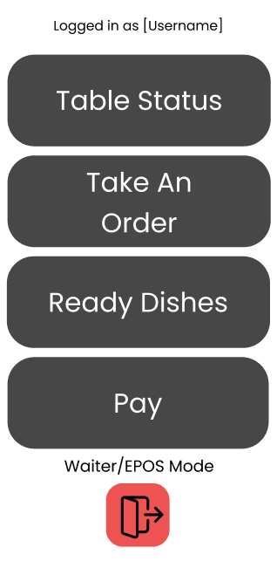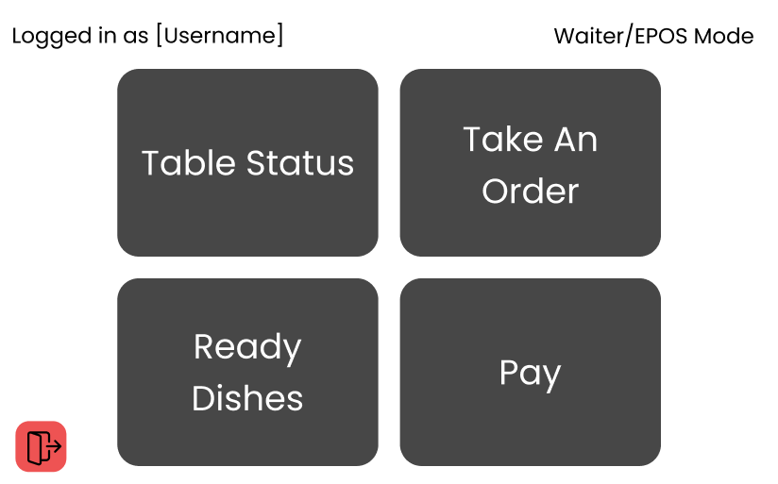

This is the menu that employees who work as waiters will be greeted by, it has 4 buttons which allow you to access the different function of DishOut. It has a red log out button which can let other staff use the same devices when changing shifts and incase someone forgets to logout the name of the currently logged in employee is displayed at the top right/ at the top for the small device.

#### Diagram Description automatically generatedChart, bubble chart Description automatically generatedTable status

This is the table status screen it shows a very simple representation of the status of each table with both colours and with writing. This allows for staff to get an overview of how each table is doing and what assistance it needs, it uses bright easy to differentiate colours to ensure it is easy to get information at a glance. The UI also includes a timer for how long the tables have been in that status other than for ready because it won’t need assistance. Having a timer can show employees that something may have gone wrong or that they should prioratise that table.

#### Order Taking system

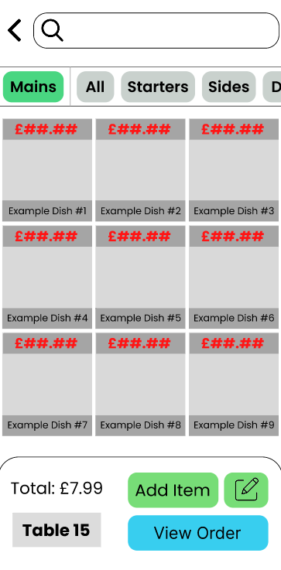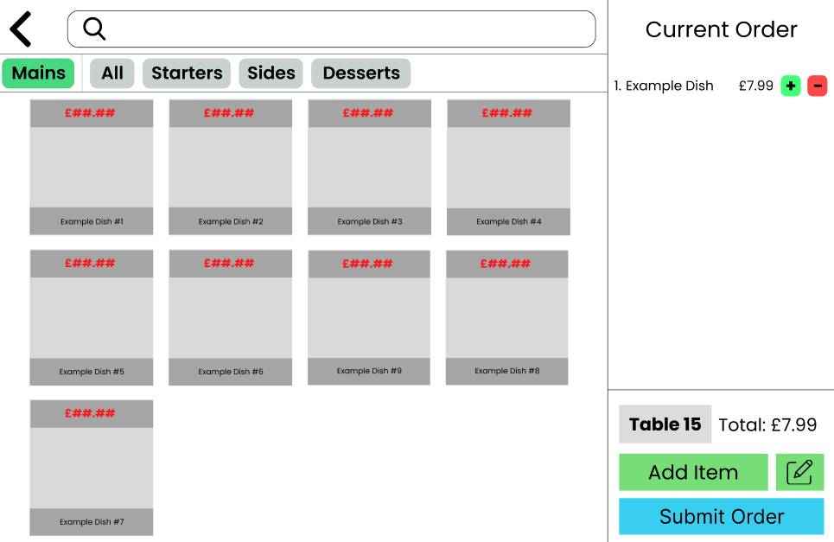

**Category Selection (Blue Box)**

At the top below the search bar there is a collection of different categories which can be selected. The currently selected category is coloured in their designated colour and is on the very left of the list while the rest of the categories are on the right. On small devices the categories list is scrollable so that all the categories can be clicked on in a small footprint. These categories tabs are for faster finding and selection of orders as it allows for only the dishes that need to be shown. However, if there are many dishes at the restaurant or that dish is hard to find there is a search bar at the top of the screen to search for the dish directly.

**Dish Selection (Yellow Box)**

This is in the middle of the screen in the mockups, it is a set of 9 example dishes. Each dish is represented with a square which has the price at the top and the name at the bottom. All the dishes in the completed project will have pictures underneath and in between the price and name of the dish which will help employees find dishes faster as it is easier to remember a picture and search for it then to search for a name of a dish. This means that it should make it easier and faster to use as all the key information per dish is shown all in one small square.

**Order Editing/Submission (Pink Box)**

This is on the right of the screen on the large device model and it is at the bottom of the screen on the small device version. This section allows the employee to see the current order, total price and edit it by removing/adding a dish with either selecting a new dish and from the Dish selection section or through adding another of the same dish by clicking the green + button or if they need to remove a dish, they can use the red – button to remove the dish. Additionally, the edit button (Pen on paper icon) can be used to add a note to the order so that the kitchen knows any special requirements the order needs. This was one of the key features that my stakeholders told me to add to my project as it will make it easier to add exceptions to orders. Then when the order has been collected the employee only has to click submit order.

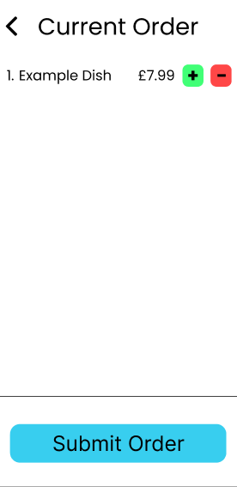On a small device to see the current order so far and allow them to submit the order, the employee would need to click on view order which will bring them to a screen like this:

#### Graphical user interface, text, application Description automatically generatedGraphical user interface, text, application Description automatically generatedPay

This UI is for setting tables which are waiting to pay as paid. This is needed because this project won’t be able to add a payment function due to the time constraint. Instead, employees take payment then click the paid button for the table.

#### Ready orders

This UI is used by the waiters to ‘take’ orders, what this means is that waiters can claim orders that are ready and take them to the table which stops multiple waiters trying to take the same order. Once the order is taken it is put to the section below called ‘Taken Orders’, this is where the waiter can see the orders that they have to take to a specific table and allows them to mark them as delivered when they have taken the order to the table.

### Shape Description automatically generated with medium confidenceKitchen System

This is the only UI element for the kitchen staff. It allows them to see new orders and their notes/comments that come in. They are added to the bottom of the queue so that orders are naturally completed in a first come first serve manner. New orders are shown by the New Order rectangle being illuminated green which means that it hasn’t started being prepared yet, to show the system an order is being prepared they just need to click on the Preparing red button which will make the New Order button grey as that has been completed and make the Preparing button green. Stages of the dish making process can be skipped by pressing stages further ahead than the one that you are on, this is so that dishes that don’t require to be cooked for example can be skipped straight to the ready stage. When an order has been put to the ready stage it is automatically removed from the queue as kitchen staff no longer need it.

### Manager System

#### Graphical user interface, chart Description automatically generatedStatistics

This is the Statistics screen of the management UI. It shows the most sold dish in big blue text so that it can be seen easily, and it has a graph underneath with the 15 most popular dishes. On the right is the most orders delivered section which shows which employee has delivered the most orders to customers and underneath it shows the rest of the waiter staff’s performance.

#### Graphical user interface, application Description automatically generatedAccounts

The Accounts tab is where managers can view information like usernames, roles, and the hashes of the passwords. Managers can also use the buttons next to the desired user entry which allow you to remove, change role and change passwords of the users. New accounts can also be added through this screen using the green add new account button.

## Graphical user interface, diagram Description automatically generatedDatabase Diagram

There will be 5 tables: Menu, Orders, Employees, Tables and Delivery.

The Menu table will hold all the dishes with their names, prices, times ordered and what type/category they are.

The Orders table holds every order that is being made, it has a unique OrderID for each order so that they can be differentiated. Each record holds the table number which is a foreign key from the table Tables which shows where the order needs to be delivered to, holds the DishID which is the dish that needs to be made and delivered which is the foreign key from the Menu table. It also holds the status of the order and any additional information under notes that is added on by the waiter.

The Employee table uses the employees’ usernames as a primary key as there shouldn’t be duplicates. It then stores the employees’ passwords in a hashes format to add security. It holds their roles so that when they log in the program know what each employee has access to and then there is also an orders_delivered field so that it is easy to keep track how many orders employees have delivered.

The Tables table uses the table number as a primary key. It also holds the status of each table and when they first started having that status. It also holds the total amount that that table must pay.

The Delivery table uses composite keys to show which employee is assigned to each order. This is done using both the OrderID from the Orders table and by the use of the Username key from the Employees table.

## Testing for development

|  |  |
| --- | --- |
| Test data | Justification |
| Logging in | |
| * Check valid Username and Password combination | * This is normal data to check that the program authorizes users when it is meant to |
| * Check that User gets signed into the correct application | * This is to test if the user only has permission to access on page, they are only sent to the page which they have access to |
| * Enter wrong information | * This is erroneous data which is to prove that it only authenticates correct data |
| * Enter correct Username and a Password | * This will be for white box testing as I will be checking if the hashing function works |
| Table Status | |
| * Change table status for table 12 then reload the page | * This should force the table status algorithm to have to show the new status, colour and time of the table |
| * Change table status of table 6 without leaving the page | * This is to test that the auto refresh is working as intended and it updates every second |
| * Wait 10 seconds and look at table 6 | * This is to check that the timer for how long a table has been on a certain status is working as intended |
| Ordering System | |
| * Search for spaghetti in the search bar | * This is to check to see if the search bar will then only show dishes that have spaghetti in the name (Spaghetti will have to be added as a dish to the menu database for this to work) |
| * Search for a dish that isn’t in the menu database (e.g. type in bolts) | * This is to make sure that when incorrect data is put in nothing is displayed as if there were it could mislead waiters into thinking that the restaurant does have that dish |
| * Leave the search bar empty | * This should make it so that it displays all the dishes in the database unless a category is selected |
| * Click the desserts category | * This will be to check that when the category button is clicked only the dishes with that category appear |
| * Add a dish to the order and check current_order 2D array (Should be the first dish, have no note , and a quantity value of one) | * This will be to test that the dish is correctly being displayed on the right of the screen and that it is also being stored correctly in the array |
| * Select dish in current order and add the note “this is a test” then check the 2D array and it should be saved in the dishes record on the note field | * This is to check that the add note function works. By performing this test we are testing multiple things, we are testing the selection of dishes already in an order and we are testing if adding a note saves properly |
| * Add an empty note to a dish | * This is to check that if an empty note is added to a dish, it does not mess up how it is stored in the database |
| * Add a 500-character note | * This will be to test what happens if a long note is written, in the real world there will be no note that will be this long so if this can be stored correctly the system is functional |
| * Add another of the same dish onto the current order | * This is to test that the program is working correctly when one of the same dish is added. Should see that the quantity field on the 2D array for that dish increases by one |
| * Remove a dish from the current order which only has one being ordered currently | * This is to make sure that when a dish is removed from the current order it is also removed from the list as well as from the UI |
| * Add 2 dishes and a note to one of them then submit the order | * This is to prove that the program, when asked to submit an order creates an order for each dish with the relevant information. In this case it would make 2 orders and one of them will have a note |
| * Submit an order without any dishes in the current order | * This is to make sure that the system does not submit an empty order to the kitchen as this would be very confusing for the cooks and would not be how the program is expected to function |
| * Submit an order and check if its times ordered is incremented. | * This is to check if when an order is submitted the times the order has been ordered increases in the database record for that dish |
| Pay | |
| * Make table 15 status into ‘waiting to pay’ | * This is to check that the program automatically refreshes the page and shows a new table waiting to pay |
| * Click the pay button | * This is to see if when the pay button is clicked the table is removed from the pay UI and changed the table status of that table to ‘Ready’ |
| * Click pay button and check if table’s orders were removed from the database | * This is to check to see that after the pay button has been clicked the orders have been removed as they are no longer needed. |
| * Click pay button and check if the table’s Total_To_Pay has been reset | * This is to make sure that after a table has paid and orders have been removed that the next customers total isn’t affected. |
| Ready Orders | |
| * Make an order with status ‘Ready’ | * This is to see if the UI will respond to a new order coming in. The UI should auto refresh or require a manual refresh |
| * Click the ‘Take’ button to take an order | * This is to test if by taking an order it goes into the taken order section and stops displaying the order to other users. This can be checked by looking at the status of the order which should be equal to taken |
| * Make 20 orders with status ready | * This is to test the UI and make sure that it can accommodate many more orders then can be displayed at one time. Expected response is a scroll mechanic |
| * Click ‘Delivered’ on an order in the Taken orders section | * This is to check that when an order is delivered it is removed from the taken order section |
| * Deliver an order and check the Orders_Delivered field for the user which delivered the order | * This is to check that when an employee delivers an order it is recorded as this will be needed for the management section |
| Kitchen App | |
| * Make a new order. | * This is to check if orders appear correctly with the right Name, Table number and dish name |
| * Make order with a note | * This is to check if orders are correctly displayed on the orders |
| * Make an order with a note of 500 characters long | * This is to test if the UI is able to display a note that is using the max number of characters |
| * Progress the orders status | * This is to test if the UI correctly progresses the order and changes the orders status in the database |
| Management App | |
| * Make a new account with different credentials to all other accounts | * This is to test if making a new account works correctly and all the credentials are saved without issues |
| * Make a new account with the same credentials as another account | * This is to test if the program detects that the user is trying to make a new user that is identical to another user which would cause a clash in the database |
| * Change the role of an account | * This is to test if it can change the role of an account correctly |
| * Change the role of an account to a role that doesn’t exist | * This should throw out an error as this would be a role that does not give any permissions to the user as it does not exist |
| * Change the password of the user | * This is to check that when changing the password of a user it is able to correctly overwrite the record for that user |

## Algorithms

### Logging in

When the Login button is clicked the login function runs. It will check the entry field username and compare it to the Username field on the Employees table to see if it exists. If it does, then the function should hash the password that was entered into the password entry field and compare it to the Password that is in the same record as the Username. If both are correct allow entry to their role which is stored under the Role field of that record. If either the username doesn’t exist, or the password is incorrect then display the error message ‘Username or Password incorrect.’

**Pseudocode:**

**function login()**

**username** = contents of entry field Username

**password** = contents of entry field Password

check if username exists in Employees table

if it does not exist:

display "Username or Password incorrect"

return access denied

if it does exist:

hash password

compare hashed password to Password field in username’s record in the Employee table

if it does not match:

display "Username or Password incorrect"

return access denied

if it does match:

retrieve Role field for that record

grant access based on retrieved role

return access granted

**username**: string

**password**: string

**Variables:**

### Table Status

To check the waiting time and status on all the tables when the page is running the function called updateTimer will be used. This function will iterate through all the table numbers by going through all the records in the Table_Number field in the Tables table. Then it will find the difference between the Timer_Status and the current time. It will then return the updated times and status fields as a 2D array.

**Pseudocode:**

**function updateTimer ()**

**currentTime** = get local time

**waitingTimes** = 2D array of length equal to the number of records in table Tables and with 2 columns

for each record in the Tables table:

retrieve Status and Timer_Status fields

**difference** = Timer_Status - currentTime

append [difference, Status] to waitingTimes array

return **waitingTimes**

**currentTime**: integer

**waitingTimes**: 2D array (Column 1 = integer Column 2 = string)

**difference**: integer

**Variables:**

### Order Taking System

This section will be an object and will be coded using OOP. This is because it will allow me to more easily use variables which are used in multiple functions without letting other parts of the code access it. All the functions in the order taking system section will be part of this class.

**class OrderTaking:**

public procedure new ():

current_order = [[DishID],[Quantity],[Note]]

totalPrice = addition of all the order prices in the current_order

**current_order:** 2D array with 3 columns

**totalPrice:** float

**Variables:**

Search - Use SQL where function to check through menu table Name field, compare it with the contents of the search entry field. Return the matching records.

**Pseudocode:**

**function search()**

term = search element contents

return SELECT Name, Price, Category FROM Menu WHERE Name = term as a list

**term**: string

**output**: list

**Variables:**

Category selection – This function will use SQL to find all the dishes which have a category equal to the one selected. It will also keep track of the currently selected category so that it will be shown in the UI.

**Pseudocode:**

**function categorySelect()**

current_selected = contents of HTML element that is the selected category

categoryToBeSelected = category name of selected category button

for i in categories:

if i == categoryToBeSelected:

i = current_selected

selectedcategoty.element = categoryToBeSelected

return SELECT Name, Price, Category FROM Menu WHERE Category = categoryToBeSelected

**current_selected**: string

**categoryToBeSelected**: string

**output**: list

**Variables:**

Add Item - Add the selected DishID of the dish that has been clicked on to the current_order 2D array, if there is already one of this dish then the method should change the second column to +1 of what it was. Add price to totalPrice variable.

**Pseudocode:**

**method addItem(self)**

selected = selected dish element DishID

if selected is in self.current_order[0]: # 0 means that it is checking the first column of the 2D array

location = find what the index of selected in self.current_order array

self.current_order[1[location]] += 1

else:

self.current_order.append([selected],[1])

**Variables:**

**selected**: integer will hold selected dish’s DishID

**location**: integer will hold the index of the existing dish in current _order

**self.current_order**: imported variable from class (Holds the current order in a 2D array)

Remove Item - Remove DishID of the dish selected from the current_order 2D array and subtract its price from the totalPrice variable.

**Pseudocode:**

**method removeItem(self,buttonNum)**

self.current_order.remove(buttonNum)

**buttonNum**: the number of the button which will indicate which index to use as the button number will be the same number

**self.current_order**: imported variable from class (Holds the current order in a 2D array)

**Variables:**

Add Note – This method takes in the information entered the note_entry box and receives what order was selected from the current order list to then add the note to the specific dish on current_order 2D array

**Pseudocode:**

**method addNote(self)**

numOfDishInList = selected dish that the note is being added to

note = note_entry.content

self.current_order[3,[numOfDishInList]] = note

**Variables:**

**numOfDishInList**: integer value of the index of the dish that the note is being added to

**note**: string which holds the note which was entered into the add note box

**self.current_order**: imported variable from class (Holds the current order in a 2D array)

Submit Order - Iterate through the dishes from the current_order 2D array and create a new record with an OrderID of +1 of the previous OrderID. Make Table_Number the table number selected on the UI. Set DishID to the current item, set order status to "New Order". Check if there is a note saved in the current_order 2D array for that dish if there isn’t don’t add a not. Add one to the contents of Num_Ordered from the DishID that was ordered on table Menu, after this go on to the next dish in the current_order 2D array.

**Pseudocode:**

**method submitOrder(self)**

NewOrderID = check the Orders table and find the last record on it and make its OrderID NewOrderID

TableNumber = selected table number on Order UI

# Iterate through current_order 2D array

for i in self.current_order:

NewOrderID += 1

DishID = self.current_order [0[i]] # This will hold the DishID of the dish for which the order is being made for

Dish_note = self.current_order[3[i]] #

# Create new order record in Orders table

createRecord.Orders (OrderID, TableNumber, DishID, “New Order”) # This would be done using SQL

# Check for Dish note

if Dish_note != “”:

addNoteToOrder(OrderID, Dish_note) # This will also be done with SQL and would add the note to the OrderID’s record under the Note field in the Orders table

# Update Num_Ordered in Menu

updateNumOrdered(DishID) # This will increase the number of times that a dish has been ordered by adding one to the Num_Ordered field for this dish

**NewOrderID**: integer which holds the next OrderID

**TableNumber**: integer which holds the table number of the table which the order is for

**DishID**: integer which holds the DishID for that dish which is being ordered

**Dish_note**: string holds the note for the current dish that is being added to the order

**self.current_order**: imported variable from class (Holds the current order in a 2D array)

**Variables:**

### Ready Orders

takeOrder method is used for when waiters claim an order to deliver. It works by taking the OrderID and making a new record in the delivery table which holds both the OrderID and the Username of the staff who claimed it. After the record is created the OrderID’s status is changed to ‘Taken’

**Pseudocode:**

**method takeOrder()**

order = order which the button was clicked on

username = currently logged in user

create new record in Delivery where OrderID is order and Username is username

select Status from Orders where OrderID = order and make it equal ‘Taken’

**order:** Integer of the OrderID of that order

**username:** String of the user’s username that is logged in.

**Variables:**

deliverOrder method is used when an order has been delivered. It works by taking the OrderID and the Username of the user to delete the record off of the delivery table, then it changes the status of the order to Delivered and changes the status of the table to ‘Waiting to pay’.

**Pseudocode:**

**method deliverOrder()**

order = order which the button was clicked on

username = currently logged in user

select * from Delivery where OrderID = order and username = Username and delete it

select Status from Orders where OrderID = order and make it equal ‘Delivered’

select Tables.Status from Tables, Orders where Table_Number = Table_Number in OrderID = order

and change the status to ‘Waiting to pay’

**order:** Integer of the OrderID of that order

**username:** String of the user’s username that is logged in.

**Variables:**

### Pay

payTable is a method that is used to mark a table as paid. It will get the table which is in the status waiting to pay then when the button Pay is clicked it will rest its status to Ready and also resets its total to pay.

**Pseudocode:**

**method payTable()**

table = table number of the table for which the button was clicked on

select Status, Total_To_Pay from Tables where Table_Number = table change status to ‘Ready’ and

change Total_To_Pay to 0

**Variables:**

**table:** Integer of the table number of the selected table that has paid.

### Kitchen App

progressOrder will be a function used to change the status of an order in the kitchen app. It will update both the database and the UI and will be run when clicked on. Works by using the index number of a list which has all the possible statuses an order in the kitchen application can have. Increments the index to find what the next status will be for the order. It then saves this new status in the database by getting the correct record by using the OrderID then changing its status to equal the new status.

**Pseudocode:**

**method progressOrder()**

OrderOfStatus = [‘New Order’, ‘Preparing’, ‘Cooking’, ‘Ready’]

orderID = OrderID of the clicked-on order

currentStatus = Order clicked on current status

newStatus = OrderOfStatus[currentStatus.index + 1]

SELECT OrderID FROM Orders where OrderID = orderID

Status = newStatus

**OrderOfStatus:** A string array which holds all the statuses in the correct order.

**orderID**: Integer which is the OrderID of the button that was clicked on

**currentStatus:** String holding the old status of the order.

**newStatus:** String holding the new status of the order.

**Variables:**

### Management App

addNewAccount is a method which will be run when the user clicks the add new account button on the management app section. It will work by adding a new record to the Employees table with the Username, password and role that has been set for that user. It will also have the password for it to then be stored on the database.

**Pseudocode:**

**method addNewAccount()**

Username = string(input())

Password = SHA256-Hashing-function(string(input()))

Role = string(input())

CREATE New record in Employees WHERE Username = Username, Password = Password, Role = Role, Orders_Delivered = 0

**Username:** String of the new employee’s username

**Password:** A hashed string which stored the password for the new user

**Role:** String which contains the role of the new employee

**Variables:**

removeAccount is a method that will take in what account is currently selected and then it will remove it from the Employees database. It uses the username to identify the record because it is the primary key.

**Pseudocode:**

**method removeAccount(selected:byValue)**

DELETE FROM Employees WHERE Username = selected

**selected:** A string which contains the username of the selected user to delete.

**Variables:**

changePassword is a method that would overwrite the password of a user with a new hashed password. It would be used for when a user forgets their password. It would take in through its parameters the username to identify the user then it will ask for the new password to overwrite with.

**Pseudocode:**

**method changePassword(selected:byValue)**

newPassword = SHA256-Hashing-function(string(input()))

SELECT Password FROM Employees WHERE Username = selected

MAKE Password = newPassword

**selected:** A string which contains the username of the selected user to change the password.

**newPassword:** A string which contains the new password for the user in a hashed state.

**Variables:**

changePassword is a method that would overwrite the password of a user with a new hashed password. It would be used for when a user forgets their password. It would take in through its parameters the username to identify the user then it will ask for the new password to overwrite with.

changeRole is a method which will be used to change the role of an employee. It will take in the selected user using the username then overwrite the role with the new role.

**Pseudocode:**

**method changeRole(selected:byValue)**

newRole = string(input())

SELECT Password FROM Employees WHERE Username = selected

MAKE Role = newRole

**selected:** A string which contains the username of the selected user to change the password.

**newPassword:** A string which contains the new role of the user.

**Variables:**

## Testing data

I will be using white box testing throughout development; this is so that I can focus first on the code to ensure that it is doing the right thing at every stage. I will likely need to use breakpoints and check variable contents during runtime to ensure that everything is going correctly. When I start Alpha or Beta stage of development, I will switch to black box testing by using a selection of data that I will define as example data to ensure the program works correctly.

This is the test data I will be using for the menu table:

|  |  |  |
| --- | --- | --- |
| Name | Price | Category |
| Beef Lasagna | £9.99 | Main |
| Spaghetti Bolognese | £8.50 | Main |
| Fish and Chips | £12.99 | Main |
| Bacon Wrapped Turkey | £14.99 | Main |
| Red Lentil Chili | £6.99 | Main |
| BBQ Burger with Bacon | £9.99 | Main |
| Chicken Fried Rice | £8.99 | Main |
| Chicken Noodle Soup | £5.50 | Main |
| Cajun Stuffed Salmon | £16.99 | Main |
| T-Bone Steak | £23.99 | Main |
| Garlic Bread | £2.50 | Sides |
| French fries | £2.99 | Sides |
| Coleslaw | £2.50 | Sides |
| Grilled vegetables | £3.50 | Sides |
| Caesar salad | £4.00 | Sides |
| Coca-Cola | £2.50 | Drinks |
| Fanta | £2.50 | Drinks |
| Wine | £4.50 | Drinks |
| Cocktail | £6.50 | Drinks |
| Fresh Juice | £3.50 | Drinks |
| Chocolate Brownie | £4.50 | Desserts |
| Apple Pie | £4.50 | Desserts |
| Cheesecake | £4.99 | Desserts |
| Bruschetta | £5.50 | Starter |
| Tomato soup | £4.50 | Starter |
| Garlic Prawns | £6.50 | Starter |
| Calamari | £5.99 | Starter |

This data set gives me a wide variety of test data that I can use during and after development as it gives me a wide variety of different prices, dish name length and categories. This will also be useful for testing functions like search and to see how the GUI populates the page with this data.

Another data set that I will need is the employees, so I generated some possible account data that is representative of the real world. I am going to use the SHA256 hashing algorithm to secure the passwords for each of the accounts. I will also have a separate column with the password in a non-hashed form so that I know what the password is to be able to test the login page.

|  |  |  |
| --- | --- | --- |
| Username | Password | Role |
| JohnDoe | Jd#123 | Waiter |
| JaneSmith | Js#456 | Waiter |
| MichaelR | Mr#789 | Waiter |
| EmilyB | Eb#012 | Waiter |
| DavidC | Dc#345 | Kitchen |
| SarahK | Sk#678 | Kitchen |
| MichaelT | Mt#901 | Kitchen |
| EmilyW | Ew#234 | Manager |

|  |
| --- |
| Encrypted Password |
| 259e05150b291f3943d3136efb722298fc4a0a862d44839eee43f390330c9d84 |
| 4931a196662051fd49e25fac2cec3efad888fa5d336858e153f8f7e2e42996b6 |
| c0d760d11e24a31ece4035d0e0b001c0b48a22250170a9c880f740e8d28f52c4 |
| cbe1fed026a802a62f6defebfa21a5874da5826a566c90c7f08d1496ecd310ed |
| cae7c43f33fb73ac17a434b57ecd60a999253995cfb5932e49e57cb52d3d011f |
| 764531467f374479aa9f86561dcdd6fd73375ceddd56ca5ad81d0b43f1b64746 |
| 8c4b5f436ab4028afae223d226585ce69785890a817517b408b66ce6202b8d21 |
| 2a7c885a4723b7d9e848d399e95a26d5c2010c34d45e1b50e0262d81e7bd234c |

Images for the dishes:

REQUIREMENTS – The images are going to have an aspect ratio of 22:25 so when picking out images I had to be careful so that the image would not get cropped too much and not clearly show what it is meant to be when it gets resized by CSS.

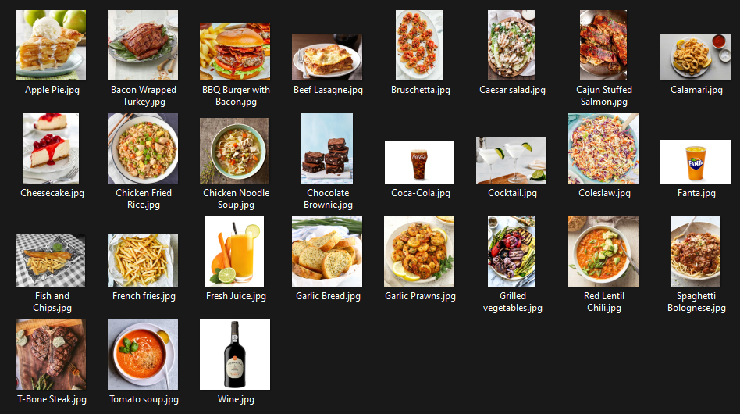

## Sign off proposal

Feedback from stakeholder:

“The functionality of this product fulfills my needs; however, I believe if there is a limit for notes to the kitchen 500 is too high it should be lower at 280. Overall, I am quite happy with the UI it seems easy to understand and use however, I would like to see the colours for the order screen changed so that they are easier to differentiate especially the note colour should be changed colour.”

* Louis Allaway

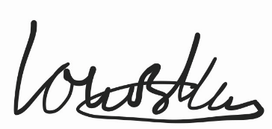

# C. Developing the coded solution (“The development story”)

**\*\*\* Some PC screenshots may seem to change in colour, but they are the same colours. I had issues with my monitors colour profiles \*\*\***

## Making the database and Adding Data (V0.1)

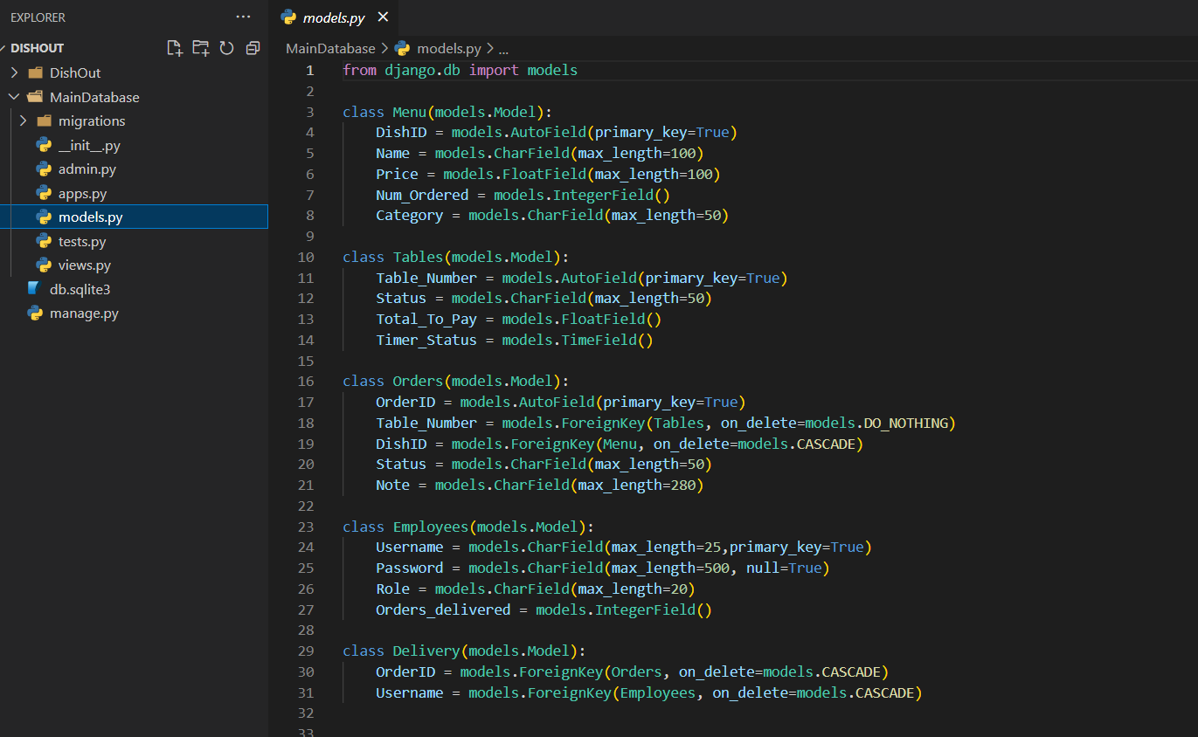To make the database I had to make an app in Django which will manage the database. Usually in Django each app would have its own database but because all the tables are so connected, I decided that it is better for them all to be in the same app and I will just reference the tables through that app.

Here you can see on the left that I created the app called MainDatabase which will hold the tables for this project. In Django you create tables using the models.py file and by defining classes which hold the individual fields. I had to specify the relationship between each of the tables as well as the variable types for each field.

You can also see that I have added a 280-character limit to the Note field in the orders table as requested by my stakeholder.

Django stored the database in a file called “db” with the format sqlite3 which is the way that Django interacts with the database. I checked to see that the tables were added correctly using an external too called DB Browser which shows me the tables.

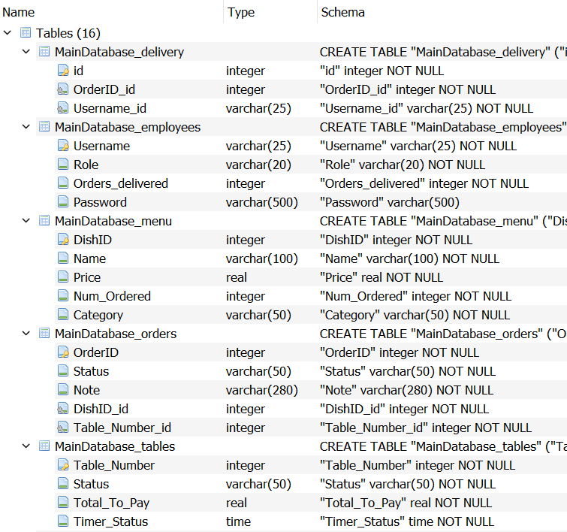

Here you can see in the DB Browser that all the tables have been added correctly and their fields have been added as well.

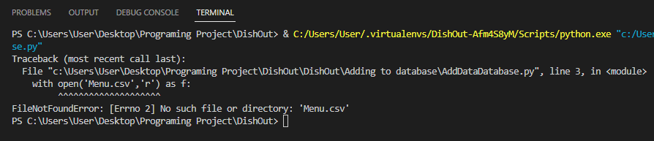After this I decided to add the test data that was specified in the Test Data section. I created a script that reads a csv file with the information to add to the table so that adding the test data to the database would be faster. I ran in to a problem with the file management while developing this script.

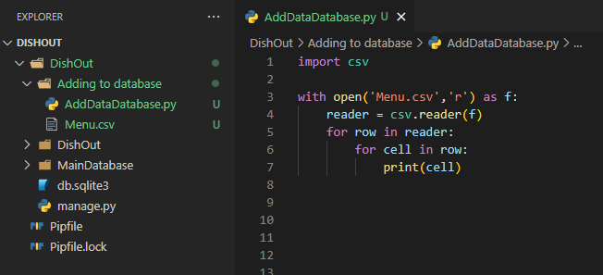

To fix this bug I had to add the full path to the file as it would not be able to find it otherwise. After re-running the code, I found that the data had weird symbols like this:

After some research I found that this is due to the way in which UTF-8 files are encoded so to remove it the file needs to be open in a way to interpret the UTF-8 file without these marks. I did this by using the io built in library:

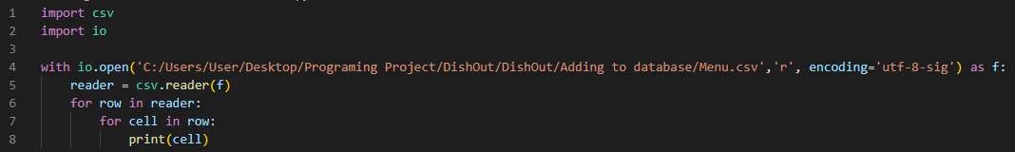

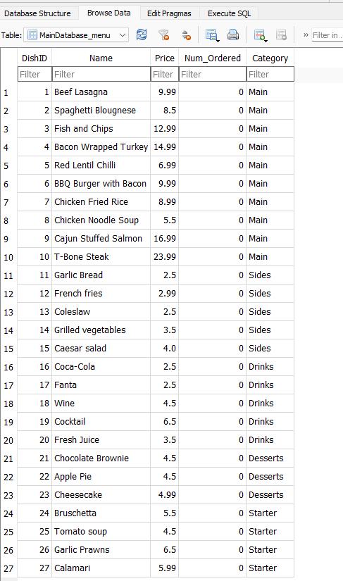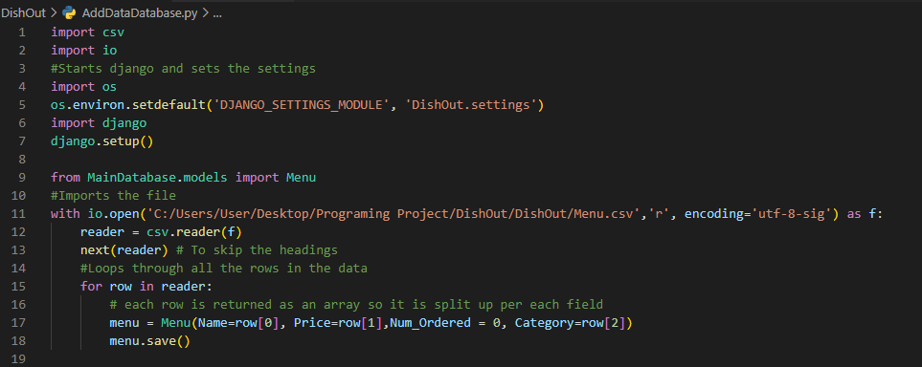After having implemented the code so that it worked with Django’s database this is how the final code looks. I had issues with it being able to communicate with Django as I did not know that when using an external script to add data to the database lines 4 to 7 are needed in every script. After having researched that and adding it in it worked, on the second image it shows the database visualisation tool proving that the records are in the database.

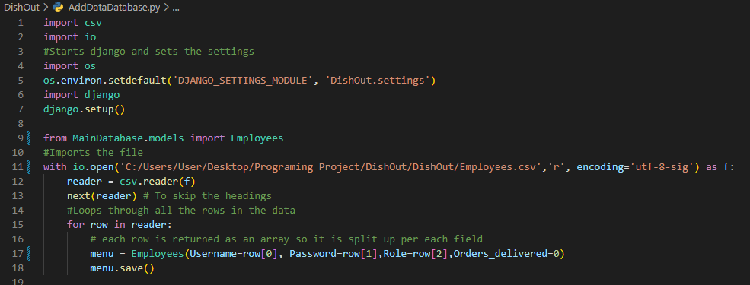I then added the other data for the employees by changing the code so that it would import the Employees table instead and I also had to change the fields names it was going to change so that it would add the data to the correct fields. After this I also

## Making the Login Page (V0.2)

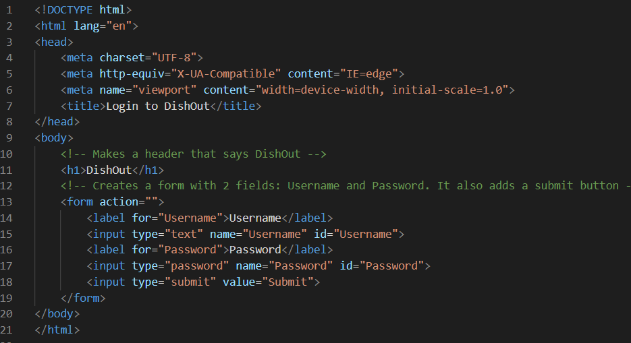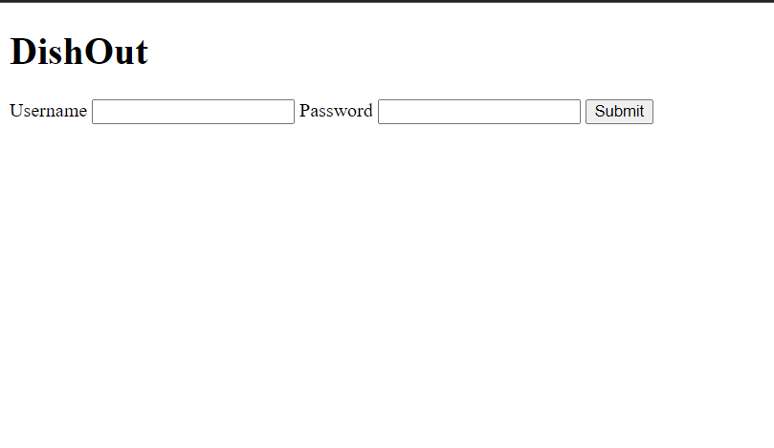First, I started by making a simplified version of what the login page will be just so that I can use it to test and integrate the backend. Currently it does not include any CSS as it is just to prototype, after I am sure the backend is working correctly, I will add CSS to improve the style of the login page to match my mock-ups.

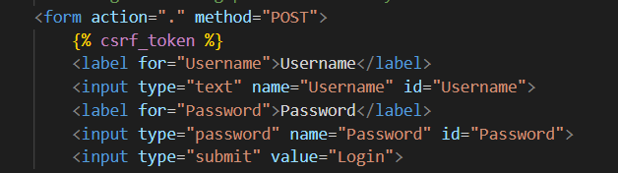I then had to change my HTML code to connect the backend to the front end. I did this by changing the method for the form to be a POST request, this will allow me to send data to Django in a secure way. I also had to add a csrf_token to add security and to allow it to work as Django requires csrf_tokens to send and receive data.

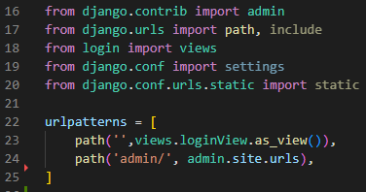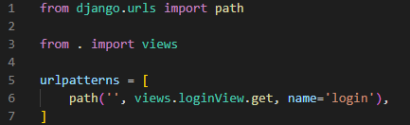Then I created the backend code for the login page. First, I had to define the URL of the login page, I did this by changing the url.py for login app and the main url.py (Url.py in the DishOut folder):

login/url.py

DishOut/url.py

This just defines that when no subdomain is typed in then it should check the loginView to get the page to display. I did this so that when the IP or Domain is typed in it automatically goes to the login page.

Then I had to create the rest of the backend for the page in the views.py. The get function simply sends the index.html page to the user so that they can view the login page (Will change it to login.html later on). The post function is for when the page sends back post requests which in this case would be the login fields (Username and Password), it first checks the request to see if it is post as it could be a get request then it saves the username and password to then check it against the database and hash the password to then check that.

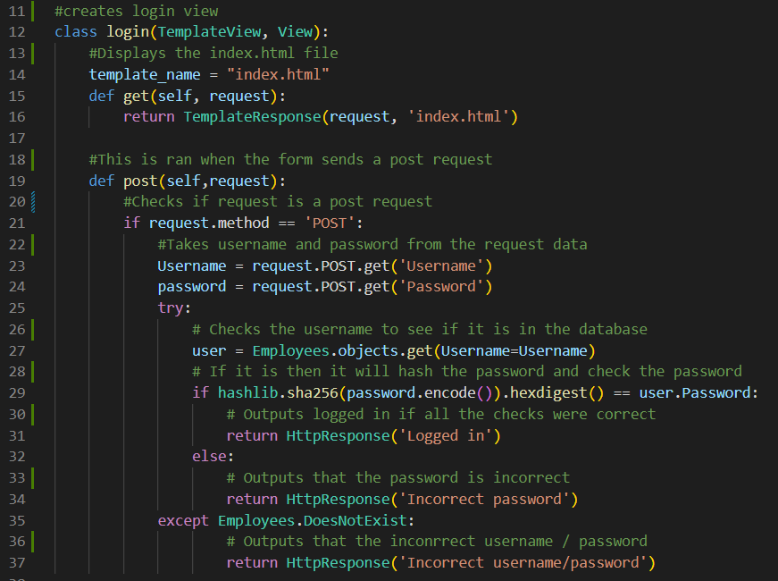

## Switching to built-in Django user management (V0.3)

After having researched deeper into how to implement this solution I have come to a decision that it would be too complicated for the time needed to complete this project using manual user checking and permissions. I have found out that you are meant to use the built in user authentication to make users and give them groups to be part of. For this reason, I will be using the Django way to make the users and check for them.

This does mean that I will need to change my code for the database and login page significantly.

First, I decided that I should add the users that were in the database to the Django Users database. To do this I had to use the built-in Django admin page.

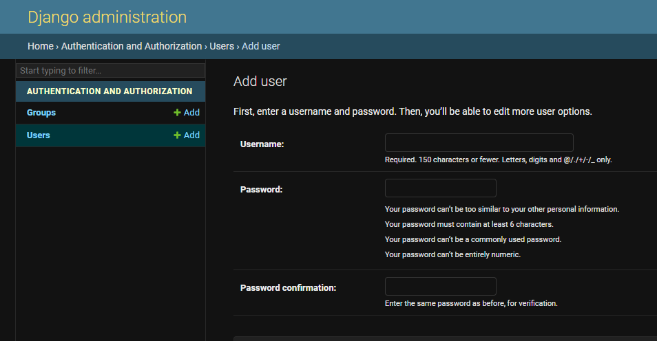

This is what it looks like. I added all the usernames and their passwords to through this. It automatically hashes and salts the passwords so that they are stored securely. All the relevant information about how the password is stored is shown in the user management section of the admin page.

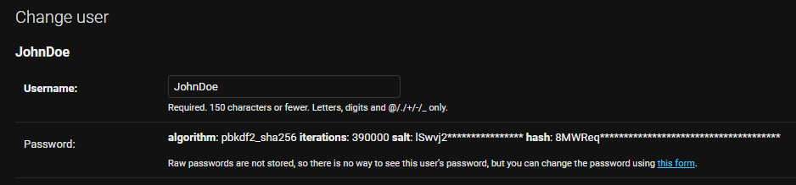

After this I decided to code the login form again so that it works with Django’s built-in user management. I did not have to change any of the HTML of the page and instead only had to change the backend of the application.

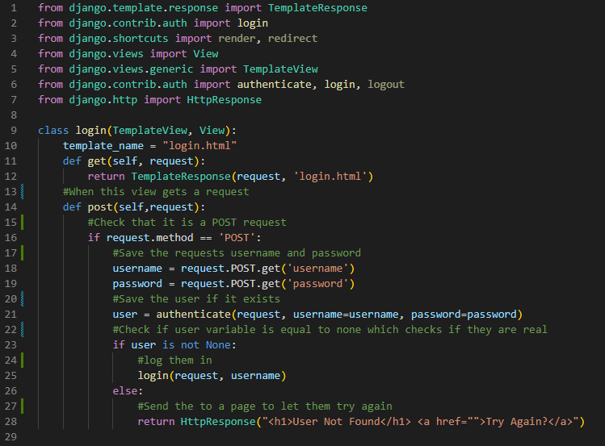

This does the same as the previous code but allows me to integrate permissions when trying to view other pages more easily. Currently when the user that has been inputted is incorrect this HTML is shown.

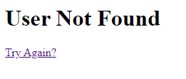

However, if the correct username is typed in an error message appears and this is because I have not currently added where it should go to next if the user has logged in correctly. In the next build I will be adding the permissions to each user and adding permissions to view a page.

## Adding Permissions To Users and Restricting Page Access (V0.04)

I first had to create groups for the users to be part of which will indicate what permissions they have. To do this I also had to use the Django admin site to create the group and add it to the users.

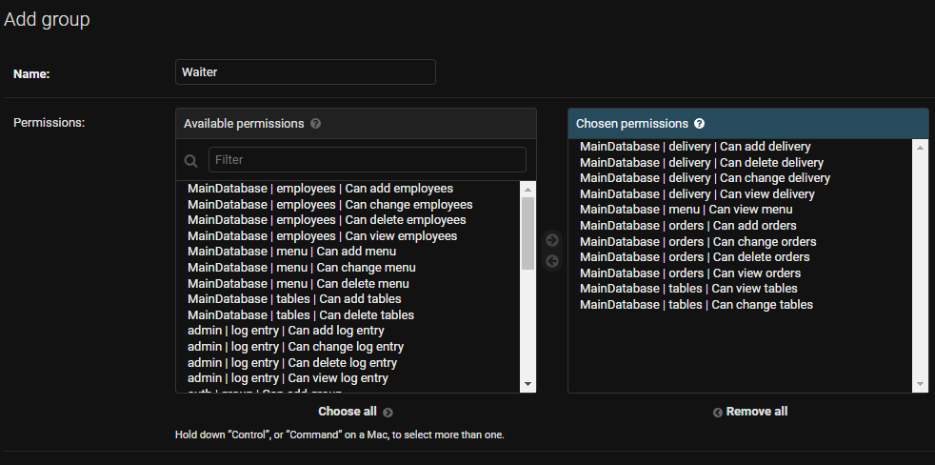

This is what it looks like when adding the group ‘Waiter’ I then did this for the rest of the groups (‘Kitchen’ and ‘Manager’)

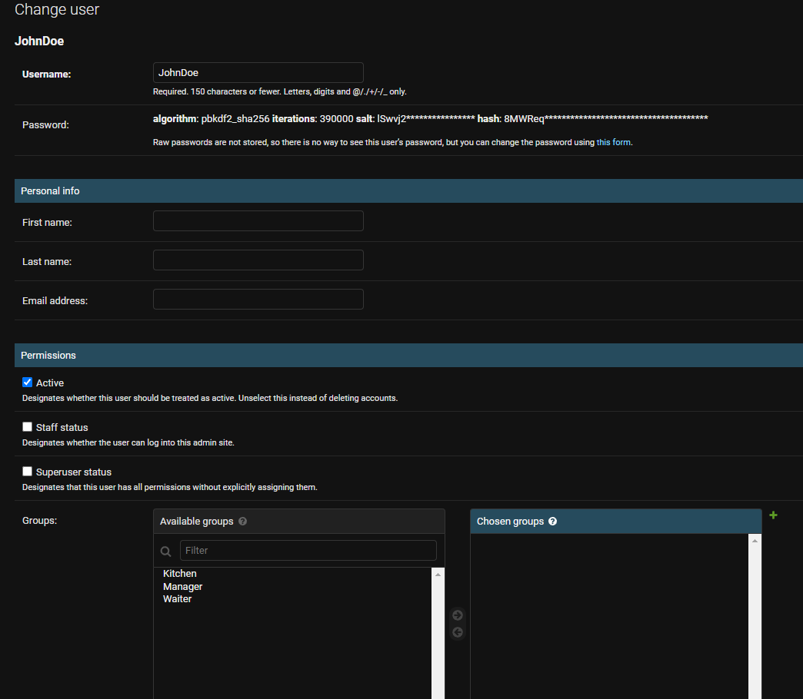After this I added the groups to each of the users:

After having added all the users to their groups I added the permission checking feature to the login page so that it knows to which page to redirect them to. Currently it doesn’t redirect them because I have not made any other pages:

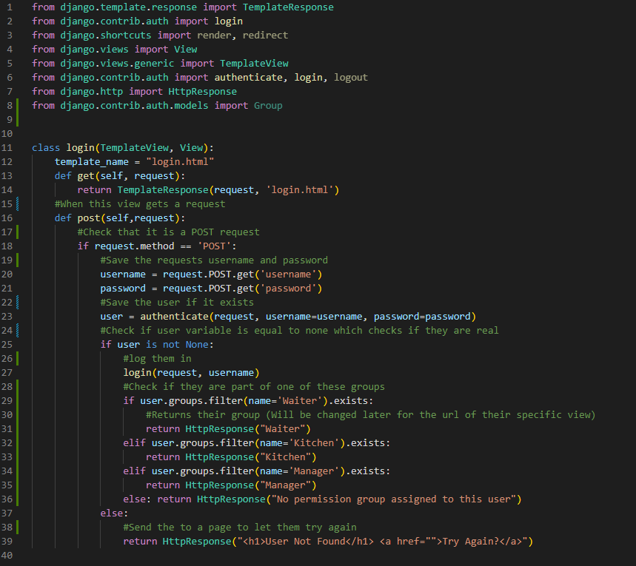

This code however ran into an error which said that ‘View.__init__() takes 1 positional argument but 3 were given’ after having researched this problem I found that it was because the name of the class was the same as one of the functions that was being used ‘login’. I decided to change the class name to loginView so that it would no longer clash with the function.

After this I ran into another error which was ‘'str' object has no attribute 'pk'’ which again after some research I found that it could be fixed by changing the parameters of the login function (Line 27) from taking in the username to taking in the user.

Fully operational code:

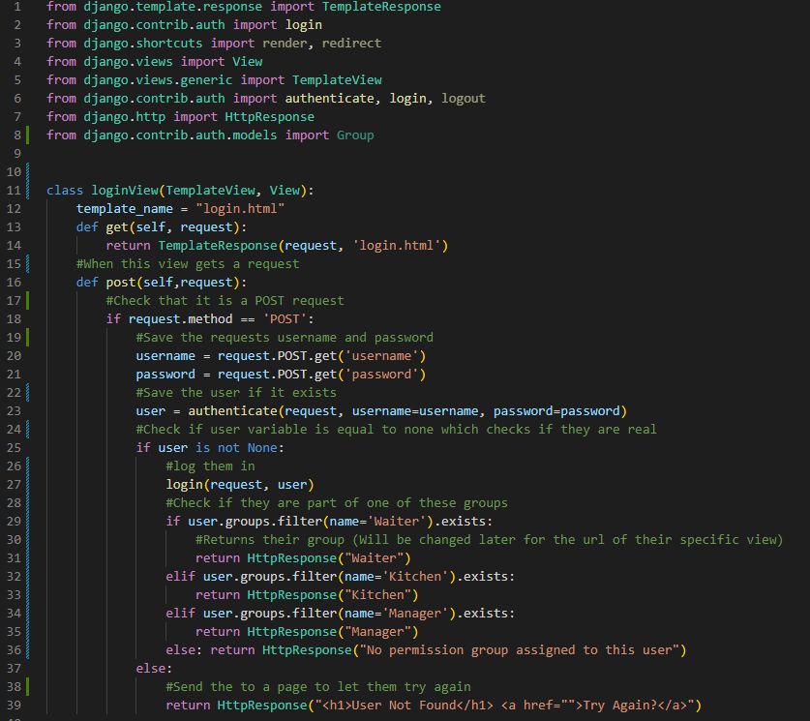

## Refining UI of login page (V0.5)

I first started by adding the DishOut logo to the page and connecting an external stylesheet to it as well. This changed my HTML code to look like this:

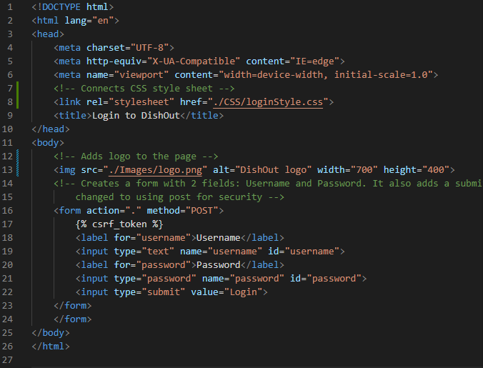

After running the server and loading the page I found that the image was not loading, and I was getting an error 404 in the server command line that it couldn’t find the image and the style sheet. After doing research into this I found that in Django you must state the static folders where CSS, JavaScript and images will be stored.

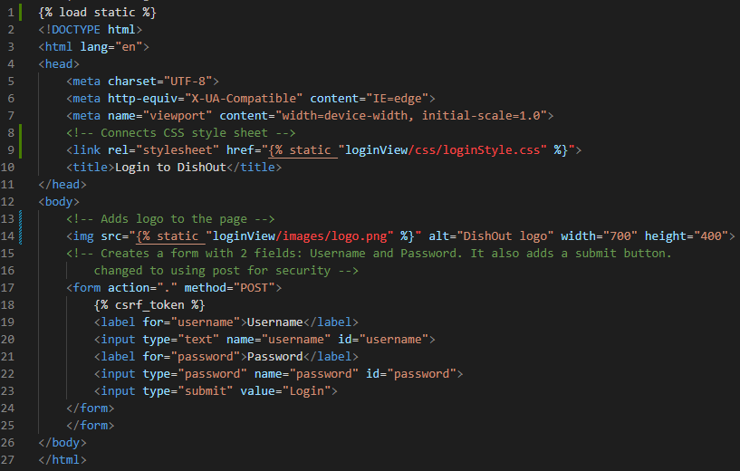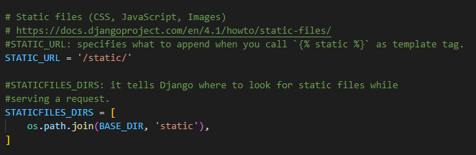This meant I had to do multiple changes to two files:

DishOutsettings.py

Templates/login.html

I also had to add one new folder which hold the static files.

I then created a reactive CSS style sheet to improve the look of the login page and match it to the mock-ups that I have made for the UI. I also had to alter the HTML so that I could align items correctly. I used multiple flexboxes to control this and used the @media tag to specify which style to use depending on the device it is being viewed on:

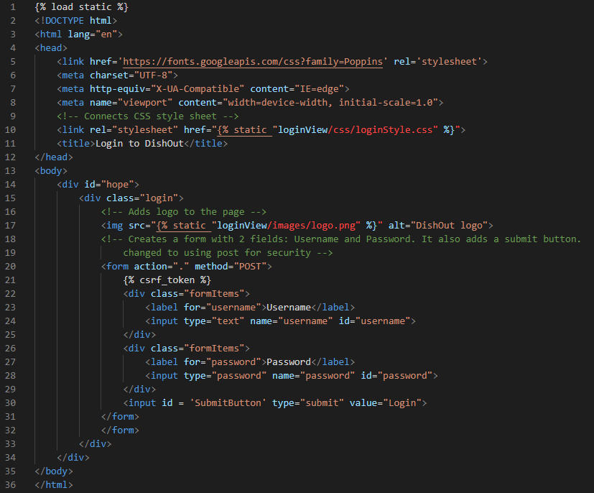

templates/login.html

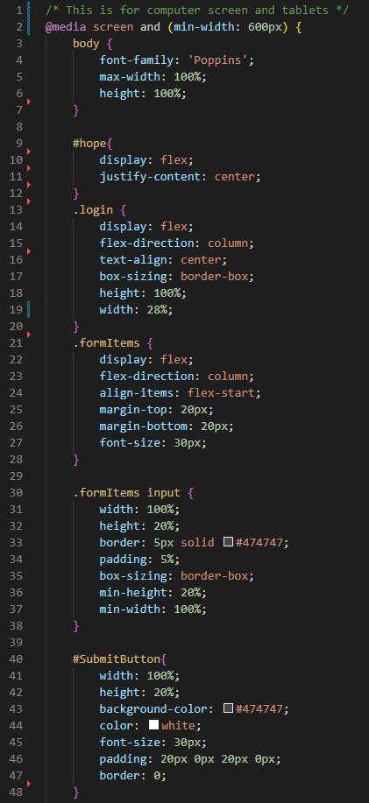

static/login/css/loginStyle.css (PC/Tablet section)

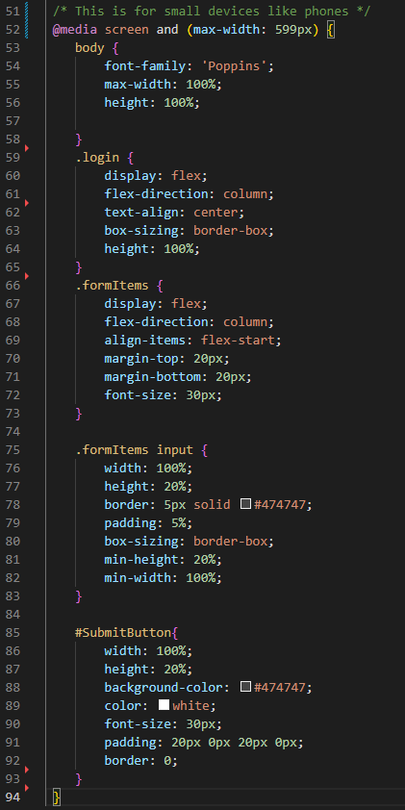

static/login/css/loginStyle.css (Phone section)

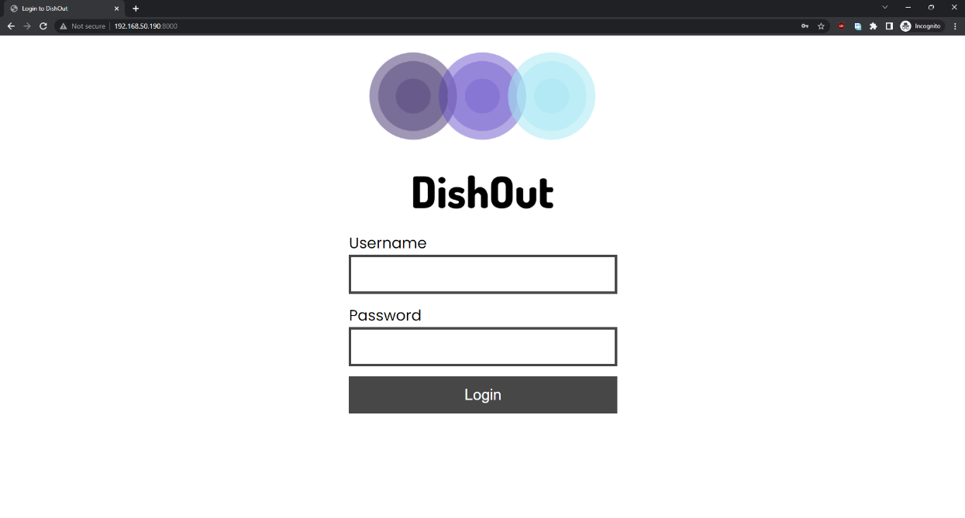

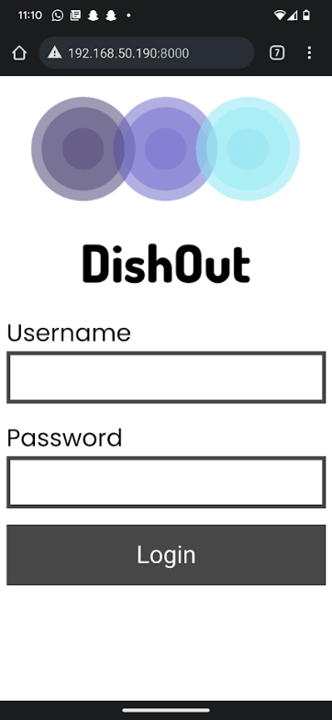**Screenshot of stylised login page for PC**

**Screenshot of stylised login page for Phones**

## Stakeholder feedback for login page (V0.6)

“I am very happy with how it turned out. The UI looks like the mock-ups for both the mobile and the PC. However, after using it I did not like that the login button does not have any feedback to the user, and it doesn’t feel like I clicked a button. I would also prefer if the text in the entry boxes was larger to fit with their size” – Louis Allaway

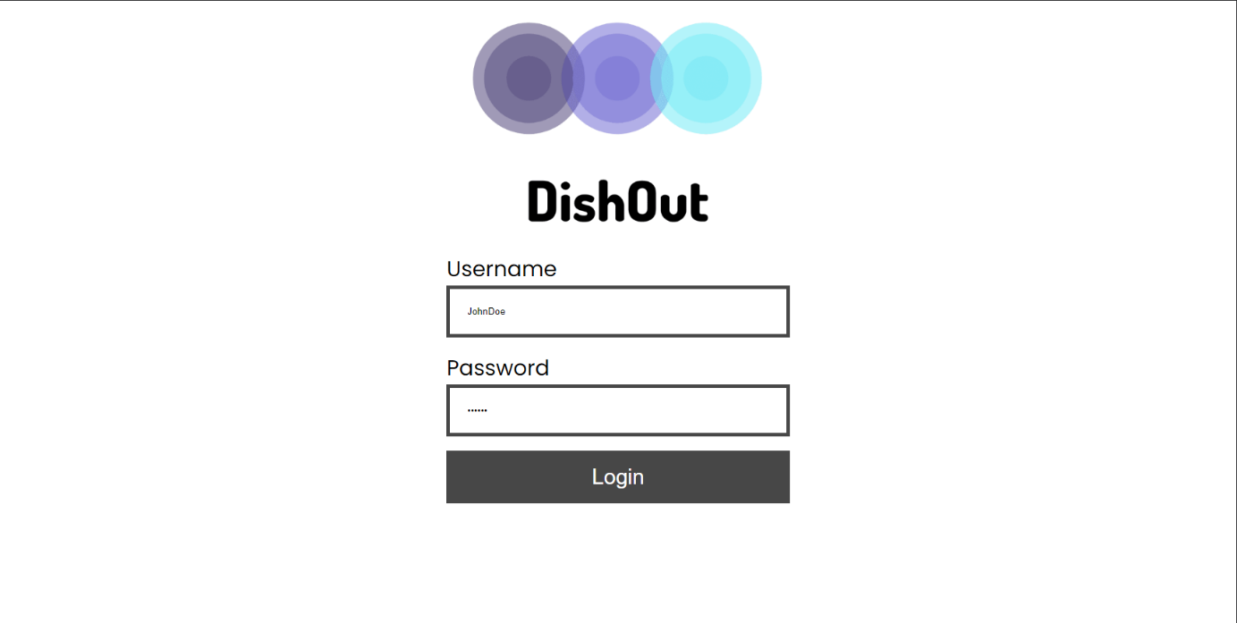I decided to implement those changes by changing the font size of the entry boxes and adding a CSS animation to the login button:

**Entry boxes text before**

Solution to the problem:

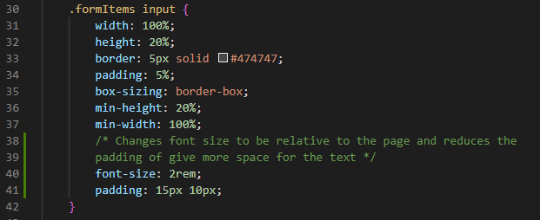

static/login/css/loginStyle.css (Phone and PC)

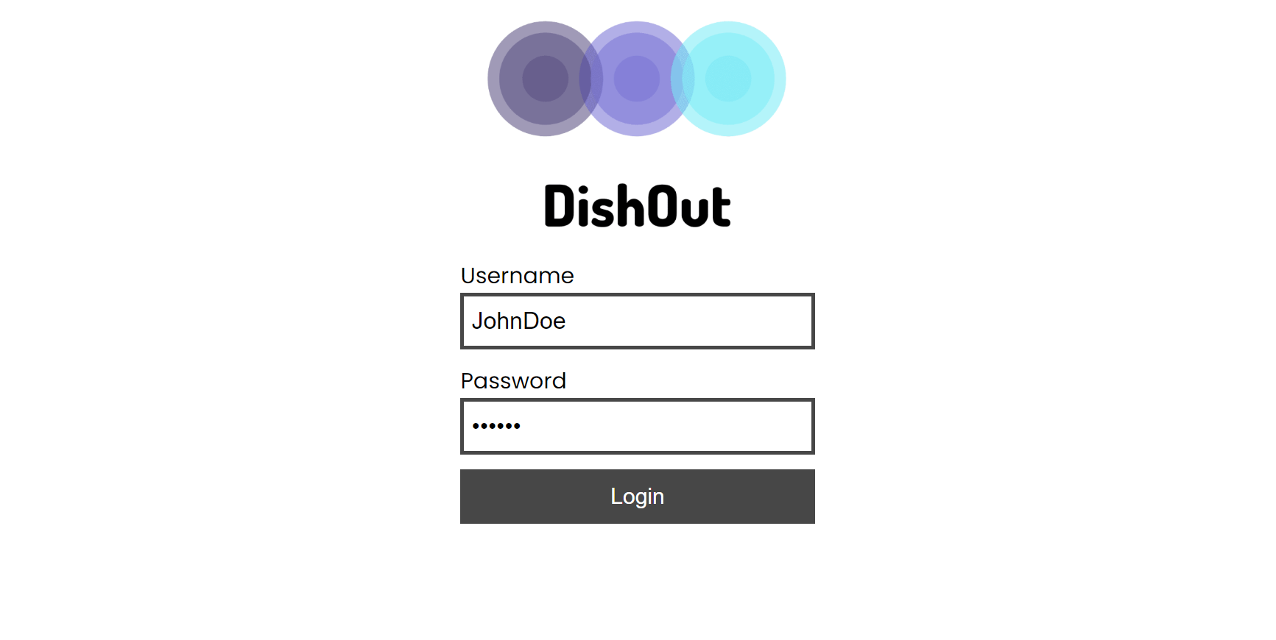

**Login in screen with the text solution**

CSS animation for the login button which makes it get darker when hovering on it and makes it move down slightly when clicking on it mimicking a button in real life:

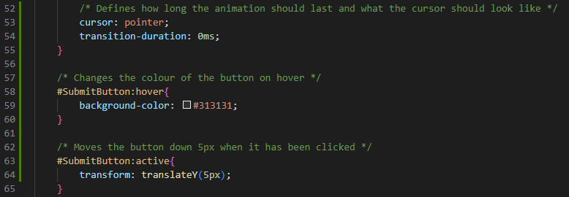

## Testing the Login Page (V0.7)

|  |  |  |  |
| --- | --- | --- | --- |
| Logging in | | | |
| Test | **Action** | **Result** | **Correct?** |
| Check valid Username and Password combination | Used the JohnDoe account to login | HTML response of waiter | Mini Green Tick Stamper - SuperStickers |
| Check that User gets signed into the correct application | Used the DavidC account to login to test a different permission (Kitchen) | HTML response of waiter |  |
| Enter wrong information | Entered test in both the username and the password fields | HTML response of User not found and a link to try again. | Mini Green Tick Stamper - SuperStickers |
| Enter correct Username and a Password and check hash | This test is no longer useful as the program has changed and Django does this for me | **N/A** | **N/A** |

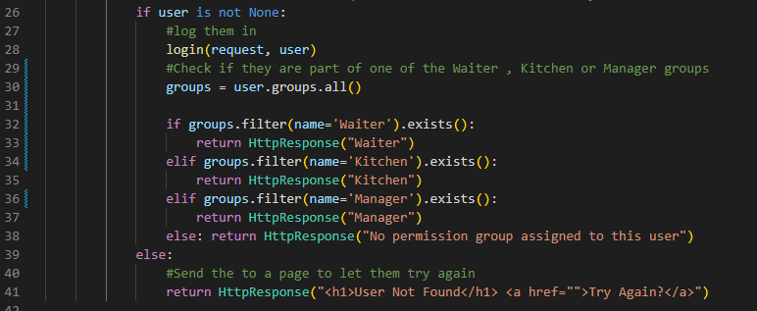After doing the tests the only test that failed was the one trying to sign into a user with a different permission other than waiter. I found that the problem was that the program was checking to see if Waiter, Kitchen, and Manager were groups that existed which meant that every successful login would send the user to the waiter page. To fix this I had to specify to check the users group:

Running the test again now using the same account:

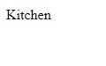

It now functions as intended.

## Implementing Waiter selection Screen (v0.8)

I began by making the waiter app in Django by using the command ‘python manage.py startapp waiter’ which made me the boiler plate files that I will be needing to use for this application:

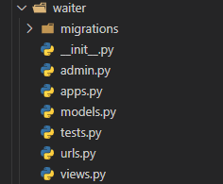

I then created the URL for the selection screen which in this case is only going to be “waiter/” as it will be the first screen you see when entering the waiter side of DishOut. I did this by editing the url.py file for the waiter app and the main url.py file just like in version 0.02:

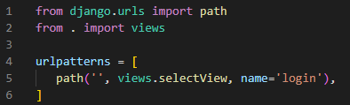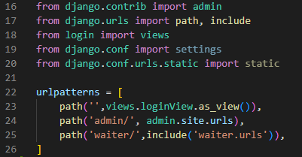

Waiter app

Main

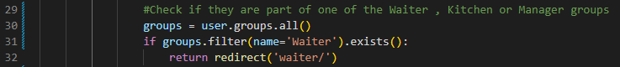After having defined the URL for the selection screen I was able to edit the login page backend to redirect the user to the waiter app if they are part of the waiter group:

Then I developed the backend for the selection screen. This meant that I had to add a login_required clause to the page so that Django automatically checks if a user is logged in and if they aren’t sends them back to the login page so that they can login. After if they are logged in the function check if they are part of the waiter group and if they are they can access the page, if not then they are given a Html response which says they don’t have the correct permissions.

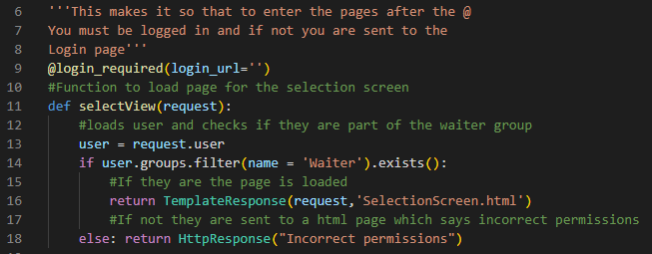

Finally, to finish this version I created the html page which is a simplified version just to set up the backend and be able to run the code so that I know it works. I will later the next version I will style the page and make the Username show the logged in user as well as make the Logout button work:

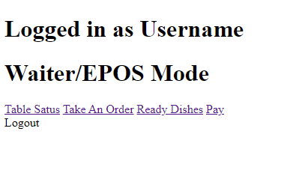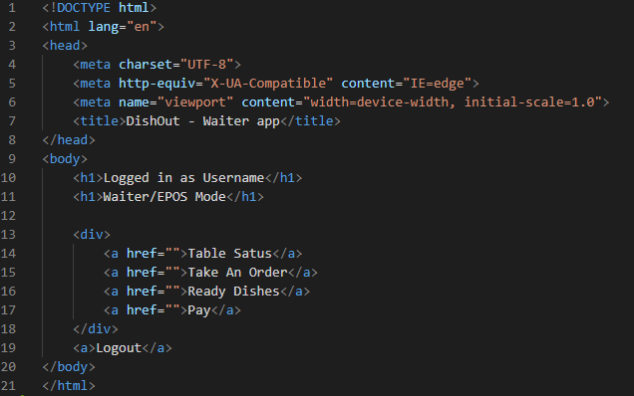

## Waiter selection screen refinement (v0.9)

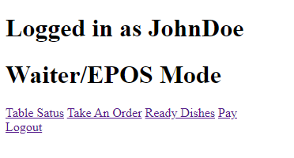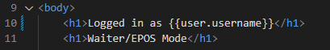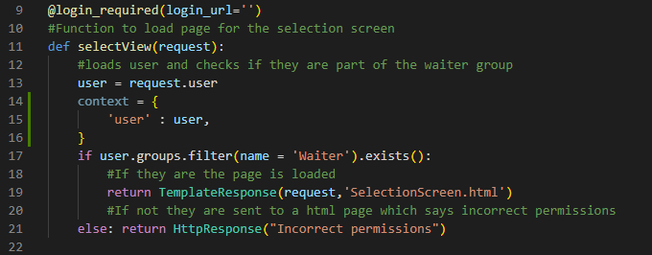I first started by adding the functionality so that it adds the username of the person currently logged in to the HTML page. All I had to do was add a tag to the HTML page and add a dictionary called context to the view.py:

While doing this I found a bug while trying to go on the waiter section without logging in. It gave me an error that it could not redirect me due to there not being a URL called “”. This was a simple fix as I only had to add a / to the code to fix it.

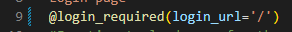

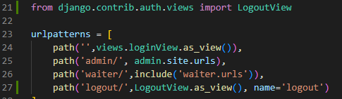After this I added the logging out functionality to the waiter selection screen. To do this I had to make a new URL to the logout function which is a built-in function for Django. This meant that I had to change the main url.py, the html and the settings so that when it logs out the user it redirects them to the login page.

templates/SelectionScreen.html

Dishout/settings.py

Dishout/url.py

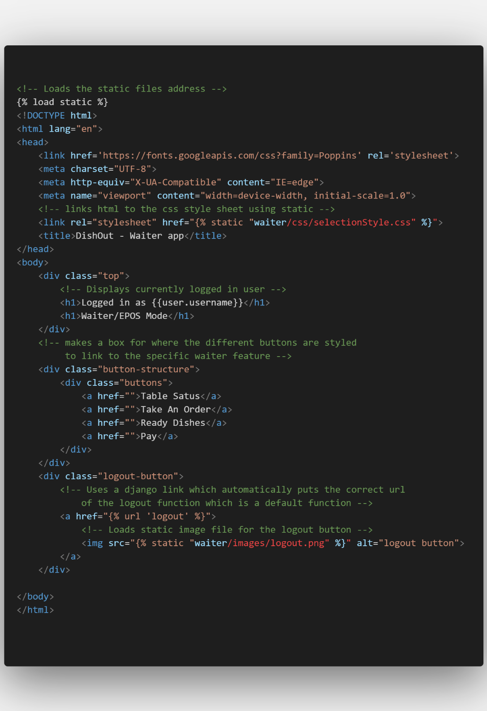After this I improved the GUI of the selection screen as well as making it responsive for both a phone and a PC interface. I edited the HTML and the CSS file to do this as well as adding an image for logging out.

templates/SelectionScreen.html

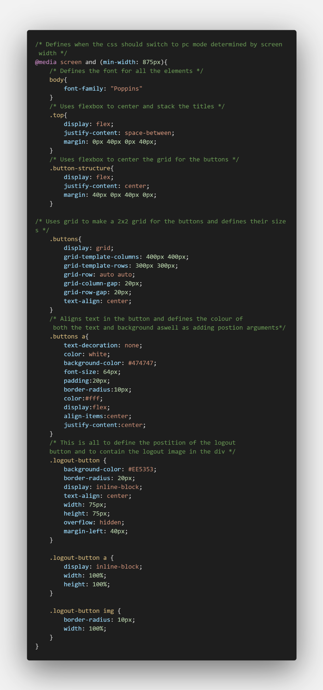

static/waiter/css/selectionStyle.css (PC)

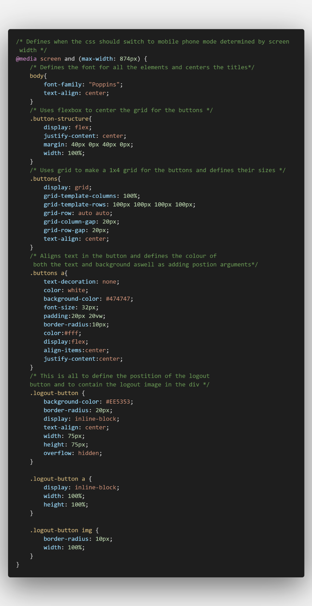

static/waiter/css/selectionStyle.css (Phone)

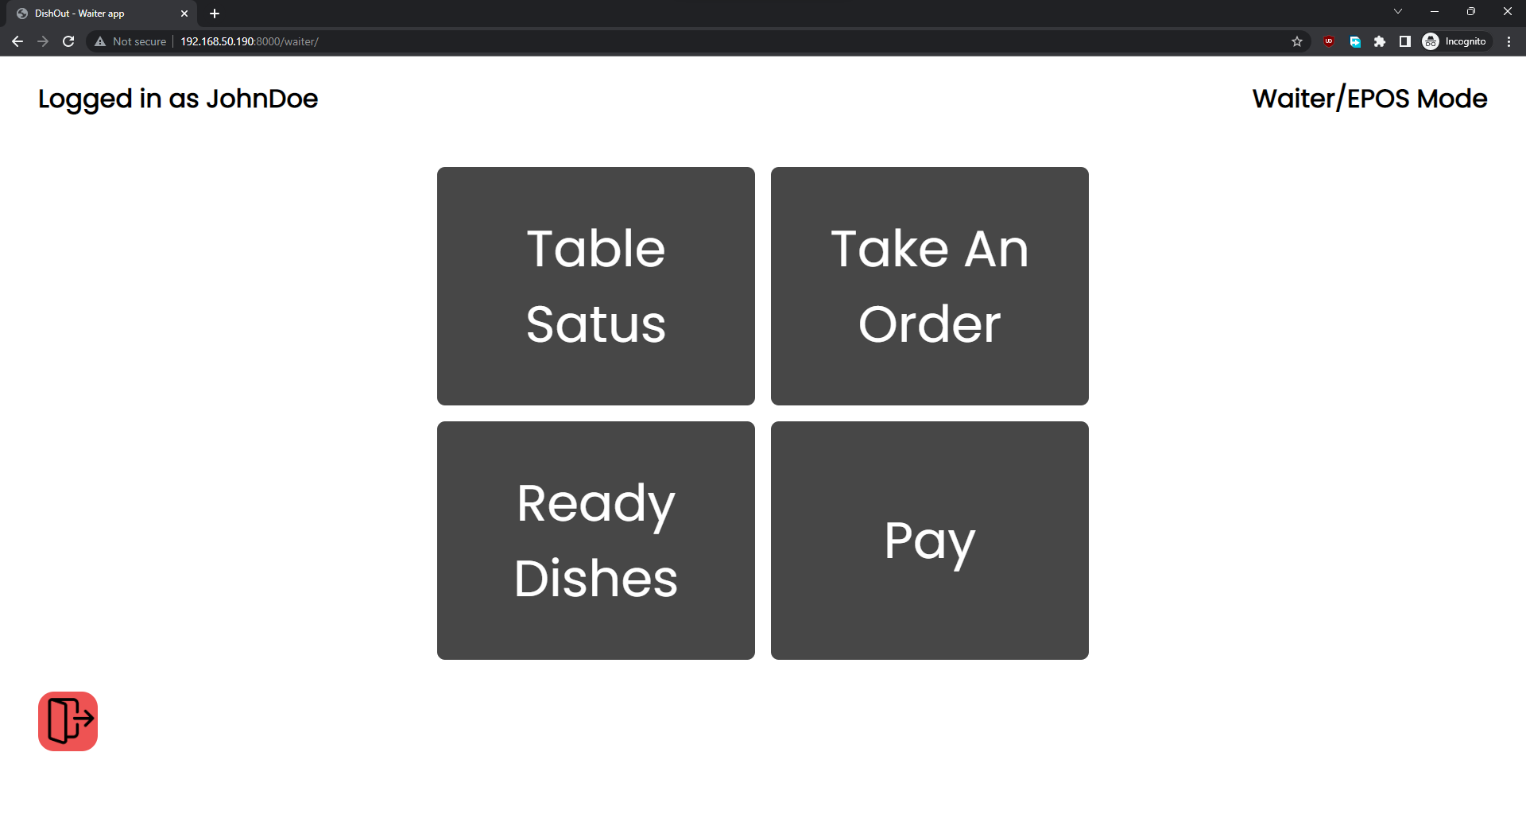

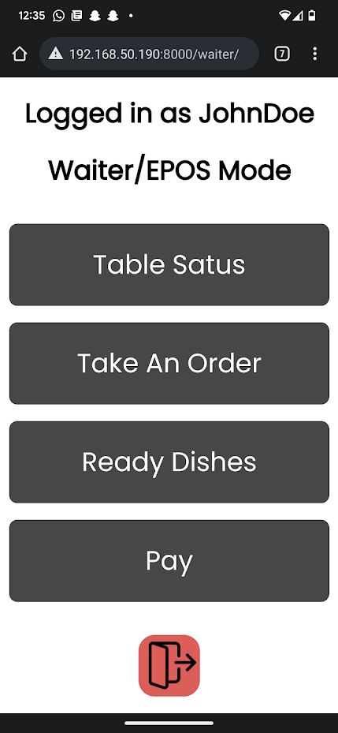**Stylised waiter selection screen for PC**

**Stylised waiter selection screen for Mobile**

## Stakeholder Feedback on the Waiter Selection Screen

“This section seems to work correctly and matches the mock-up completely. I have no complaints about it especially since employees will interact with this screen a minimal amount of time” – Louis Allaway

## Implementing Table Status solution Screen (V1.0)

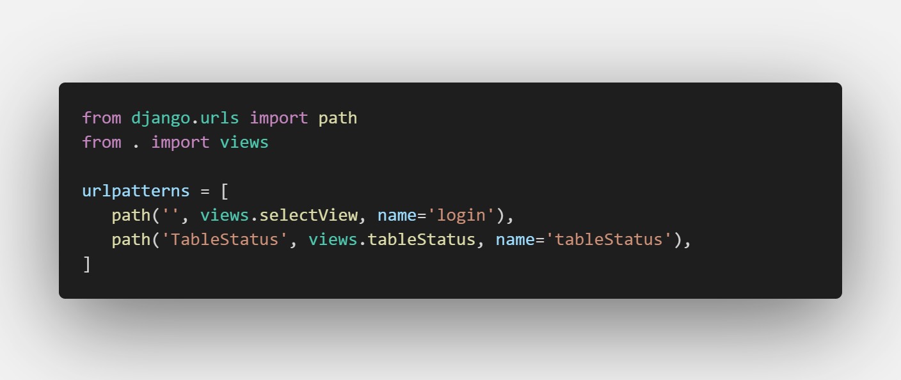For this version I will be adding the table status section to the waiter application. To do this I first had to create the new URL path to this section of the code in the waiter app I created in Django, and I had to create the function where the back-end code will be which is in the views.py of the waiter app:

Waiter/url.py

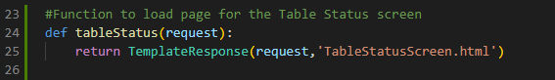

Waiter/views.py

After doing this I decided to set up the basic html on the TableStatusScreen.html file. I decided that it would be best if it was dynamic meaning that it would change the number of tables that it displays depending on the number of tables on the database. This would mean that if the restaurant using DishOut ever decided to change the number of tables they wouldn’t need to change the html.

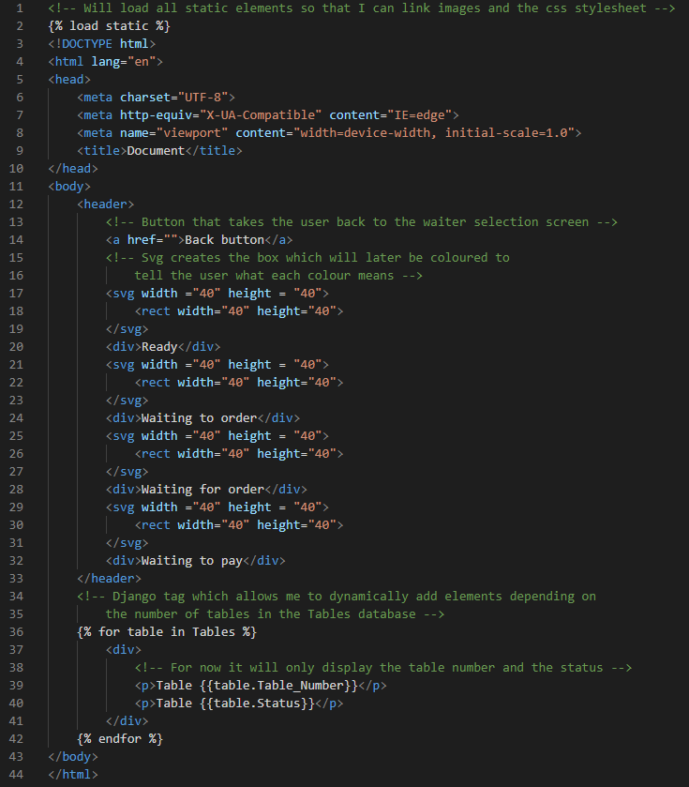

templates/TableStatusScreen.html

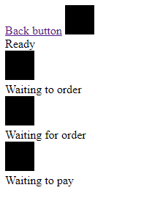

Rendition of html

After coding this I decided to open it to see if it works and found that it was not displaying any table information. I figured out that this was because I did not include the context for the page in the backend which feeds the data to the html. Thus, I decided to add the context to the views.py file as well as other features like login checking and group checking so that not just anyone can access the page as they will need to be logged in with the correct permissions.

After having implemented this in the views.py I found that it did not work due to a syntax error in my HTML which led me to change the for “table in Tables” to “for table in tables”:

waiter/views.py

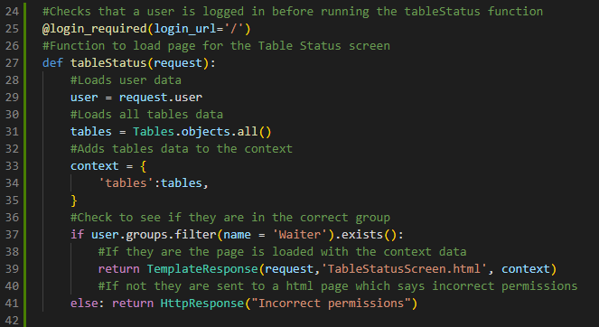

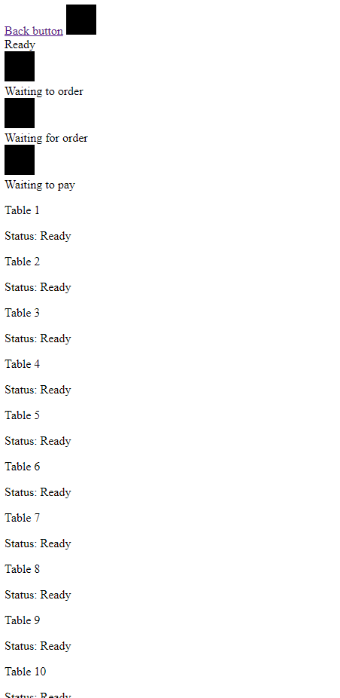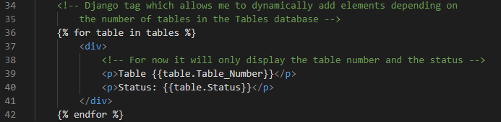

Rendition of html

templates/TableStatusScreen.html

After having completed this I found a major flaw with my program which is that there is no way for the waiters to tell DishOut that a table is now waiting to order. This would mean that every table would always be ready even though they may have people sat on them so I decided that the table status screen would allow the waiter to click on the table which has a status of “Ready” to change it to a status of “Waiting to order”. This would solve the issue and make the application work logically but may make it slightly less user friendly as this would not be obvious from the naming scheme.

To make this change I am going to have to change both the html and the views.py as I am going to have to make the currently div elements that hold the table status and number into forms with a button that will check the table status to make sure that it has a status of ready and then if it does it will have to change it to a status of “Waiting to order”

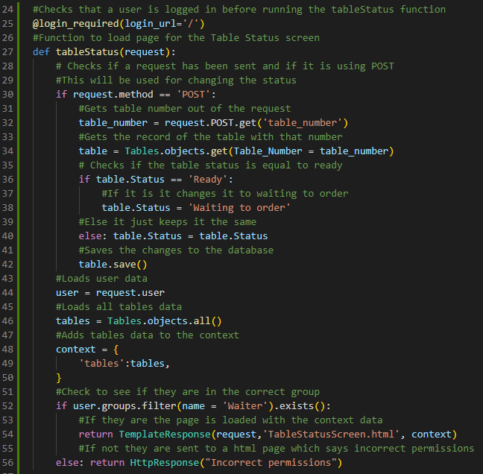

waiter/views.py

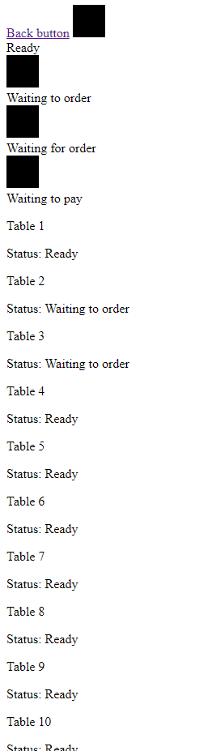

Rendition of html

templates/TableStatusScreen.html

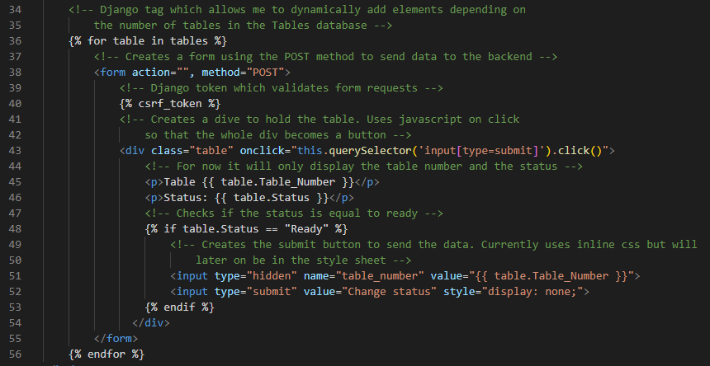

I made this piece of code have extra redundancy as it checks if the status is equal to “Ready” both in the html and in the python. This should make it harder for it to accidentally alter the status of an element which is not equal to “Ready”.

After this I changed the waiter selection screen code so that it would link to the table status screen. I did this by changing the HTML to include a Django token that pointed the URL towards the URL of the table status screen.

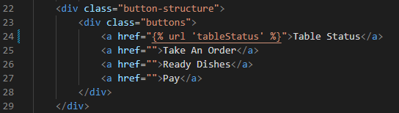

templates/SelectionScreen.html

## Refining the Table Status Screen (V1.1)

First, I began by making the UI look better using CSS as well as making it so that the table buttons change depending on which status they are. To do this I had to make it so that the class name of each button would change depending on the table status, this was the best way that I found to do it as it means that all the CSS can be done externally which makes it easier to edit.

I have also not yet added the mobile styling for the page as I have decided to first refine the PC version and then do the mobile version.

I also changed my mind on putting the style which tells the actual HTML button to be invisible in the external CSS as I found that it would make it harder to understand than if it just stayed in the HTML.

templates/TableStatusScreen.html

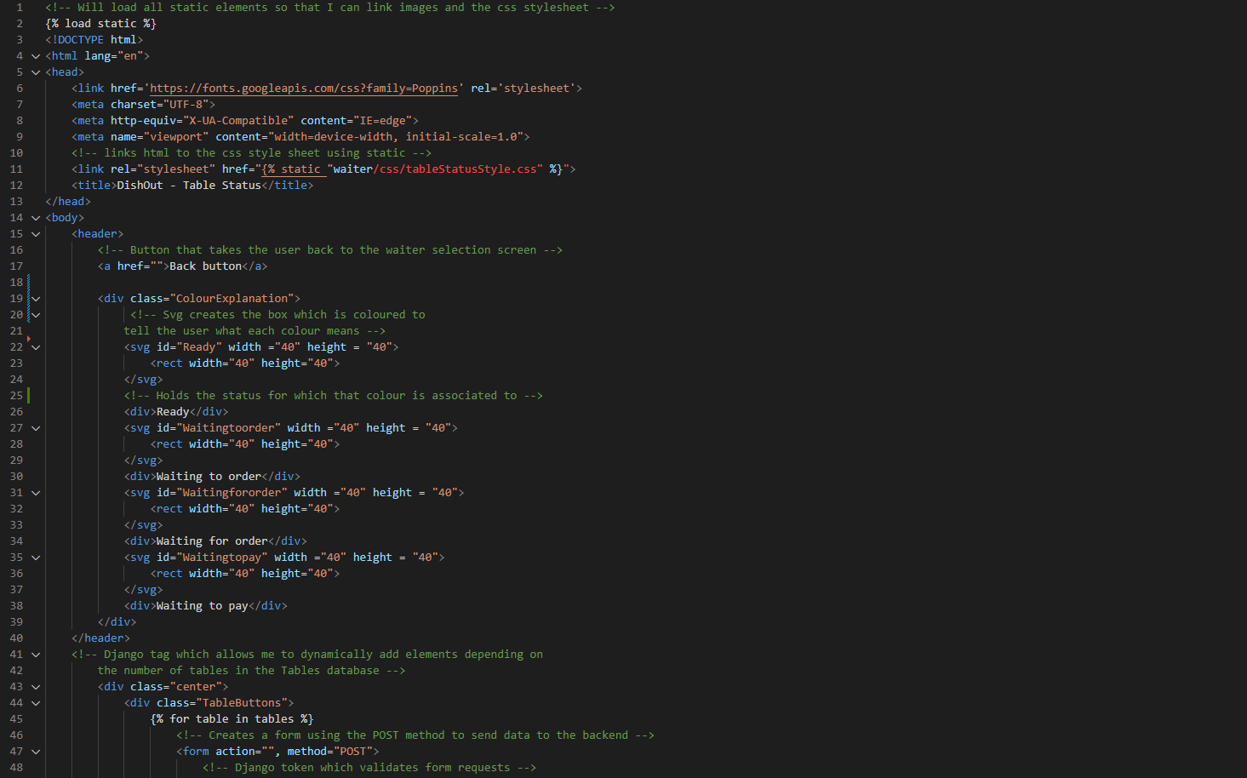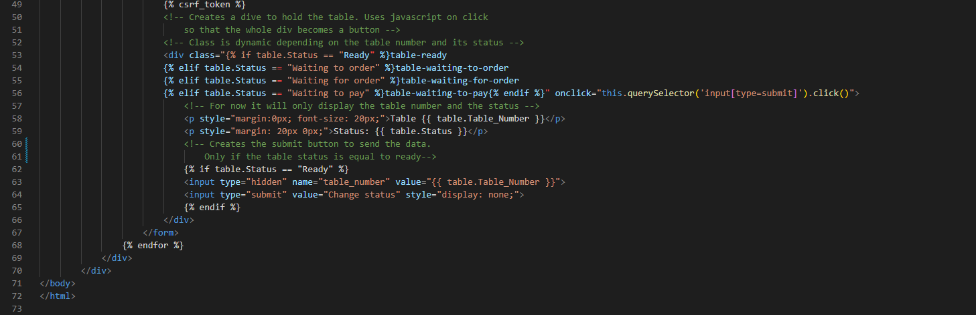

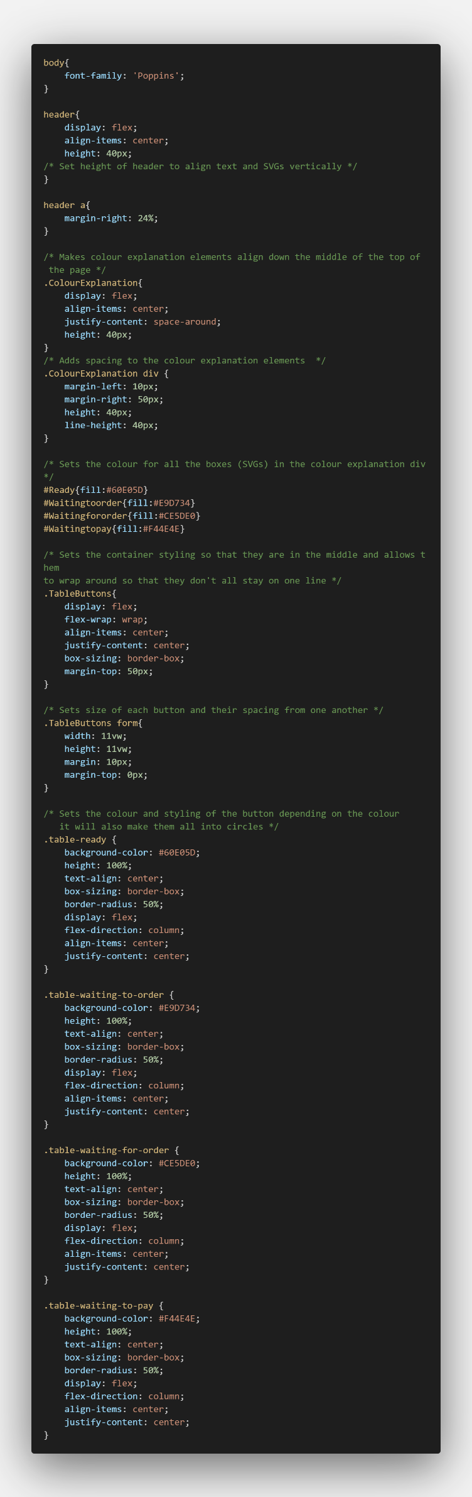

static/waiter/css/tableStatusStyle.css

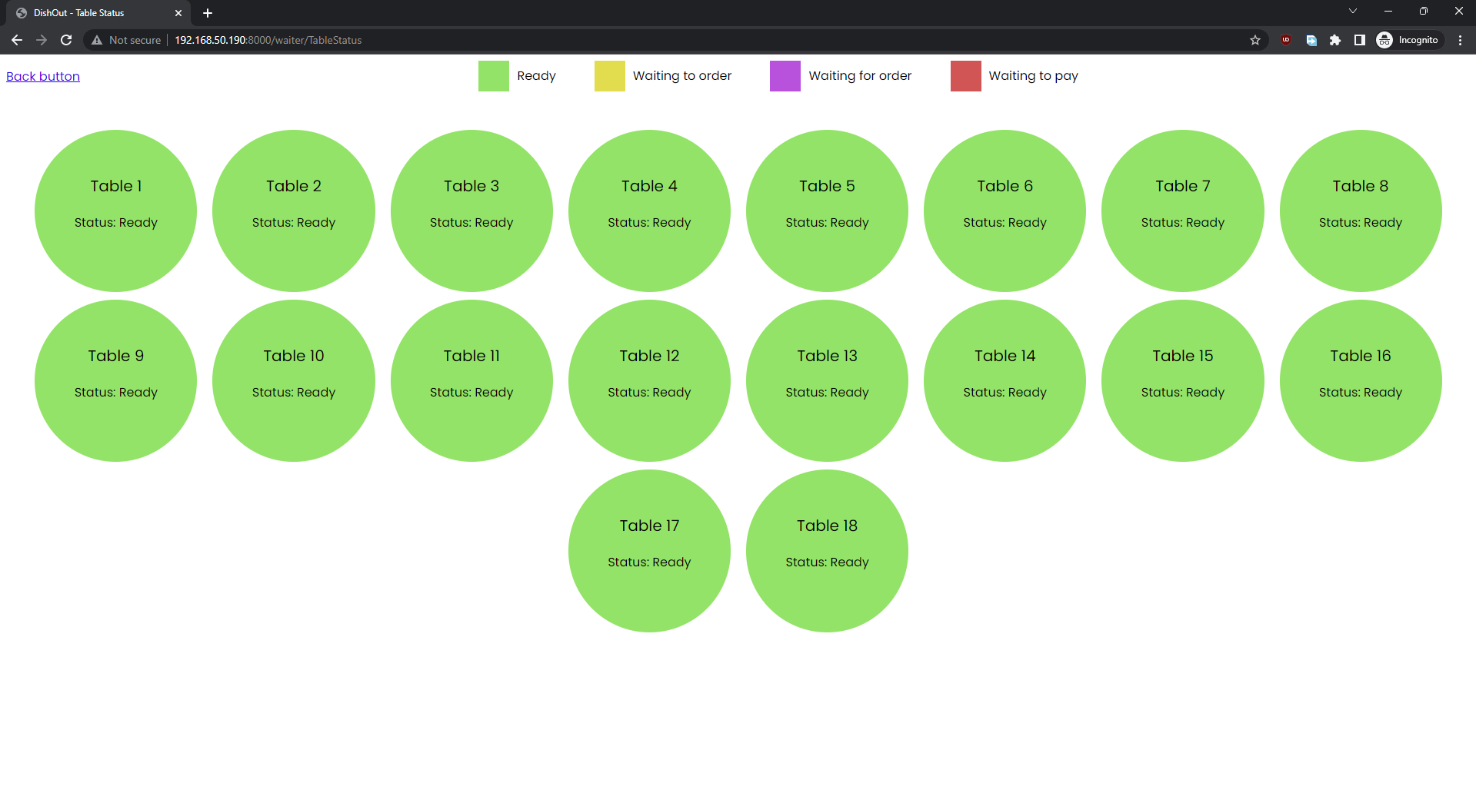

**Current table status UI on PC**

The next step will be to change the back button to have an image instead of just saying back button as well as giving it the URL of the waiter selection screen so that it works. After that I need to make it so that it auto refreshes the page in case of any changes to the table’s status.

While coding the back button I ran into an error that the URL couldn’t be found. This led me to find that in the Waiter/url.py file the name for the waiter selection screen was set to login so I had to change it to the correct name selectView.

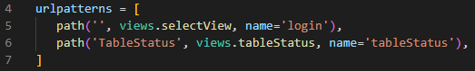



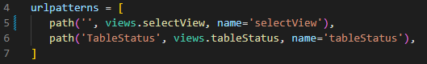

After this change it worked. This is the finished code for the back button on the page, it required both changing the HTML and the CSS.

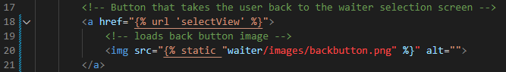

templates/TableStatusScreen.html

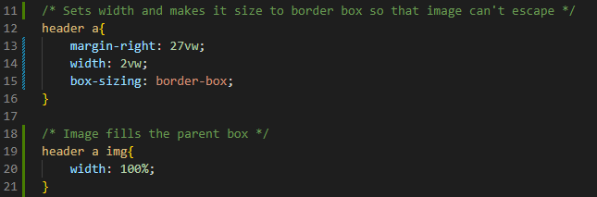

static/waiter/css/tableStatusStyle.css



**Back button now after change**

Now I tried to implement the feature to refresh the page. I started off with this solution in the HTML:



This solution refreshed the page every 5 seconds. However, it would also bring the user to the top of the page when it refreshed which means that for the mobile app this is not suitable as every 5 seconds the waiter would have to scroll back down to where they were before the refresh to check the tables. This is why I decided to change my solution so that it would use JavaScript to save the scroll position of the user and then refresh the page but allow them to be in the same spot on the page thus making it seamless.



templates/TableStatusScreen.html

static/waiter/js/tableStatusJS.js

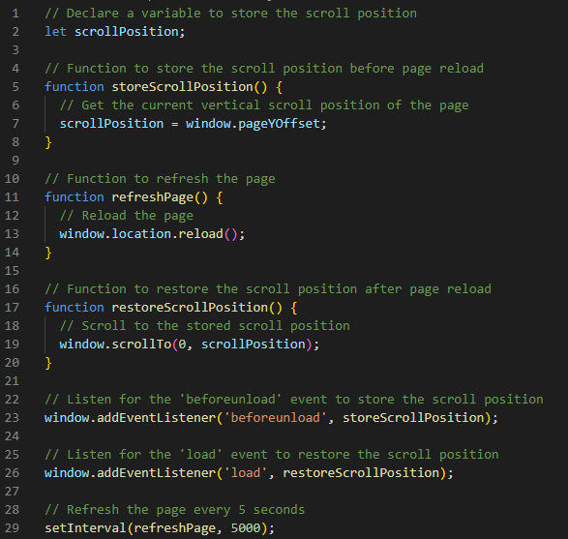

Now that I have implemented the auto refresh, I need to add the timer feature to the table buttons. To add the timer feature I will have to use JavaScript to check the Timer_Status and check how long it has been since that time.

While trying to implement this solution I found a problem in my code which is that when the table status buttons are clicked to switch from ‘Ready’ status to ‘Waiting to order’ it does not save the time that the change was made to the Timer_Status of that table. To fix this I first had to import datetime in the views.py of the waiter app:

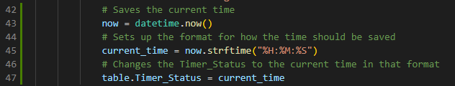And I also had to change the code for when a request is sent, and the table status of the table is ‘Ready’. I had to make it so that it first saves the current time then formats it correctly then finally changes the tables timer status accordingly:

After this I decided to implement the timer feature to the site. This involved me having to use JavaScript again, but first I would have to make a Django API to send the data to JavaScript in JSON format. To do this I first had to make a new URL linked to the table status page so that the data could be requested using fetch.

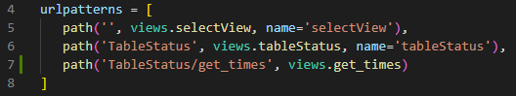

Waiter/url.py

Now I had to make a new function called get_times that would send a JSON response to the JavaScript holding all the tables which need to have a timer function.

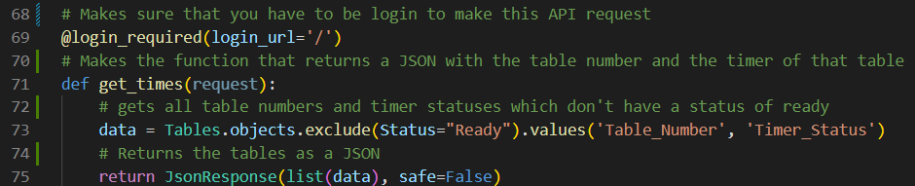

Waiter/views.py

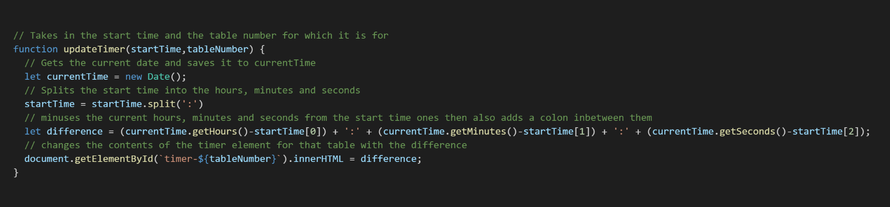After having made this, I created the JavaScript code to do this which involved having 2 functions: One for getting and separating the data from the JSON and another to calculate the difference between the status time and the current time then display it.

static/waiter/js/tableStatusJS.js

static/waiter/js/tableStatusJS.js

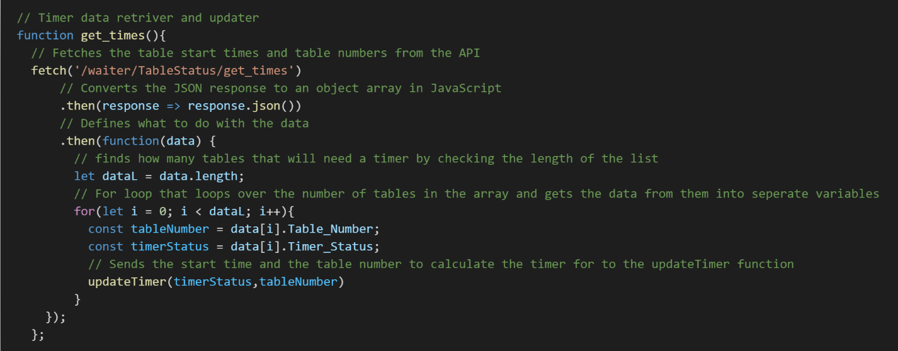

After running this it does work but it has a logical error which makes it that at certain times when the time is less than the start time it shows it as a negative. This is shown in this image:

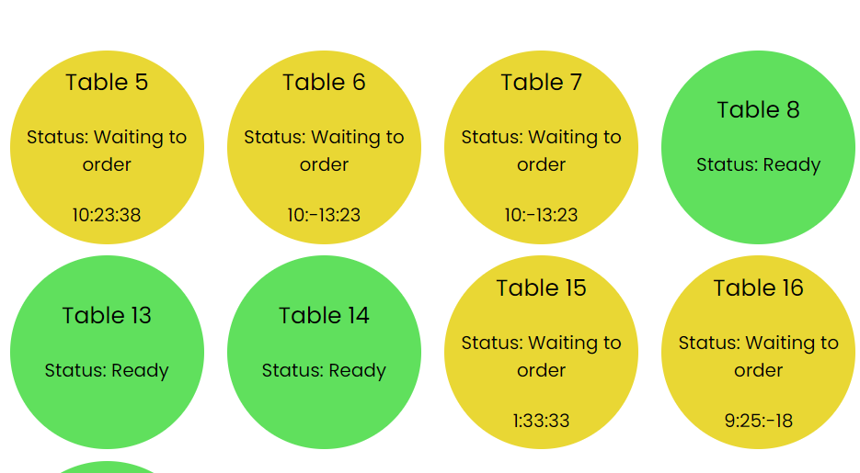

**Cropped screenshot of Table Status UI**

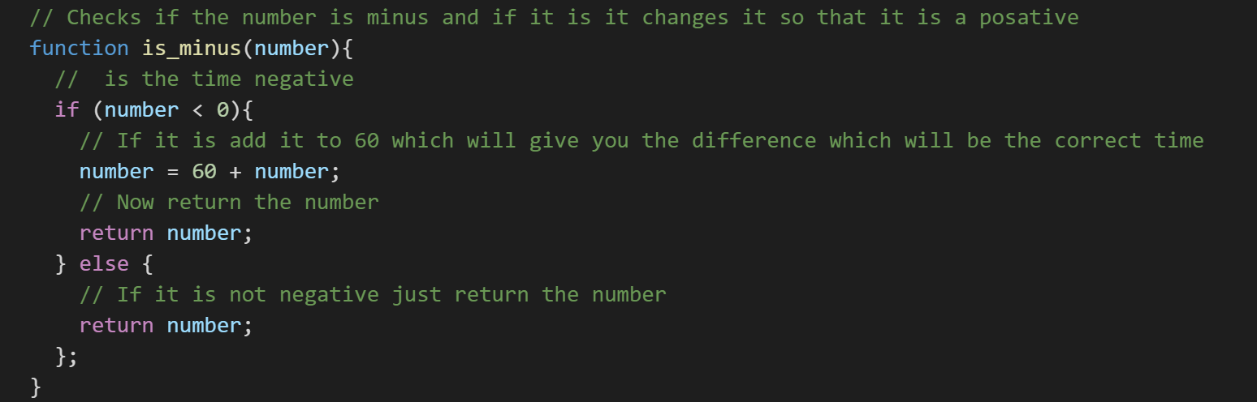To fix this I had to create an additional function called is_minus which checks if the difference is a negative and if it is it minuses it from 60 then returns it as this bug will only affect the minutes and the seconds.

static/waiter/js/tableStatusJS.js

I then just had to put this function outside the minute and second brackets in the difference variable statement to make it work.

static/waiter/js/tableStatusJS.js

After doing this and looking at the timer to make sure it works properly, I found another flaw in the program that is that by just finding the difference between each individual hour, minute, second means that for example when the seconds reach 60 the minutes do not increment by one. For this reason, I decided to make it so that it will find the time in seconds then minus the seconds together to find the difference. After that it will divide the seconds into the individual hours, minutes and seconds and combine it to make the timer like the previous function.

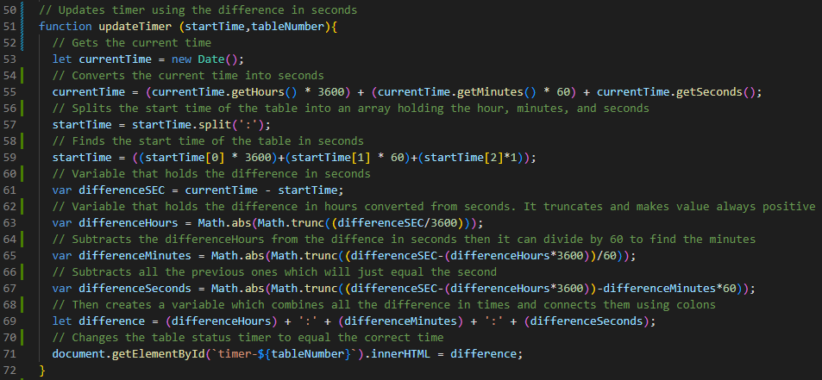

static/waiter/js/tableStatusJS.js

Due to this implementation I also no longer need the is_minus function as it is no longer a problem.

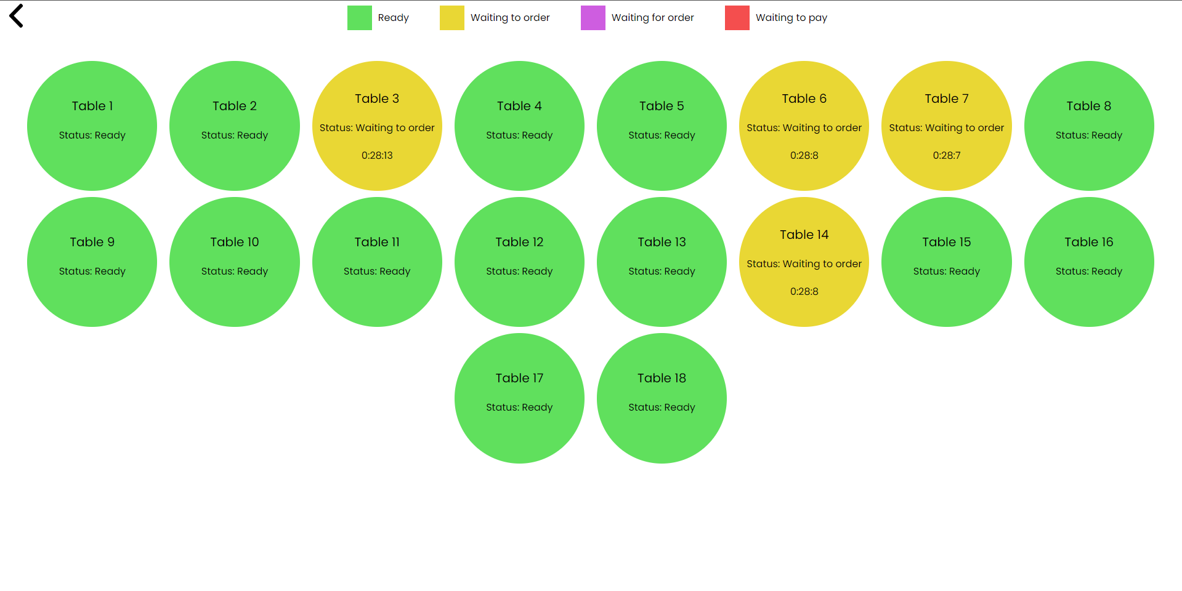

**Working timer Table Status site (PC)**

The next thing that I must do is implement the mobile version of the UI. To do I just had to adapt the CSS for when the screen width is below 900px.

Whilst starting to develop the mobile app I found that I needed to change the text size for the table status, so I converted the inline CSS into a class and then defined it in my stylesheet. This also allowed me to make the text relative so that bigger screens would get bigger text.



templates/TableStatusScreen.html

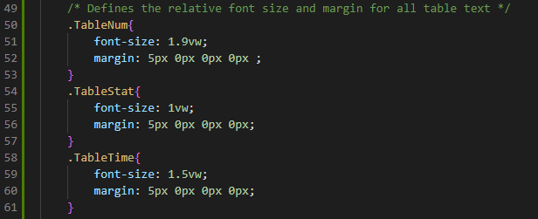This code change adds the classes to edit the CSS properties of the text in the tables. Then after doing this I had to add the CSS to the stylesheet. I used vw which is a relative unit in CSS which lets you give a size to elements and text by giving it a percentage of the view width.

static/waiter/css/tableStatusStyle.css

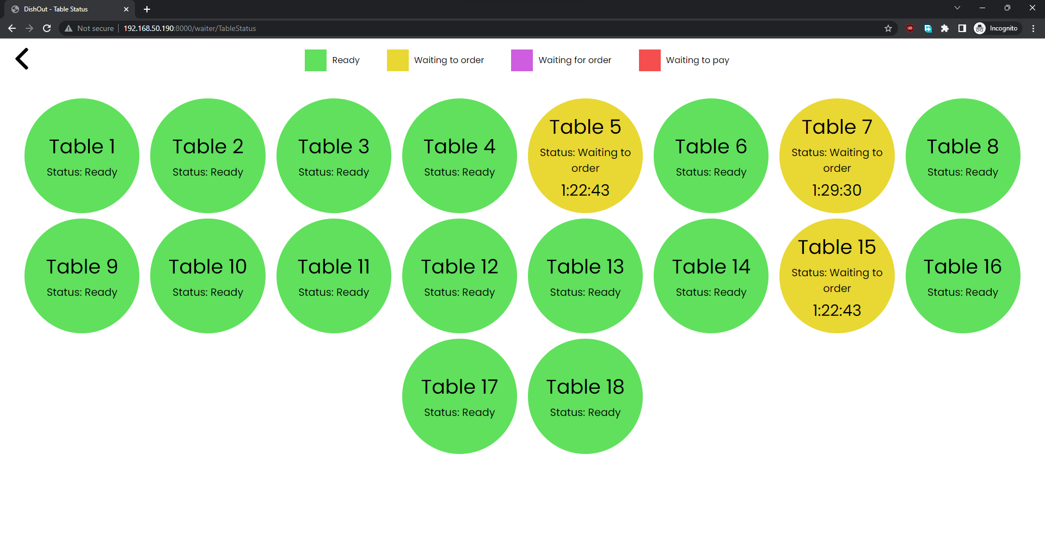

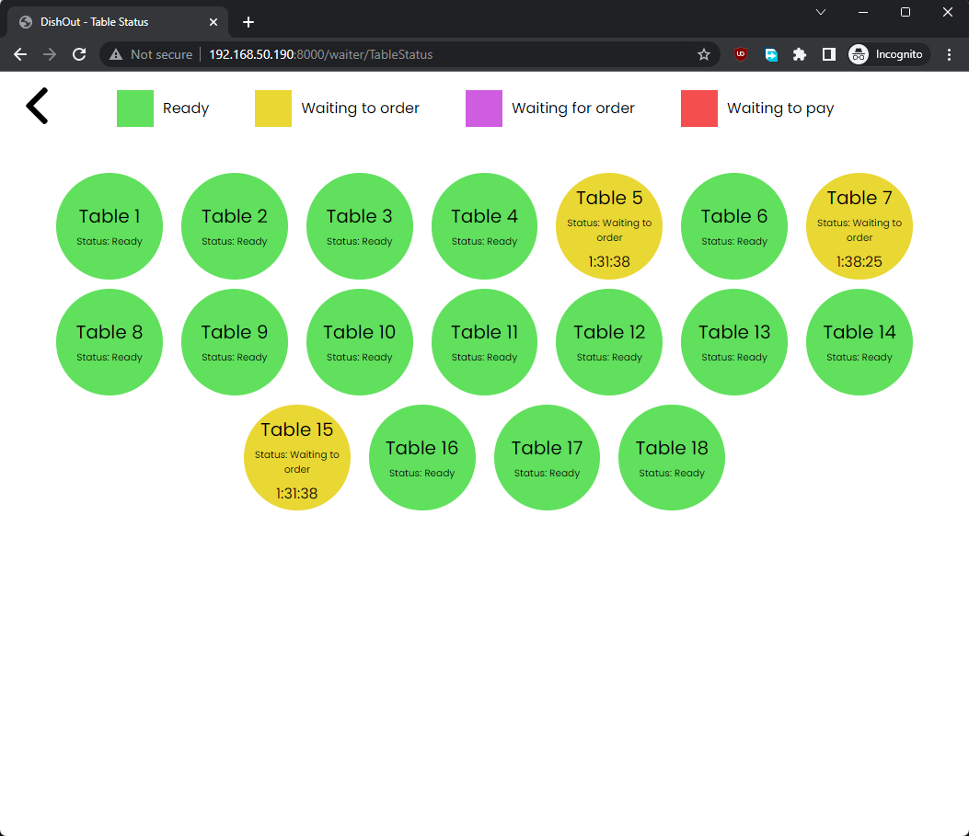

**Text now resizing depending on screen width.**

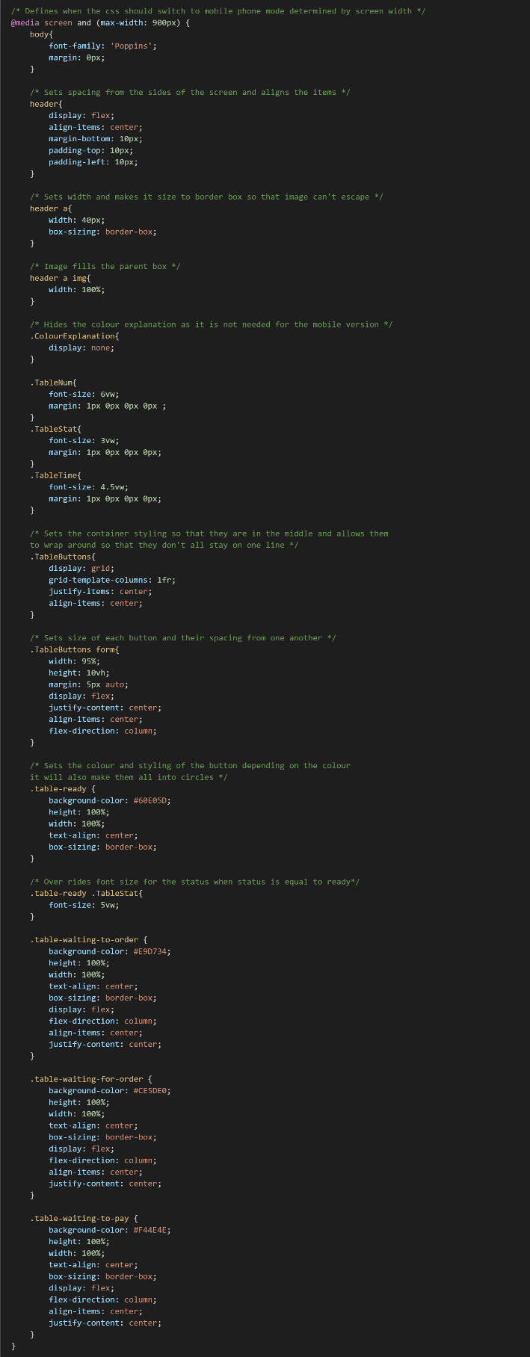After having completed this fix, I was able to finish the mobile UI. I used a grid instead of a flexbox to manage the tables as they will be laid out in a list format. This meant that I was able to recycle some of the code from the previous section to speed up development.

static/waiter/css/tableStatusStyle.css

## Stakeholder feedback for Table Status (V1.2)

“The table status screen looks good and it is functional but I will like to see the timer to add 0s so that it is always displaying the time in the HH:MM:SS format. I would also prefer if the table numbers were bold to make them stand out more.” – Louis Allaway

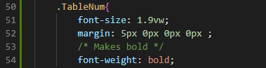To meet the stakeholder’s criteria, I first started by making the table number bold as this would be the quickest feature to implement. To do this I changed the class for the TableNum and made it bold on both the mobile and PC version.

static/waiter/css/tableStatusStyle.css

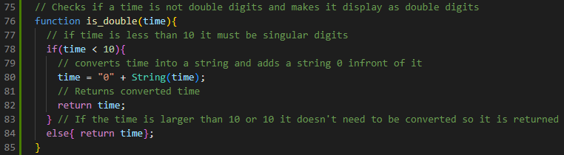To make the format for the timer be consistent I had to create a function which takes in the difference and check if it’s double digits, if not then it adds a 0 in front of it.

static/waiter/js/tableStatusJS.js

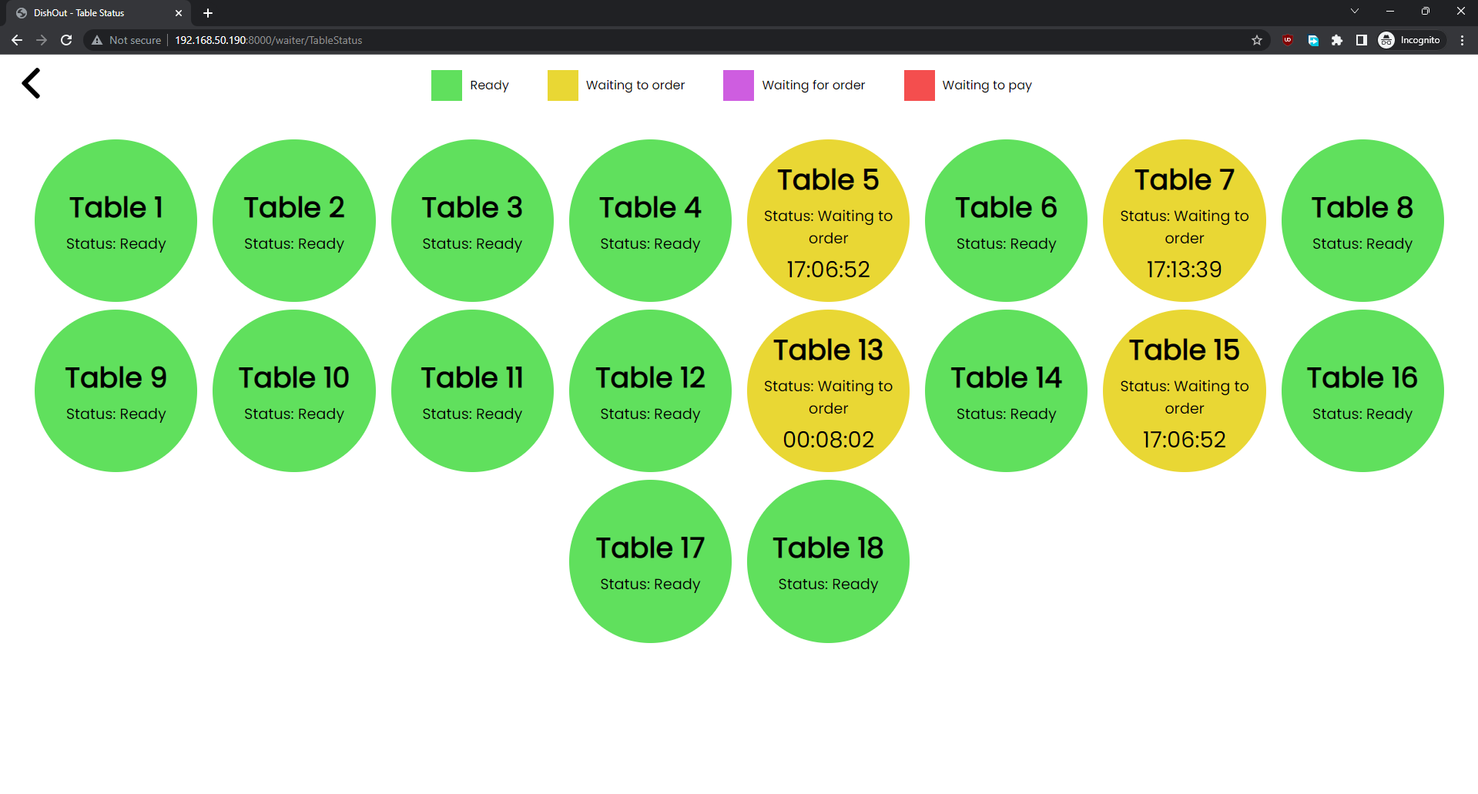

**Screenshot of the table status screen looks like now after changes.**

## Testing The Table Status Screen

|  |  |  |  |
| --- | --- | --- | --- |
| Table Status | | | |
| Test | **Action** | **Result** | **Correct?** |
| Change table status for table 12 then reload the page | Change table 12’s status from ready to waiting for order by changing the database | It displayed the correct colour and changed the status instantly as well as updating the timer correctly | Mini Green Tick Stamper - SuperStickers |
| Change table status of table 6 without leaving the page | I opened 2 tabs running DishOut and clicked on table 6 on one of them then waited to see when the other changed | After clicking table 6 it changed to waiting to order after 3 seconds on the other instance of the program | Mini Green Tick Stamper - SuperStickers |
| Wait 10 seconds and look at table 6 | I will take a screen shot and then wait 10 seconds to take another screen shot to see if the timer works correctly | As expected after 10 seconds the table 6 timer went up by 10. | Mini Green Tick Stamper - SuperStickers |

**There were no bugs found in the testing of this section.**

## Implementing the Structure of the Order Taking System (v1.3)

I began by first adding the URL to the site and adding the basic Django code that returns the html for the page.

Waiter/url.py

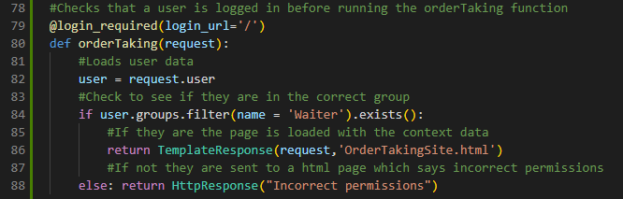For the views.py I recycled some of the code for checking if the user has the correct permissions as this does not change and makes it faster to code.

Waiter/views.py

After this I decided to connect the waiter selection screen to the order taking page by changing the URL for it in its HTML

templates/SelectionScreen.html



Then I created some simple HTML code to give the general structure of this site as most of it would be dynamic and not hard coded.

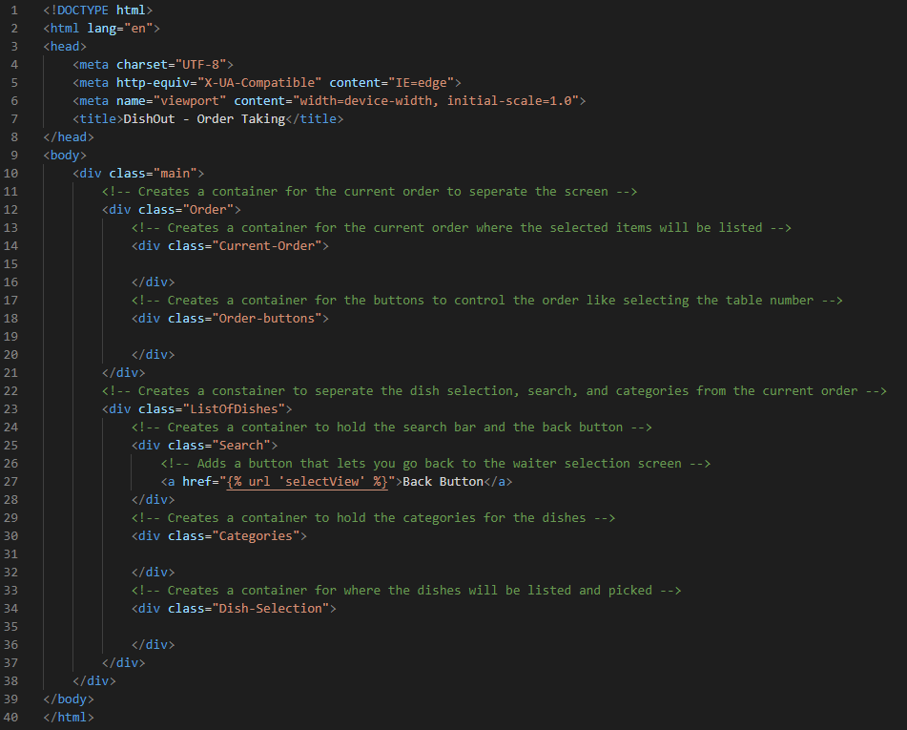Due to this screen being the most complicated screen in the whole project. This made me decide to start making the styling for it now so I can visualise the website. To begin to do that I had to add the static files so I can add the CSS style sheet.

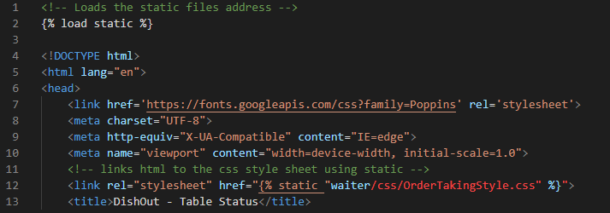

templates/OrderTakingSite.html

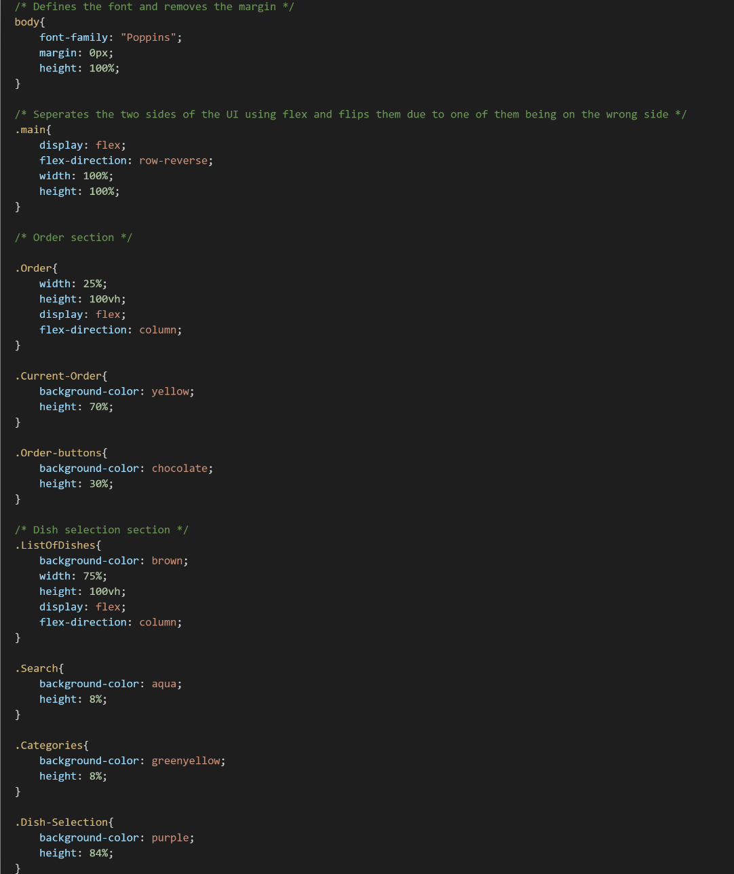Then I created some CSS to manage where each part of the UI is and visualised it by giving each part a colour. All the colours will be removed later in development.

static/waiter/css/OrderTakingStyle.css

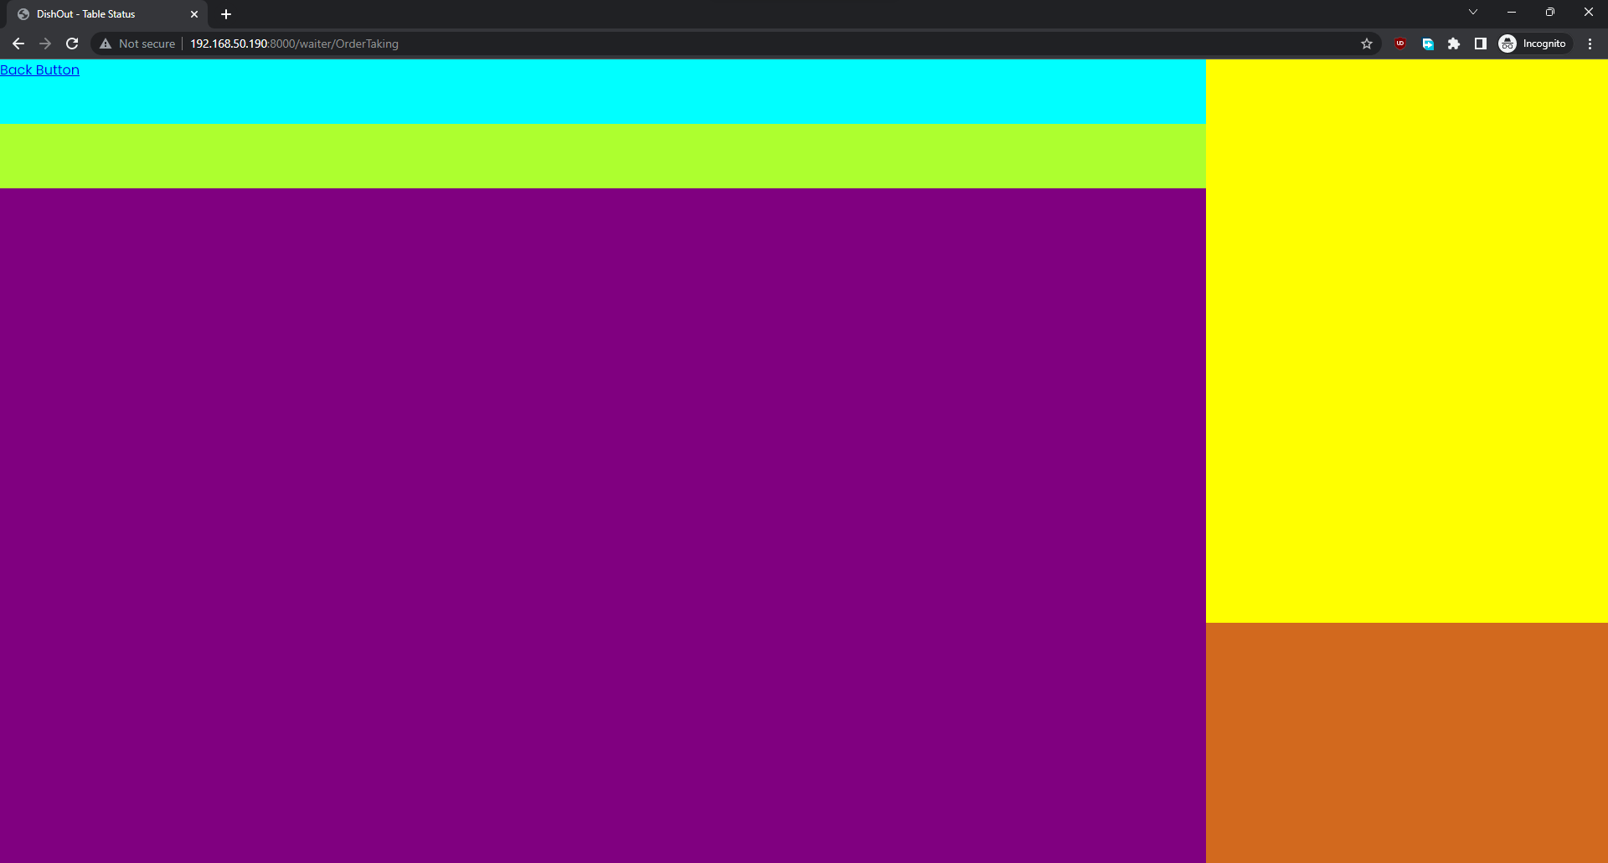

**Current Order Taking System view for PC.**

Now I am going to be making the JavaScript code to hold the current order. This will be a class which will have many functions which will be used to make buttons interact with the current order. I first had to link the JavaScript file to the page.

templates/OrderTakingSite.html



Then I created the class which I will be using and made its constructor method.

static/waiter/js/orderTakingJS.js

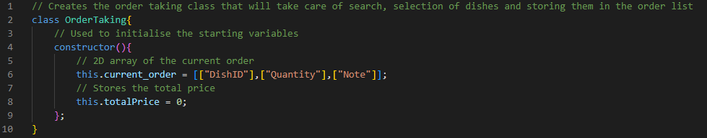

After this I decided to make an API so that I will be able to feed the dish information to JavaScript. This will be useful later for checking the price of items and for the search feature. For this I needed to create another function on my views.py so that I can send the data. I also had to create the URL for it to send the data to.

Waiter/url.py

Adding URL:



Then I had to import the Menu table in the views.py to get the dish data from the database

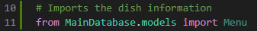

Waiter/views.py

Lastly I used some of the code from my API I used for the table status section to return the data of the database to the URL using JSON

Waiter/views.py

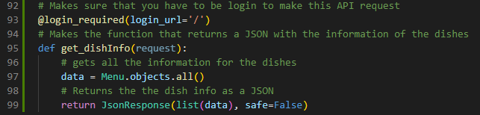

When running this code I ran into an error saying that “TypeError: Object of type Menu is not JSON serializable” after doing some research on the error I found that the error is due to when getting all the data out of a database in Django it saves it in a different format. To fix this error I have to get the Menu’s values and convert them into a list so that JSON can understand them.

Waiter/views.py

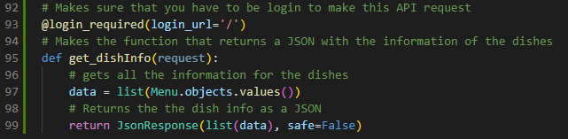

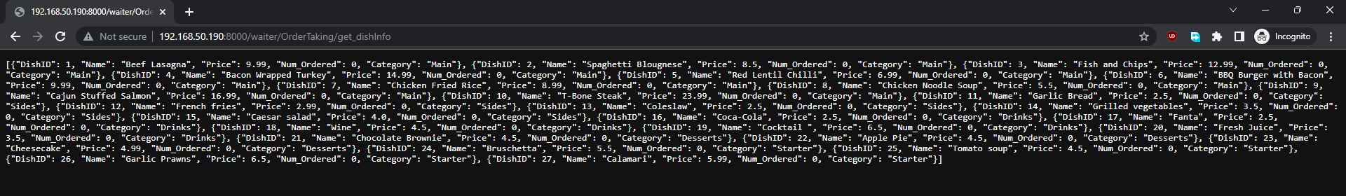After that fix, all the data is sent to the URL:

## Implementing Search into Order Taking System (v1.4)

Firstly, I’m going to make a function in JavaScript to convert the JSON data into an array so that I will be able to use it in my search function. To do this I had to fetch the data from the URL and convert it into a 2D array which could be used in the class.

I had to add the DishList 2D variable to my class so that other functions in the class could use it:

static/waiter/js/orderTakingJS.js



Then I made the function which fetches the data and stores it:

static/waiter/js/orderTakingJS.js

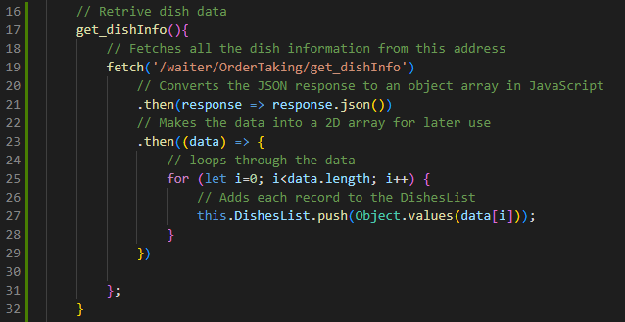

Now to implement the search feature I am going to need to first have an input box in the HTML which I can take the search query out of using JavaScript and compare it against the database in the DishesList.

Creates the search bar where text can be inputted:



templates/OrderTakingSite.html

Search bar:

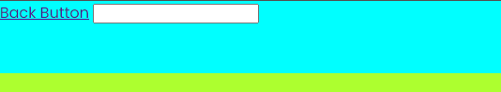

To get the text out of the search bar I’m going to need to make an event listener which is always checking if the enter key has been pressed. While trying to code this I had an issue with my JavaScript which told me that the search bar did not exist. To fix this I moved the linking of the JavaScript file to the HTML from the top to the bottom which fixed it.

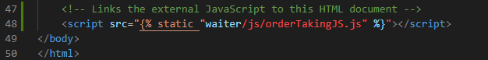

templates/OrderTakingSite.html

Then I was able to make the code needed to get the data from the search bar:

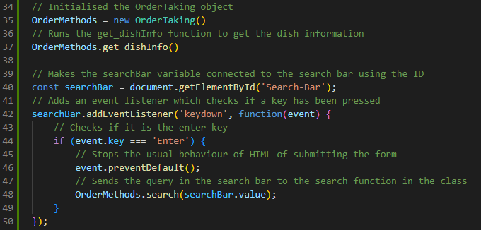

static/waiter/js/orderTakingJS.js

Then I also made a search function in the OrderTaking class which right now will just display an alert box with the search query. This will be changed when I add the orders to the selection screen.

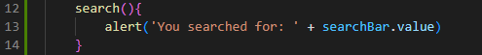

static/waiter/js/orderTakingJS.js

I tested to see if it was showing the correct value by typing in “Does it work”.

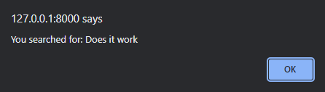

As you can see it does work as it outputs the correct value.

Now I decided to add the styling for both the search bar and the back button to complete the styling of this section.

Firstly, I replaced the text from the back button to the back image:

templates/OrderTakingSite.html

After this I added some styling to it and its parent class so that I would be central:

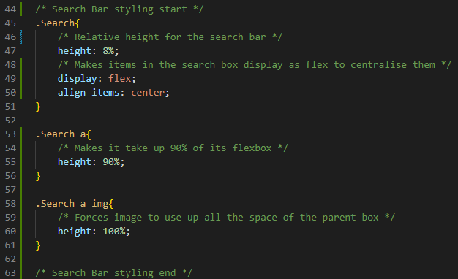

static/waiter/css/OrderTakingStyle.css

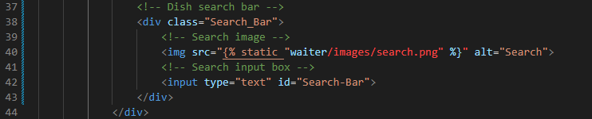I now must add an image to the inside of the search bar so to do this I have to add a div to encapsulate the image and the input box. Then I am going to remove the default styling of the input box so that it looks like it is the size of the div:

templates/OrderTakingSite.html

After having added the div I styled it and its contents using CSS:

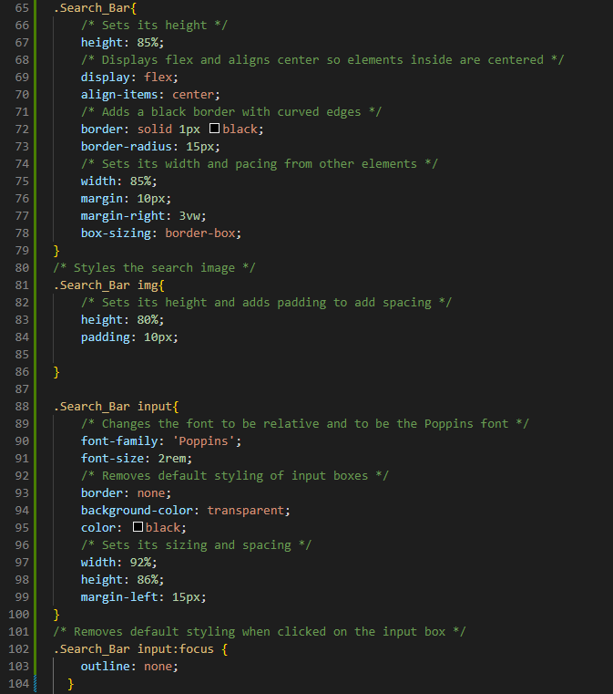

static/waiter/css/OrderTakingStyle.css

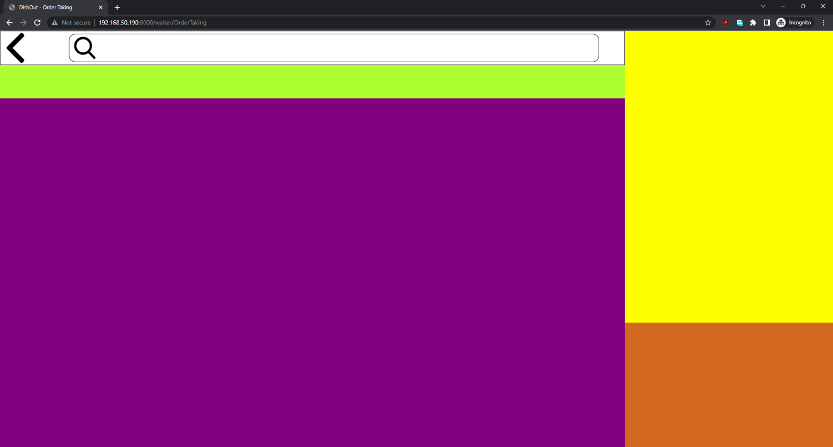

**Current look of the Order Taking site**

## Implementing the Dish list and selection (V15)

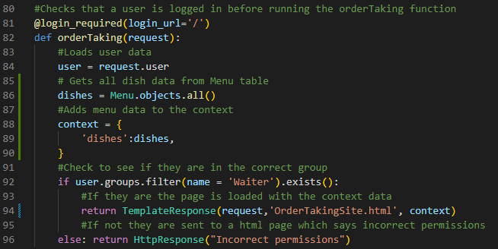To add the dish list and selection I must add a for loop that loops through the database and adds all the dishes. This will be using the same system that the table status used to generate the HTML dynamically. Firstly, I will have to add context tot the back end.

Waiter/views.py

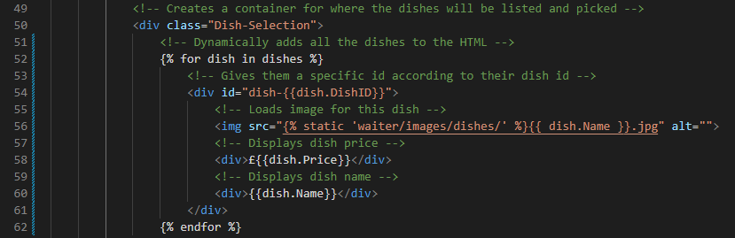Now I’m going to add a for loop using Django tokens to generate the dynamic HTML which will show the dishes’ data.

templates/OrderTakingSite.html

I am now going to style these elements as right now the images are not the correct size which is making them overflow out of the UI. To do this I am going to use CSS and create a grid where they will be placed. I also added the overlaying of the text on top of the images so that the users can see the pricing and the name of the dish. Finally, I made it so that the container in which they are in is scrollable so that the dishes don’t overflow out of the page.

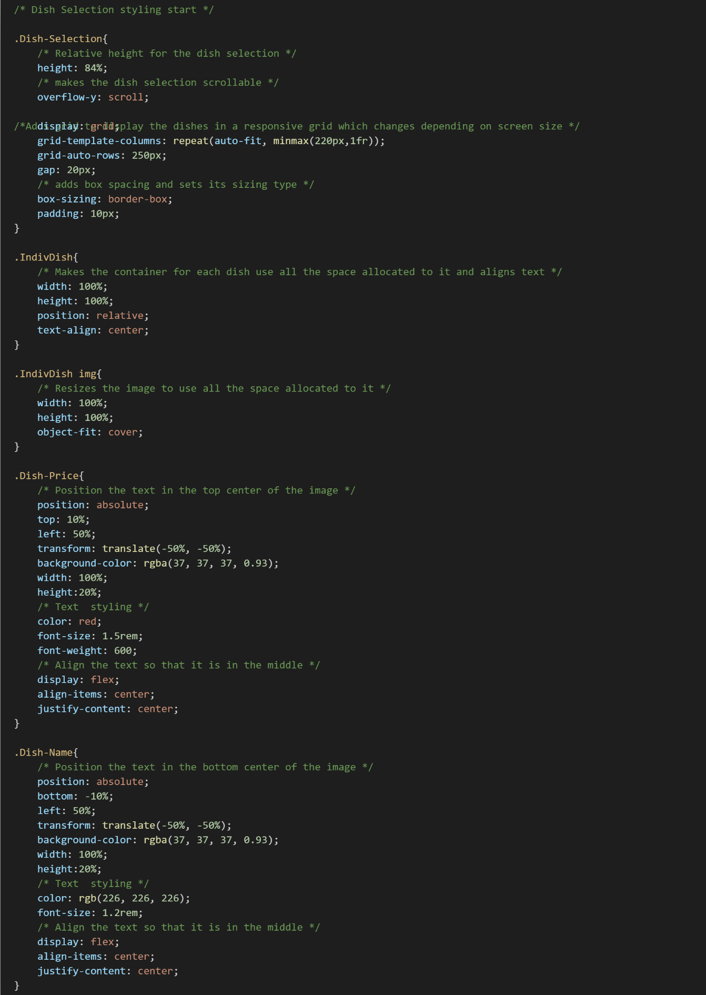

static/waiter/css/OrderTakingStyle.css

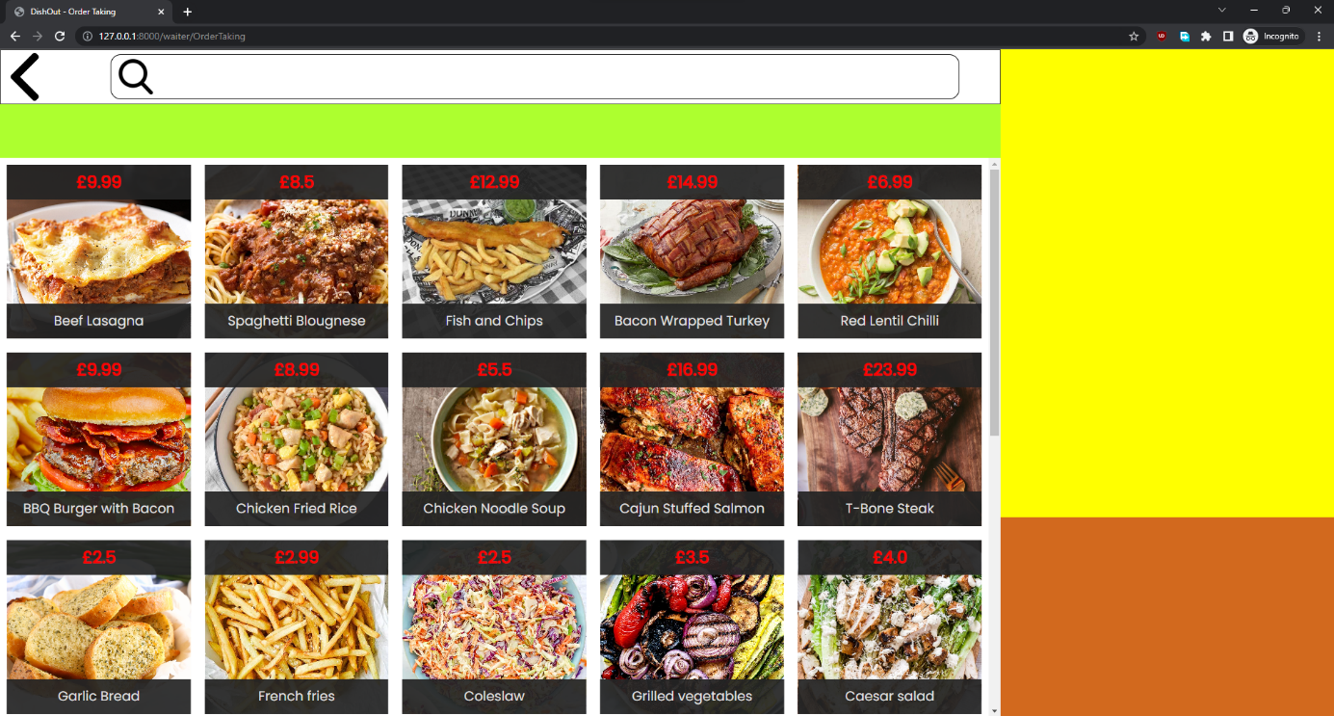

**Current UI for the Order Taking screen.**

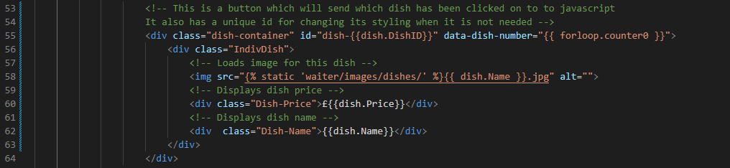Now I wanted to add the actual JavaScript to allow the user to click on the dish to then add it to the current_order array for it to be used later. Firstly, I am going to have to change my HTML code so that the dishes become a button and allows me to send data to the JavaScript. To do that I wrapped the individual dishes in another container.

templates/OrderTakingSite.html

Then I had to make the JavaScript to receive this data and make a function which adds this data to the current_order in the class. First I had to add another event listener for each container so that it could register the value.

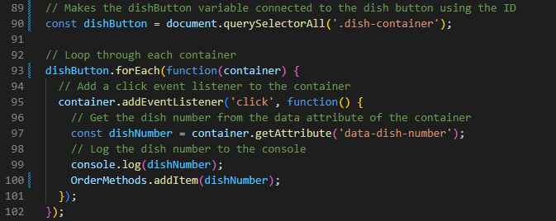Now I made a function in the class so that checks to see if the dish is already in the order and if it is then it changes the quantity and updates the total price. It also adds the dish if it is not at all in the current_order. I have added console.logs to show that the array is storing correctly these will be removed after being tested.

static/waiter/js/orderTakingJS.js

I couldn’t use my pseudocode exactly as I required a for loop which means that it has to be structured differently for it to work.

static/waiter/js/orderTakingJS.js

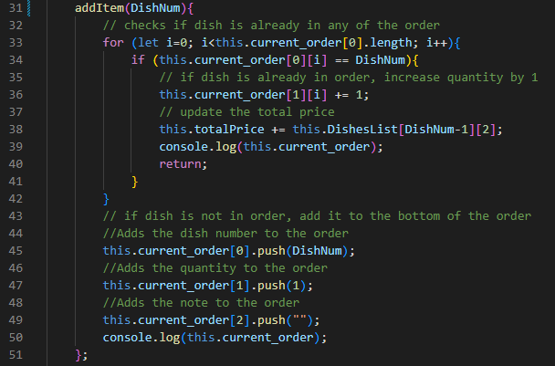

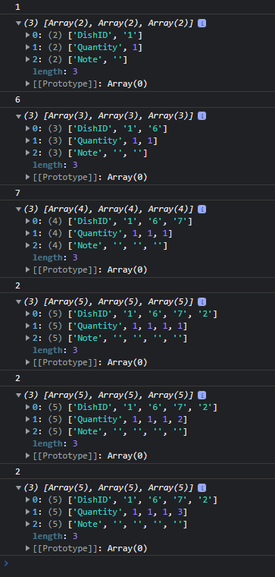

It is printing the DishID of the selected dish and then printing the array. As you can see it is working correctly as it is changing the quantity when adding 3 DishID 2s

## Implementing Categories and Dish Filtering (V1.6)

Firstly, since I have added the dish selection, I can now implement the search feature fully, so I decided to do that first. To do that I am going to add to the search function so that it uses wildcards to search through the DishesList. Since I don’t need to use the actual database, I do not have to use SQL and instead just must search through an array:

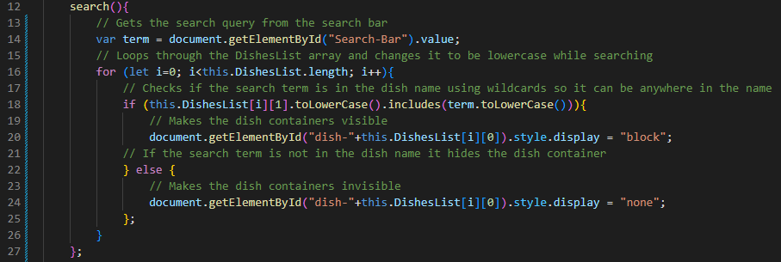

static/waiter/js/orderTakingJS.js

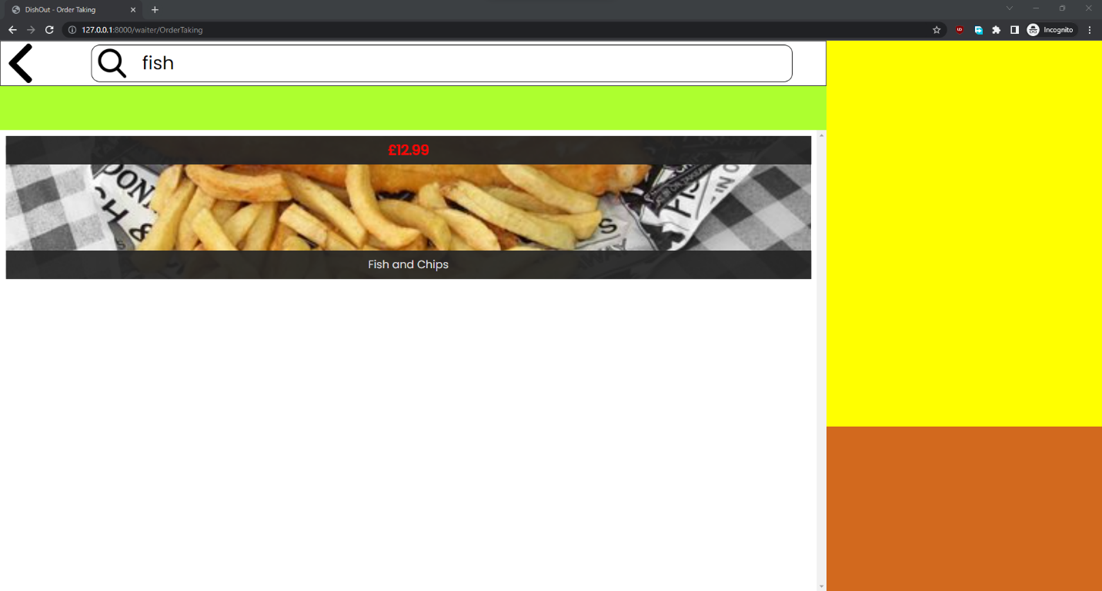After testing this I found that the search function worked but there was a bug with my UI which made it so that if there were less than 3 dishes on the screen it made them occupy the whole width of the screen. To fix this I made it so that there was a minimum grid column.

**UI bug**

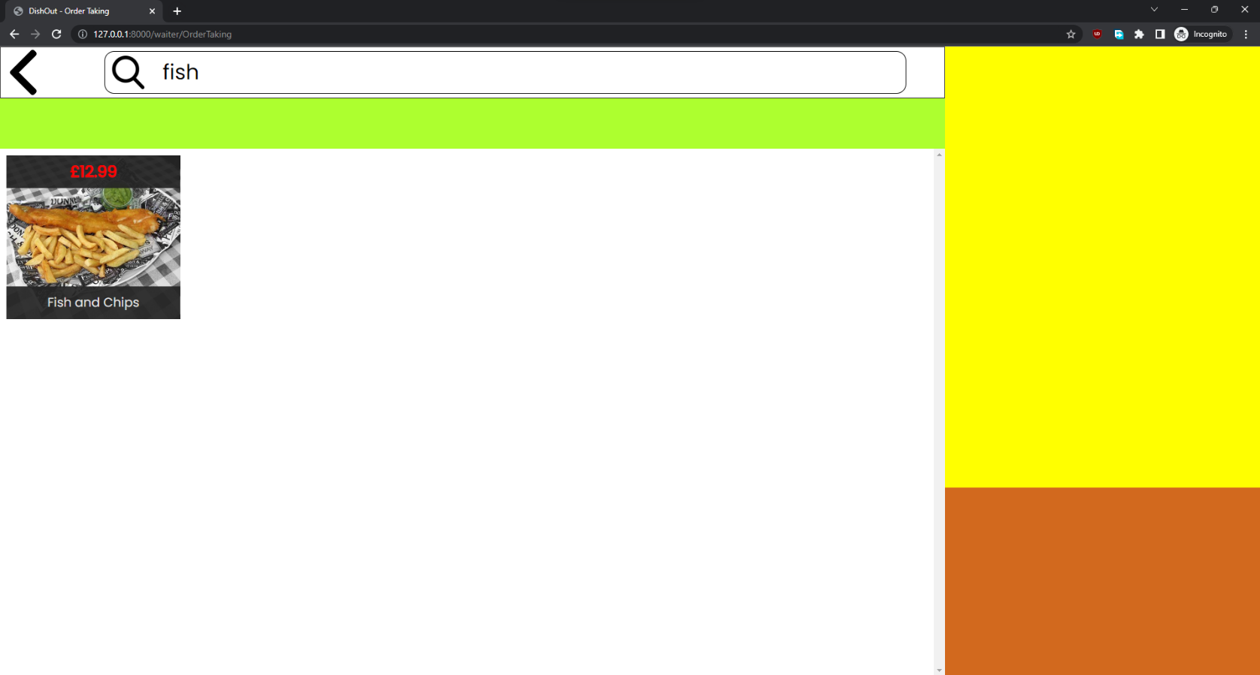Fix:

static/waiter/css/OrderTakingStyle.css

**After having fixed it, it now appears correctly in the UI.**

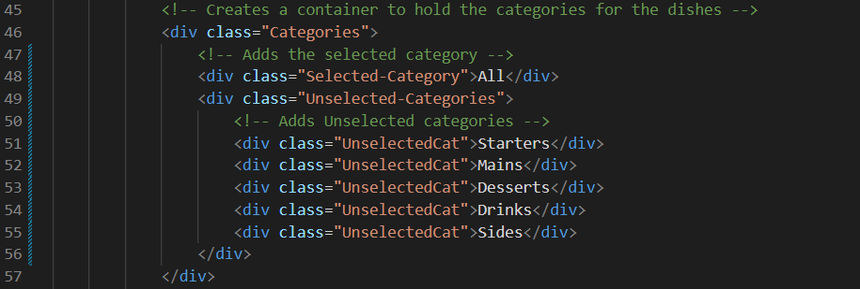The next step for this section is to add the category selection bar in between the dish selection portion and the search bar. To do this I first am going to have to add the buttons which I will use the same technique as I used for the dish selection screen which is to make each button a div and then scan through the divs to find when one has been clicked on.

templates/OrderTakingSite.html

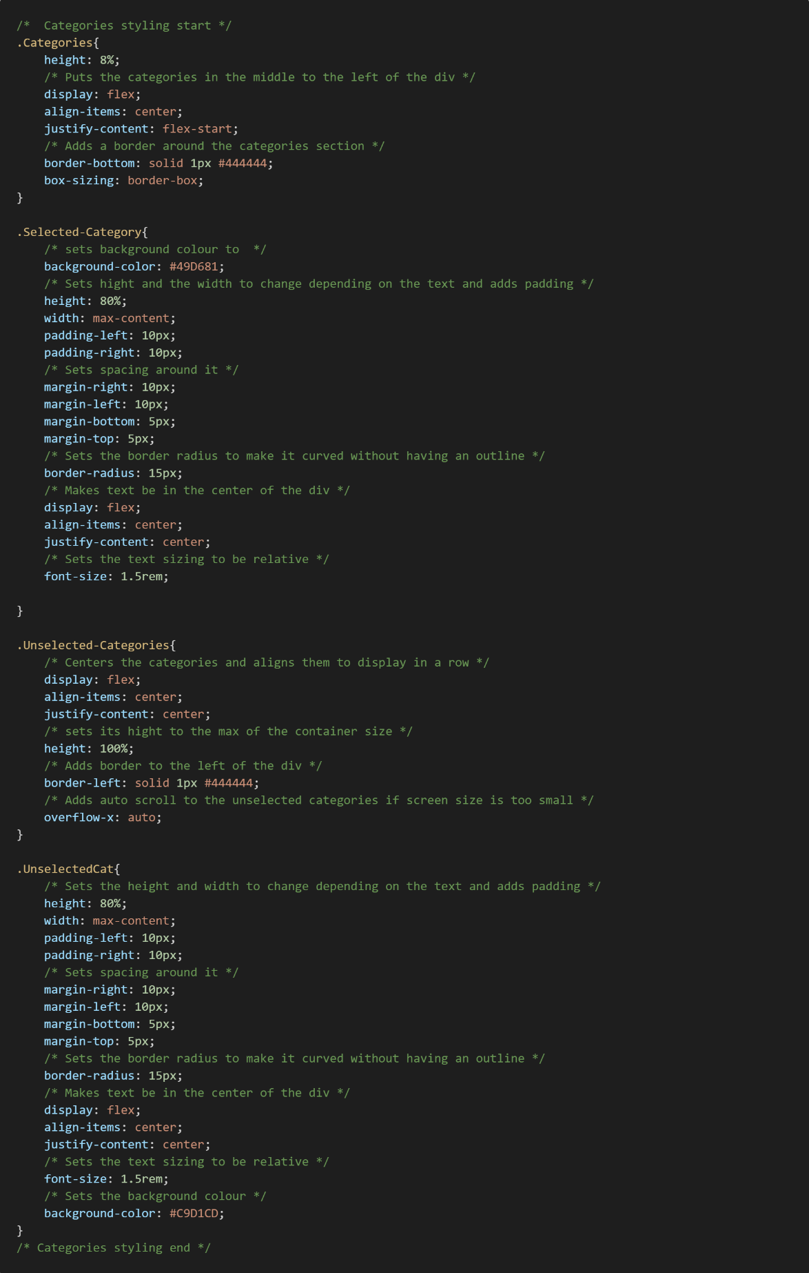After this I decided to add some styling so that they would display properly as currently they were overflowing into the dish selection section. To make the category selection tab look like the mock ups I used flexbox multiple times to centre the divs so that they could align. I also made the unselected categories section scrollable in case the screen is too small to display all of them

static/waiter/css/OrderTakingStyle.css

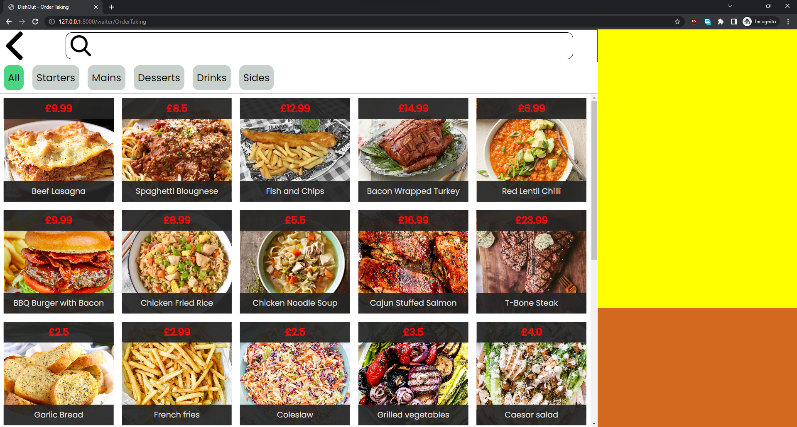

**Updated view of Order Taking screen with categories**

The next step is to add the JavaScript which will hide the dishes which are not in the category that has been selected. But first to do this I need to add another listening event for pressing the category buttons.

While coding this solution I found a conflict between the category names stored in the HTML and the ones stored in the database. To fix this I changed the ones in the HTML to match those of the ones in the database.

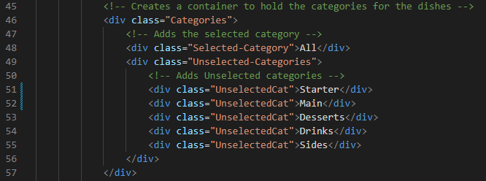

templates/OrderTakingSite.html

After fixing that bug I ran into another problem which was accessing the correct unselected category to change the contents of. To fix this I decided to give each one of the containers a unique ID so that they would be easily retrievable.

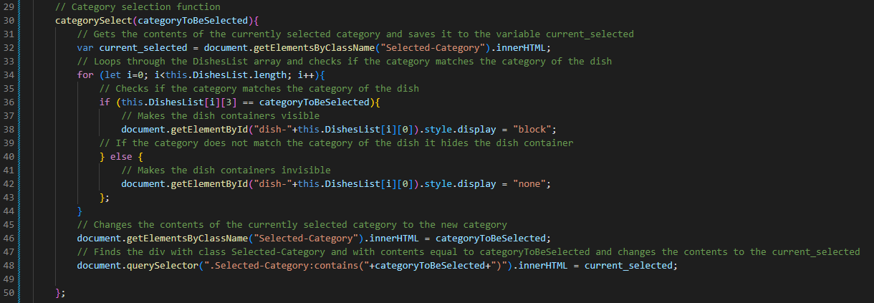Previous code: (Bug is due to the 48th line not being able to find the correct category.)

static/waiter/js/orderTakingJS.js

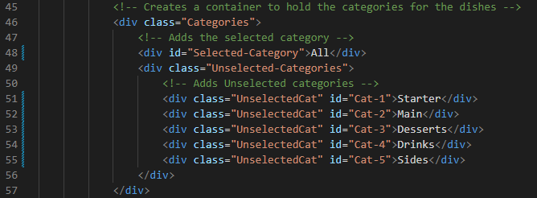To implement this fix, I’m going to add IDs to the html and then retrieve them with the previous function which has an event listener for when it is clicked.

templates/OrderTakingSite.html

Had to also make a change to the CSS so that it would still function correctly

static/waiter/css/OrderTakingStyle.css

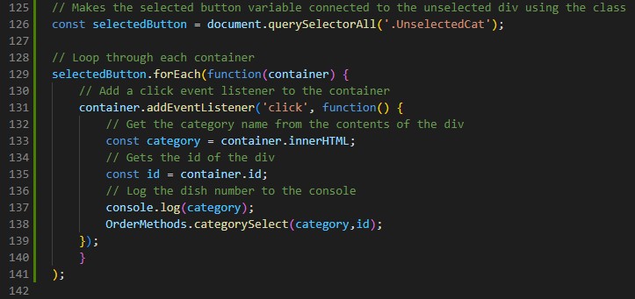

static/waiter/js/orderTakingJS.js

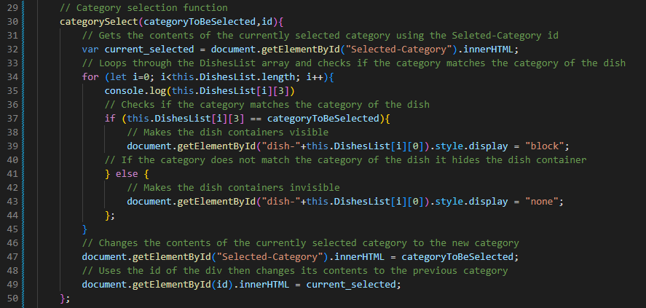I also changed the function in the class so that it takes in the ID and uses that instead. I also made it so that it uses the ID for the selected category.

static/waiter/js/orderTakingJS.js

This did work as it did swap around where the categories are in the category selection bar, but it did not function correctly when trying to filter the dishes. After printing the array of the Dishes list, I found that the problem was that the category is not stored on index 3 its stored-on index 4. In the process of testing this I also found that there is not all category in the database of course so I needed to add an additional if statement in case all is selected so that it can display all.

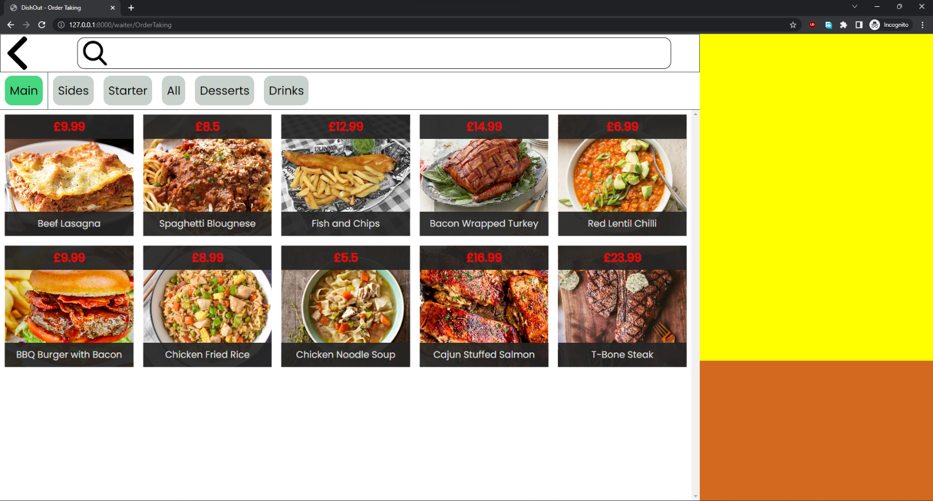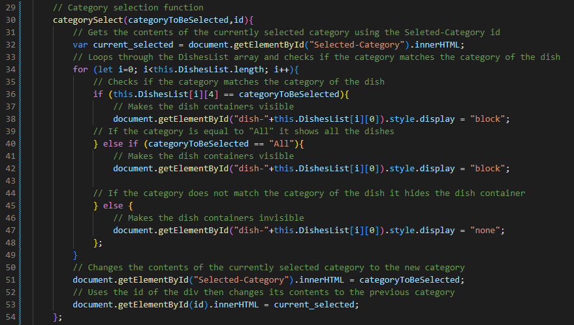

static/waiter/js/orderTakingJS.js

**UI after selecting Main category.**

## Implementing the Current Order List (V1.7)

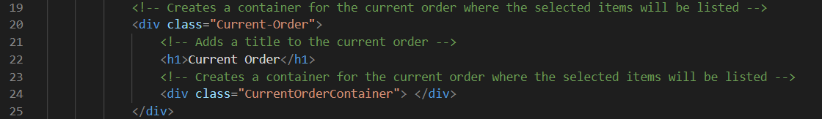Firstly, I decided to add the styling and the title to the HTML and the CSS. To do this I added a h1 tag to make the title of the current order and then I also made a div for where the current order will be generated and displayed.

templates/OrderTakingSite.html

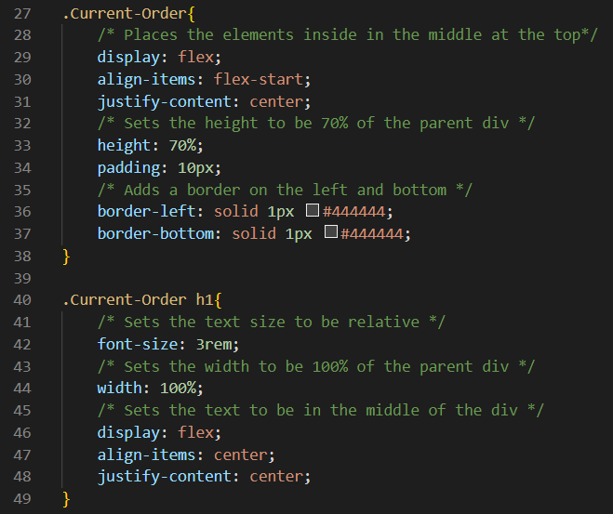

static/waiter/css/OrderTakingStyle.css

Now I must implement the function which will add these items to the actual CurrentOrderContainer so that they can be displayed with how many dishes there are, the price of each of them and the add and minus buttons.

While coding this I ran into the issues that due to my current_order array having the names of each of the columns as its first value my for loop which started from 0 did not work correctly. To fix it I just changed it to start from one.

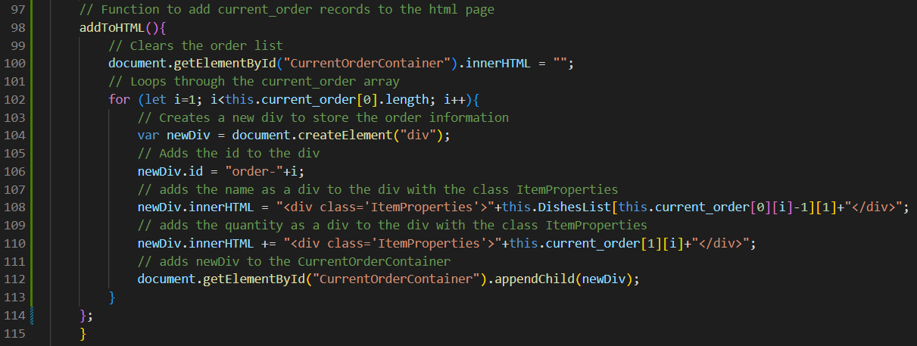

static/waiter/js/orderTakingJS.js

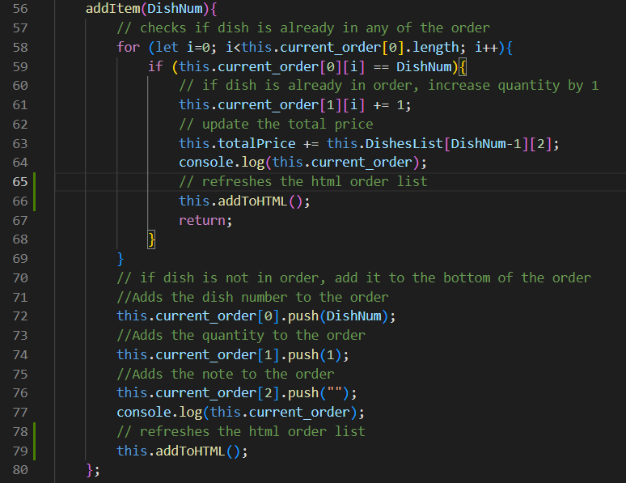I also added the function to the addItem function so that any time an item was added the add to HTML function would run ensuring that the current order is displayed.

static/waiter/js/orderTakingJS.js

After testing the function to see if it adds the items correctly to the HTML if found another bug. I found that each of the IndivDishes were giving one ID lower than what they were. For example, in this screenshot I clicked Red Lentil chilli 5 times, but it says in the current order that it is Bacon Wrapped Turkey:

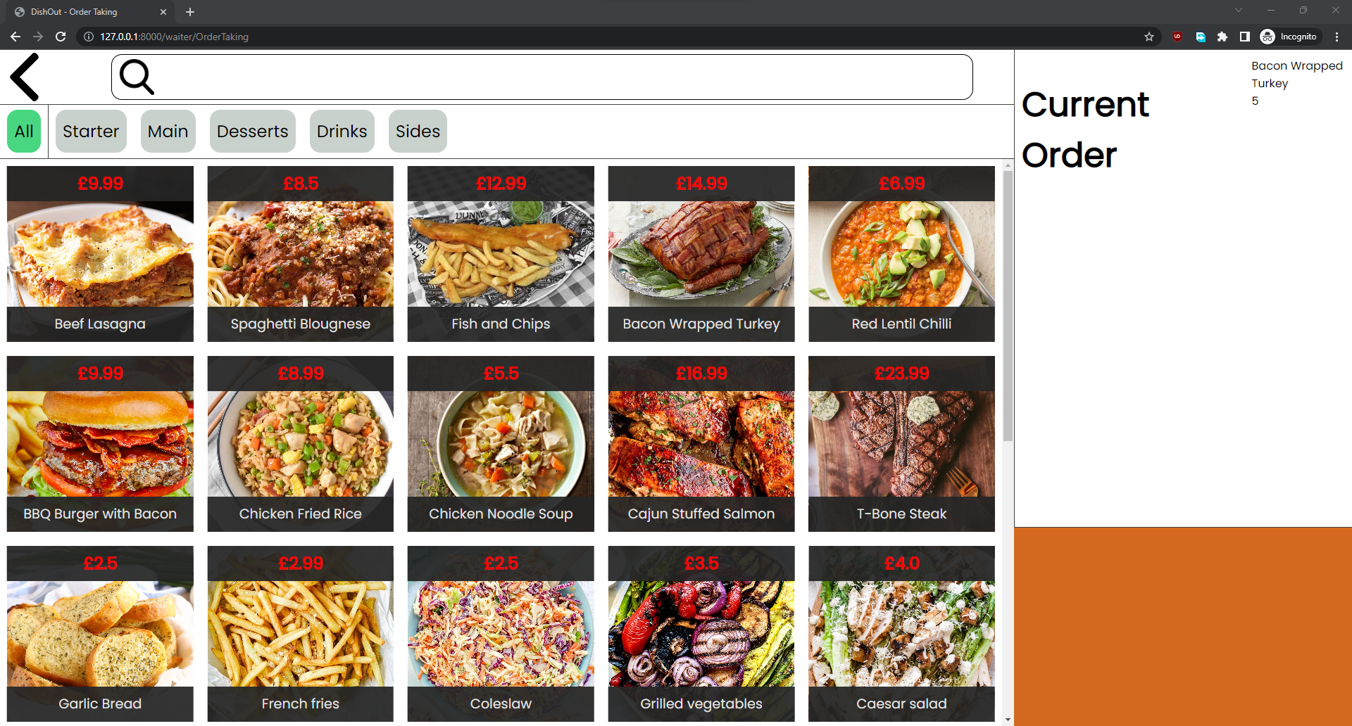

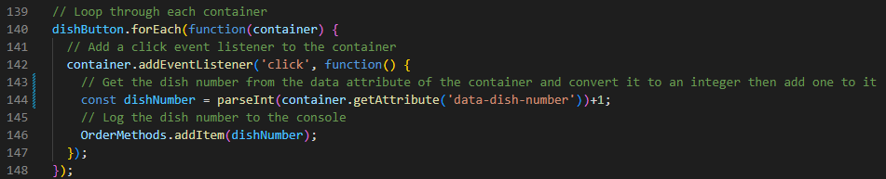To fix this I had to change the method that was getting the inputs for the dishes and had to make it convert the dish ID into an integer than add one to it.

static/waiter/js/orderTakingJS.js

After this it works perfectly. The next step is to add the price and the two buttons to it. To do this I added another div for the price which is fetched from the DishList array times by the quantity ordered and also rounded to 2 decimal places to ensure that the double zeros show for currency. The add and remove buttons are button elements that use the addItem function and the removeItem function which I will be coding next.

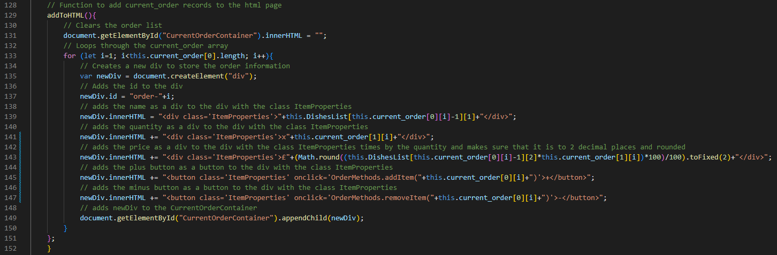

static/waiter/js/orderTakingJS.js

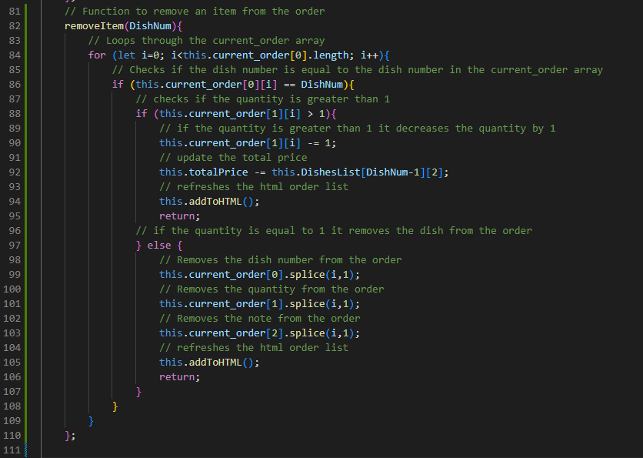Then the removeItem function works by first finding the record where the item that is being removed is in the current_order array. Then it is checked to see if it has more than one in the quantity because if it does then the quantity is just decreased by one. But if it is one then it is completely removed and it updates the HTML both times.

static/waiter/js/orderTakingJS.js

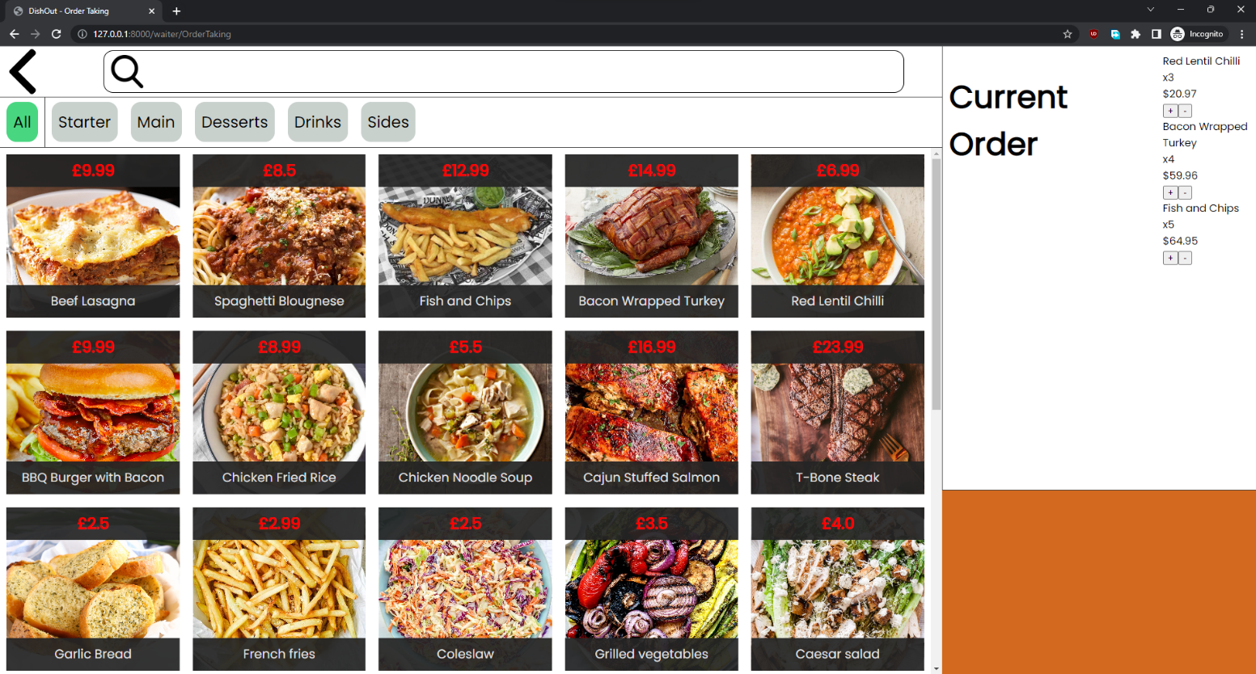

**Order Taking screen with working current order buttons and display but without correct styling.**

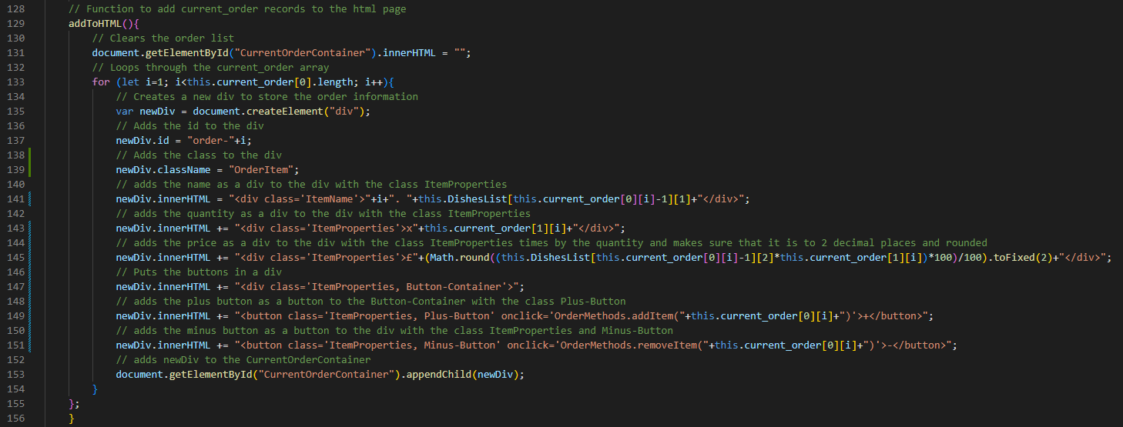The next and final step is to refine the CSS styling of these elements so that they display properly and ready for client use. To style them correctly I needed to add other classes to the generated items in the current order list. I also put the two buttons in a div together and added a number to the front of the name of the order.

static/waiter/js/orderTakingJS.js

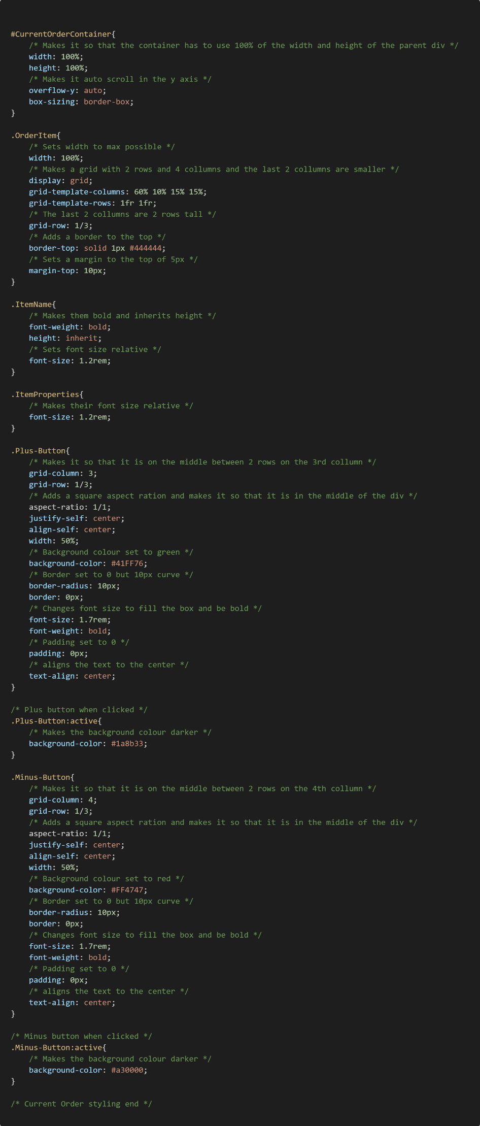

static/waiter/css/OrderTakingStyle.css

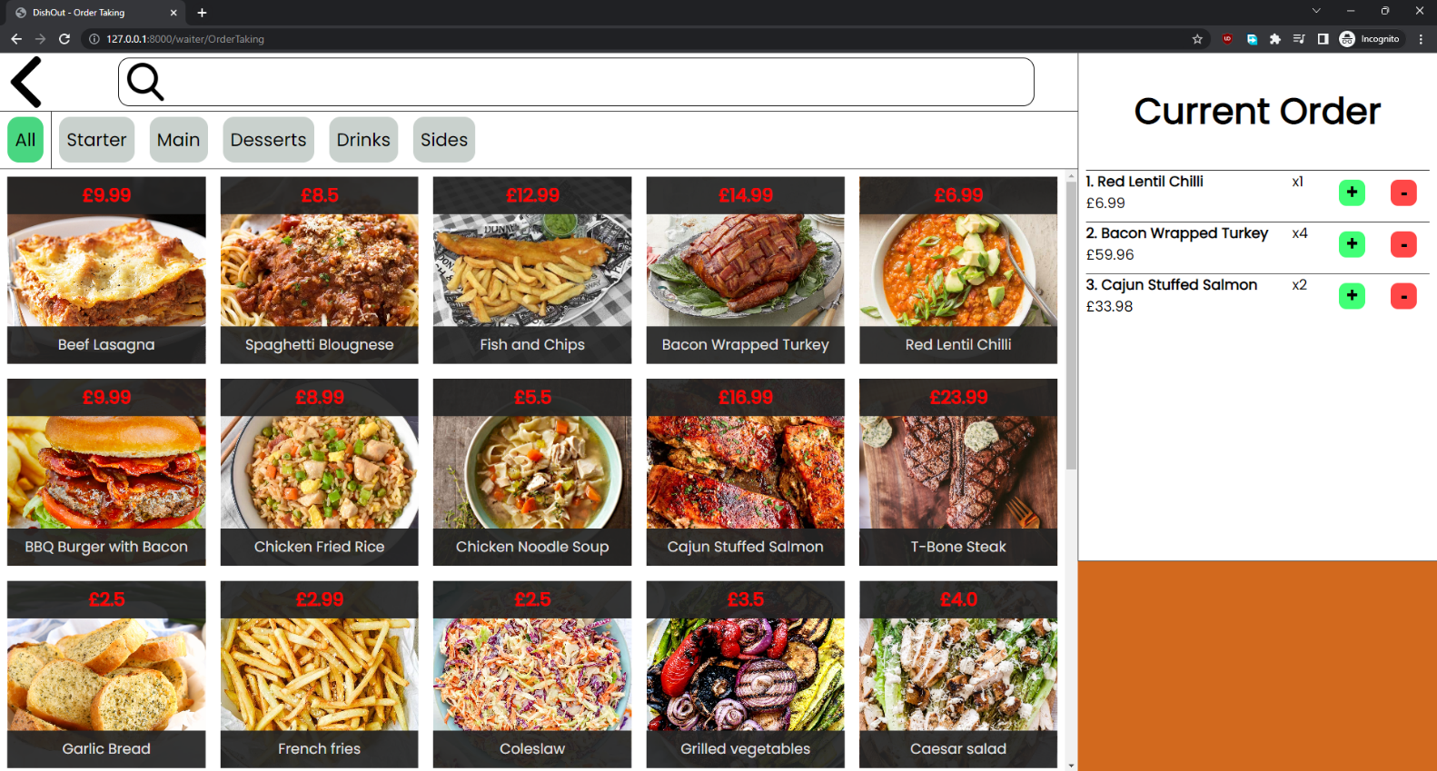

**Order Taking screen with finished Current order UI.**

The CSS also makes it so that when the add and remove buttons are pressed, they change to a darker shade to add some feedback for the user. It should make it easier to use the application.

## Implementing Order buttons (V1.8)

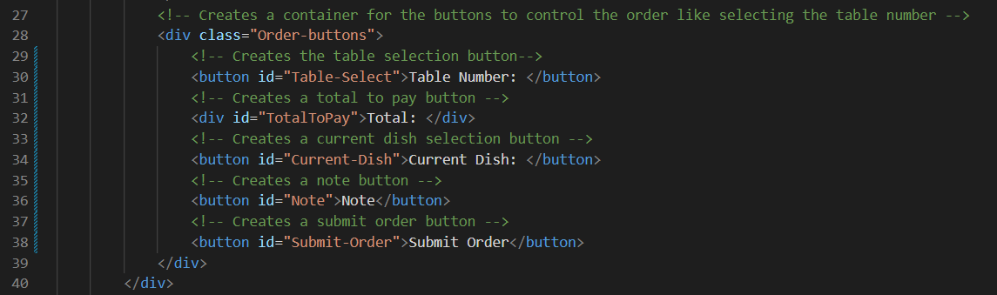I decided to start by adding the HTML for each of the buttons and styling them. Whilst coding in the buttons I realised that there will be no use for the add item button as it is done automatically when it is clicked on. This means that the site will look slightly different to the mock-up. Instead, I decided to change the add item button to be a dish selector from the current order so it can be selected to add a note to it.

templates/OrderTakingSite.html

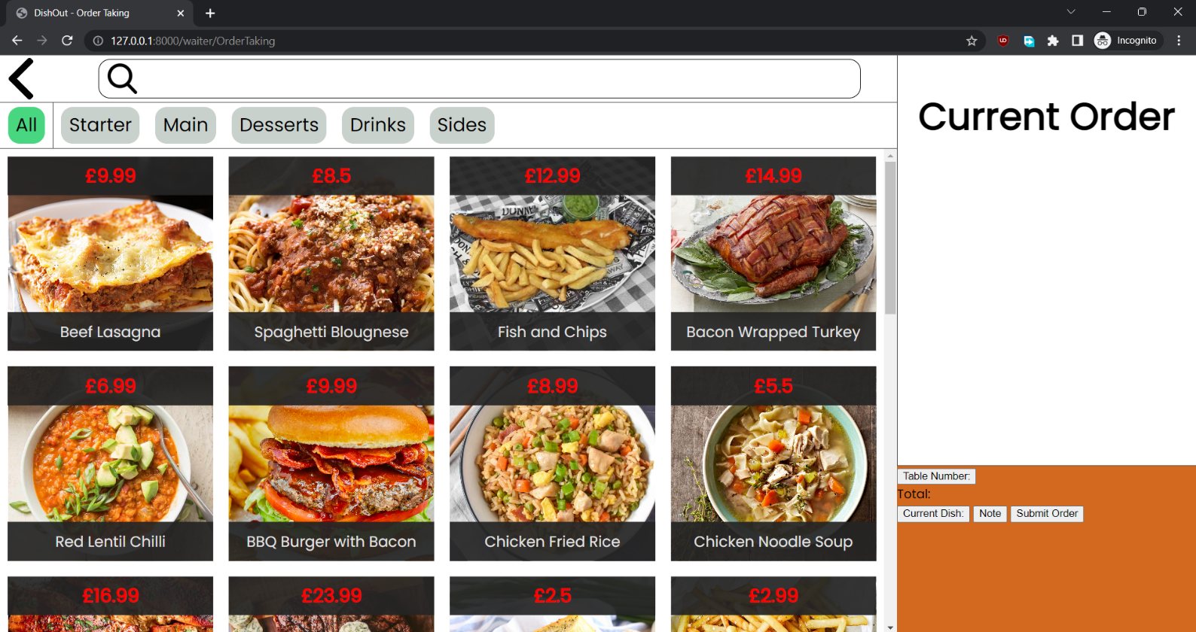

**Order Taking screen with buttons HTML and no styling.**

Next, I decided to add some styling to the buttons so that they have correct layout and look similar to the mock-up. To do this I made it so that the buttons use a grid to display them. They each have unique IDs so that they can be styled individually and have different background colours. I will also add animations to the buttons to make them more responsive, but I will do this when developing the buttons individually as the may change and which could lead to having to change the CSS.

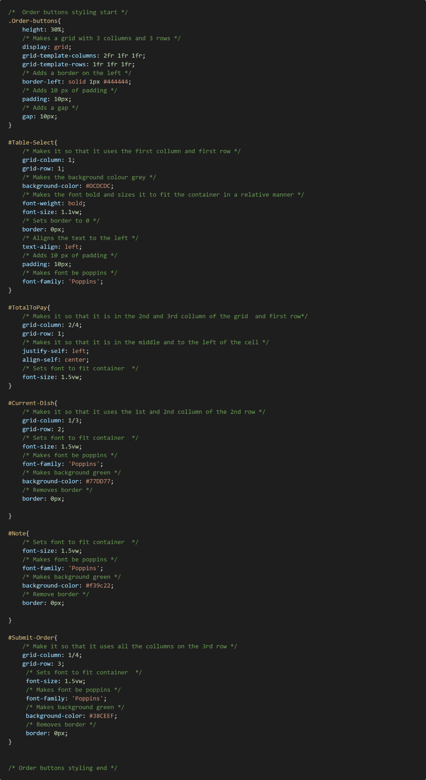

static/waiter/css/OrderTakingStyle.css

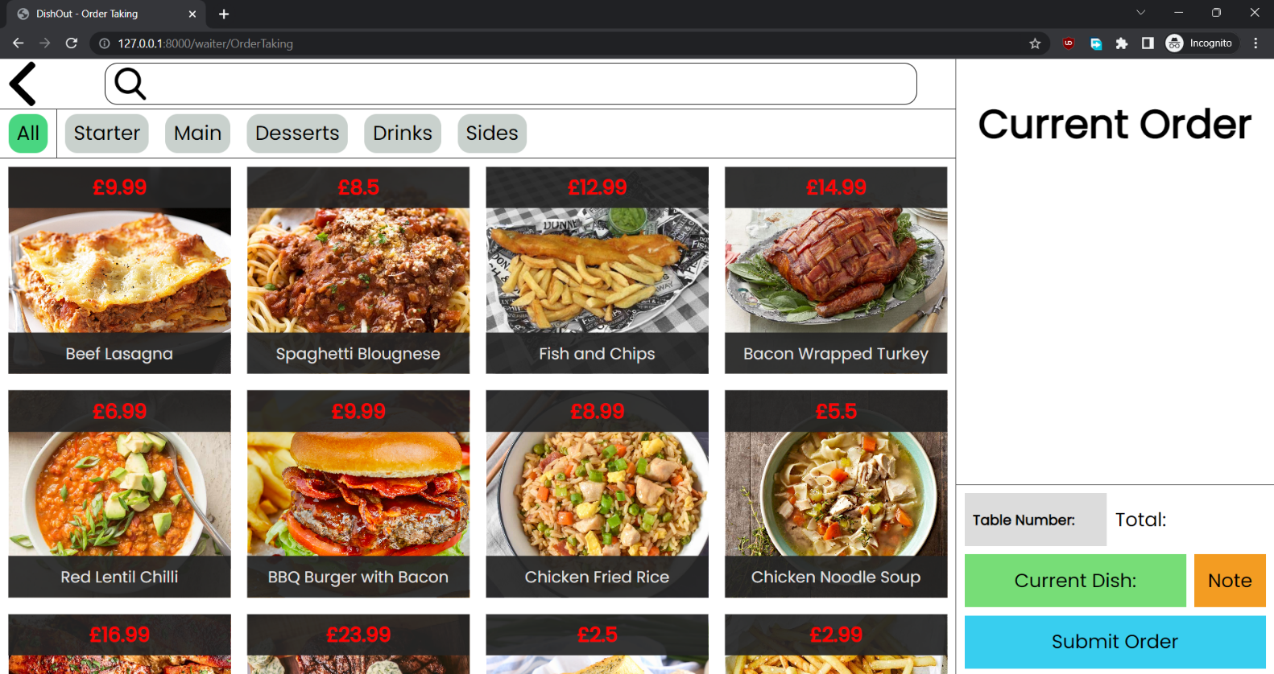

**Order Taking screen UI with button styling.**

After making the styling I decided to make the Table Number selector. To do this I found out that I had to use a HTML selection tag not a button tag. I also added dynamic Django code in the HTML so that all the tables can be added as an option.

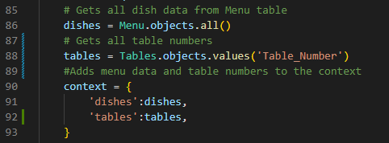I also had to add the tables to the context of the page in the views file so that the HTML can access the number of tables.

Waiter/views.py

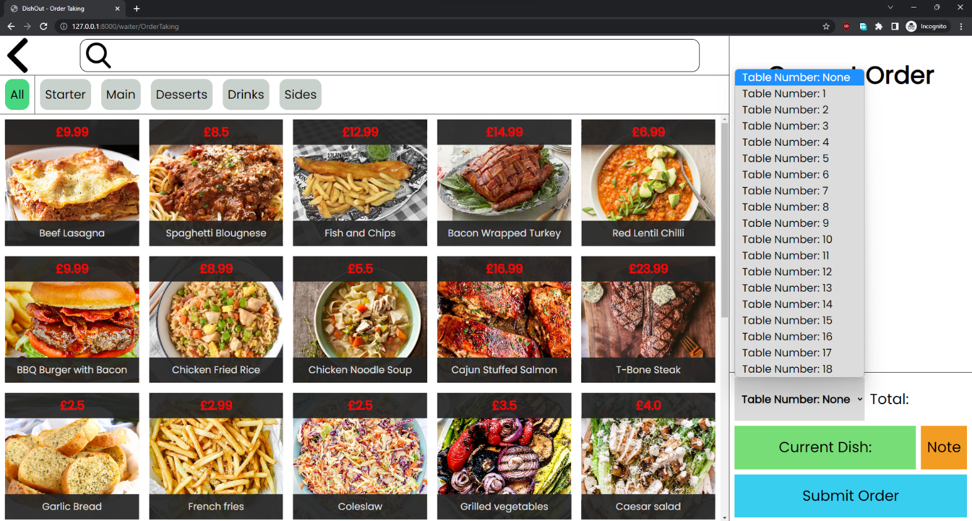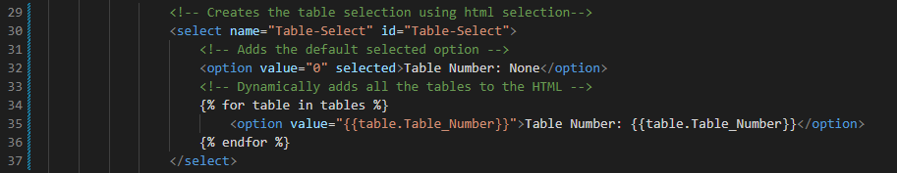Then I added the HTML:

templates/OrderTakingSite.html

**Order Taking system with working table number selector.**

Next step is to add the JavaScript so that when the SubmitOrder function is ran the getTableNumber function will also be ran to use for when placing the order.

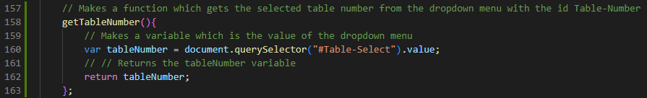

static/waiter/js/orderTakingJS.js

Next, I decided to add the total function so that every time an item is added or removed it is updated in the UI:



static/waiter/js/orderTakingJS.js

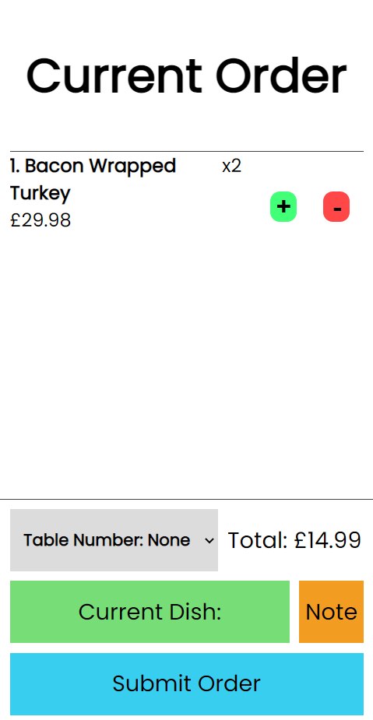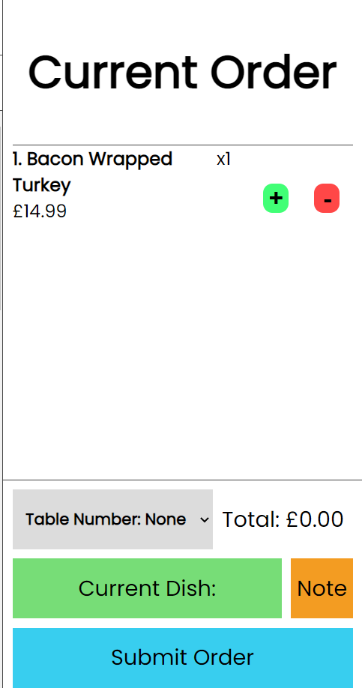I also added a function call to this function in the addItem and removeItem functions. After running the code, I found an error that the total price was only changing when the item had a quantity higher than one.

I found that in my code it only updated the total price variable during the if statement. This resulted in this bug. To fix this I added the code to update the total price to the other parts of the functions.

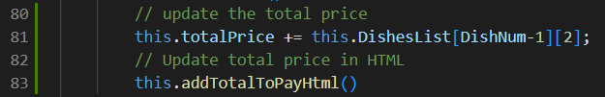

static/waiter/js/orderTakingJS.js

I added this code to the addItem function and the removeItem function. After doing these fixes the total pay worked correctly:

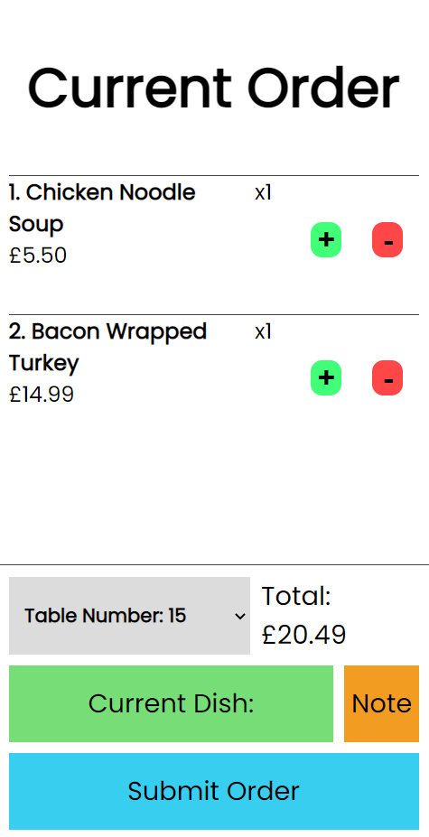

templates/OrderTakingSite.html

The next button to add is the current dish which will also need to change to a select element like the table number selector. It will hold all the dishes in the current order. To do this I decided to add code to the function which adds the current order to the HTML as it always runs when there is a new order and will only use a few extra lines of code.

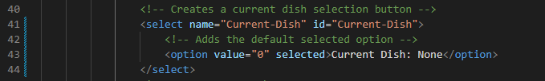

templates/OrderTakingSite.html

I added these 2 lines of code to the addToHTML function. It uses and if statement to check if the dish is already in the options before adding it and if it isn’t it adds it with the value equal to its position in the array and it sets its name/contents as the number it is in the list and the dish name:

static/waiter/js/orderTakingJS.js

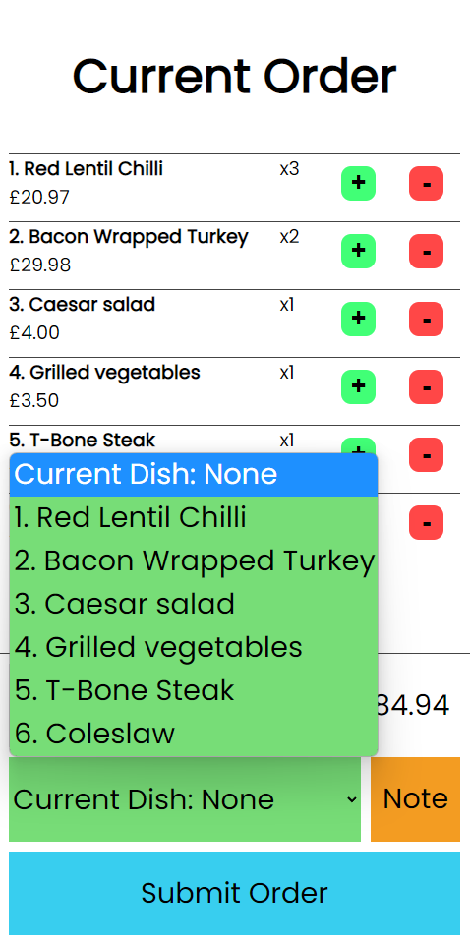

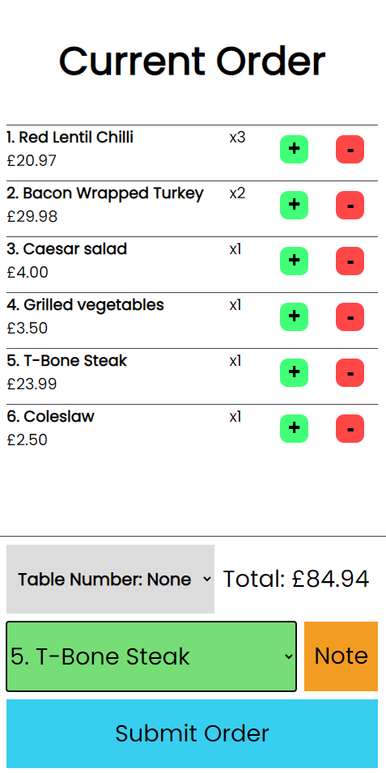

**Screen shots of the Order Taking cropped to show the Current Order UI displaying the dish selection function.**

Next button to add is the note button which I will first change it to use an image instead of saying note as this is how it was displayed in the mock-ups. To do this I had to add a Django static tag and had to add some CSS to make sure the image displays correctly.

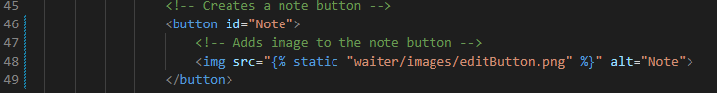

templates/OrderTakingSite.html

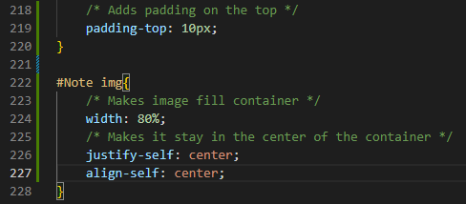

static/waiter/css/OrderTakingStyle.css

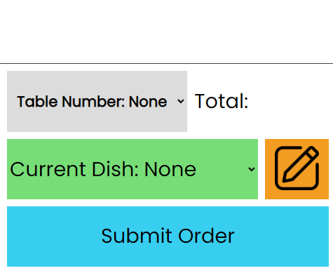

**Note taking button with image icon.**

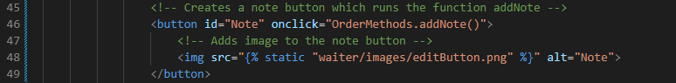Now I need to implement the function which will make the note. It will use an alert box to get the note from the user then it will save it to the correct dish in the list by taking the selected dish information from the Current dish. Firstly, I must connect the note button through HTML to the function I’m going to make:

templates/OrderTakingSite.html

Then I made the function in the Order class in JavaScript:

static/waiter/js/orderTakingJS.js

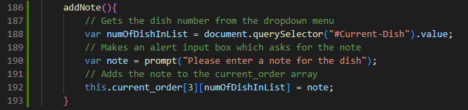

After running this, it did not work as it said that there was no index found. I noticed that my pseudocode is slightly wrong as the index of the notes is 2 not 3. After changing this it works:

static/waiter/js/orderTakingJS.js

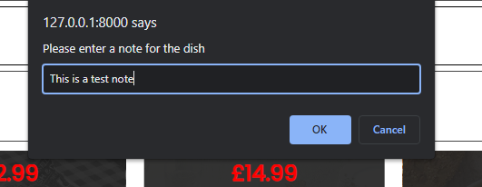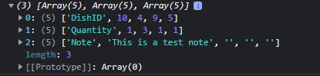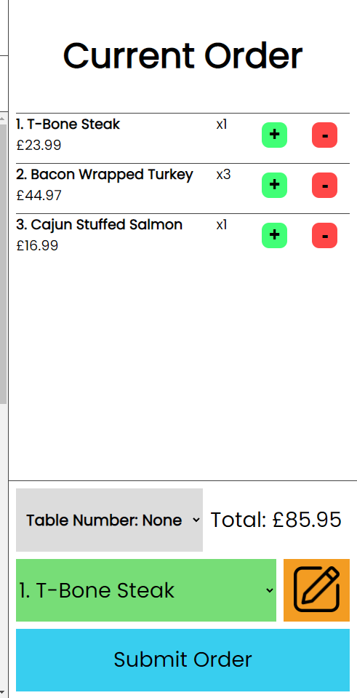

As is shown above when the dish is selected and the note button is clicked a prompt appears for the user to type in their note and then it is saved to the array.

Next, I will be making the Submit order button. I will be making the submit order function in the next version so I will only be linking the button to the function’s future name in this version.



static/waiter/js/orderTakingJS.js

## Implementing the Order Submition (V1.9)

I firstly began by making a simpler version of the submit order function which just gathered the orders and printed them to the console for me to later connect them to the backend. I had to adapt my pseudocode as when I was making the pseudocode, I thought this would be done in the backend which would mean direct access to the database but due to it not being done in the backend it has to be done differently. I also did not know when making the pseudocode that Django allows me to auto generate primary keys, so I do not have to check what the current primary key is before making the order.

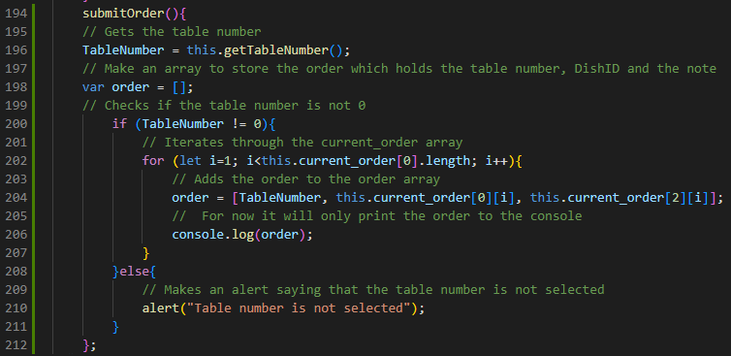

static/waiter/js/orderTakingJS.js

This function currently gets the table number and checks that it is not 0. If it is it stops the user from completing the order and alerts them of the table number not being selected. Then the program loops through all the orders and it makes each one an array with the table number, the dish ID being ordered and any note it may have.

After running this code, I ran into an error which stated that the TableNumber variable was not defined. I first tested the table number function, but it worked so then I researched the problem and found that it was due to not using the let term to define the constant.

static/waiter/js/orderTakingJS.js

After having done this the function runs.

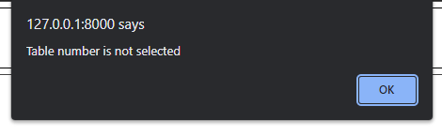**When the table number is set to 0:**

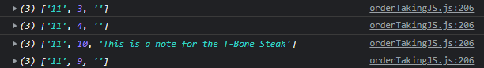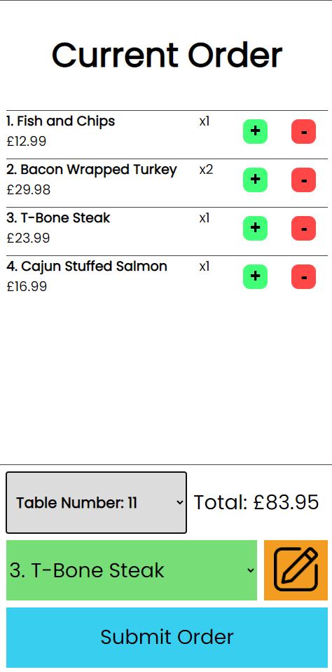**Correctly placed order with a note for the T-Bone steak:**

After running this test, I have realised that the submit order function does not consider dishes which have been ordered multiple times. In this test it is shown in the bacon wrapped turkey which has a quantity of 2 but only one has an order. To change this, I am going to add another nested for loop that loops over the quantity of that dish:

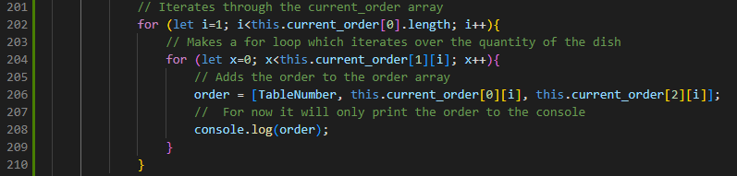

static/waiter/js/orderTakingJS.js

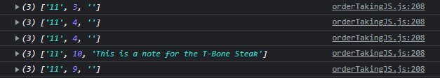Now after running it again with the same order it works as expected:

Next, I need to make it so that JavaScript submits this to the backend for it to be added to the database. Firstly, I need to make a new URL for JavaScript to submit the data:

Waiter/url.py

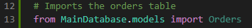Now in the views file I began by importing the orders database:

Waiter/views.py

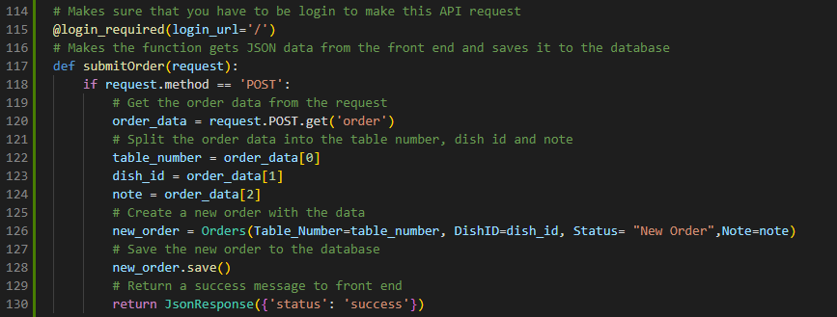Then I created the function which receives the data from the front end. It then splits up the order into Table number, order id and the note. Then it creates a new record using that information and gives it a status of new order then saves and sends a response to the front end so that it knows the order went through successfully.

Waiter/views.py

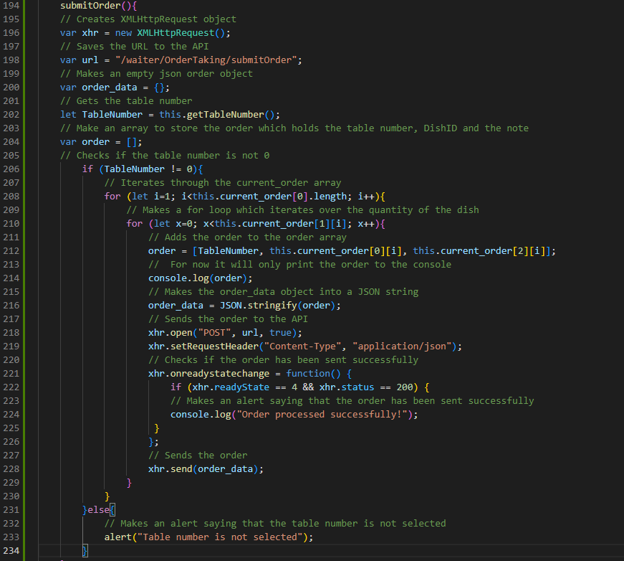Then I added the XMLHttpRequest code which allows for the data to be sent to the URL of the API:

static/waiter/js/orderTakingJS.js

However, after running this I received a CSRF token missing error which stopped the transaction of data. To fix this I am going to need to add another URL point for the JavaScript to receive the CSRF token from Django to then use in the request.



Waiter/url.py

After adding the URL, I added the function that gets the CSRF and sends it to the frontend. I also had to import the CSRF get_token function to get the token:

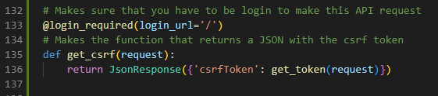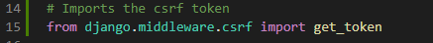

Waiter/views.py

Then in the JavaScript I added a function to get the CSRF token using fetch. The function then returns the CSRF token so it will be added to the code of the submitOrder function.

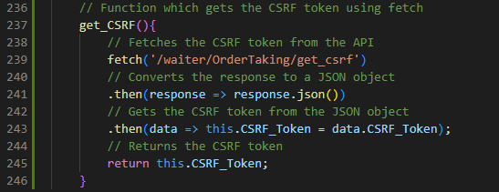

static/waiter/js/orderTakingJS.js



static/waiter/js/orderTakingJS.js

After I added this line to the submitOrder function:



static/waiter/js/orderTakingJS.js

I was still having problems with the CSRF token so after further research I found that I had to run the get_CSRF function asynchronously so that it would wait till the data arrived because before it ran the function before it got there. After doing that I also changed it to run when the website is loaded and to save the variable to the class for the submitOrder function to get instead of running it every time:

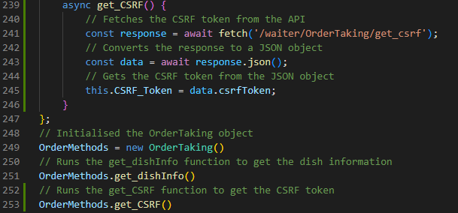

static/waiter/js/orderTakingJS.js

After having done this, I had problems with the back end saying that it was unable to read the request. I found out that it was because I was not reading the request as a JSON, so I changed it and imported the JSON function:

Waiter/views.py

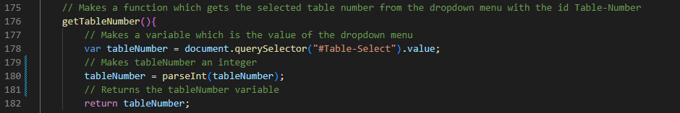After having fixed this, it was throwing another error that said that the table number must be an integer which led me to change the getTableNumber function in JavaScript and the views.py just in case.

static/waiter/js/orderTakingJS.js



Waiter/views.py

After this I was getting the error that the table number was not in the Table instance although that is not true as it is. After looking through Django documentation I found that due to it being a foreign key it needs to be passed in as a part of a record in that table, so I had to implement that into the code:



Waiter/views.py

I then also got the same error for the DishID as it is also a foreign key which meant that it had to be passed in differently:

Waiter/views.py



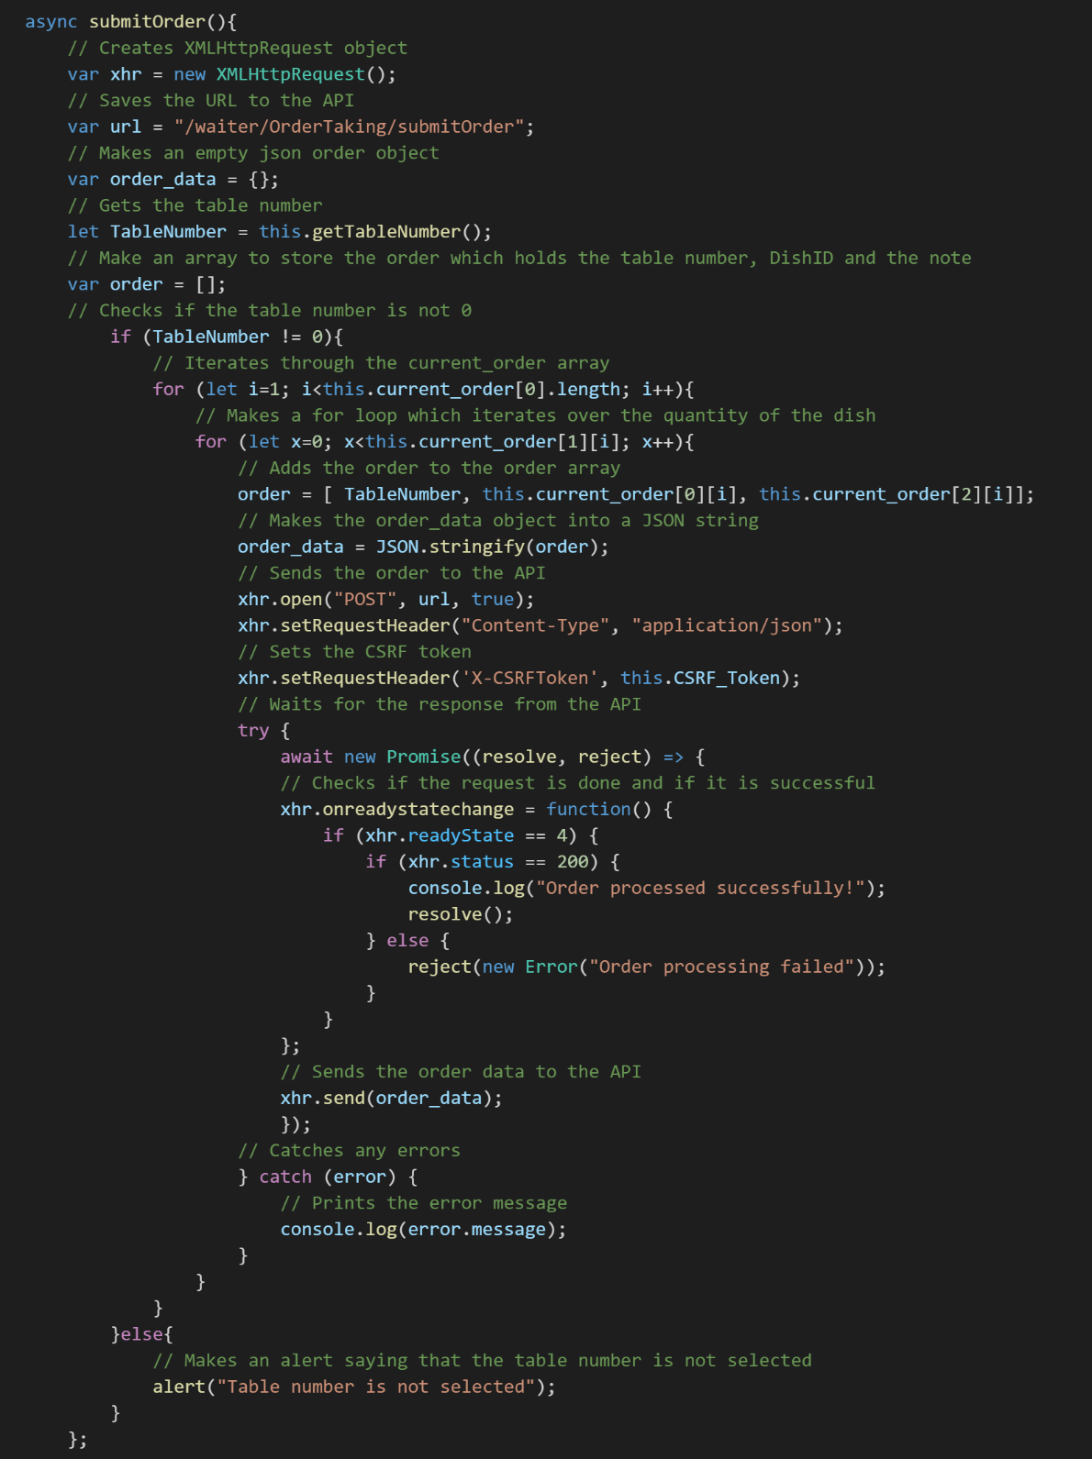After running it again I found that it finished the transaction between the front end and the back end but only saved the last order. This leads me to believe that the other orders are getting ignored because the transaction isn’t getting fully completed. To fix this I’m going to have to make the submitOrder function also asynchronous so that it waits for the transaction to be finished before doing the next one.

static/waiter/js/orderTakingJS.js

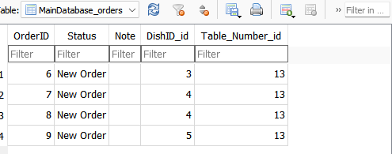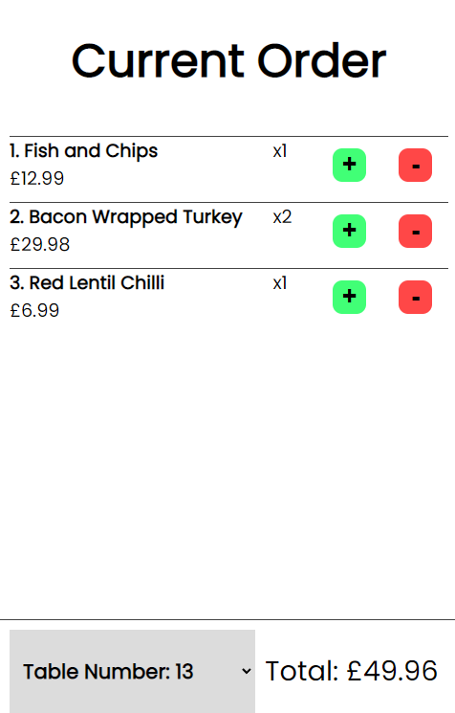After fixing all those bugs the program can submit an order. Here is a test to prove it:

**Not OrderID one because I ran it before and did not take screen shots.**

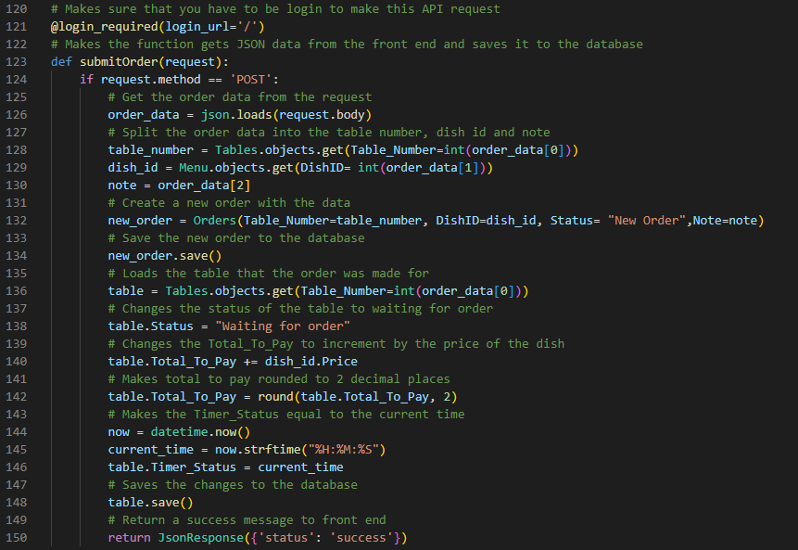Now to finish the submit order I need to add the code to the backend receiving this order data so that it updated the status and total to pay of that table. It also sets the Timer_Status to the current time.

Waiter/views.py

Now when the same order is placed:



**Table 13 has a status of waiting for order, the total has changed, and the time has changed.**

**It has also instantly updated on the table status page:**

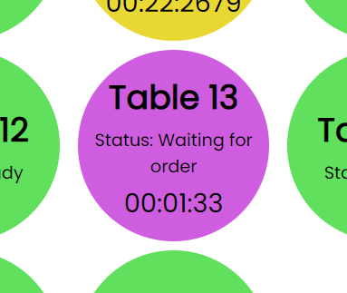

## Testing Ready Dishes (V2.6)

|  |  |  |  |
| --- | --- | --- | --- |
| Ready dishes | | | |
| Test | **Action** | **Result** | **Correct?** |
| Make an order with status ‘Ready’ | Made an order have the status of ready and checked the UI | Graphical user interface, application  Description automatically generatedDisplays the order in the Ready section: | Mini Green Tick Stamper - SuperStickers |
| Click the ‘Take’ button to take an order | Clicked the Take button on an order and checked if it | Graphical user interface, text, application  Description automatically generatedAfter clicking the Take button it instantly went into the delivery section | Mini Green Tick Stamper - SuperStickers |
| Make 20 orders with status ready | Made 20 orders using the Order Taking system then made their status ready using database commands | A screenshot of a phone  Description automatically generated with medium confidenceUI worked correctly as it shows the orders in a scrollable list: | Mini Green Tick Stamper - SuperStickers |
| Click ‘Delivered’ on an order in the Taken orders section | I clicked delivered on the Garlic bread order | Graphical user interface, text, application  Description automatically generatedWhen I clicked on delivered it instantly was removed: | Mini Green Tick Stamper - SuperStickers |
| Deliver an order and check the Orders_Delivered field for the user which delivered the order | After having delivered the Garlic Bread order I checked the record on the account I was logged in on (JohnDoe) | The Orders_Delivered field did not increment meaning that this test failed   |  |

To fix this I had to access the Employee database using the account saved on the delivery table and increment the orders delivered for that employee:

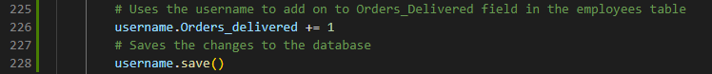

Waiter/views.py

After performing the test again, it worked correctly:

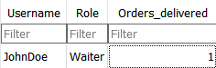

## Making the mobile GUI for the Order Taking System (V2.0)

In this version I am going to need to adapt the current UI to work on a mobile device. I am going to do this by adding a class to some elements called Mobile which will let me control what elements are visible depending on if it is being shown on mobile or not.

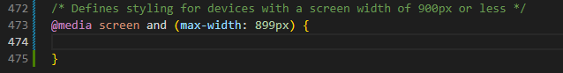I first began by making the media calls in the CSS which defines when to use a certain styling depending on the screen width:

static/waiter/css/OrderTakingStyle.css

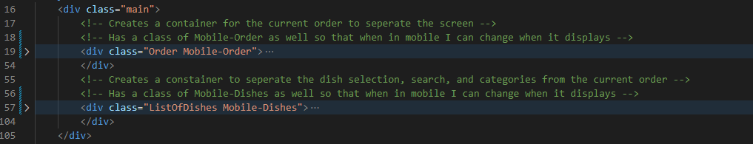Then I added the styling from the PC version to the mobile version and added mobile classes to the ListOfDishes div and the Order div.

templates/OrderTakingSite.html

Then I made it so that when in mobile the Mobile-Order class is set to display hidden:

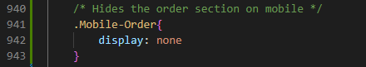

static/waiter/css/OrderTakingStyle.css

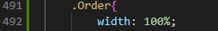And changed the Order class and the ListOfDishes class to use 100% of the width of the screen when in mobile.

static/waiter/css/OrderTakingStyle.css

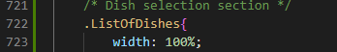

Then I checked to see how it displays on mobile and it works as intended:

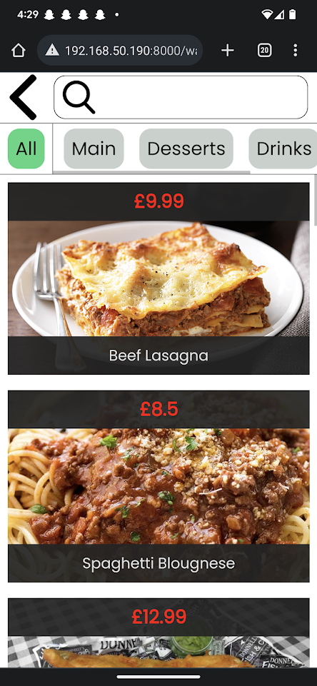

**Order Taking UI on mobile after adding Mobile classes.**

Next, I decided to deviate from the mock-ups to make it easier to develop and maintain. I am going to make it so that the view order button is the only button that the user can use on the bottom bar so that I can just hide the dish selection view and show the current order view which is a lot faster to implement.

To add this, I am going to need to add a rounded box to the bottom of the screen which sticks to the bottom and has a button which shows the current order screen. Firstly, I added the HTML which is a div containing the button to take the user to that screen.

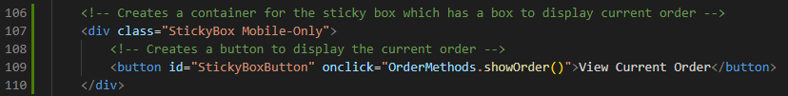

templates/OrderTakingSite.html

Then I added the CSS to style it and make sure that it does not display in the PC version.

Makes it so it doesn’t show on PC.

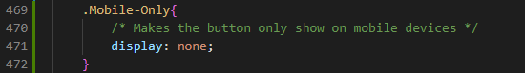

static/waiter/css/OrderTakingStyle.css

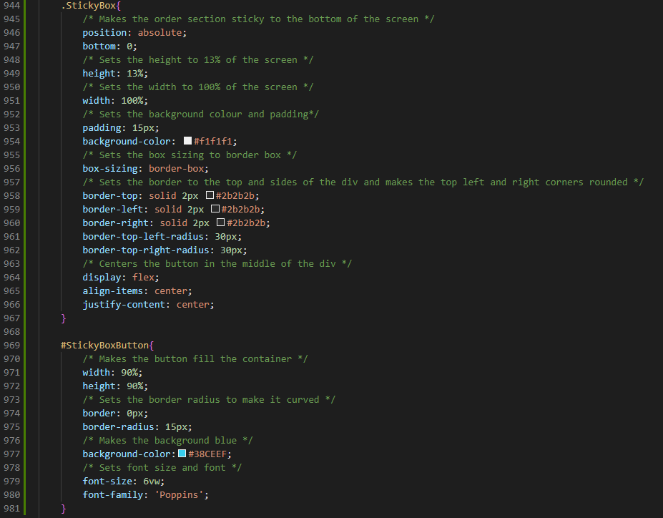Styling for the StickyBox and the button:

static/waiter/css/OrderTakingStyle.css

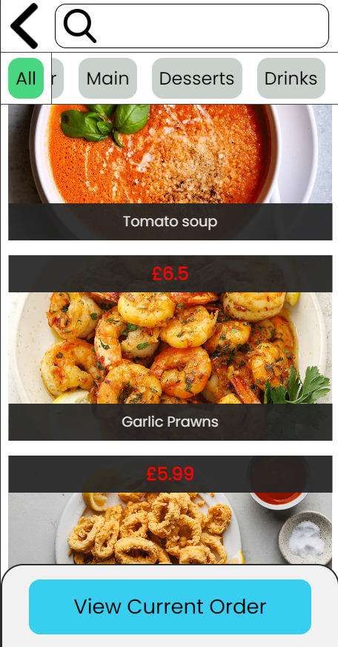After running this and trying out the UI on mobile I found a bug which was that the StickyBox was blocking the view for the last dish, and I noticed that a similar thing was happening to the category selection. The starter category select was being hidden by the current selected category:

****To fix the scrolling for the dishes I added padding at the bottom of the page:

static/waiter/css/OrderTakingStyle.css

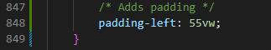To fix the category scrolling bug I did the same but added the padding to the left.

static/waiter/css/OrderTakingStyle.css

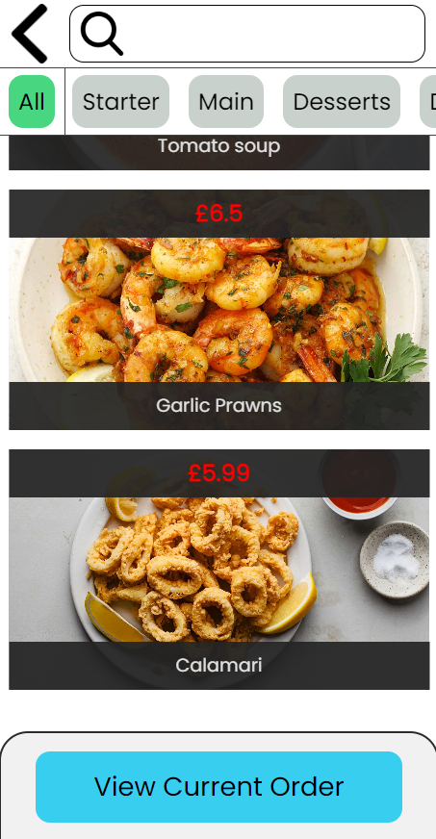After adding these fixes both scrolled correctly:

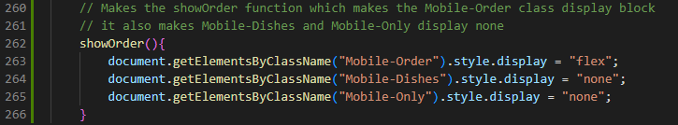Now I wanted to implement the function which displayed the current order. To do this I had to make the function which I defined in the button for the sticky box in JavaScript. It is going to have to change the display of ListOfDishes to none and the StickyBox but change the display of the Order to flex.

static/waiter/js/orderTakingJS.js

After running this function it did not work as it displayed and error saying that it cannot set the properties of undefined. I realised it is because they are classes which made it indexed but since they all have unique classes anyway, I decided to change them to IDs which meant that I had to change the HTML, JavaScript and CSS.

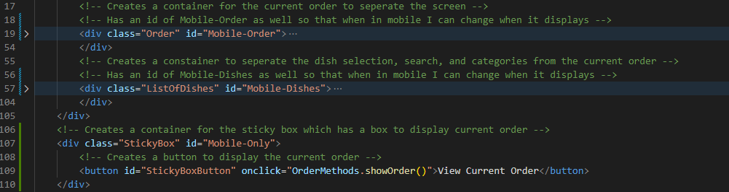

templates/OrderTakingSite.html

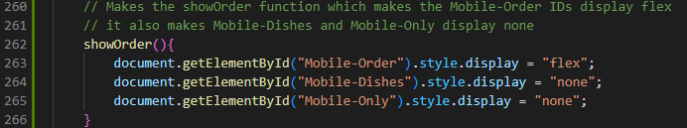I then changed the JavaScript to use IDs:

static/waiter/js/orderTakingJS.js

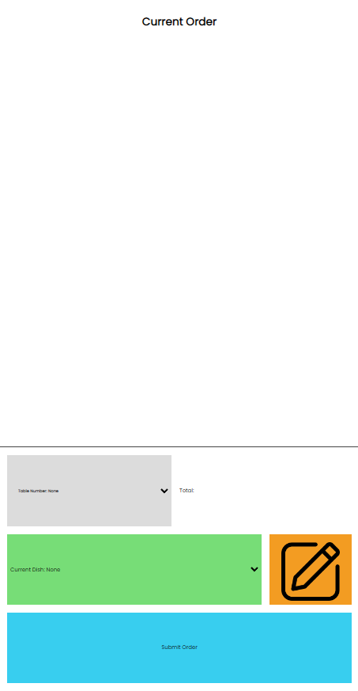Now when the JavaScript is running it works correctly but it is not displaying the text correctly due to it being relative to the width of the screen:

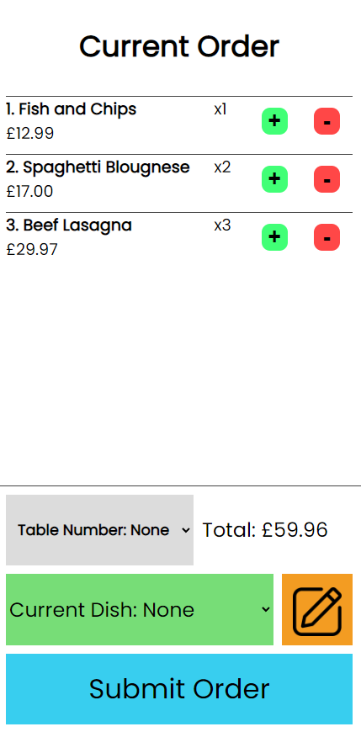To fix this I increased the relative size number of all the texts. After doing this the UI looks correct:

Lastly, I added a back button to the Current Order UI which hides the Current Order but shows the List of dishes and the StickyBox. It uses the same image as the back button.

templates/OrderTakingSite.html

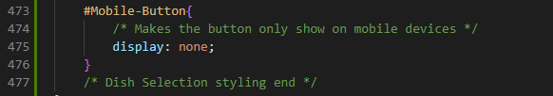Then I had to add styling and make sure that it didn’t display on the PC UI

static/waiter/css/OrderTakingStyle.css

Finished button CSS. It makes the button stay in the top left of the screen and makes it so that the image is contained inside the size of the button:

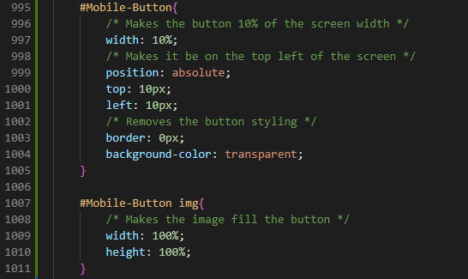

static/waiter/css/OrderTakingStyle.css

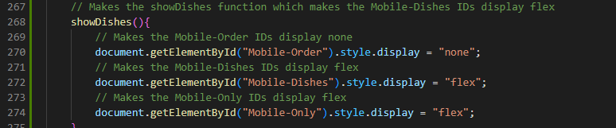Next, I added the JavaScript function which showed the Dishes:

static/waiter/js/orderTakingJS.js

After running it the button works correctly and looks correct as well:

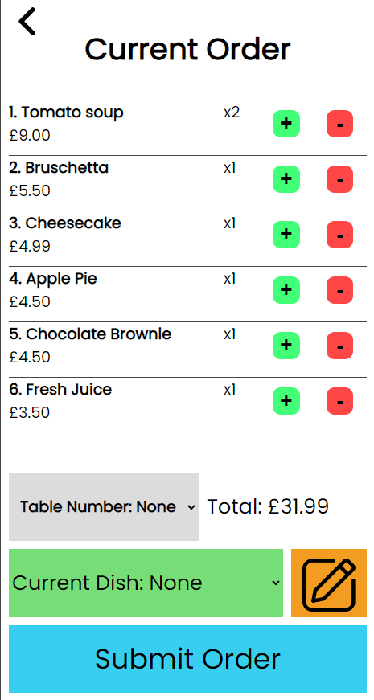

## Stakeholder Feedback for Order Taking System (V2.1)

“I am very happy with the UI and its responsiveness between mobile and PC applications. The change which was made to the mobile solution to make it easier to make doesn’t seem like it will affect the efficiency of my workflow. The prices of the dishes not having a 0 at the end is the only flaw I have with the UI, but it is not crucial for the system to work. Although I would like there to be a pop up which checks if you are sure that you want to make the order and for it to clear the current order after the order has been submitted.”

– Louis Allaway

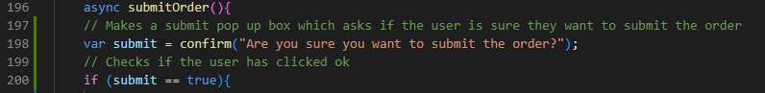After getting this feedback from my stakeholder I decided that I would focus with the main concerns and at the end of the project if I have time, I will try to address his issues with the prices of the dishes. Firstly, I am going to implement the pop up to check if the user is sure they want to submit the order. To do this I am going to use the JavaScript submit which makes a pop up to check if the user wants to do something:

static/waiter/js/orderTakingJS.js

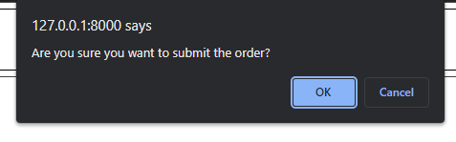After trying to submit an order after adding this feature:

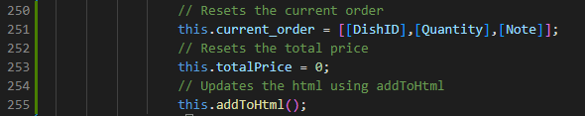Next, I made it so that when a user submits an order it resets the current order. To do this I just have to reassign the value of current_order to just contain the default array:

static/waiter/js/orderTakingJS.js

After running this I got an error that DishID was not defined. I instantly realised that this is because it is not in quotation marks and is causing the program not to run. Then I ran it again and found that the function addToHtml was not working and this was because it was not capitalised correctly. After tweaking the code with these changes, it works correctly:

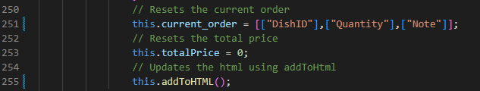

static/waiter/js/orderTakingJS.js

## Testing the Order Taking System (V2.3)

|  |  |  |  |
| --- | --- | --- | --- |
| Order Taking | | | |
| Test | **Action** | **Result** | **Correct?** |
| Search for spaghetti in the search bar | Searched using the search bar for spaghetti | After searching the search bar with spaghetti the only result was the dish spaghetti which is what was expected: | Mini Green Tick Stamper - SuperStickers |
| Search for a dish that isn’t in the menu database (e.g. type in bolts) | I typed in bolts into the search bar to see if it would return anything | As intended, there were no results after searching for bolts: | Mini Green Tick Stamper - SuperStickers |
| Leave the search bar empty | Emptied the search bar and clicked enter | It loads all the dishes when the search bar is set back to empty as intended | Mini Green Tick Stamper - SuperStickers |
| Click the desserts category | Clicked the desserts category | Once I clicked the desserts category it showed only the desserts as intended and it moved the button to show it is the current category: | Mini Green Tick Stamper - SuperStickers |
| Add a dish to the order and check current_order 2D array (Should be the first dish, have no note , and a quantity value of one) | I added French fries to the order and then checked the console logs | As expected, it stored it the order correctly: | Mini Green Tick Stamper - SuperStickers |
| Select dish in current order and add the note “this is a test” then check the 2D array and it should be saved in the dishes record on the note field | Selected the French fries using the current dish selector and clicked the note button to add the note | As is shown it correctly updated the array to show the new note: | Mini Green Tick Stamper - SuperStickers |
| Add an empty note to a dish | For this I added a note to the French fries that was empty | This correctly stored the note back to what it was before adding the note: | Mini Green Tick Stamper - SuperStickers |
| Add a 500-character note | For this I had to change what I did due to the change in requirements from the stakeholder which meant that I only added a 280-character note using lorem ipsum to the French fries | It works as intended and stored all the characters: | Mini Green Tick Stamper - SuperStickers |
| Add another of the same dish onto the current order | I clicked the + button for the fish and chips and checked the quantity of it | It stored it correctly as it showed one fish and chips with a quantity of 2: | Mini Green Tick Stamper - SuperStickers |
| Remove a dish from the current order which only has one being ordered currently | For this I added a Chicken Fried Rice and then removed it | Worked as intended when I added it, I just clicked the minus button, and it removed it from the order: | Mini Green Tick Stamper - SuperStickers |
| Add 2 dishes and a note to one of them then submit the order | For this I added 2 lentil soups and then I gave one of them a note then submitted it | While doing this I found a bug where the dishes that were previously added were still in the selection for the current dish:  This will need to be fixed.  Then after submitting the 2 red lentil soups they both were stored with a note which is not was meant to happen. As well as when the order is submitted the price for the total is not changed to 0: |  |
| Submit an order without any dishes in the current order | I submitted an empty order | The function that submits the order did not run as there was no data needed to be sent. | Mini Green Tick Stamper - SuperStickers |
| Submit an order and check if its times ordered is incremented. | I submitted an order with a garlic bread in it | After ordering the garlic bread I checked the database but found that the garlic bread Num_Ordered didn’t change |  |

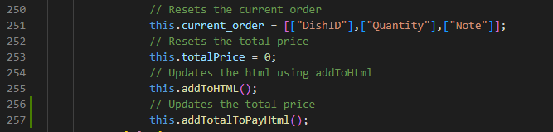To fix the bug with the total to pay I just had to add a function call to the end of the submit function in JavaScript:

static/waiter/js/orderTakingJS.js

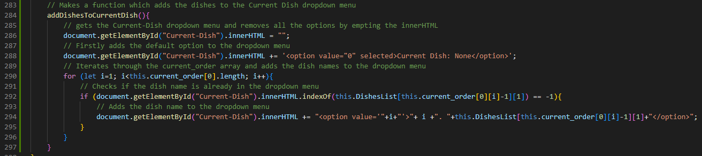To fix the bug with the notes I decided that I would make a function for adding the selection dishes instead of it being part of the addToHTML function. This is the function I made which gets the element to then:

static/waiter/js/orderTakingJS.js

Then I added the function to the addToHTML:

static/waiter/js/orderTakingJS.js

To fix the bug where one note was assigned to all those dishes, I decided to make it so that the program will prompt the user to enter the number of dishes that should have that note. Then it will add how many are needed to have the note to the note itself using a special character to be able to separate the note itself from the number.

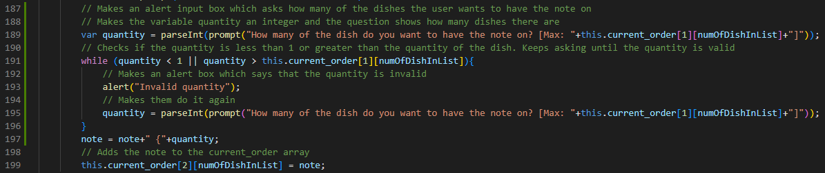I first changed the addNote function code to run a while loop while the quantity is out of the boundaries of how many dishes have been ordered for that dish. When a valid input is entered it changes the note and saves it to the array:

static/waiter/js/orderTakingJS.js

Then I changed the submitOrder function. Firstly I added an if statement to check if the note is empty as if it is then it will just set the note variable to empty. If it is not empty, it will extract the note and quantity from it to the have another if statement which checks if the quantity of the note is larger or equal to 1 because if it is then the quantity needs to be changed in the note for the next loop iteration:

static/waiter/js/orderTakingJS.js

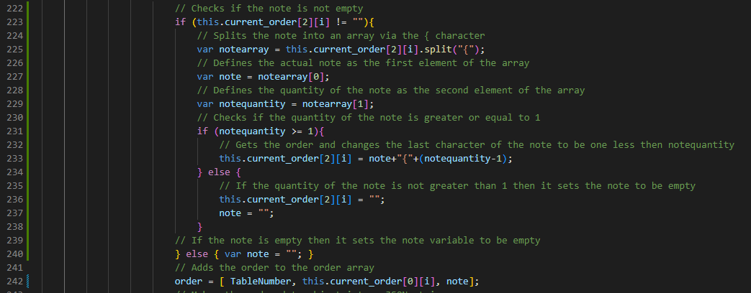

I added 2 lentil soups and submitted it one having a note and then I checked the database to see if only one had a note. I found that it worked correctly.

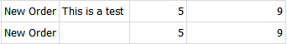

Next bug to fix is the Num_Ordered not increasing when the dish has been ordered. To fix this I added a line of code to the submitOrder function in the views.py:

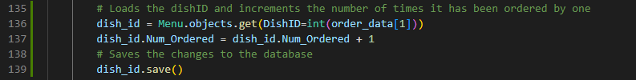

Waiter/views.py

After re-doing the test I checked the database and it incremented correctly:

## Implementing Ready Dishes (V2.4)

I firstly began by making the URL for the ready dishes section:

Waiter/url.py

I then added the function which loads the page. I also added the context as I know that I will need to access the orders table to get all the ready orders and I also added the delivery table as they will be needed for the Taken Orders section. This also meant having to import the Delivery table.

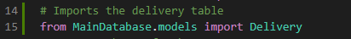

Waiter/views.py

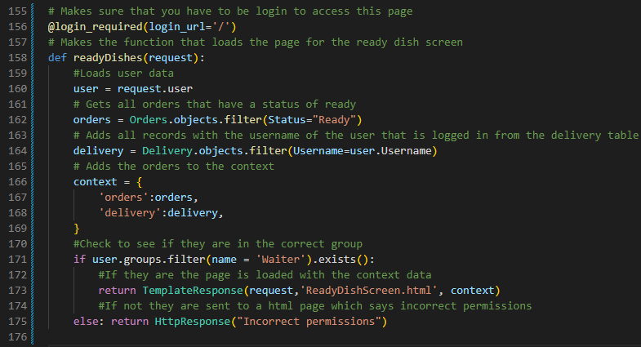

Waiter/views.py

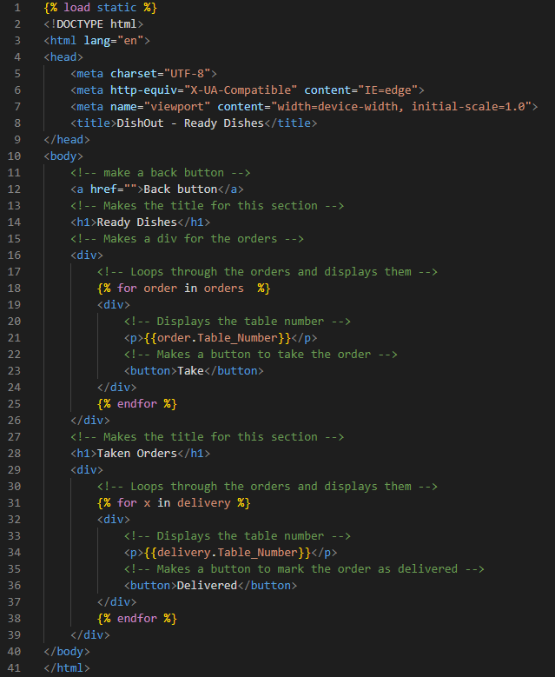After implementing this function, I created the HTML for the page. I created a back button using a link tag which will link to the waiter selection screen. I also added 2 h1 tags for the titles of each of the 2 sections (Ready Orders and Taken Orders). Finally, I added 2 divs one in each section which have dynamic Django HTML to generate the records with the information for each one.

To be able to see if this page works, I need to link this page to the waiter selection screen so that I can easily access it. To do this I added the URL to the HTML of the waiter selection screen.

templates/SelectionScreen.html



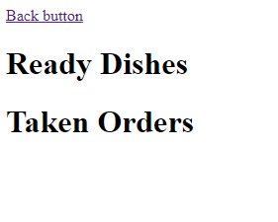After adding this I tried to access the page but got an error that the User attribute has no Username attribute. I found out that this error was due to the Username attribute having a lowercase u. After changing that it worked:

templates/ReadyDishScreen.html

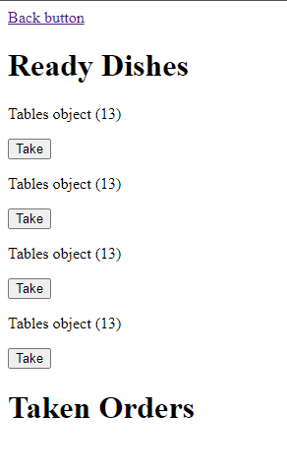Due to the kitchen section of the program not being completed yet I am manually going to change some orders status so that they show up in this part of the program. After having done this, it displayed the correct number of ready orders. However, it displayed them incorrectly as it says Table Object then the number:

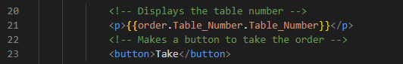After researching I found out that because the Table_Number is a foreign key it is trying to display the whole object/record on the Tables table. To fix this I need to specify what attribute I want from the Tables table which is the Table_Number:

templates/ReadyDishScreen.html

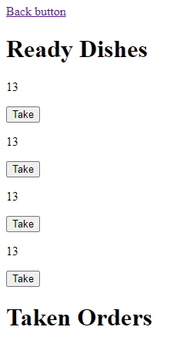

I am now going to style the elements in this section. I will first have to link in the style sheet for this section using Django’s static files.

templates/ReadyDishScreen.html

Now I can create the styling for each of the sections of the page. I am going to be able to reuse CSS as the buttons themselves look the same for both sections which is going to mean that it will be quicker to develop:

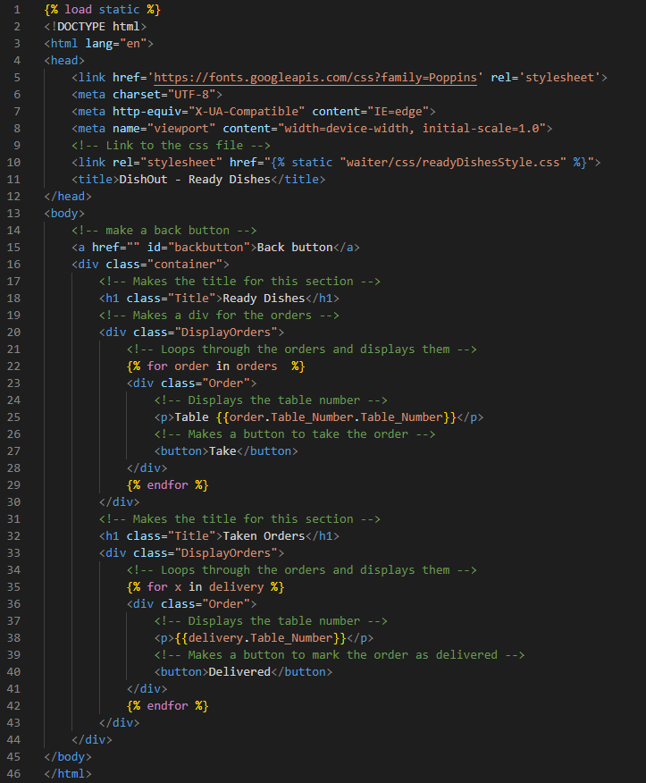

templates/ReadyDishScreen.html

After adding the classes I created the CSS which looks very similar to the mock-ups:

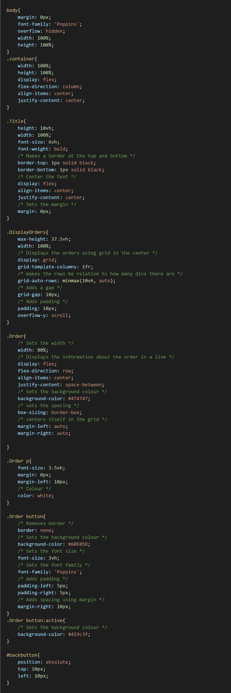

static/waiter/css/readyOrdersStyle.css

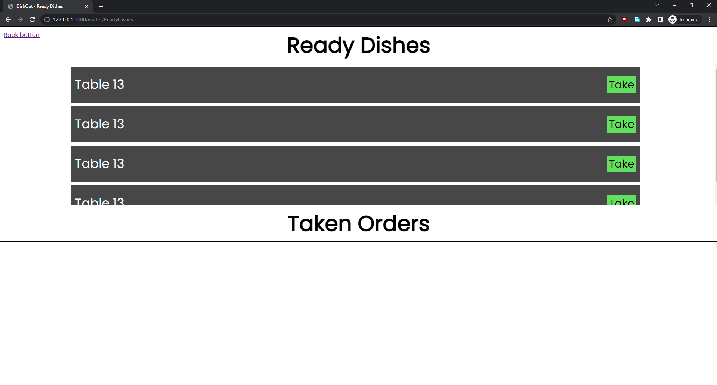

**UI for the Ready Dishes screen**

Next step will be to add the back button image and the functionality for both the ‘Take’ and the ‘Delivered’ button.

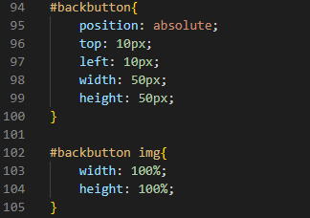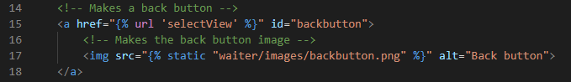Firstly, I added the image and the CSS for it:

static/waiter/css/readyOrdersStyle.css

templates/ReadyDishScreen.html

Next, I need to add the button function which will also meant that I will need to make an API for the buttons to access and send the data to. I am going to start by making the backend that will receive the data and commit it to the database:

Waiter/url.py

I first had to make a URL entry point to access the API:

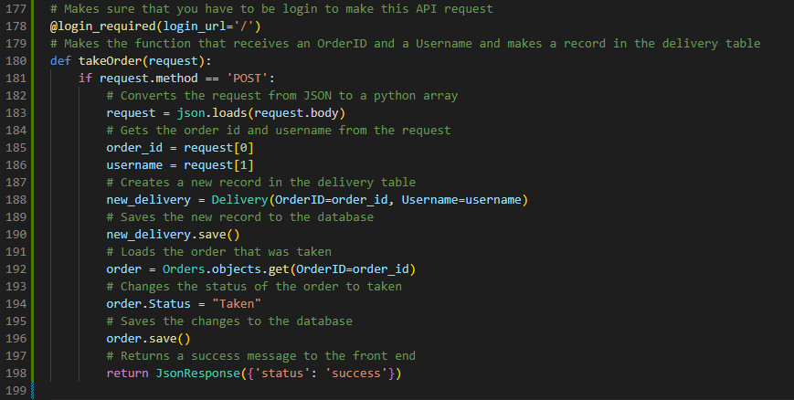This function receives the data then turns it from JSON to an array. Then it creates a new record in the database with the OrderID and the Username. It then also updates the status of the order to taken.

Waiter/views.py

After having done this, I started to develop the front-end part of the API. Firstly, I imported the JavaScript file to the HTML and added an onclick function to the take button so that it runs the takeOrder function and gives it the necessary information through the parameters.



templates/ReadyDishScreen.html



templates/ReadyDishScreen.html

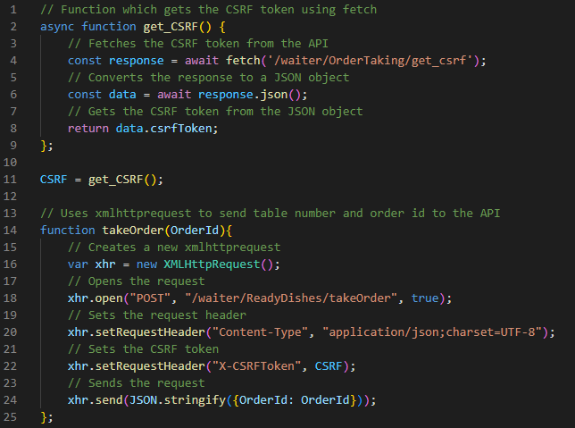I then copied over the function to get the CSRF as I know that it will also be needed to process these API calls. Then I made the function that is ran when the button is clicked on the HTML:

static/waiter/js/readyDishes.js

The takeOrder function works by taking in the OrderID then changing them into JSON form to then send to the backend. I didn’t realise that the username would be easier and more secure if it was accessed through the backend so I will have to change the backend now to get the username itself.

Waiter/views.py

After running the function, I was getting an error again saying that the CSRF token was of incorrect length. After researching the problem further, I found that I should try making it regenerate the CSRF in the function which makes the CSRF be UpToDate.

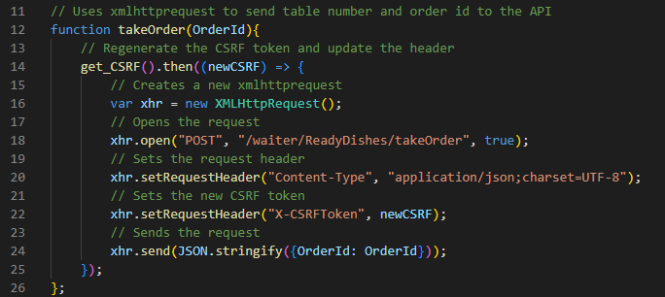

static/waiter/js/readyDishes.js

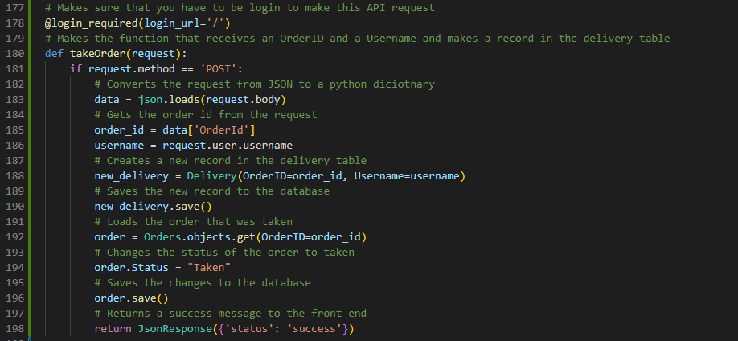After running this, it no longer gives me the CSRF incorrect length error but instead it gives me an error for trying to get the OrderID from the request. I found that the problem is that it is stored as a dictionary, so I had to set the index as OrderId:

Waiter/views.py

However, this did not work for both the username and the OrderID due to the same bug as last time which is that they are foreign keys so the whole object needs to be passed in:

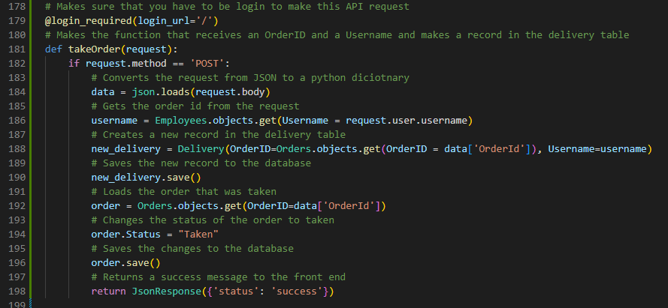

Waiter/views.py

This did work and correctly recorded the delivery. However, I found a problem with my HTML being that it is trying to get the Table_Number out of the delivery table but it must use the OrderID from the delivery table to get the Table_Number from the Orders table.

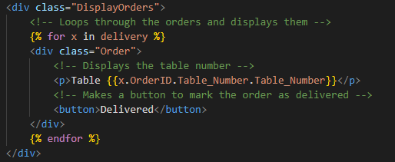

templates/ReadyDishScreen.html

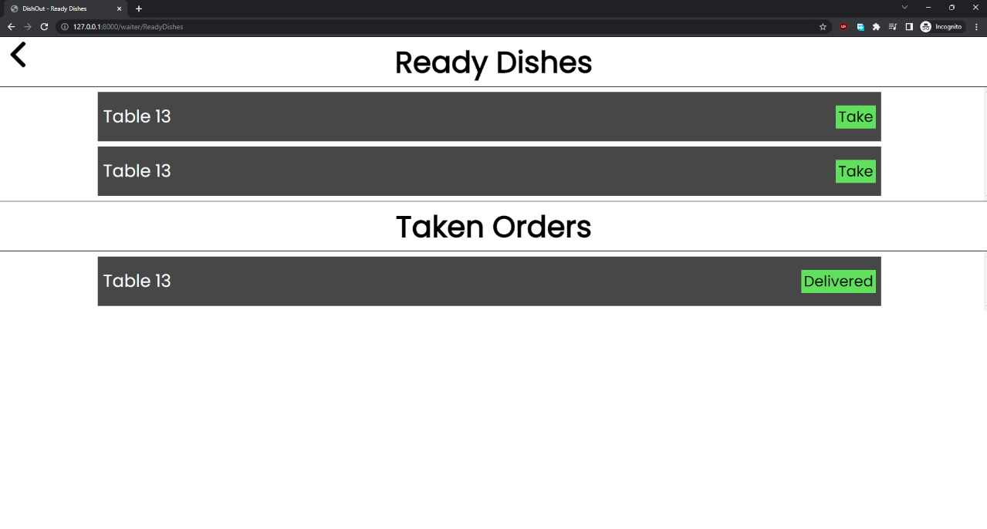Now it all works correctly:

The last step for the Ready Dishes version is to add the delivered button functionality which should be simple as it is going to be very similar to the Take function code. I again started with doing the URL and backend code. The backend code gets the request then removes the record from the table.

Waiter/url.py

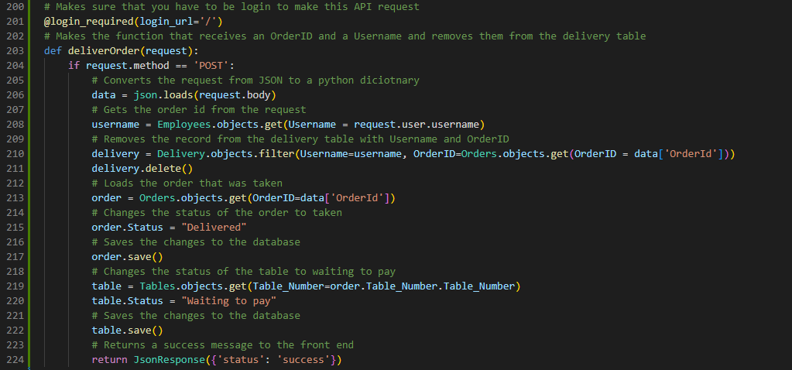

Waiter/views.py

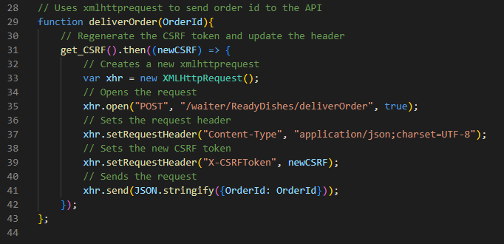After making the backend I added the button to the HTML and made the function for it:

templates/ReadyDishScreen.html

static/waiter/js/readyDishes.js

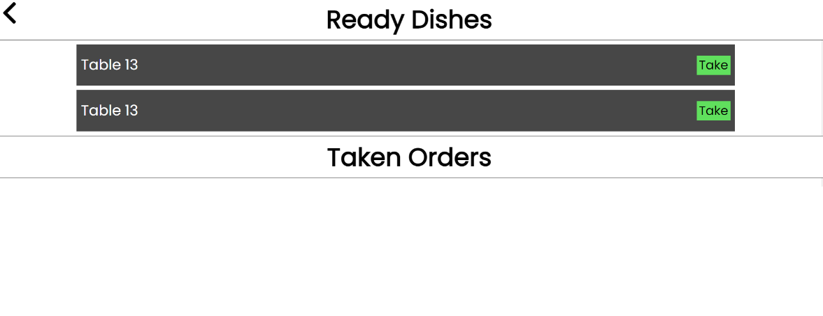After running this, it worked first try. I then checked if everything else updated correctly and they did:

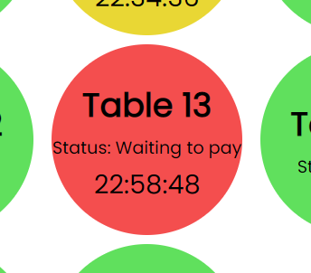

Table status of the Order updated correctly.

Order status was correctly updated thus removed from the taken and ready orders.

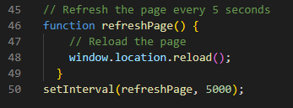To finish the Ready Dishes section completely I decided to also add an auto refresh to the page so that new ready orders can be seen coming in.

static/waiter/js/readyDishes.js

I also added the refresh functionality to the functions for clicking the buttons so that the buttons are more responsive.

static/waiter/js/readyDishes.js



static/waiter/js/readyDishes.js

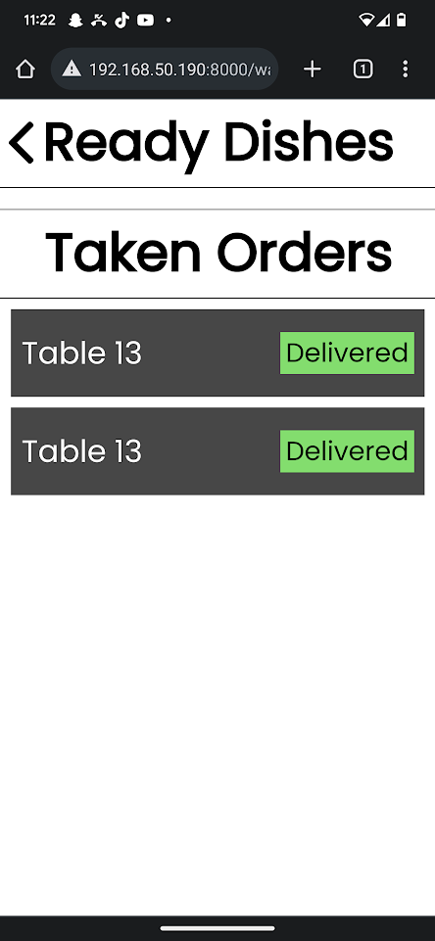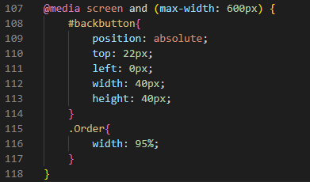Now I need to make the UI work on mobile. Due to it already being very relative it does not need much tweaking and only needs for the back button to be smaller and more towards the left. I also had to make the orders wider to fit the screen better. These were all the changes needed for the UI to be functional on mobile.

static/waiter/css/readyOrdersStyle.css

**Finished Mobile UI for Ready Dishes**

## Stakeholder Feedback for Ready Dishes (V2.5)

“I am very happy with the UI and its functionality; I liked the responsivity of the UI from that refresh feature you added. I think you should add the dish name to the UI because as a staff I would like to know what dish I am supposed to be taking to the customer.” - Louis Allaway

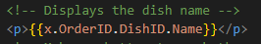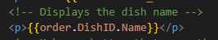To add this feature, I added a p tag to the HTML which fetched the dishes name using the DishID and then displayed it:

templates/ReadyDishScreen.html

templates/ReadyDishScreen.html

**Ready Screen UI after changes**

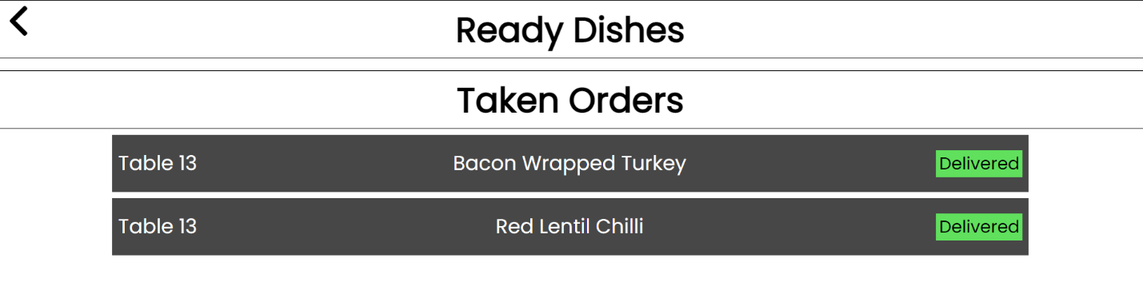

## Implementing Pay (V2.7)

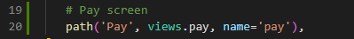I firstly began as per usual by making the URL for this section.

Waiter/url.py

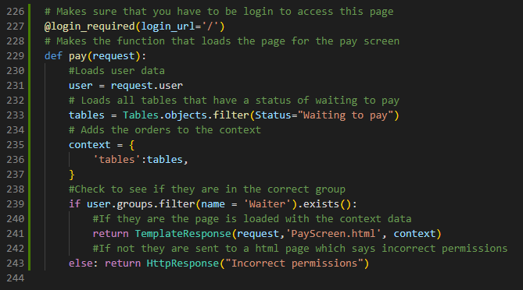After this I created the function to return the site which also sends the tables which have a status of waiting to pay so that they can be displayed and paid for:

Waiter/views.py

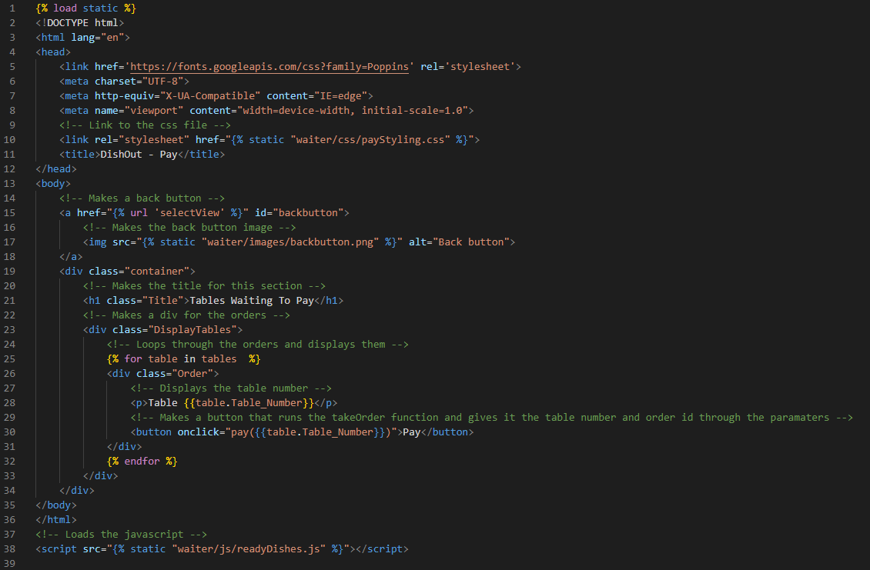Next, I wrote the HTML for the page. I was able to reuse a lot of the HTML from the previous section due to them both being very similar:

templates/PayScreen.html

Now I’m going to update the HTML for the selection screen so that I can access the Pay screen through it.

templates/SelectionScreen.html

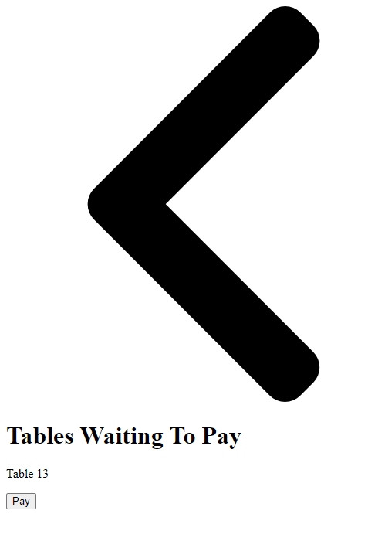After changing this line of code in the selection Screen HTML I was able to access the pay page as it currently is, and it currently looks like this:

To fix this I am going to add some CSS which will also be recycled from the last page as they are very similar in terms of styling. I will have to change the styling for the titles as the Pay section has no border as well as the sizing since there isn’t two sections to the page.

I also had to make a few extra changes to the classes in the HTML like changing the Order class to the Table class as it fits in better with what the page is displaying.

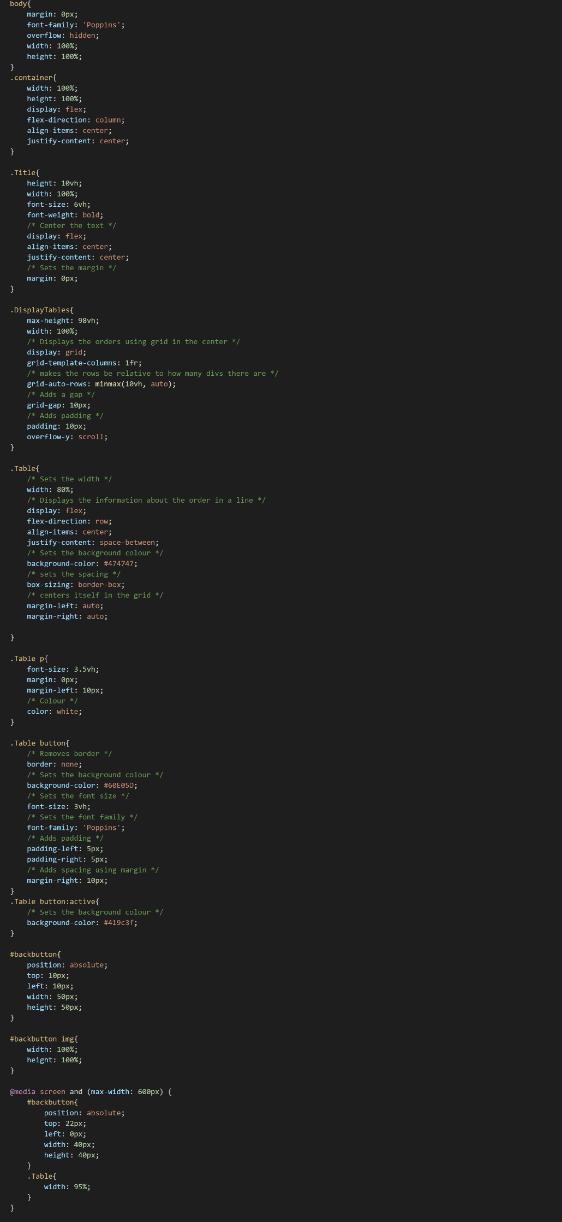

static/waiter/css/payStyling.css

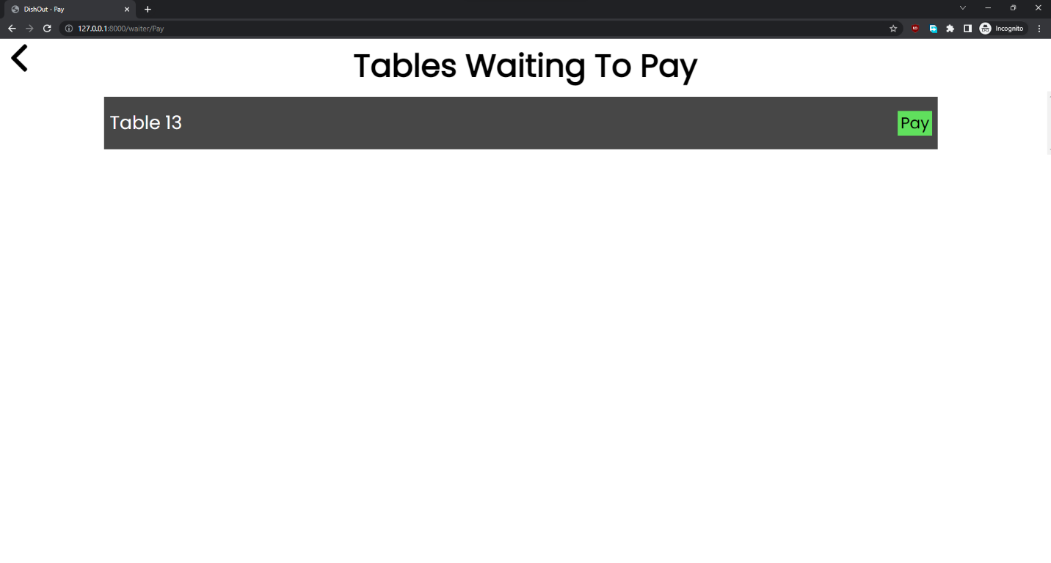After making those tweaks to the CSS of the previous page it works correctly on the page as everything displays as it is meant to:

**UI for the Pay screen**

The final step is to add the JavaScript for the button and add the API to Django so that they can communicate. To do this I first have to change the static JavaScript file which the HTML is connected to.

templates/PayScreen.html

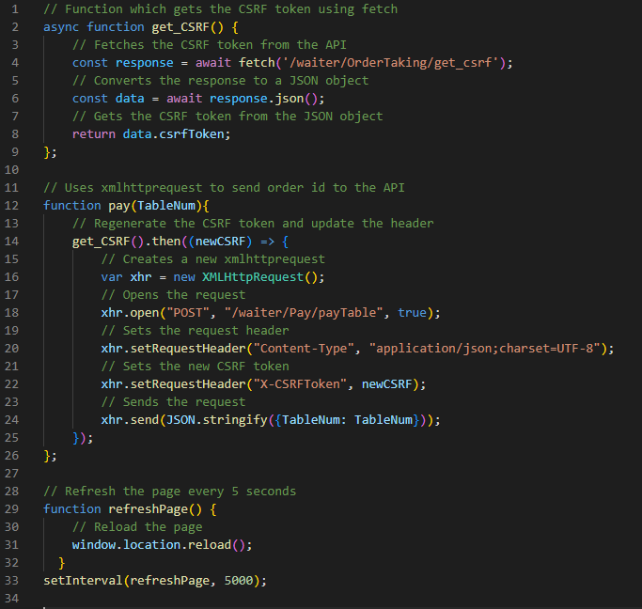After having imported the correct JavaScript file I tweaked the previous sections code for the buttons to fit in with the function name and variables so that it would work correctly. I also added like the previous section the coded to get the CSRF and to auto refresh the page.

static/waiter/js/payJS.js

Next step is to add the backend code to make the API using Django. The backend function will receive the table number and reset their total to pay and will also reset their status back to ‘Ready’.

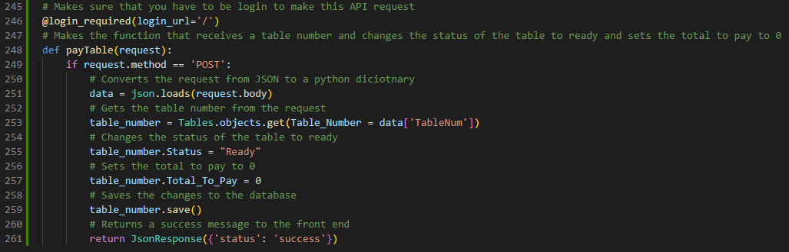

Waiter/views.py

After adding this I tried running it but it the console in JavaScript gave me an error 404 which means that the URL isn’t working correctly. I then noticed that I had not made the URL for the function yet so I made it:

Waiter/url.py

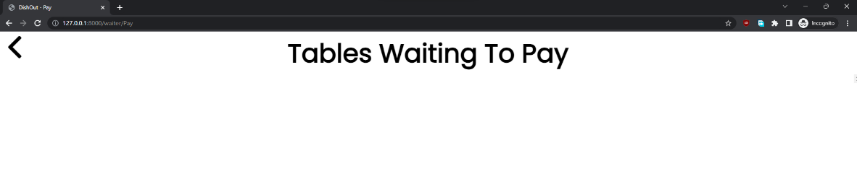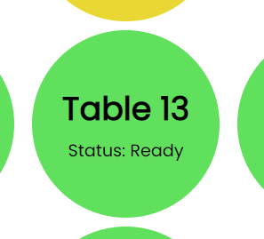After running it again it worked correctly. It removed the table from the Pay section and changed its status to Ready:

However, I found that it took a long time to be responsive to the user, so I made it so that it refreshes itself after being done.



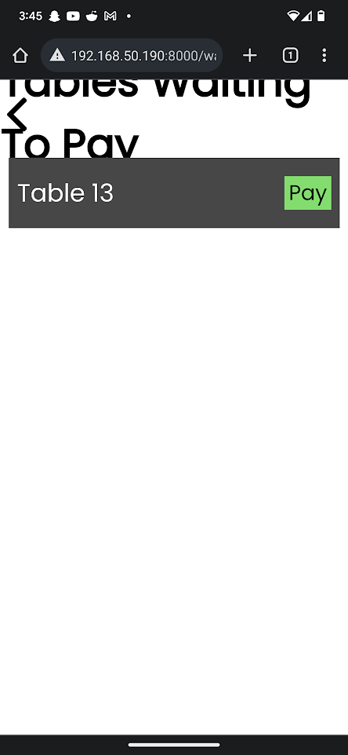Finally, I need to make sure that this page will work correctly on mobile. After trying it I found that the title is too big on mobile devices.

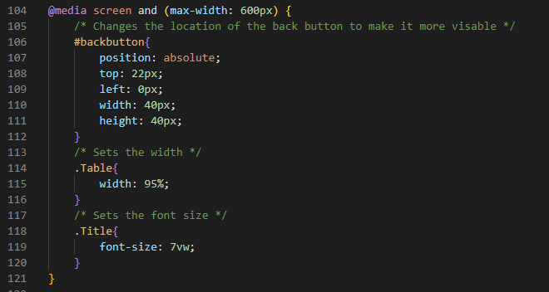To fix this I added a new relative height to the screen width section of the CSS code so that when the width of the device is less than 600px it will reduce the size of the text:

static/waiter/css/payStyling.css

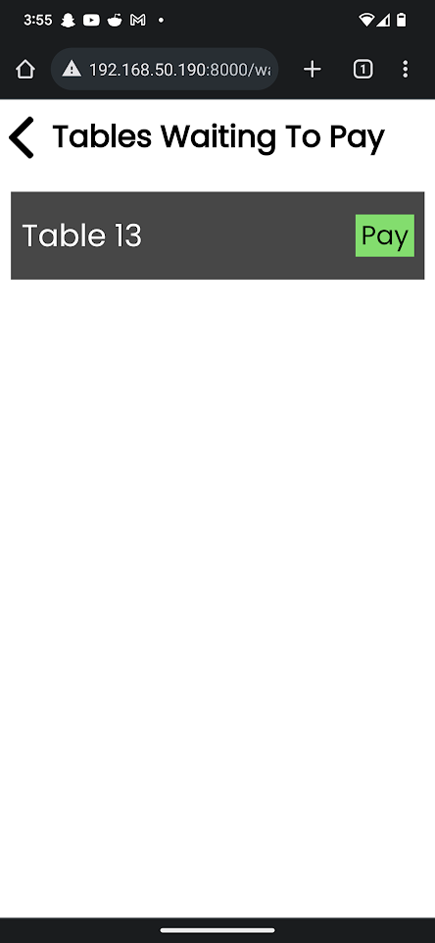

**Finished Mobile UI for the pay screen.**

## Stakeholder Feedback for Pay section (V2.8)

“I am quite happy with it but having thought about it now, I believe that there should be a fraction showing how many of the dishes that have been ordered are delivered and if not all the dishes have been delivered it should not let the waiter pay. It should also show how much the table must pay.”

– Louis Allaway

To do this I had to make an array which holds the number of orders that have been done for each table as well as the total orders that that table has. Due to the limitations of Django, I can not loop over 2 arrays at the same time using templates and I can’t access multiple arrays at the same time. To fix this I used the zip function to join all the tables that are waiting to pay to the table orders counter array.

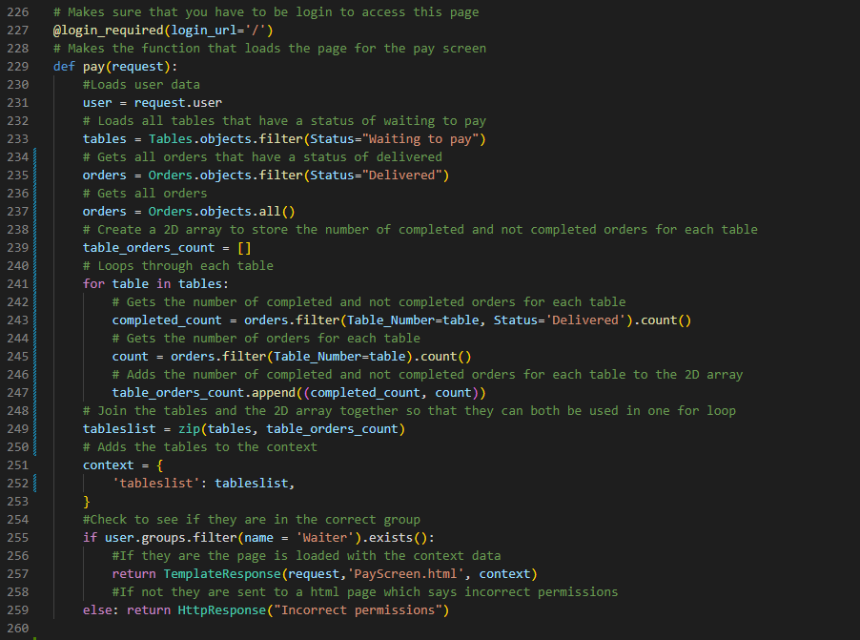

Waiter/views.py

After making those changes to the backend I was able to work on the HTML. It loops over the tablelist and uses two variables as counters for each of the two lists inside it. This allowed me to add the orders count and I added a p tag to show the total price.

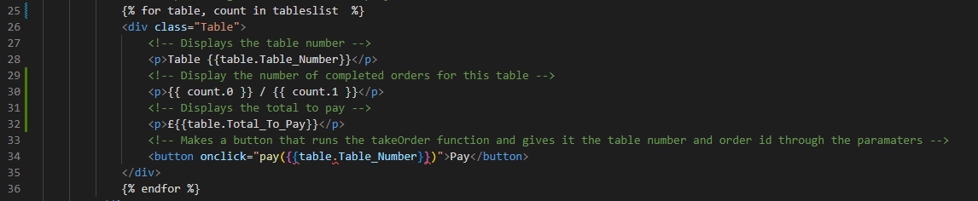

templates/PayScreen.html

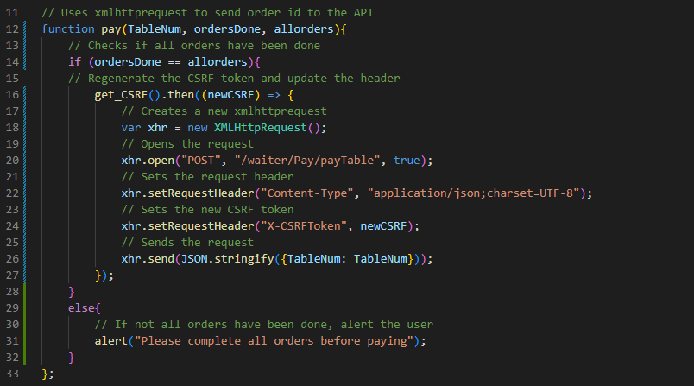Next, I need to add the functionality that the JavaScript won’t let you pay a table if all the orders aren’t done. To do this I am going to add 2 more parameters which are going to take the orders completed and all the orders for that table which will then be used to check if all the orders are done. If not, all orders are done but the user still tries to pay there will be an alert telling them that they cannot pay till all orders are done:

static/waiter/js/payJS.js

Then I added the variables to the parameters in the HTML:

templates/PayScreen.html

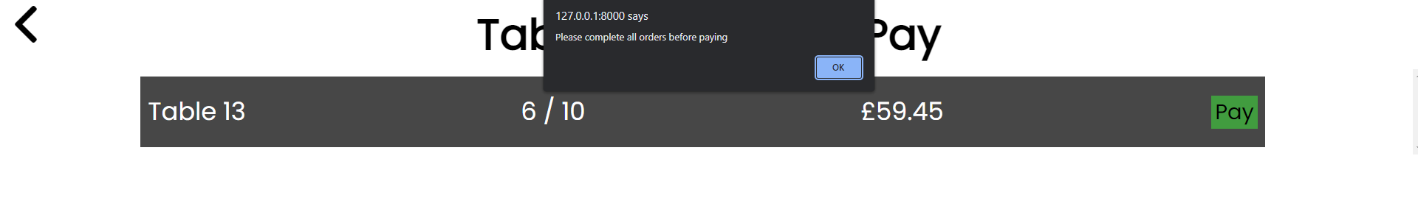

**Pay UI showing added features and what happens when not all orders are complete.**

## Testing Pay (v2.9)

|  |  |  |  |
| --- | --- | --- | --- |
| Pay | | | |
| Test | **Action** | **Result** | **Correct?** |
| Make table 15 status into ‘waiting to pay’ | To do this I made an order and advanced it through all the statuses | Displayed the table as waiting to pay and showed the dishes as well as the total: | Mini Green Tick Stamper - SuperStickers |
| Click the pay button | I clicked the pay button the checked the status of the table | After clicking the pay button the table was removed from waiting to pay and its status correctly changed to ‘Ready’ | Mini Green Tick Stamper - SuperStickers |
| Click pay button and check if table’s orders were removed from the database | To do this I first checked to see if the order that I used for table 15 got removed | The order did not get removed after paying the order so this will have to be fixed. |  |
| Click pay button and check if the table’s Total_To_Pay has been reset. | To do this I again just looked at table 15 to check if its total to pay had become 0 | After checking the Table 15 record I found that the program does correctly remove the total to pay | Mini Green Tick Stamper - SuperStickers |

To fix the bug where after paying the orders are not deleted I added the function to the payTable function which is to get all the orders that have that table number and then delete them:

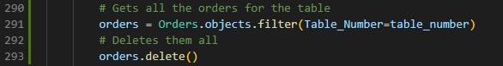

Waiter/views.py

After testing this I found that it worked as intended.

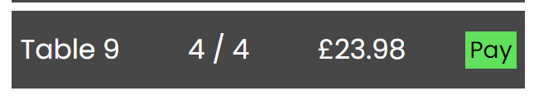

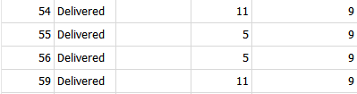

The table was sorted in order of table number and after it was deleted there were no orders in between tables 2 and 15.

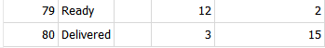

## Making the Kitchen Application (V3.0)

I first began by initiating the Kitchen application in Django since this isn’t the same as the waiter application and will not be using the same files. To do this I had to use the command ‘python manage.py startapp Kitchen’ and after running that Django created the boilerplate files for the application.

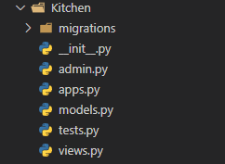

Next step is to connect the Kitchen application to the main program by setting the URL for it in the main URL file. We will only be using the main URL because the kitchen application is only one page, so it does not need sub directories.

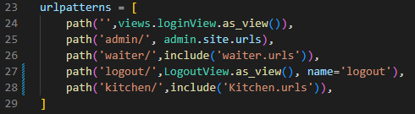

DishOut/urls.py

I did also need to include in the kitchen URL file an empty URL so that it will connect the kitchen function that returns the page to the URL.

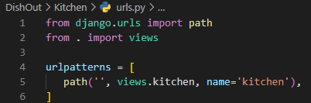

Kitchen/urls.py

Now I must set up the views.py file so that I can make the kitchen function. To do this I will be using the same imports as the waiter section so that I can use the database and make sure that the user that is logged in has the permissions to access the page.

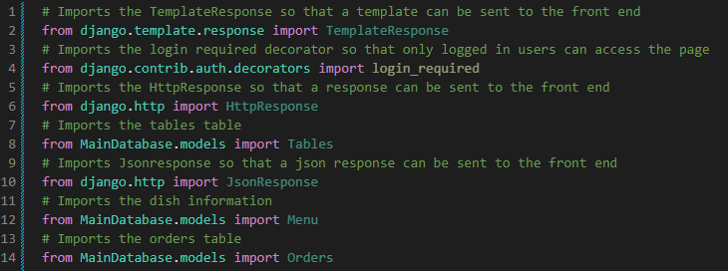

Kitchen/views.py

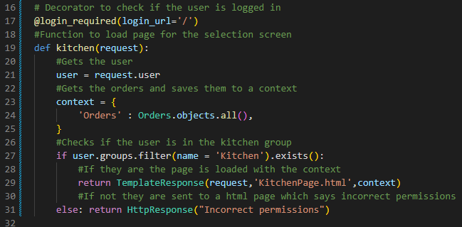After having imported the needed libraries and databases I made the function to return the html site. It also has a context that includes data on the orders which will be used to get the status, note, name of the dish and the table number for which it is for.

Kitchen/views.py

I next need to connect the login page to redirect the user to the new Kitchen URL so that users with the kitchen permission can access the page.

login/views.py

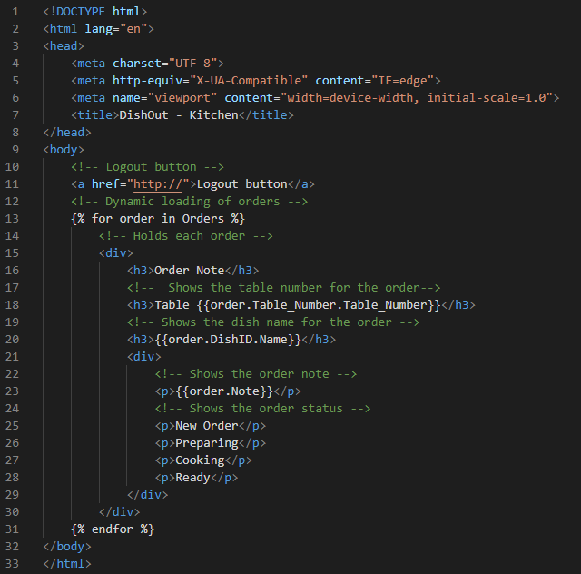Now that it is accessible, I decided to make the HTML code of the page. This code iterates over all the orders that are given from the back end and extracts the information needed from them to show the order to the kitchen staff. Later, I will use CSS to visually show to the kitchen staff what status each dish has.

templates/KitchenPage.html

After having coded this, I decided to check that all the data is loaded correctly. After testing it I found that all the orders were displaying instead of only the orders that the kitchen staff need to see:

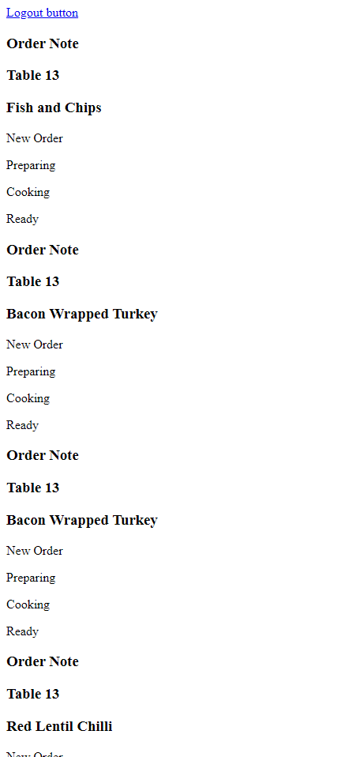

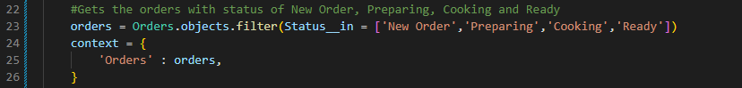To fix this I must change which data is being sent to the front end, so I must filter the backend to only show orders which the kitchen staff need:

Kitchen/views.py

After adding the filter, the orders which are meant to be displayed are displayed.

Firstly, I must add the static files to the HTML so that I can use a stylesheet and later use JavaScript.

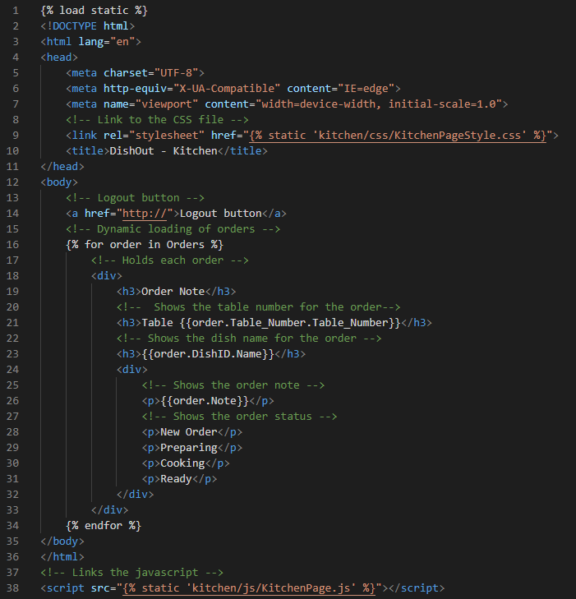

templates/KitchenPage.html

The next step is to add styling so that the orders can be visualised better. To do this I will need to add classes and tags to the HTML to correctly style each part of the HTML.:

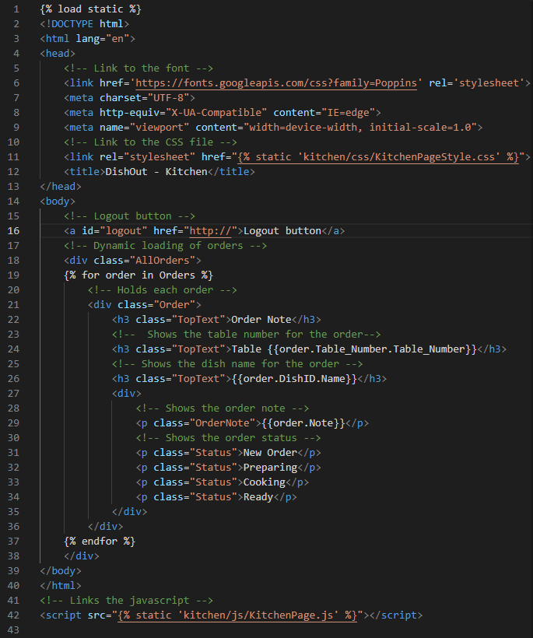

templates/KitchenPage.html

Next, I will be making the logout button functional and add the correct styling to it. To do this I am going to add the logout image inside the a tag and connect the link to the logout link:

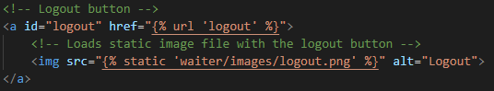

templates/KitchenPage.html

I then added the styling which sticks the logout button to the top right of the screen and makes it so that it does not affect the other elements positioning.

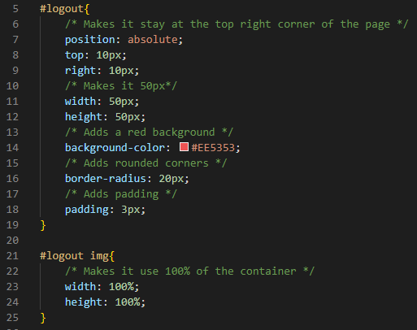

static/kitchen/css/KitchenPageStyle.css

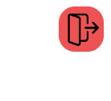After adding this styling to the button this is what it looks like on the page.

Next, I have to style the orders themselves. To do this I have noticed that I will need to add a class to the div holding the status and the note of the order as well as I must add a div to all the different statuses otherwise I won’t be able to centre them correctly.

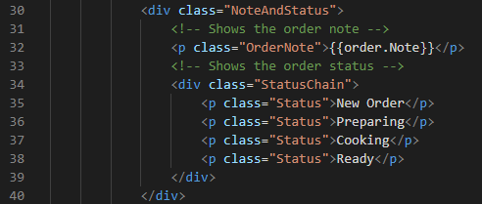

templates/KitchenPage.html

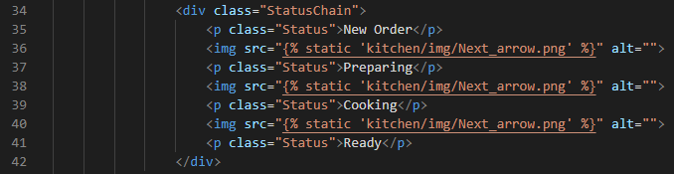After having added the classes and div I needed I also added the arrows that separate the different statuses in-between each of the p tags

templates/KitchenPage.html

Then I just styled all the elements to look like the mock-up. I used grid to layout where the text on the outside would be and to make the dimensions of each of the orders correct. All the statuses are going to have the default colour for being done, next I will add the JavaScript which checks which status each order is on and thus changes their colour accordingly by adding another class to them which represents if the status is the current one or is yet to be done.

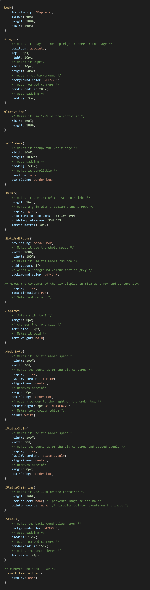

static/kitchen/css/KitchenPageStyle.css

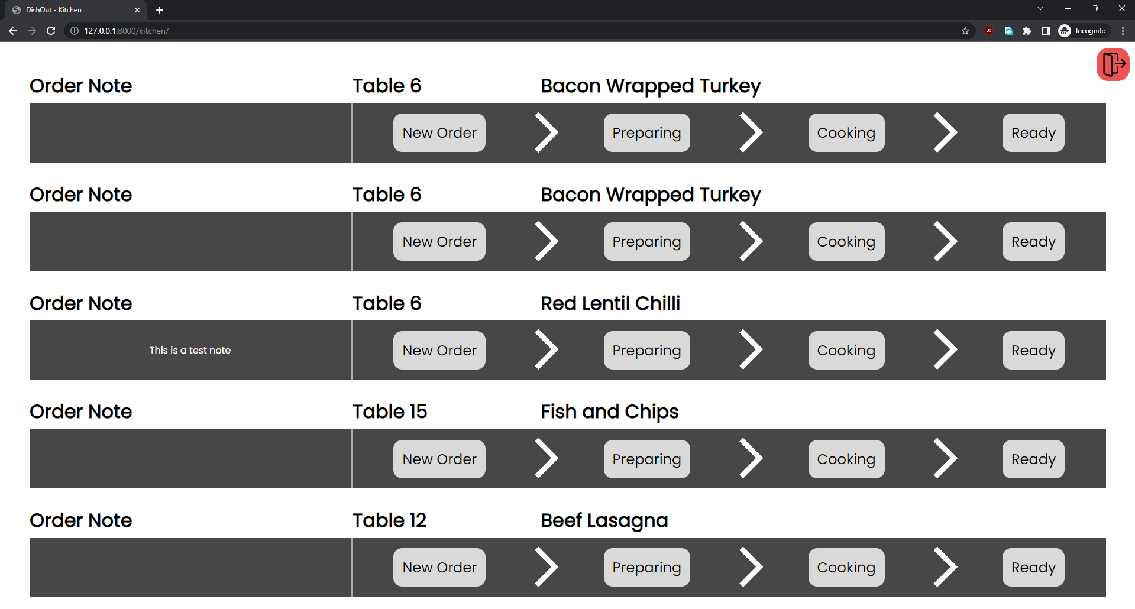That CSS makes the page look like this:

**UI for the Kitchen page without the status state styling**

Next, I must add the JavaScript function which colours the status chain correctly. To do this I first need to add a data tag to the StatusChain div so that it can store the current status of each of the orders.

templates/KitchenPage.html

Now I can make my JavaScript function which will get all the div’s with a class of StatusChain and the check what their status is from checking the data-status. It will then iterate through the statuses setting the CurrentStatus class to the status which matches the one in the data-status and it will give the IncompleteStatus class to the status which are not current.

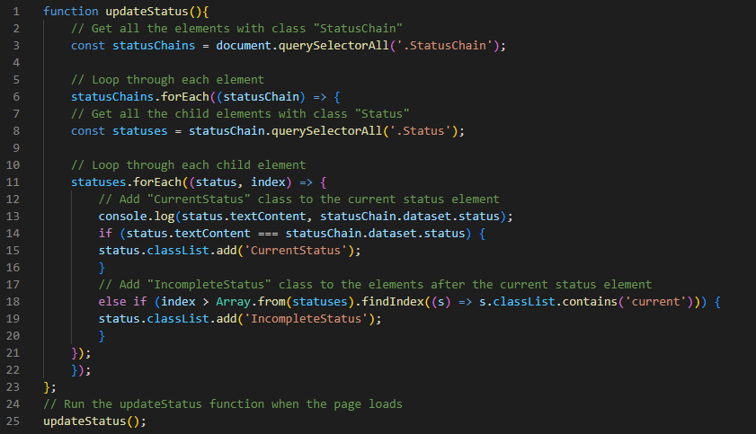

static/kitchen/js/KitchenPage.js

Next, I styled those classes with their correct background colours so that when I refresh the page, they will have the correct colour. These are same colours used in the mock-up:

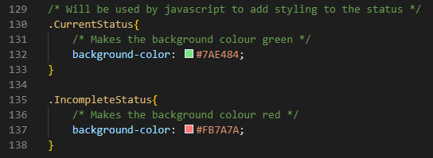

static/kitchen/css/KitchenPageStyle.css

Refreshing the page now shows the correct colours of their status as intended:

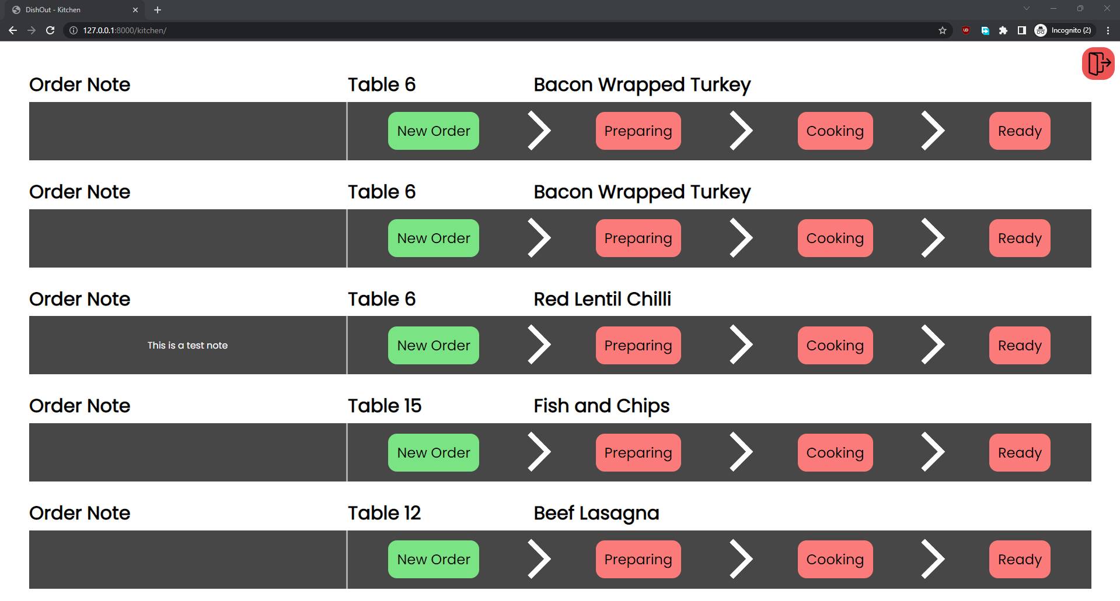**Finished status colours for the Kitchen UI**

## Implementing the status buttons for the Kitchen UI (V3.1)

In this section I will be making the status elements work as buttons so that the kitchen staff can progress the order forward. To do this it is going to be one function which will check the status of the order which has been clicked on and progress it one along the chain till it gets to ready where it will be removed from the kitchen page and be sent to the ready orders.

First step for me is to turn the StatusChain div into a button and add the onclick event of running a function which will be called progressOrder.

templates/KitchenPage.html

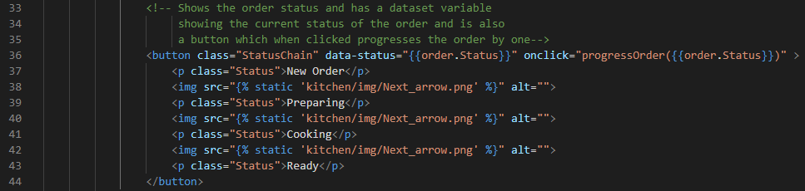

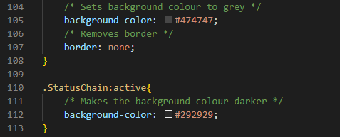Then I had to change the styling so that it would not use the default colours for a html button. I changed the background colour and removed the border. As well as adding a button animation where the buttons become darker when clicked on to give the user some feedback.

static/kitchen/css/KitchenPageStyle.css

Now to make the function to change the status it will have to access the Django API so I will first add the get_CSRF function which I have been using to the JavaScript for the kitchen application:

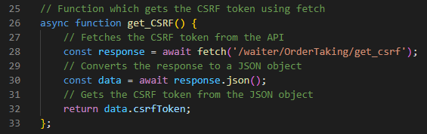

static/kitchen/js/KitchenPage.js

Then I created the function which will send the data to the backend. It works by receiving the status of the order and then finding it in an array that has all the different status in order so that the function only must increment the index by one. After it does that it updates the database with the new status and refreshes the page which will subsequently update the HTML:

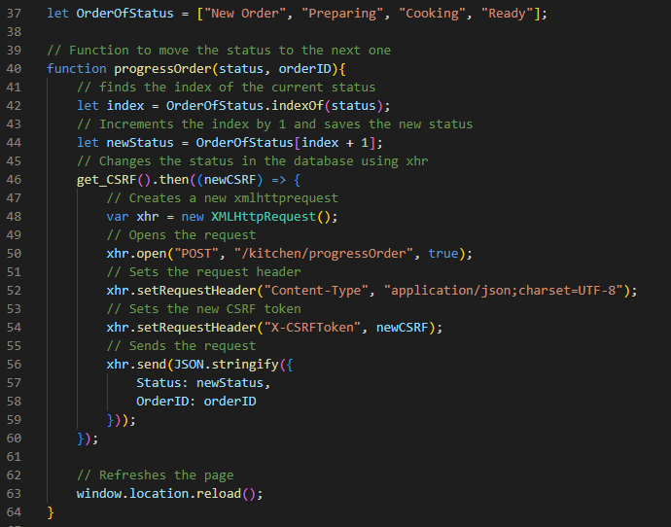

static/kitchen/js/KitchenPage.js

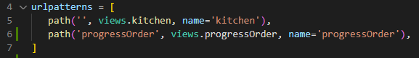Next, I need to make the API endpoint that will receive the data in Django. To do this I have to make a new function in the views.py that receives the data through a new URL and changes the database. Firstly, I made the URL:

Then I made the function which gets the OrderID and the Status from the JSON response and finds the order in the database to change its status to the new status that was sent to the backend from the frontend.

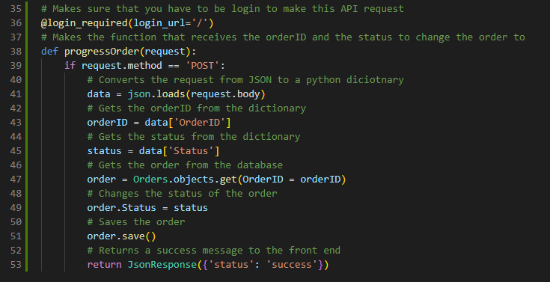

Kitchen/views.py

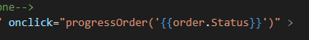I decided to now test the button and backend by trying to progress an order, but I ran into an error stating that there was a missing syntax from the HTML when calling the function. After looking at the code I realised that Django returns the status to the HTML without quotations which means that it doesn’t work. I added quotation marks.

static/kitchen/js/KitchenPage.js

After fixing this I was getting another error from the back end saying that it couldn’t get the OrderID out of the request. I found that it is because I did not pass in the OrderID in the function call in the HTML. To fix this I added a Django tag which added the OrderID to the parameters of the function call.



static/kitchen/js/KitchenPage.js

Now when I clicked the button there was no errors, but I found that it refreshed the page too quickly and it led to the orders status not looking like it changed so I added some delay to the refreshing of the page after the function is done.



static/kitchen/js/KitchenPage.js

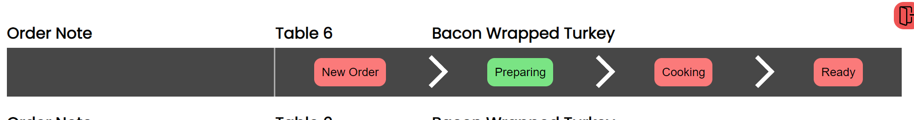This worked to fix the page reloading too quickly, but I found another problem. There is a problem with the updateStatus function due to it making everything that is not the current order red although it is meant to make the statuses that have already been done stay grey. To fix this I added a variable that is false till the current status has been passed. I then use an else if statement to check if the variable is still false than go to the next iteration of the loop.

**Image of UI illustrating the problem**

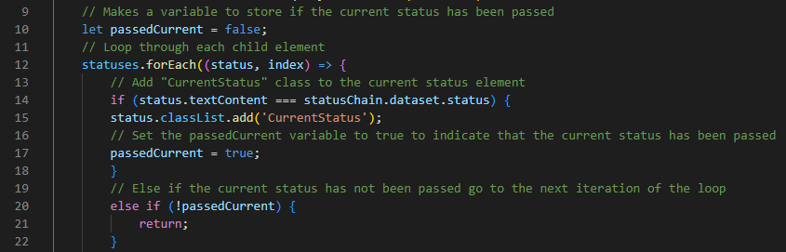

static/kitchen/js/KitchenPage.js

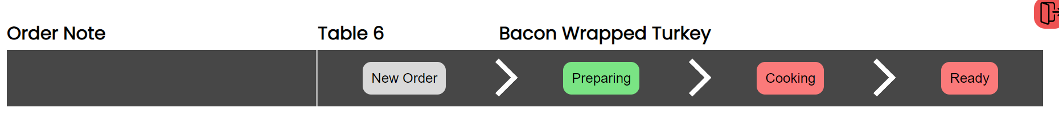After adding these fixes:

## Stakeholder Feedback for the Kitchen application (V3.2)

“The kitchen UI is exactly what you designed originally, I am very happy with it, but I would like to see that when an order is finished and is ready, it should get removed from the kitchen app so that they don’t take up unnecessary space.” – Louis Allaway

To do this I need to change what order statuses I am supplying to the html. This meant changing the filter on the views file.



Kitchen/views.py

## Testing Kitchen Application (V3.3)

|  |  |  |  |
| --- | --- | --- | --- |
| Pay | | | |
| Test | **Action** | **Result** | **Correct?** |
| Make a new order. | I made a new order and checked the Kitchen UI | It correctly added the order and shows the table and dish name correctly | Mini Green Tick Stamper - SuperStickers |
| Make order with a note | I made a new order and added a note | It after checking it added the note correctly | Mini Green Tick Stamper - SuperStickers |
| Make an order with a note of 500 characters long (280 now) | I made a new order which had a 280-character note | It did not work correctly as the text does not correctly fit |  |
| Progress the orders status | I clicked the status of the first order and checked if it changed | It correctly changed both the UI and the database for that order. | Mini Green Tick Stamper - SuperStickers |

To fix the note length problem I changed the font size in the CSS for the kitchen app to 12px so that it will fit.

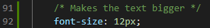

static/kitchen/css/KitchenPageStyle.css

# D. Evaluation

## Final Post Development Testing

In this section I will make a recorded video of me testing the features of the program to make sure they all work as intended when all connected. I will be doing similar tests that I did in the development process but instead of having to change the status of some elements using the backend to test certain features I will only be using the frontend.

**Video location: Videos/PostDevTesting.mp4**

|  |  |  |  |
| --- | --- | --- | --- |
| Test | Timestamp | Expected outcome | Worked correctly? |
| Login with correct credentials | **00:00** | User is logged in correctly and to the correct part of the program | Mini Green Tick Stamper - SuperStickers |
| Try to go to another section in the program which is unauthorized for that user | **00:08** | Program should respond saying that the user does not have permission to do that | Mini Green Tick Stamper - SuperStickers |
| Try the logout button | **00:16** | Should log out the user and send them back to the login page | Mini Green Tick Stamper - SuperStickers |
| Try to login with incorrect credentials | **00:18** | Should output that the user could not be found | Mini Green Tick Stamper - SuperStickers |
| Use the search bar to search for Beef | **00:37** | Should only show beef lasagna | Mini Green Tick Stamper - SuperStickers |
| Use search bar to only search ‘slaw’ | **00:44** | Should only display coleslaw | Mini Green Tick Stamper - SuperStickers |
| Click category buttons | **00:51** | Should change what is displayed so that it fits the category. | Mini Green Tick Stamper - SuperStickers |
| Click on any dish on the order section | **01:08** | This should add the dish to the current order and display it as only one. Should also update the total | Mini Green Tick Stamper - SuperStickers |
| Click the plus button on the dish | **01:13** | This should make the dish have a x2 display and double the price | Mini Green Tick Stamper - SuperStickers |
| Click the minus button | **01:15** | This should reduce the amount by one | Mini Green Tick Stamper - SuperStickers |
| Click the minus button again | **01:17** | This would remove the dish completely from the order | Mini Green Tick Stamper - SuperStickers |
| Add 2 other dishes and try to submit the order | **01:22** | This should stop the user as they have not yet added a table number | Mini Green Tick Stamper - SuperStickers |
| Add another of one of the dishes then add a note to it | **01:41** | This will result in the kitchen app showing the note on one of the dishes | Mini Green Tick Stamper - SuperStickers |
| Submit the order | **02:00** | Should check if the user is sure they want to submit it then submit successfully | Mini Green Tick Stamper - SuperStickers |
| Check table status | **02:12** | Should show that the table which just ordered is waiting for order | Mini Green Tick Stamper - SuperStickers |
| Make a table waiting to order | **02:15** | Should show the table in yellow and with a timer as well as now saying waiting to order | Mini Green Tick Stamper - SuperStickers |
| Advance the orders through the stages in the kitchen application | **02:27** | Orders should go through each step and every time change their status indicated with a green rectangle | Mini Green Tick Stamper - SuperStickers |
| Check that order appears on ready dishes | **03:02** | Orders should be on ready dishes waiting to be taken for delivery | Mini Green Tick Stamper - SuperStickers |
| Take a dish for delivery | **03:06** | Should move the dish from the ready orders to the user’s taken orders | Mini Green Tick Stamper - SuperStickers |
| Check with a different user on ready orders | **03:09** | Should only be able to see 2 orders because one is taken | Mini Green Tick Stamper - SuperStickers |
| Deliver the order | **03:27** | Should remove the order from the ready dishes | Mini Green Tick Stamper - SuperStickers |
| Check Pay and click on pay | **03:34** | Should show the table with 1/3 orders delivered and the pay button should not work | Mini Green Tick Stamper - SuperStickers |
| Check table status | **03:43** | Should show that the table is now waiting to pay | Mini Green Tick Stamper - SuperStickers |
| Take and deliver the rest of the orders then pay | **03:45** | Should allow the user to pay and have correct total | Mini Green Tick Stamper - SuperStickers |
| Check table status | **03:56** | Table status should now be back to ready | Mini Green Tick Stamper - SuperStickers |

## User Usablity Testing

This test is done by my stakeholder Louis Allaway, and it is to show that the program meets the success criteria that was set out originally in the analysis section of the project. It will include a video where it is visible how he uses the program and how it meets the requirements.

**Video location: Videos/Stakeholder_testing.mp4**

Stakeholder feedback:

“I am very happy with the finished product. It is highly responsive, and all the buttons react instantly to my presses. It was very easy to use and intuitive as this was my first time actually using it, I was still able to make an order in 23 seconds which is much lower than the target that we had put in place for the success criteria. However, there is still some visual flaws especially with the mobile interface and the kitchen app did not change to my order within 5 seconds as I had to click the reload button for it to show up. Other than that, I believe the program meets the main features that are needed for it, and I could see myself using it in my job as a replacement to the old EPOS systems we use.” – Louis Allaway

## Evaluation of Solution

After having finished the project, I am happy that I have managed to include the main features like the ordering of dishes, table status management, kitchen application etc. However, I was unable to make the management section of the program due to time constraints which meant that I was not able to implement all the features that I set out to add.

Using my testing videos as evidence I was able to meet most of the success criteria that I set out. The program is very responsive as Louis (the stakeholder) has commented and it updates throughout the program instantly due to the fast database transactions of Django. The one success criteria I did not meet would easily be implemented as the Kitchen page just needs an auto refresh feature which I must have forgotten to add during development.

In terms of future maintenance, I made sure to add comments to all my code so that it will be easier for people in the future to understand the code. Furthermore, all the code is in functions and in classes which means that they are all modular, this would make it a lot easier to. However, my code especially the CSS portion is quite bloated and not optimised which means that it can be hard to use and look at. This could add problems in future developments as well as the JavaScript which I used which is not using any libraries. This tends to make it harder to scale up, this is why most business use packages like React instead of just pure JavaScript which would have to be replaced. Another important change that would need to be made in the future is improving the UI as there is still some visual glitches in the UI as pointed out by Louis which haven’t been able to be fixed during development due to time constraints.

One possible problem with the program is security. Due to time, I was not able to implement HTTPS which makes all transactions between the network unencrypted. This makes it less safe and easier for hackers to infiltrate the data which could mean they could order dishes without paying. However, due to having to change from my own design and database of employees to Django’s built-in user management system it meant that users logins also use salt which makes it more secure.

Some possible things to implement in the future is making the program into a webapp. This would make it into an app which meant that users wouldn’t have to always be in a browser and instead be inside an app. This could also add security if the devices running the app are owned by the restaurant as the device could be locked to only be able to use that app which means that staff are unable to access other pages. Another feature which I talked about in the Analysis is to allow users to order for themselves. This could be quite easy to implement as the UI could be almost the same as it is now for the order taking system but include a QR scanning feature to access the correct table.

# Project Appendixes

## Code listing

### Python Screenshots

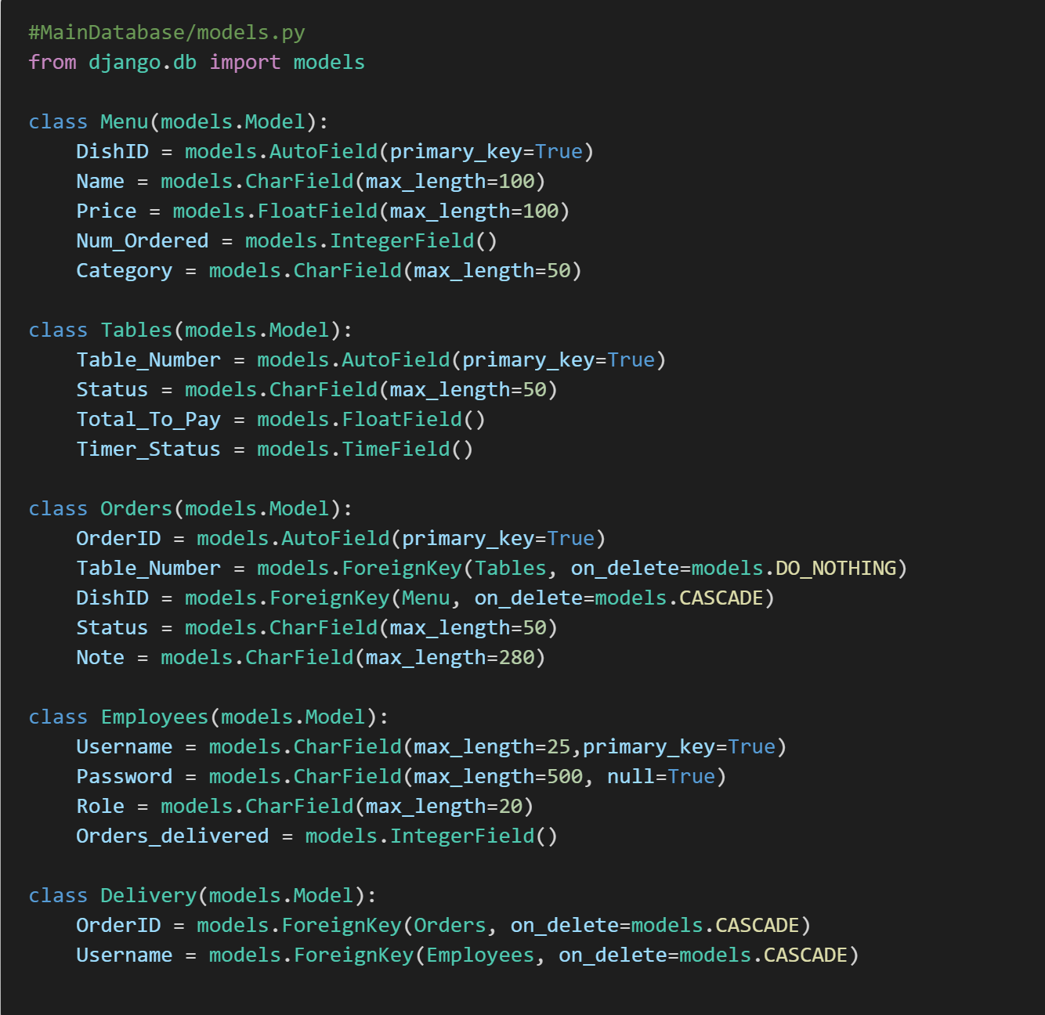

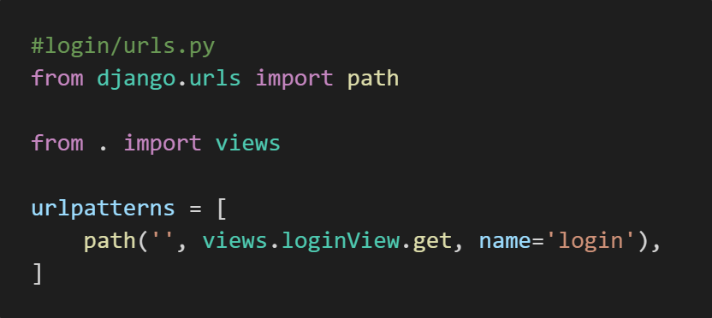

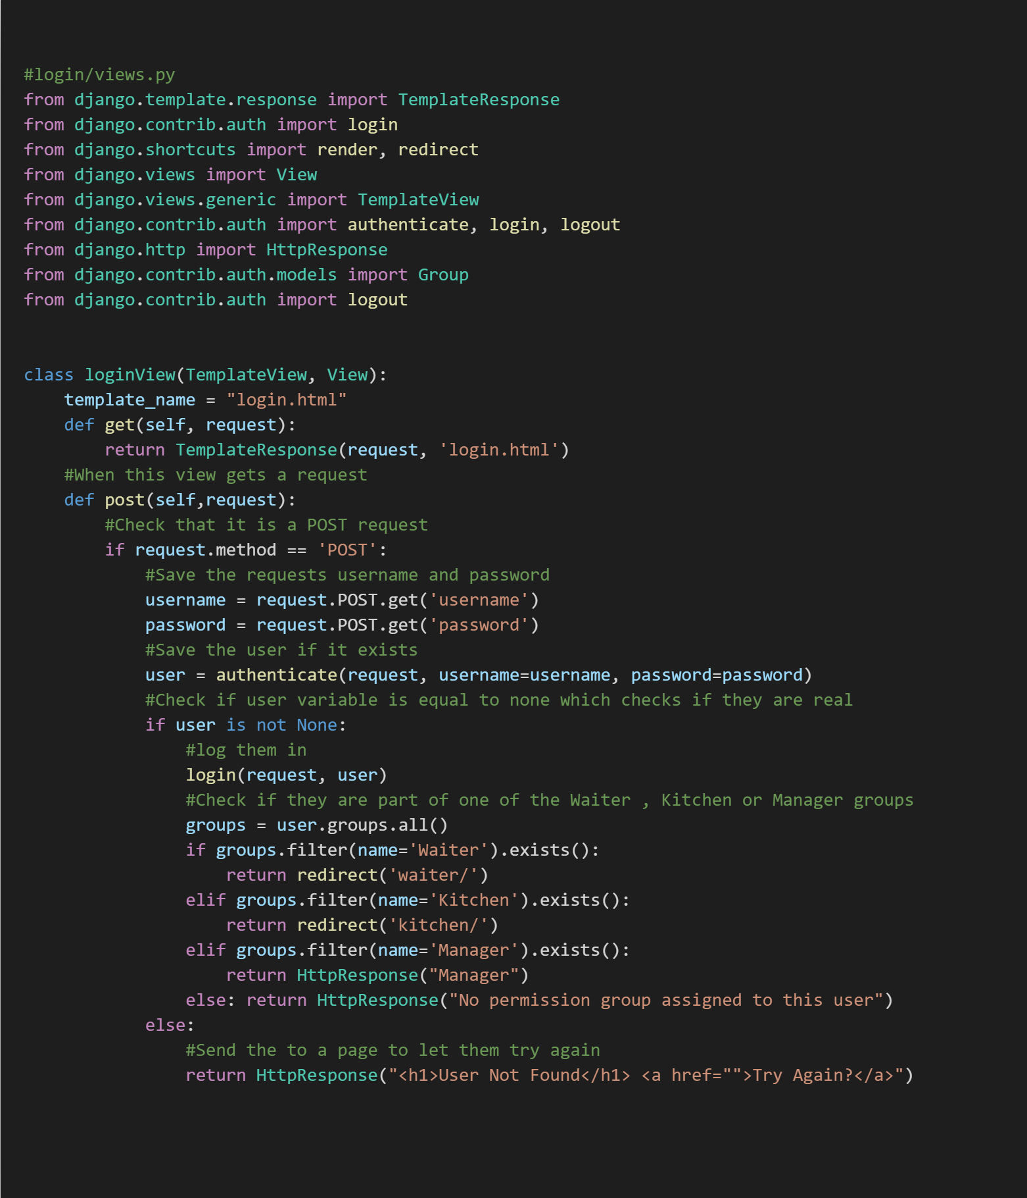

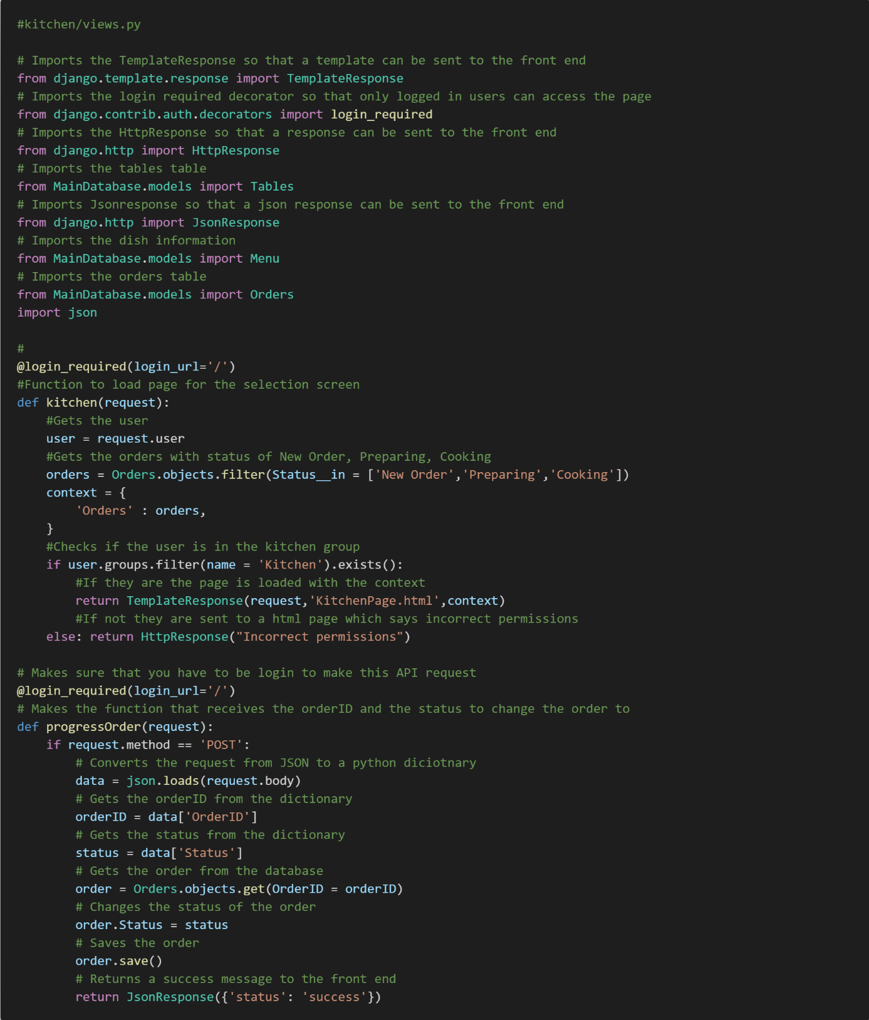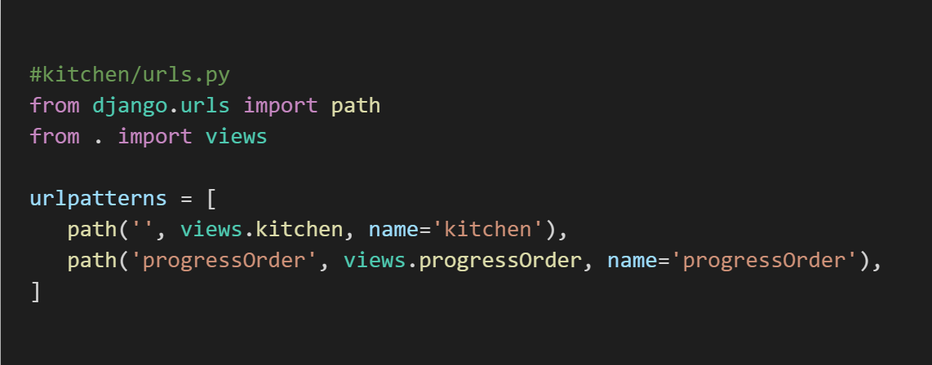

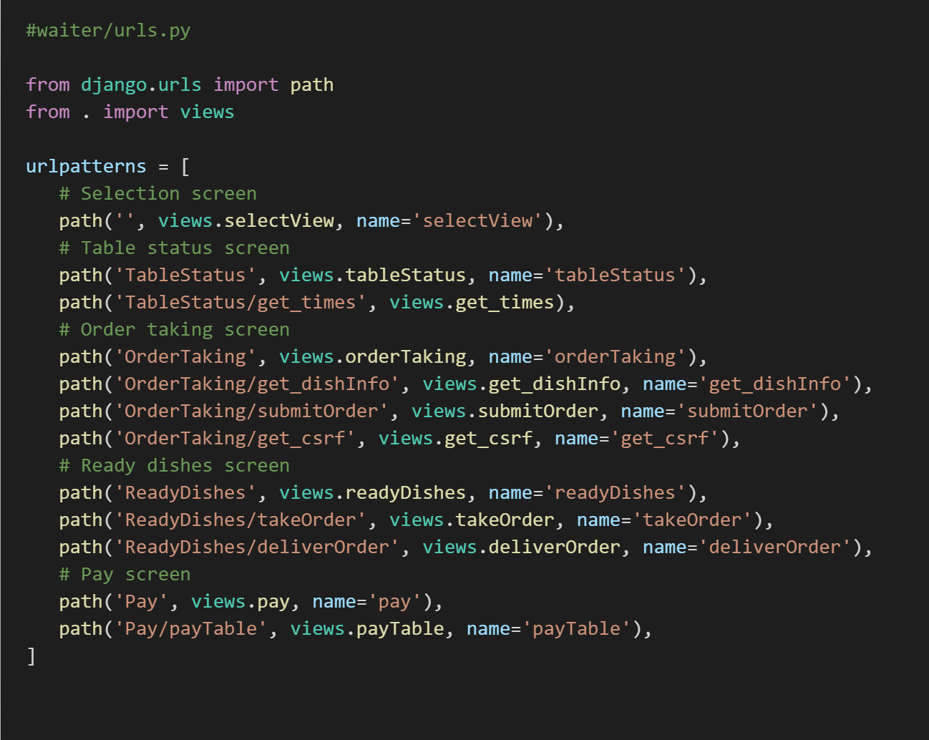

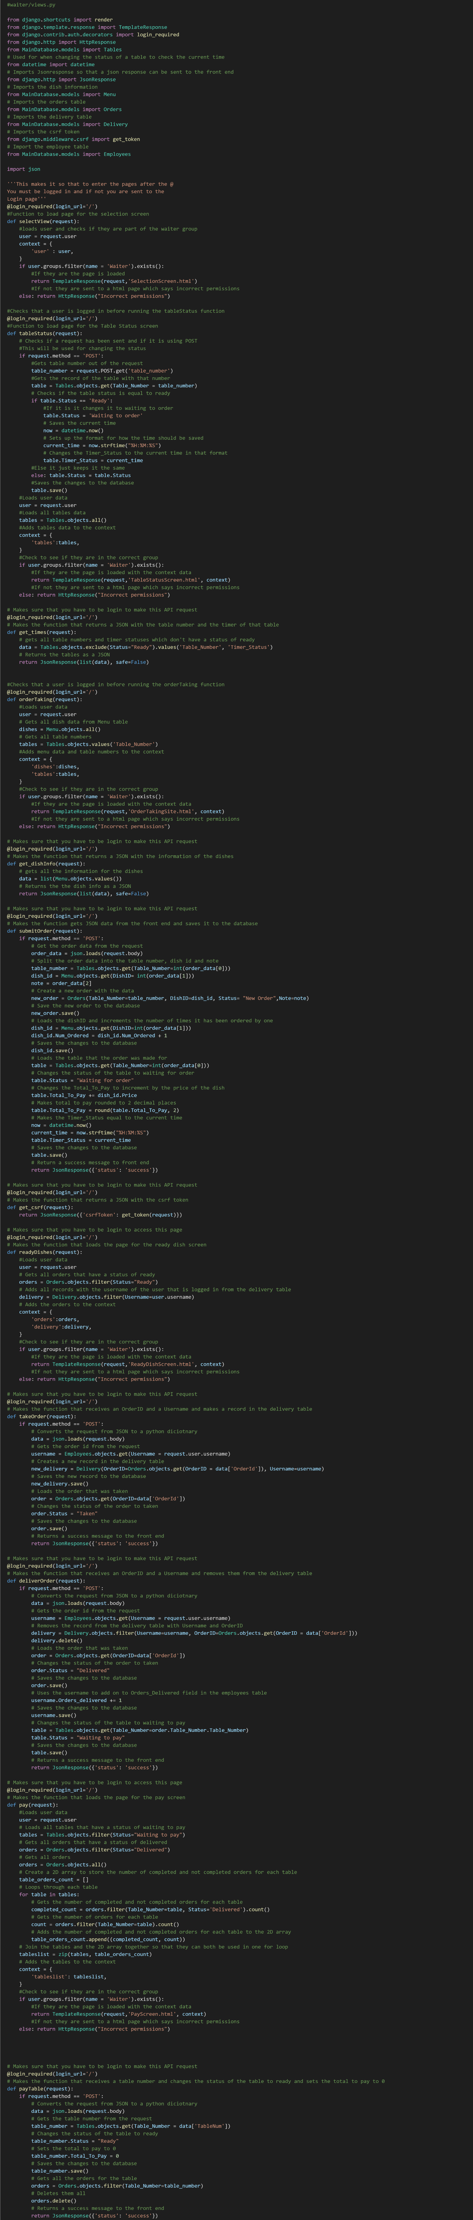

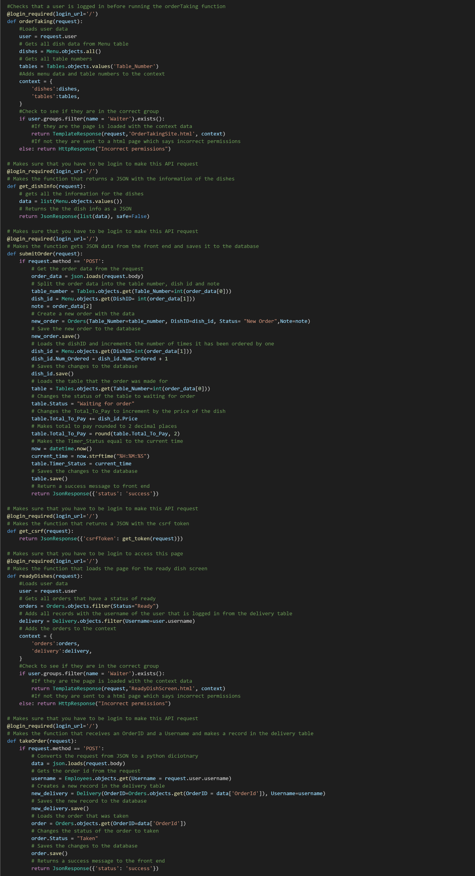

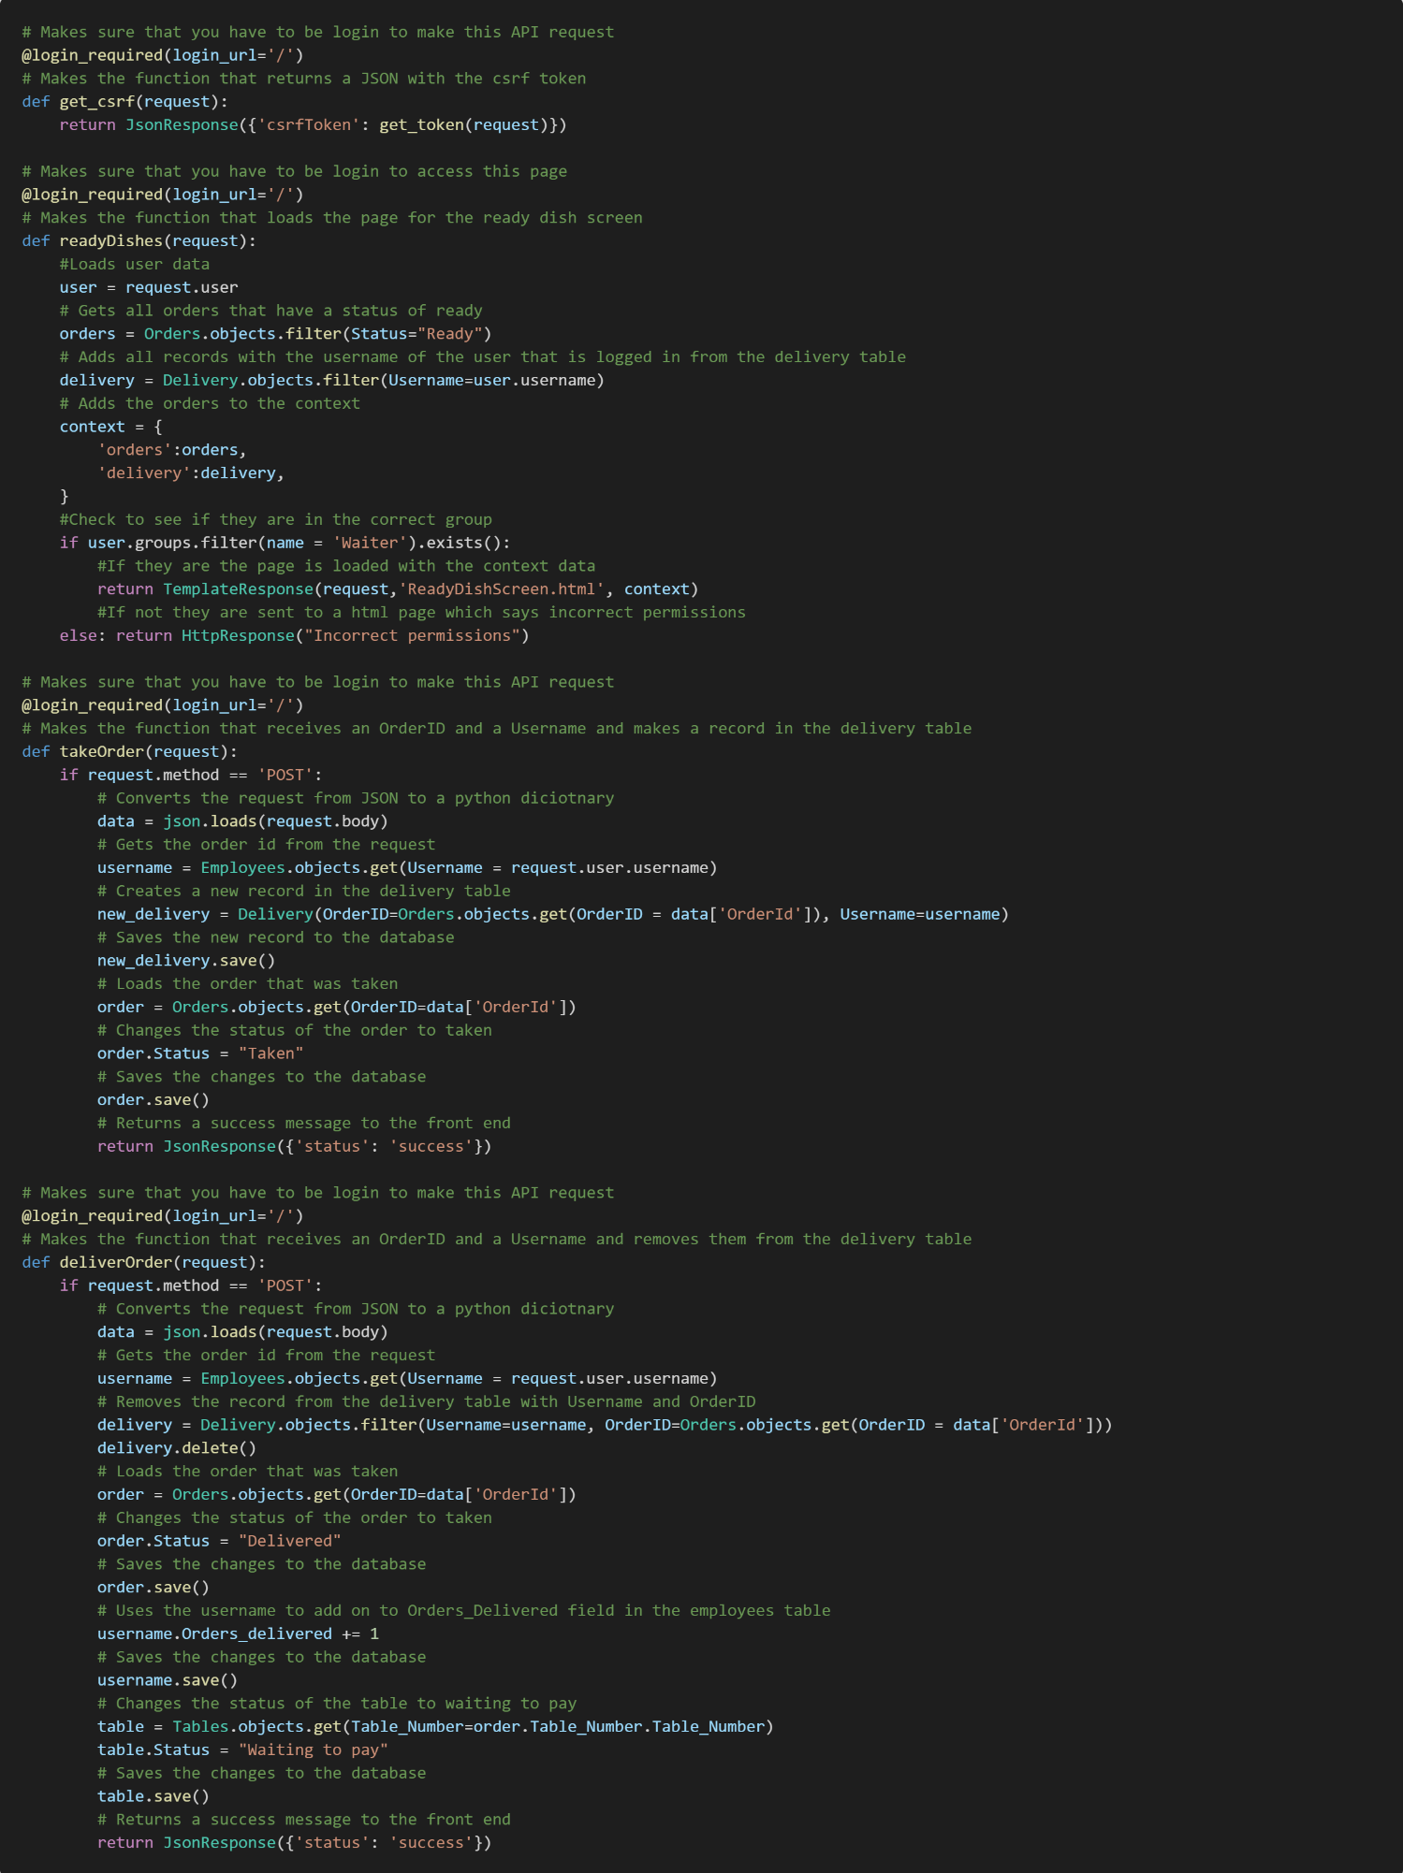

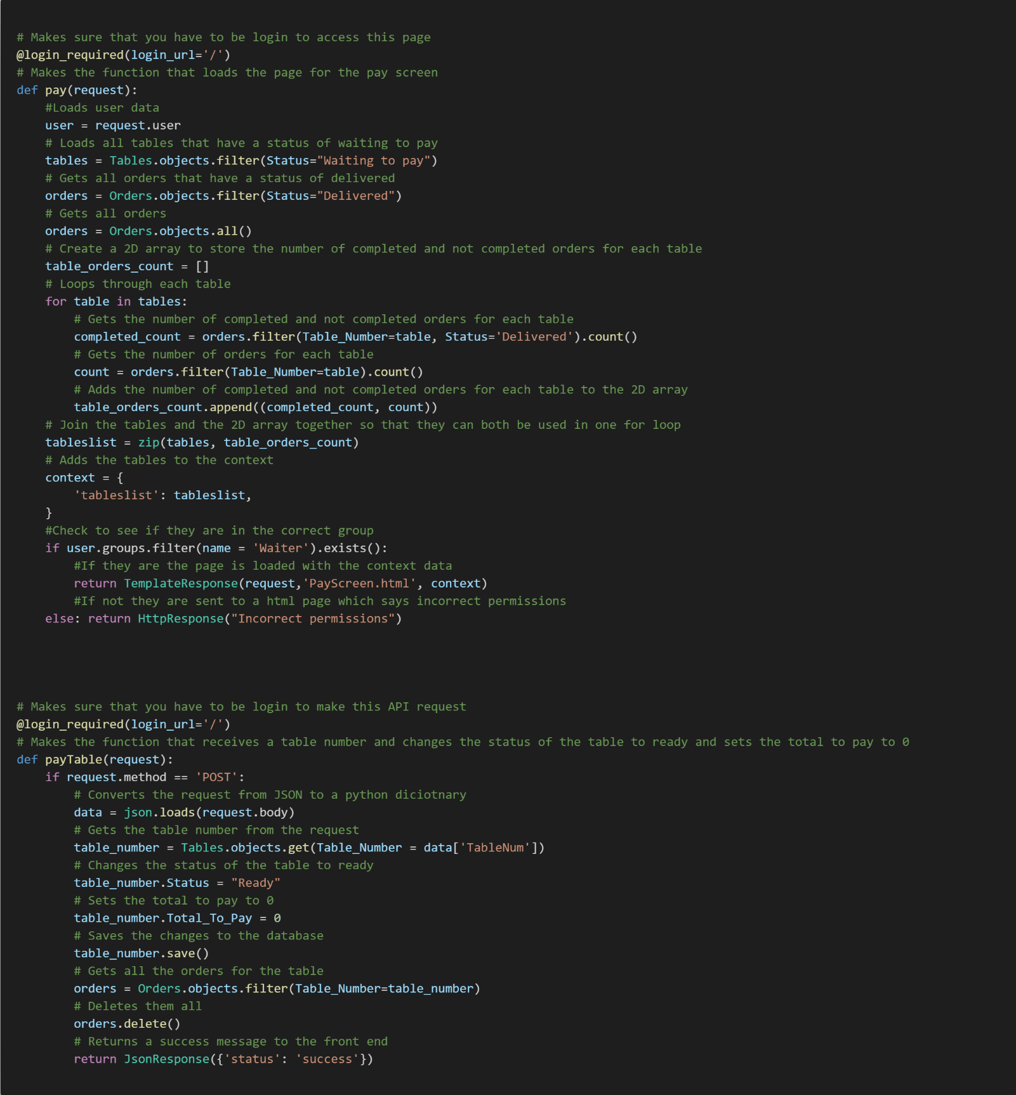

### HTML screenshots

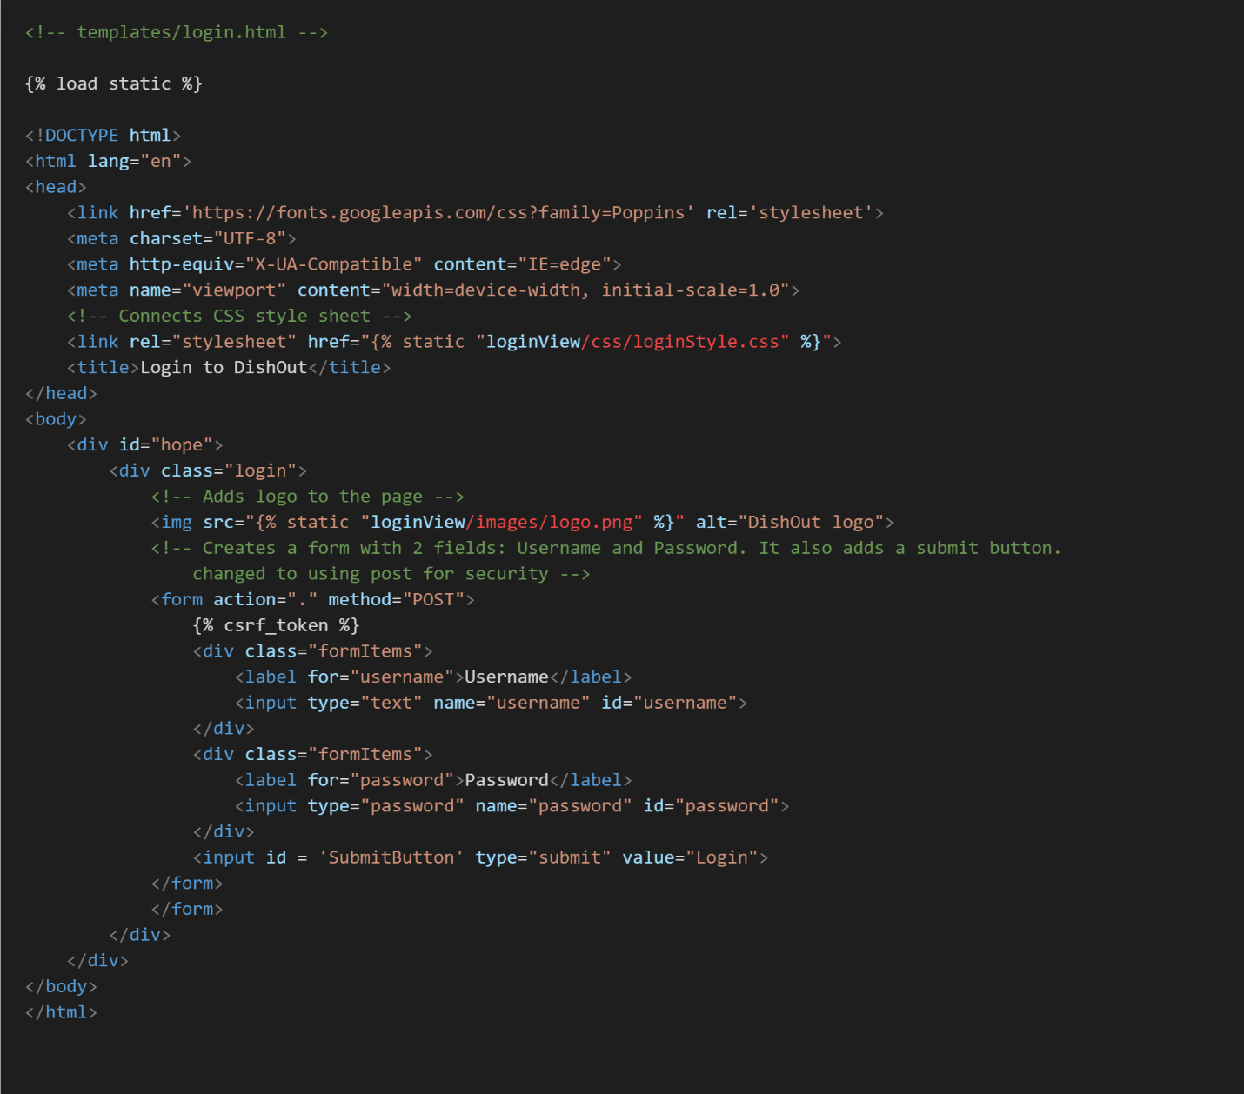

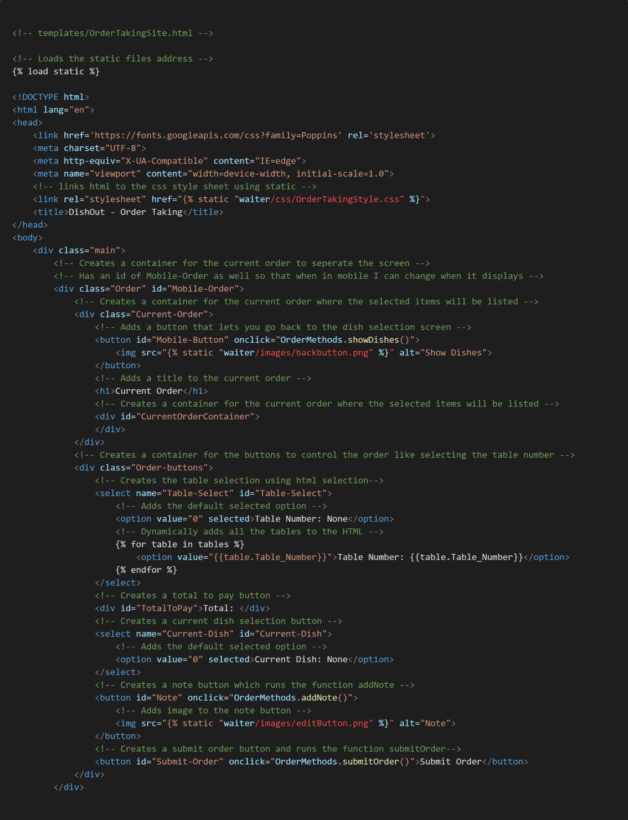

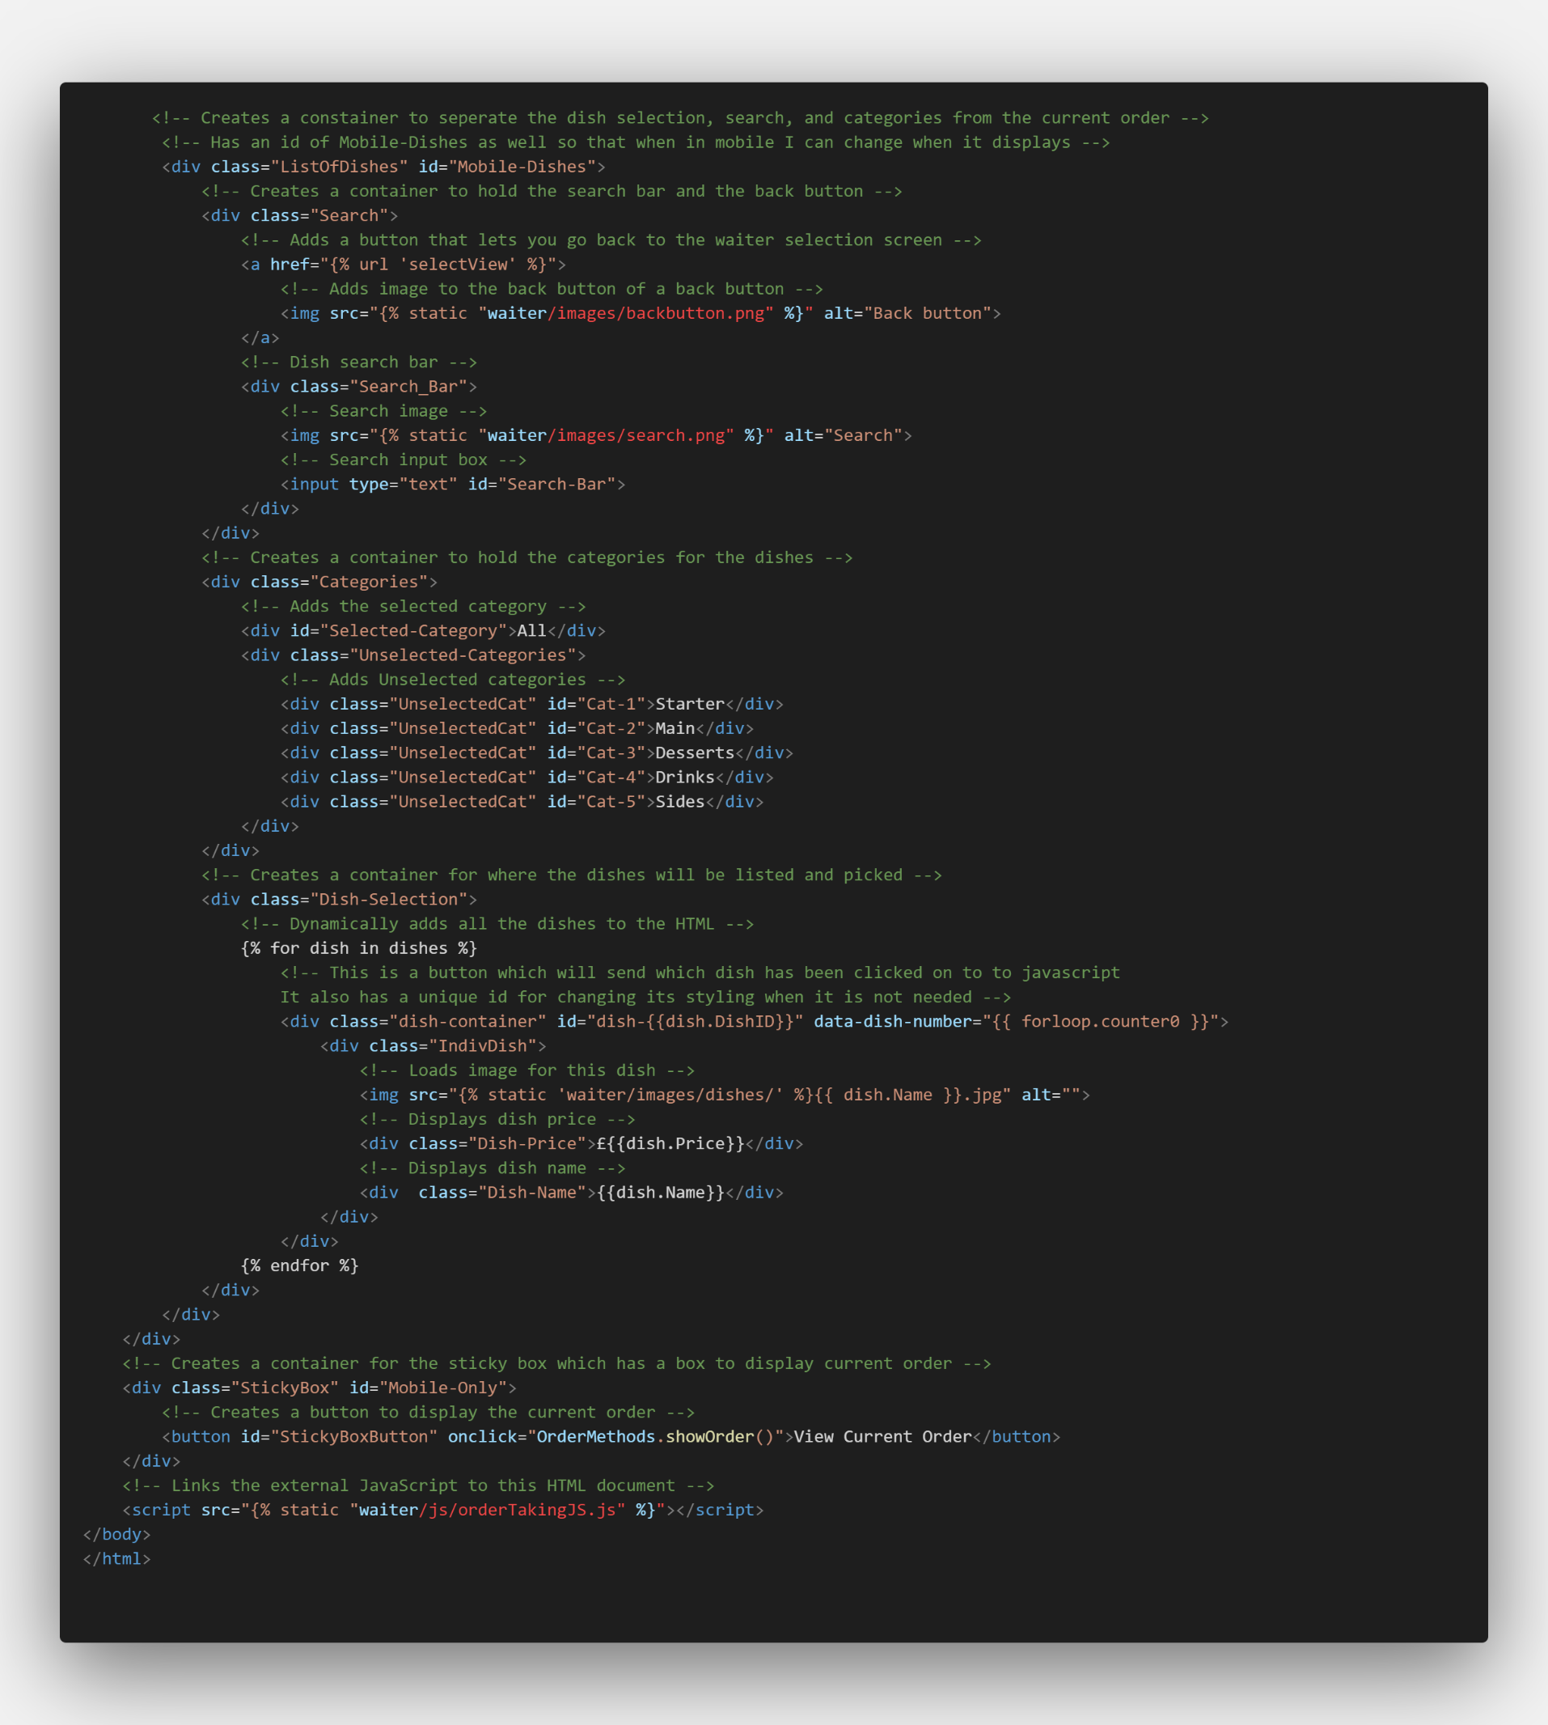

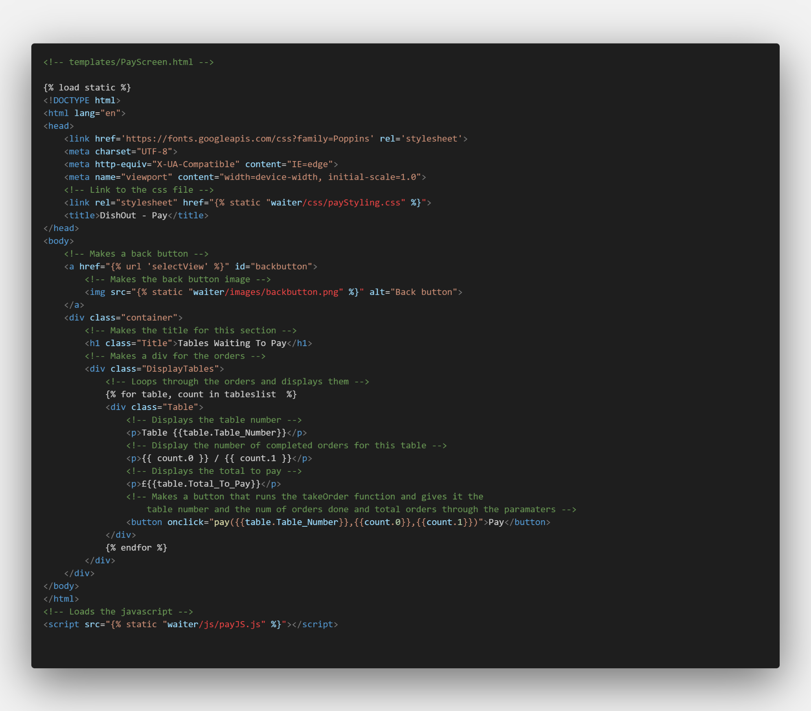

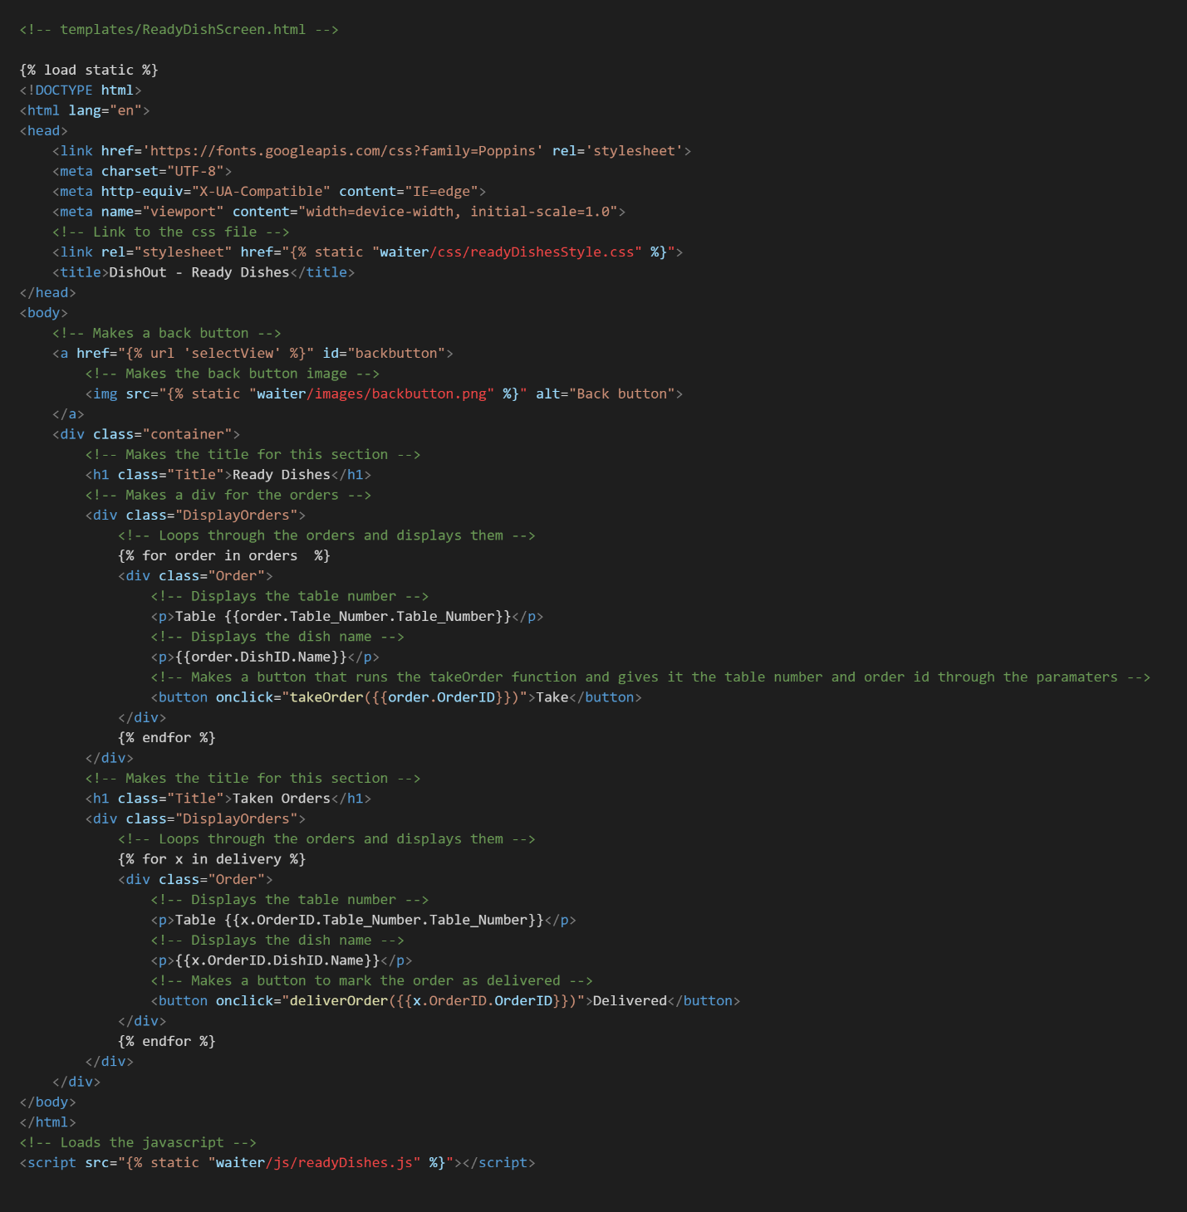

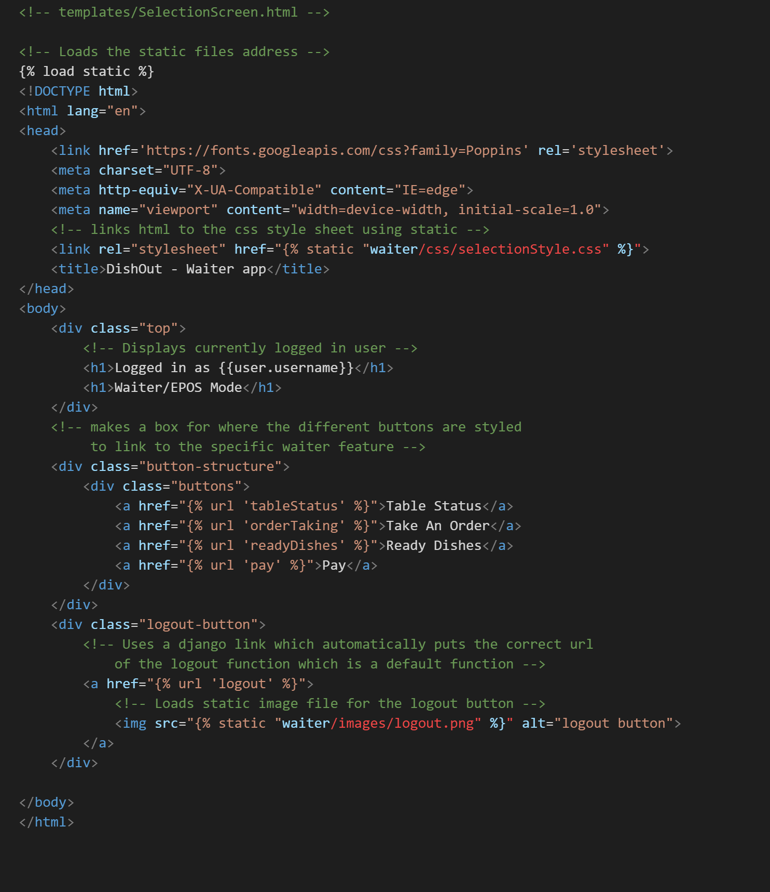

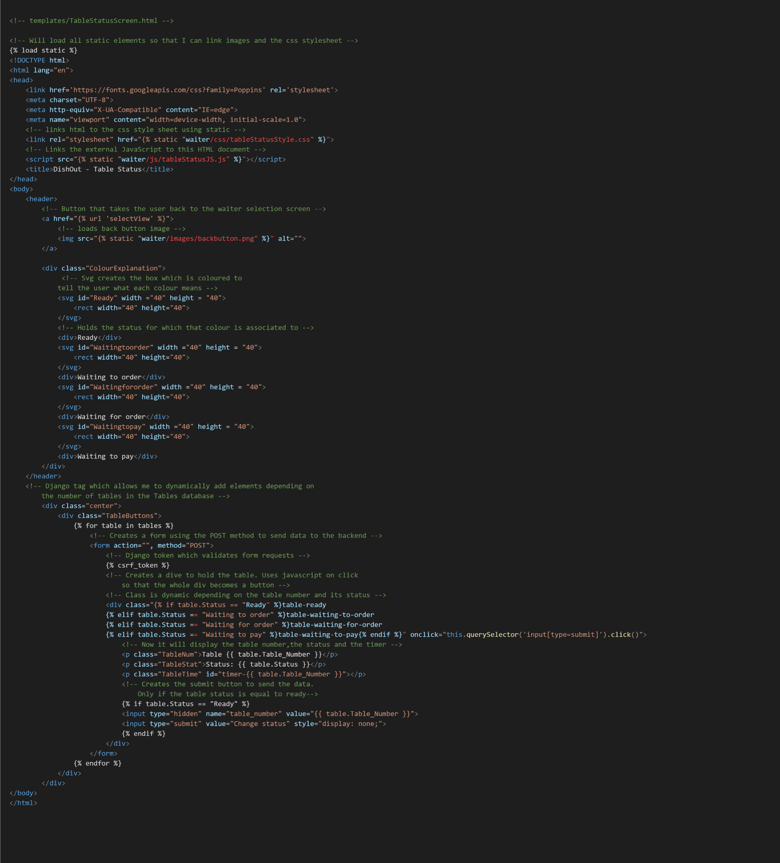

### CSS Screenshots

#### Kitchen Page

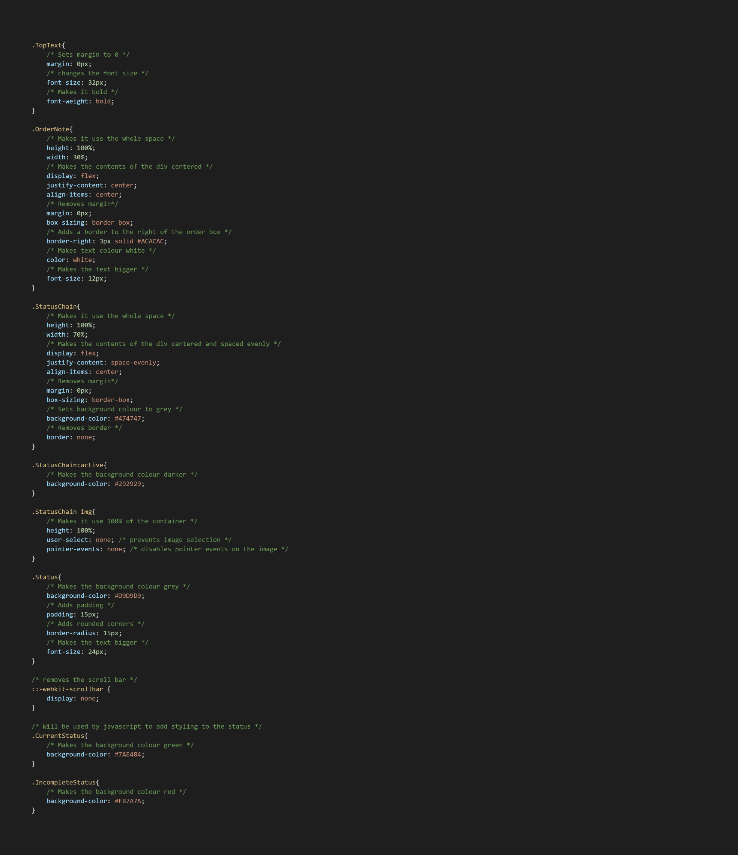

#### Login

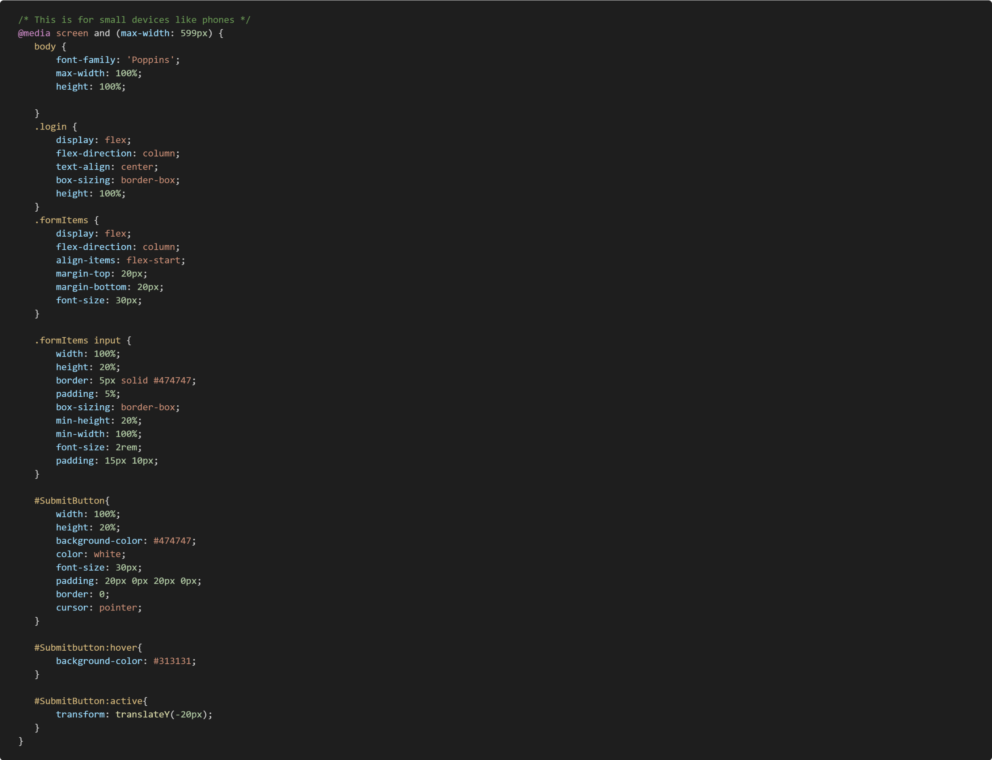

#### Order taking

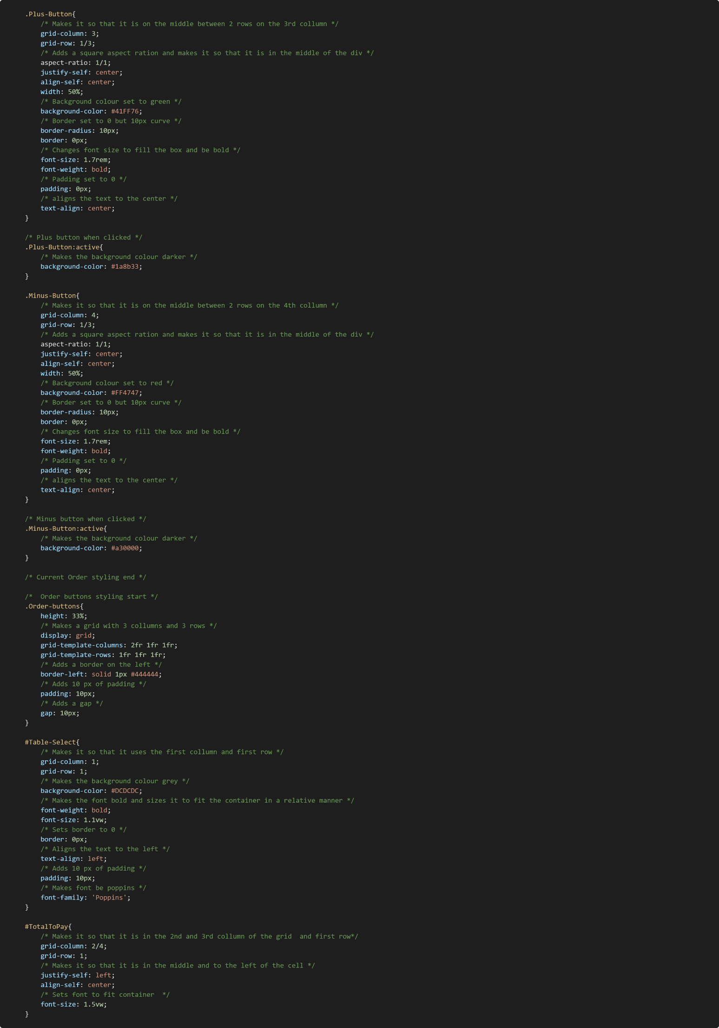

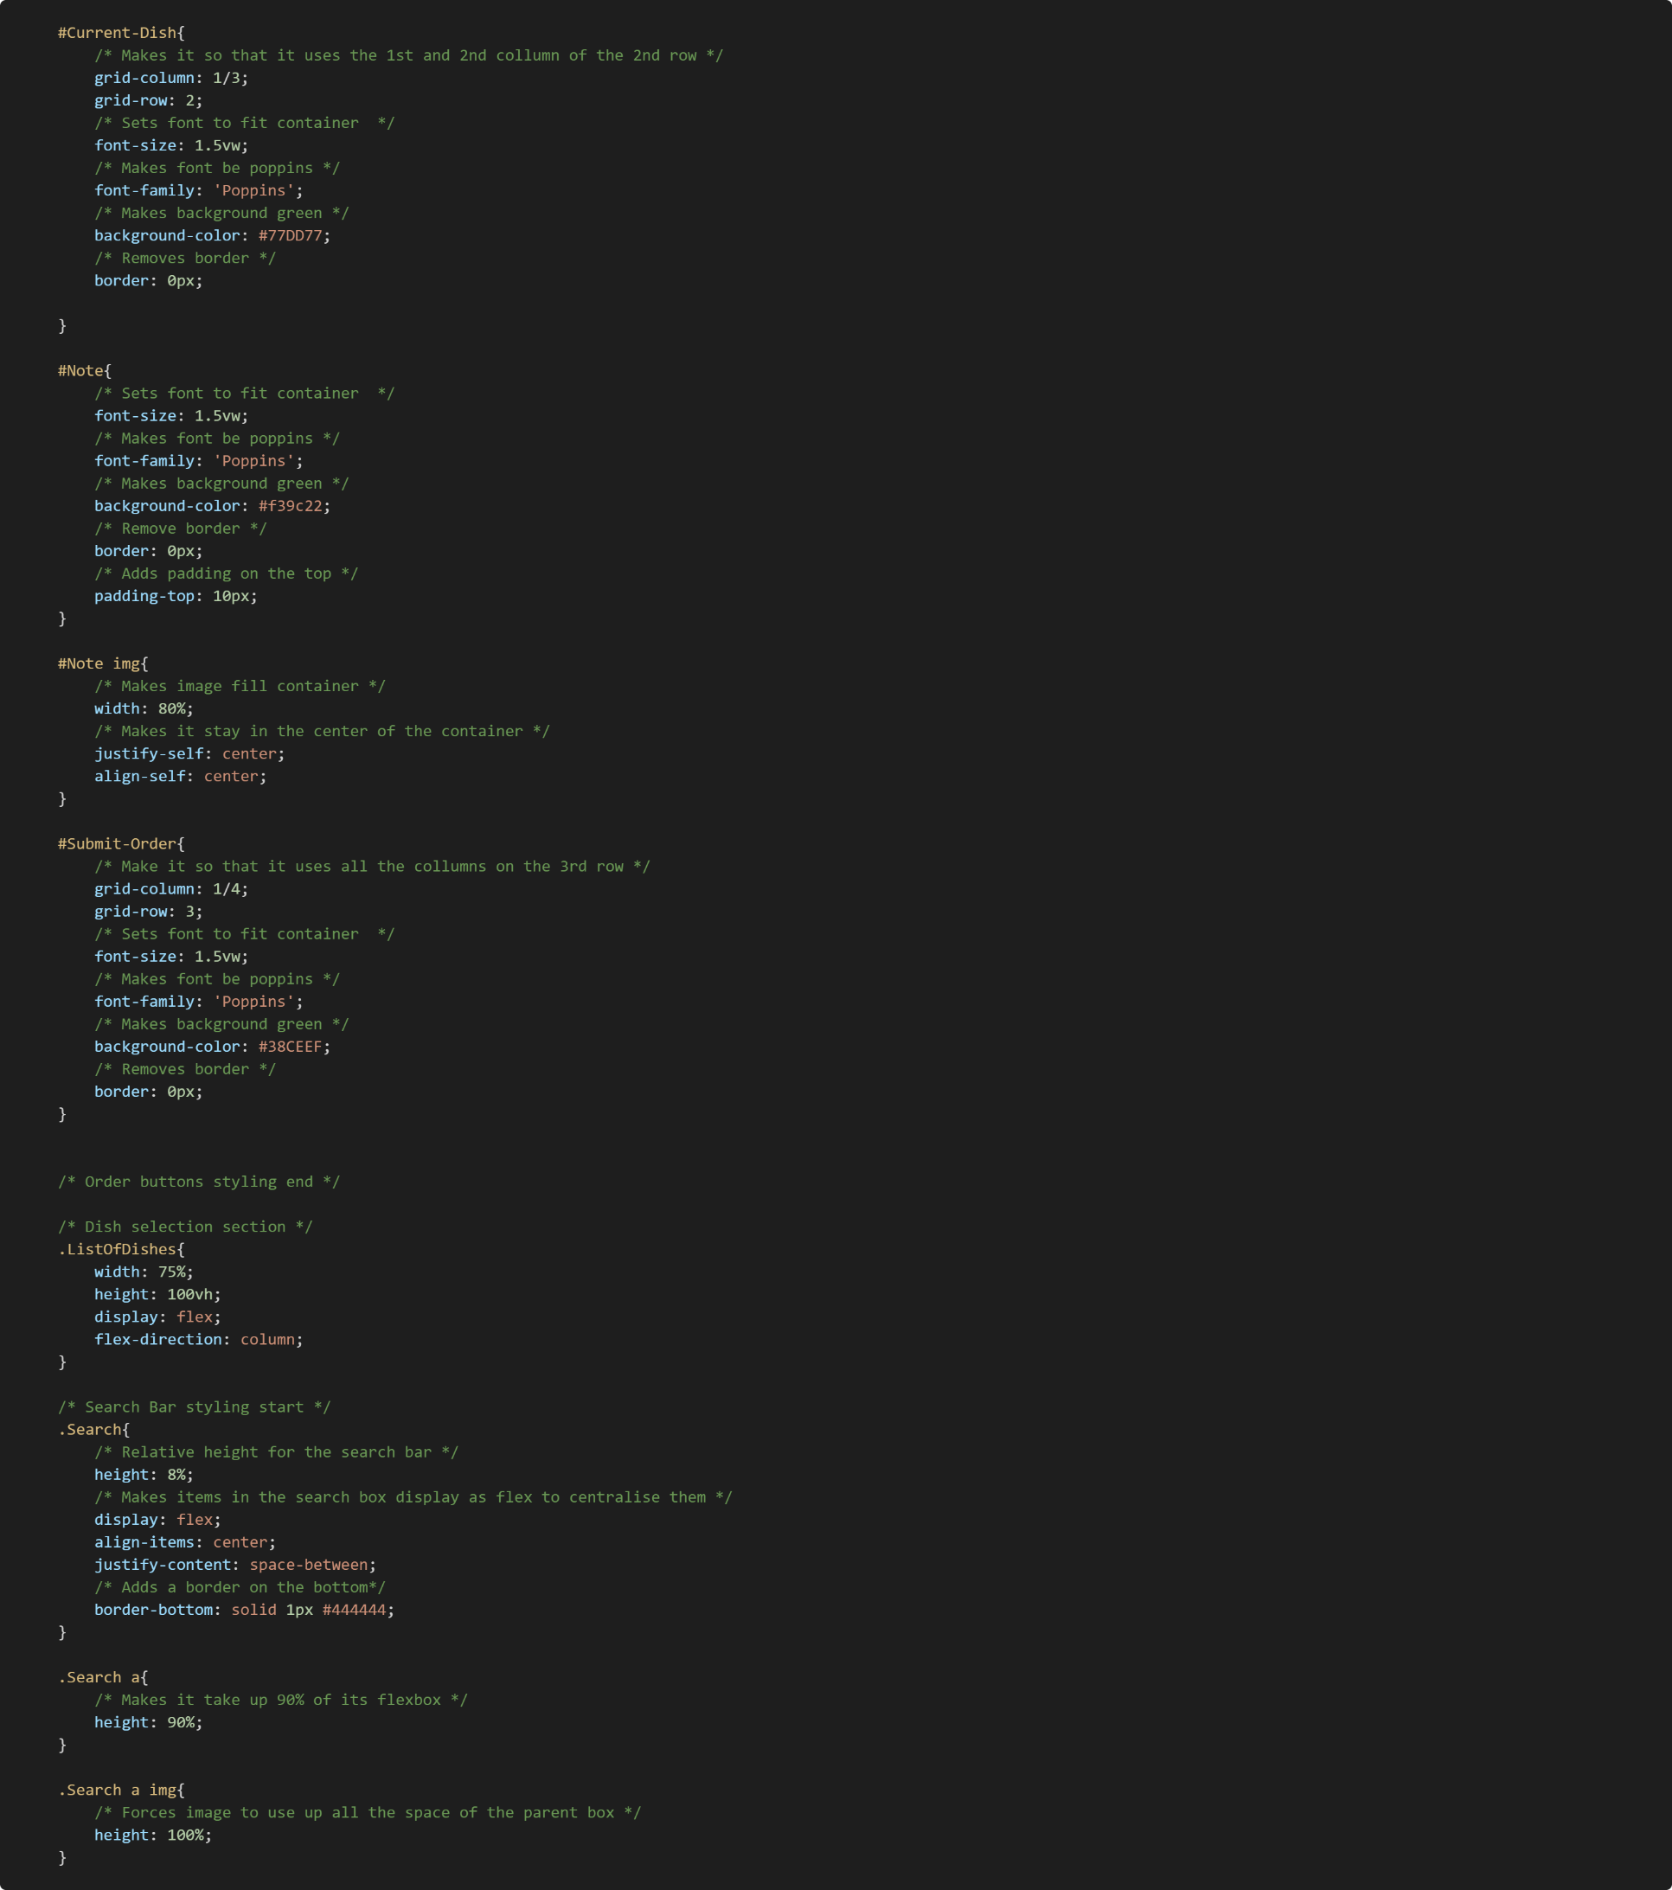

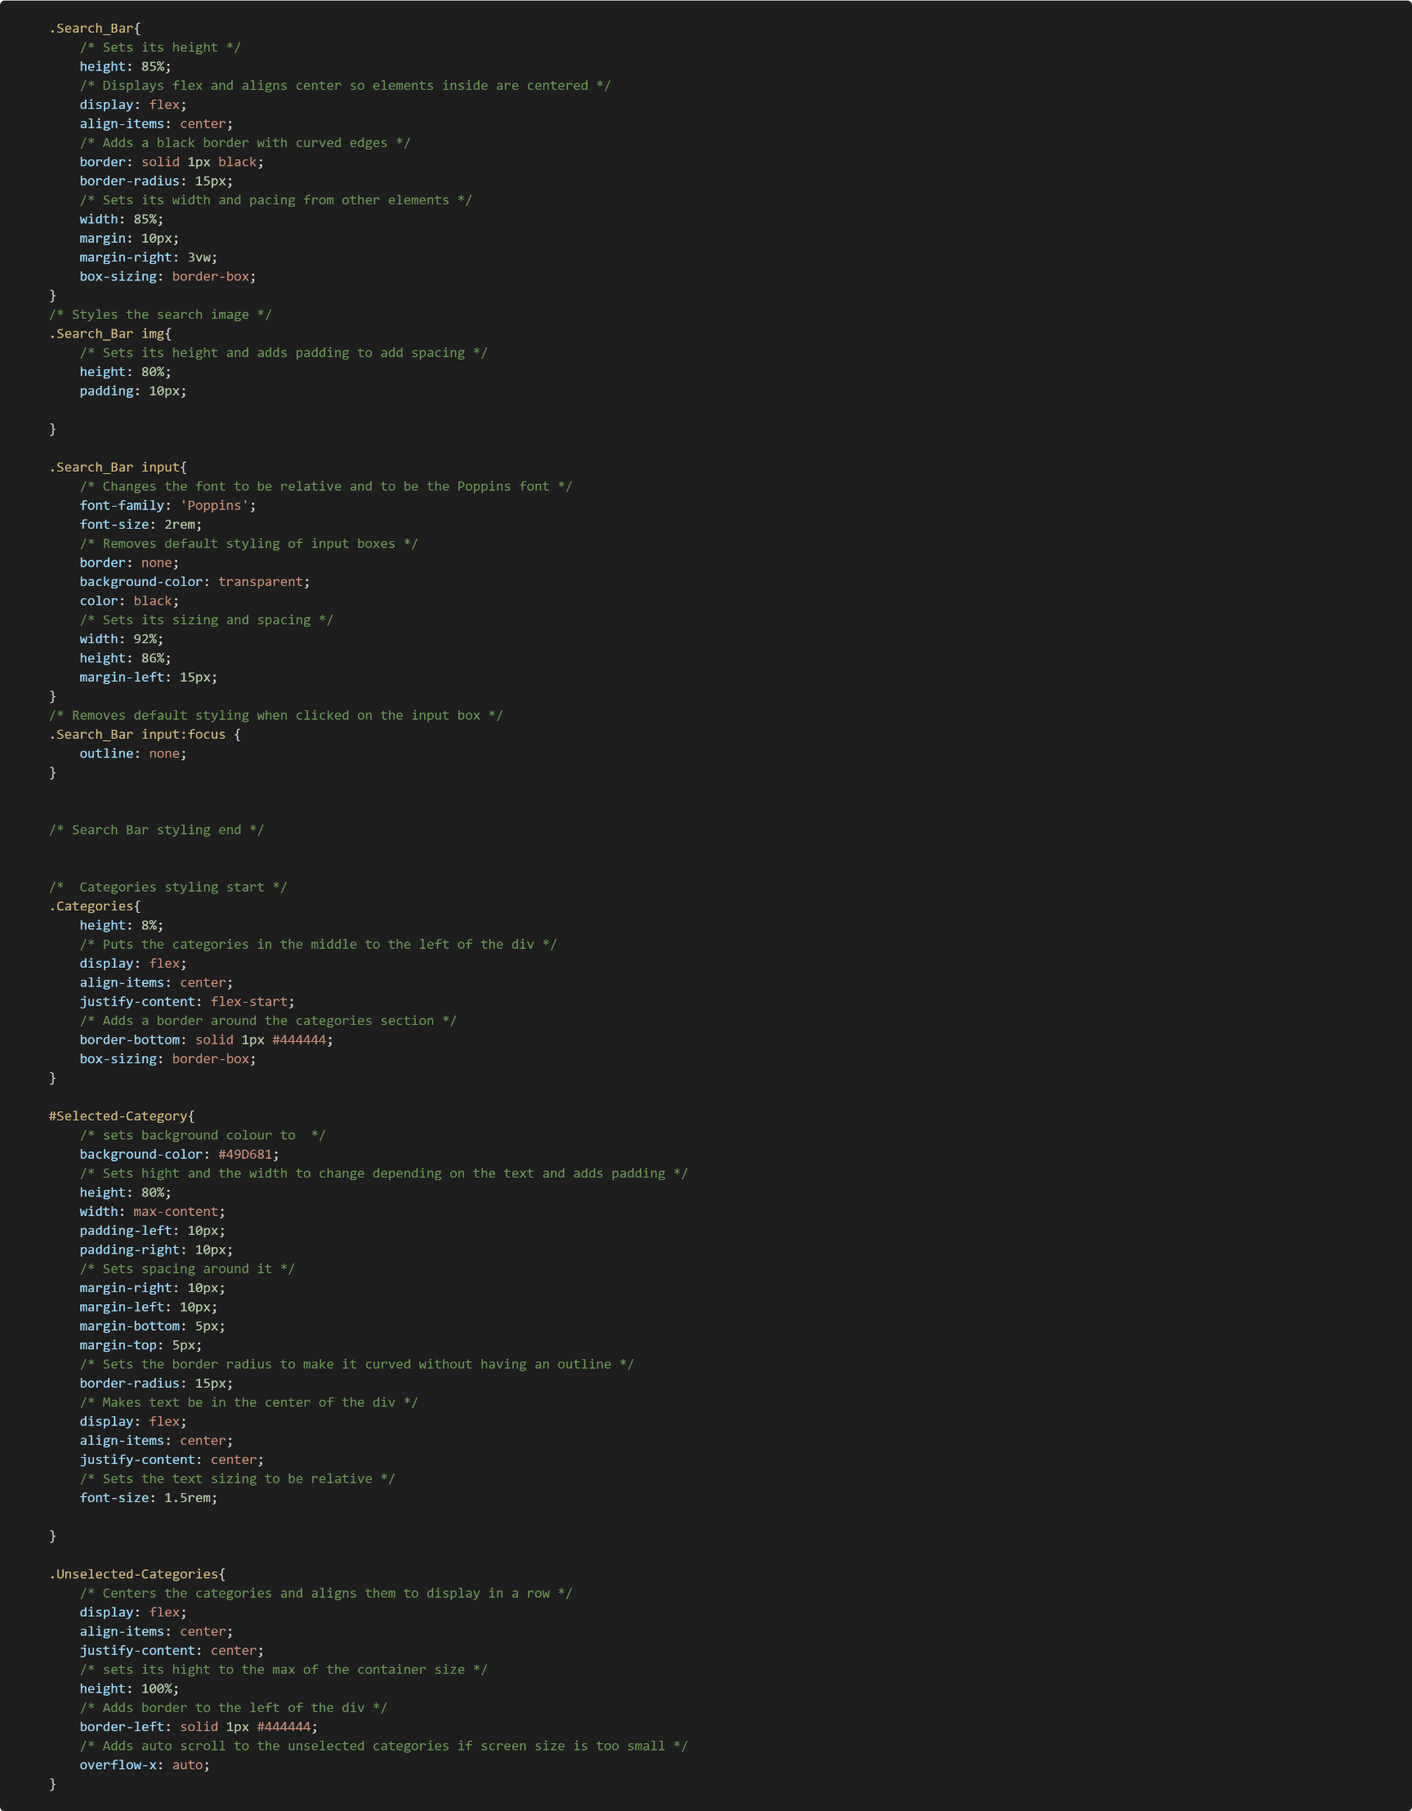

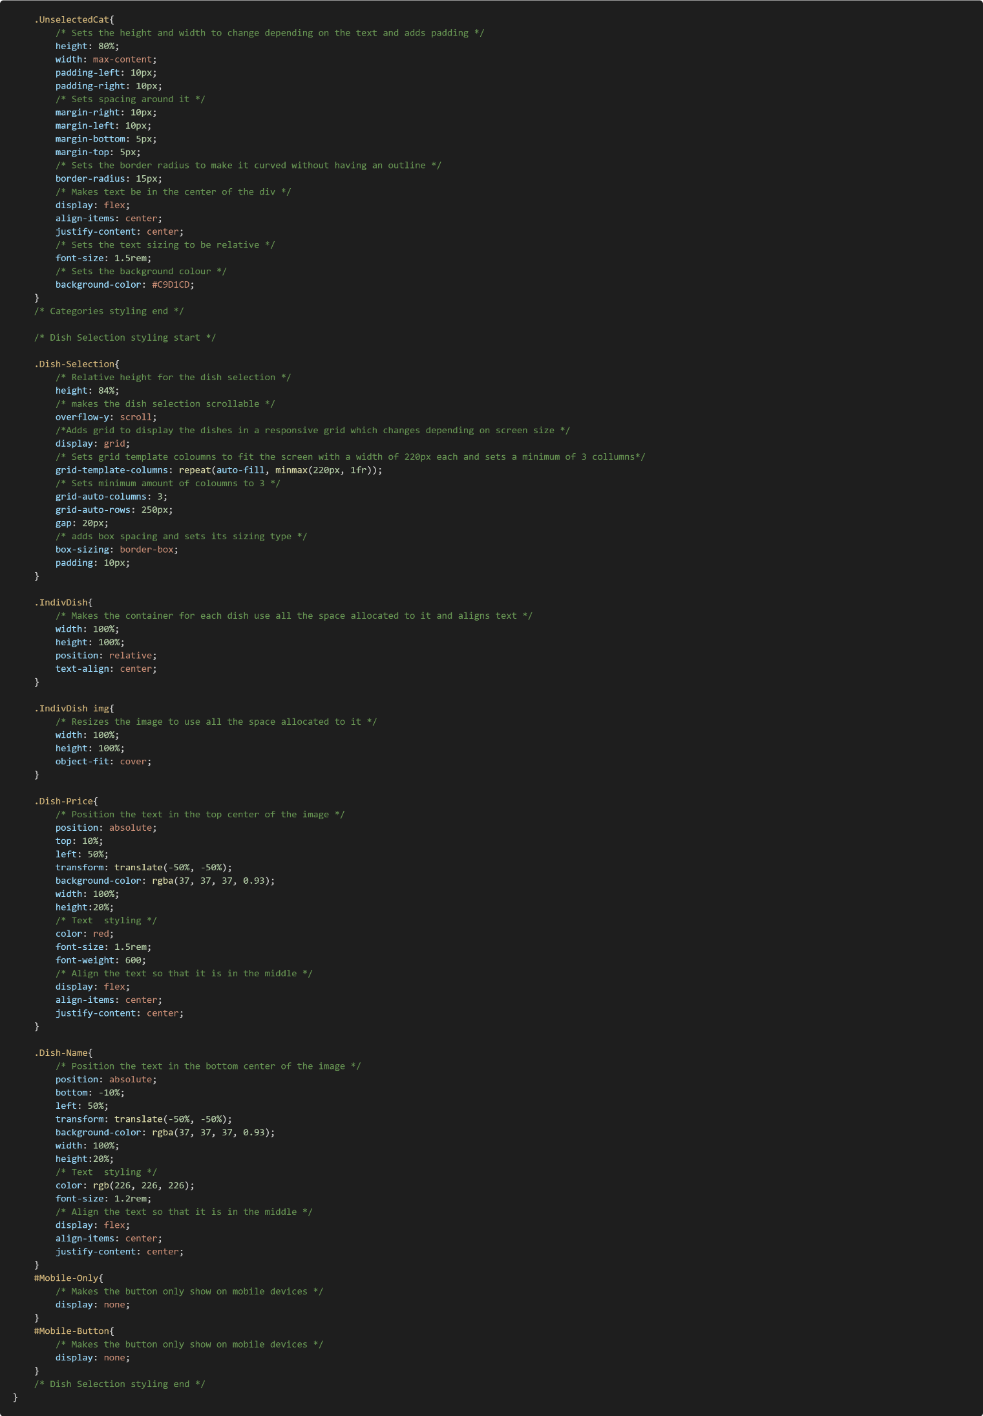

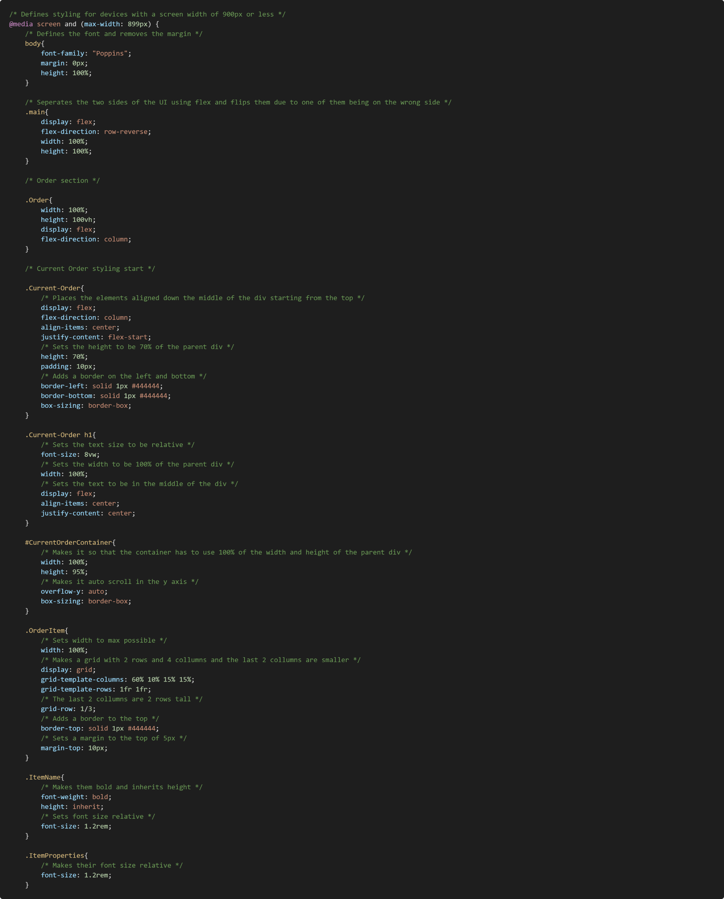

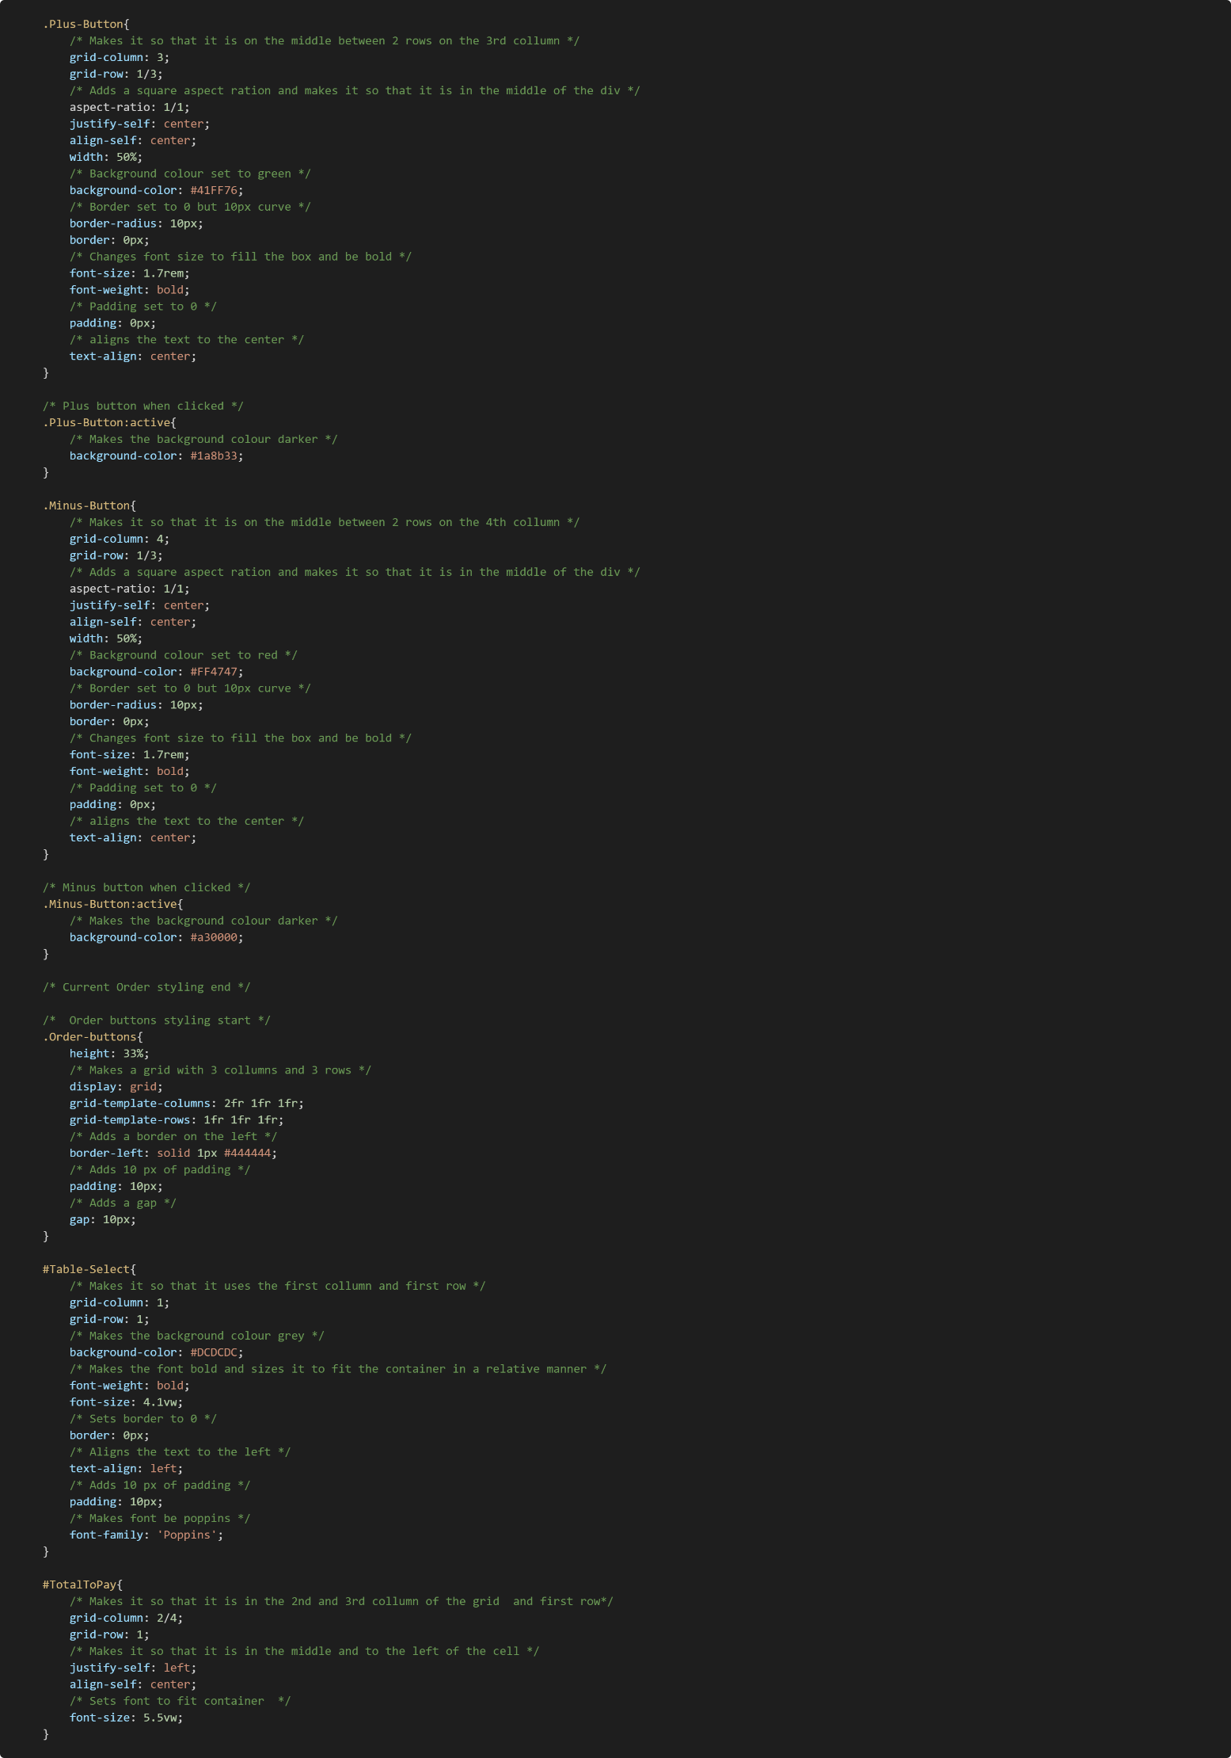

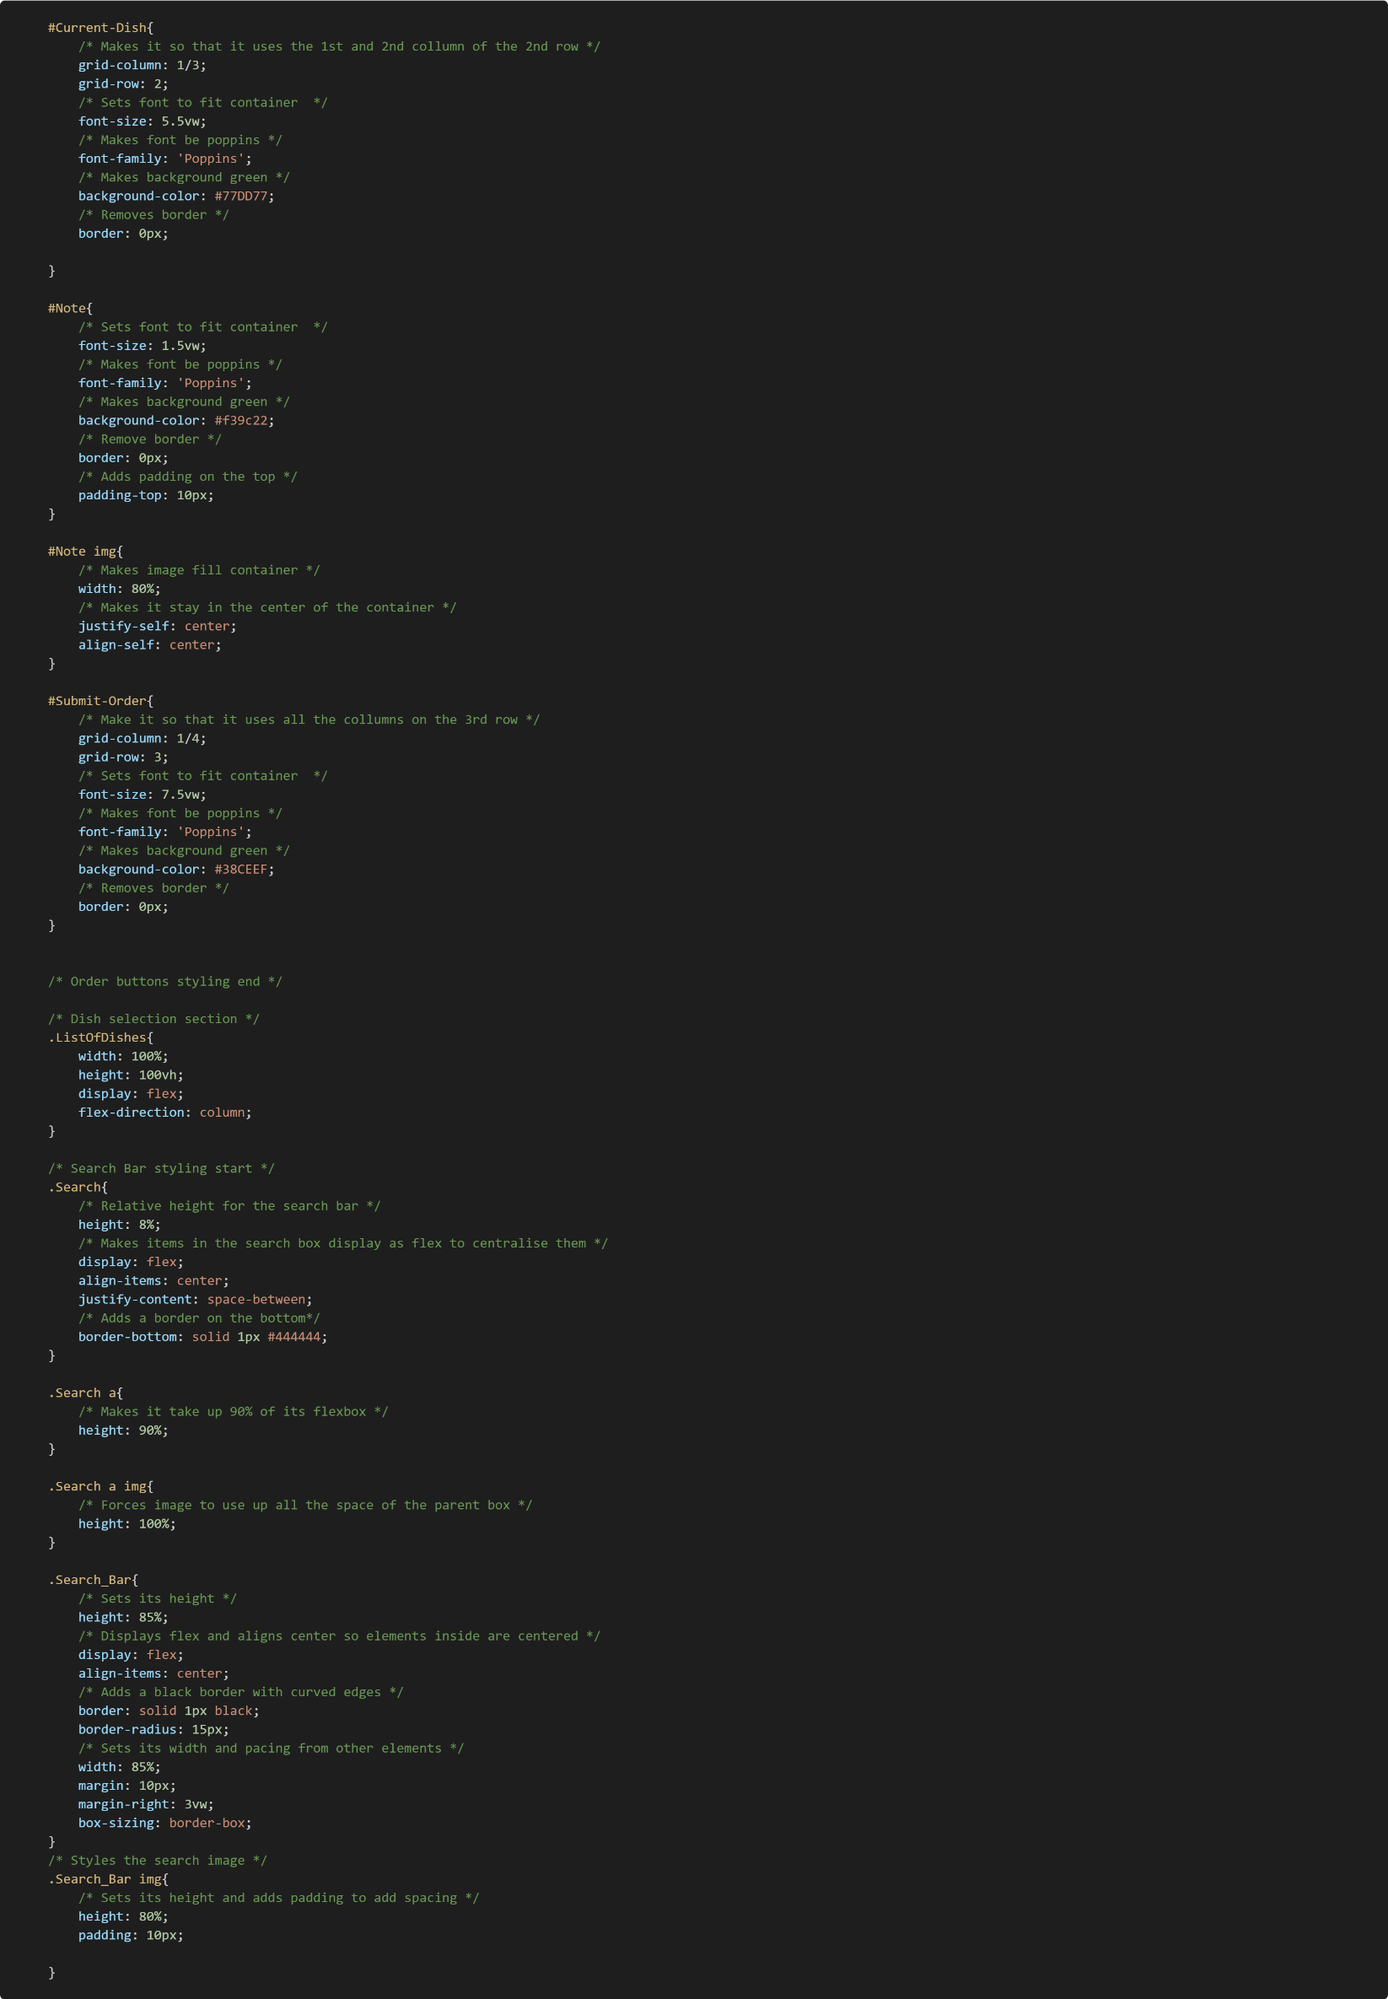

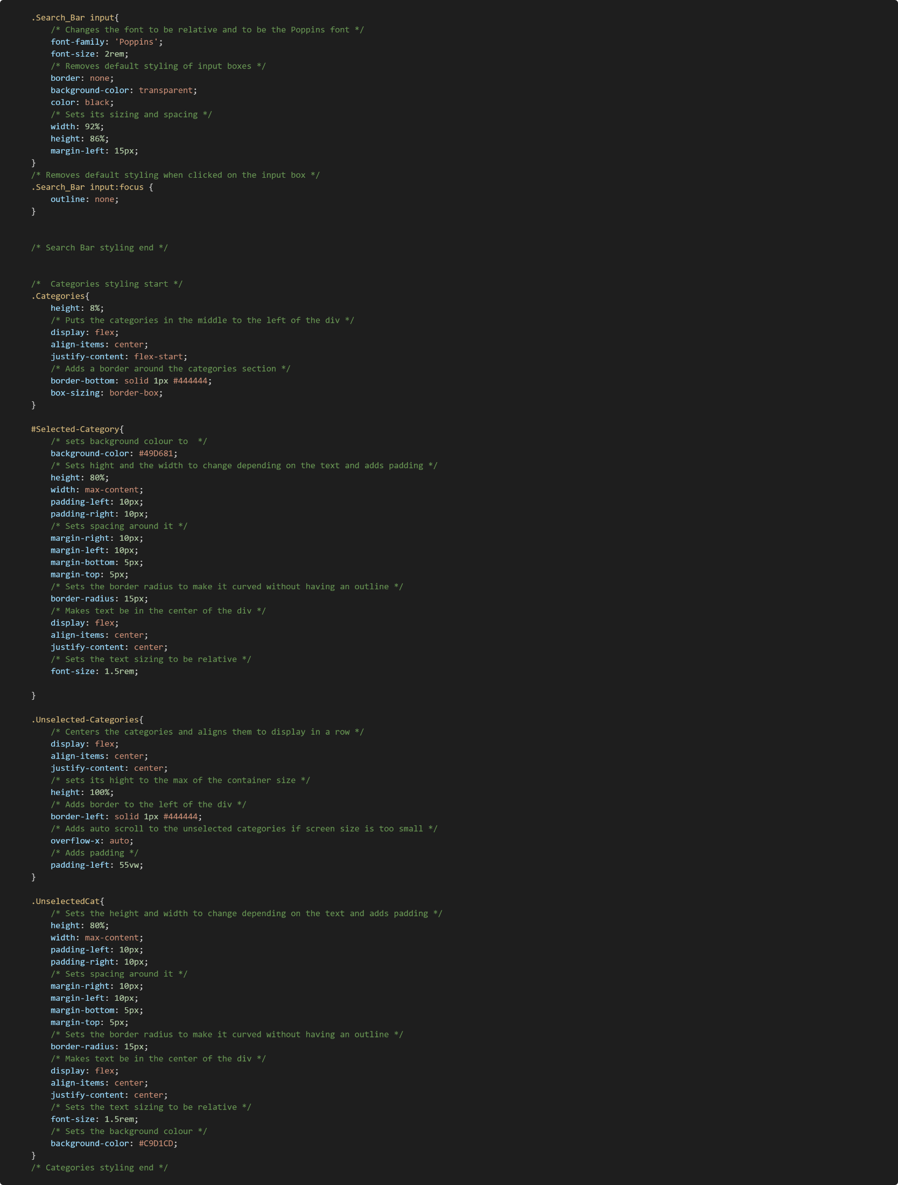

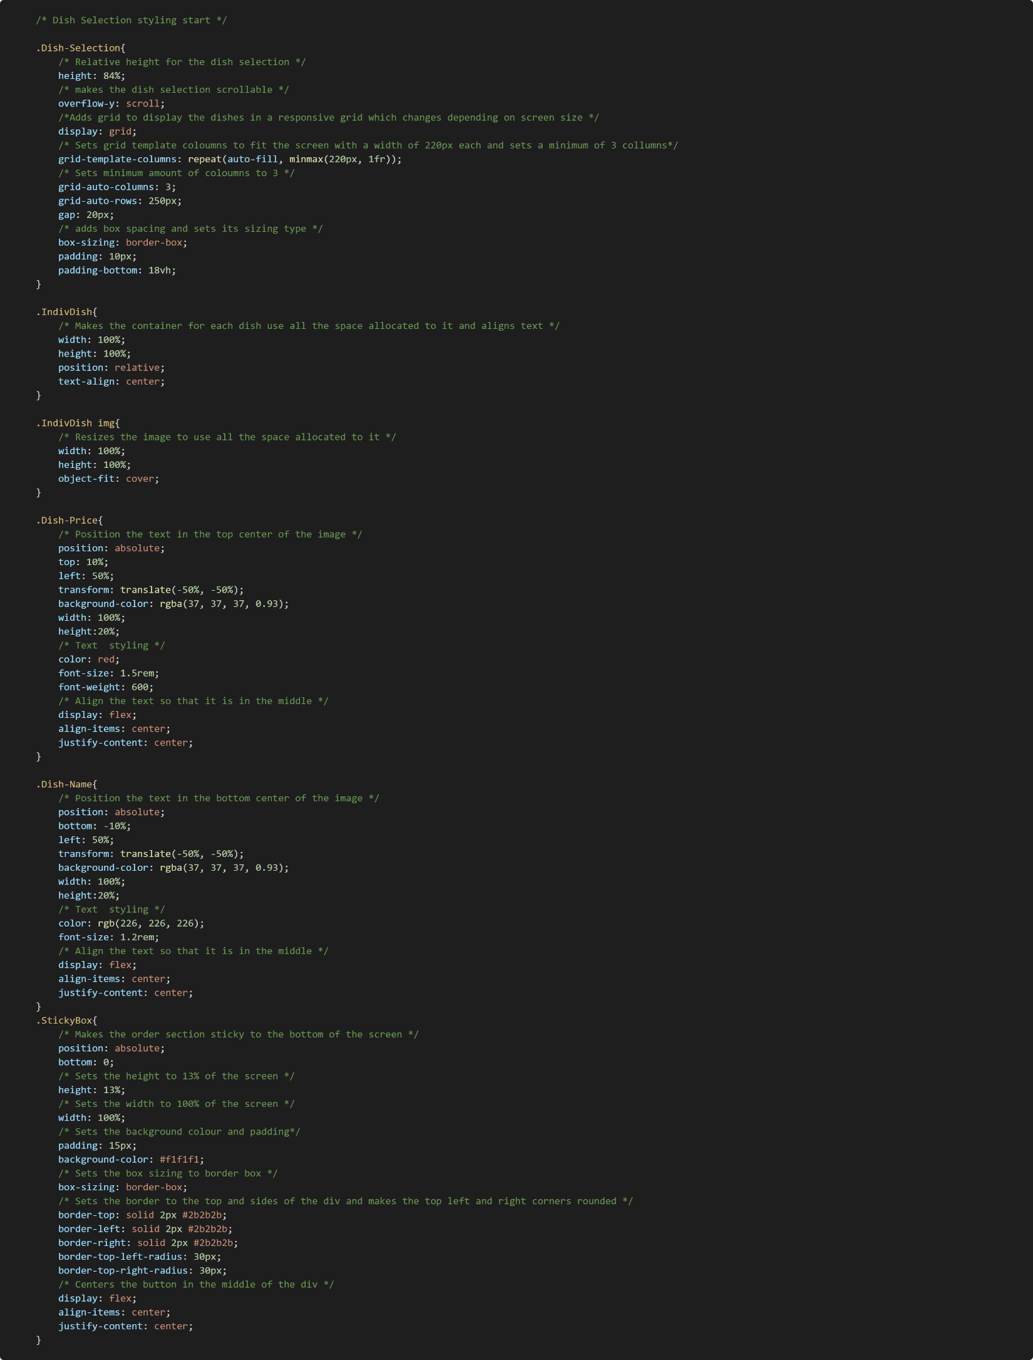

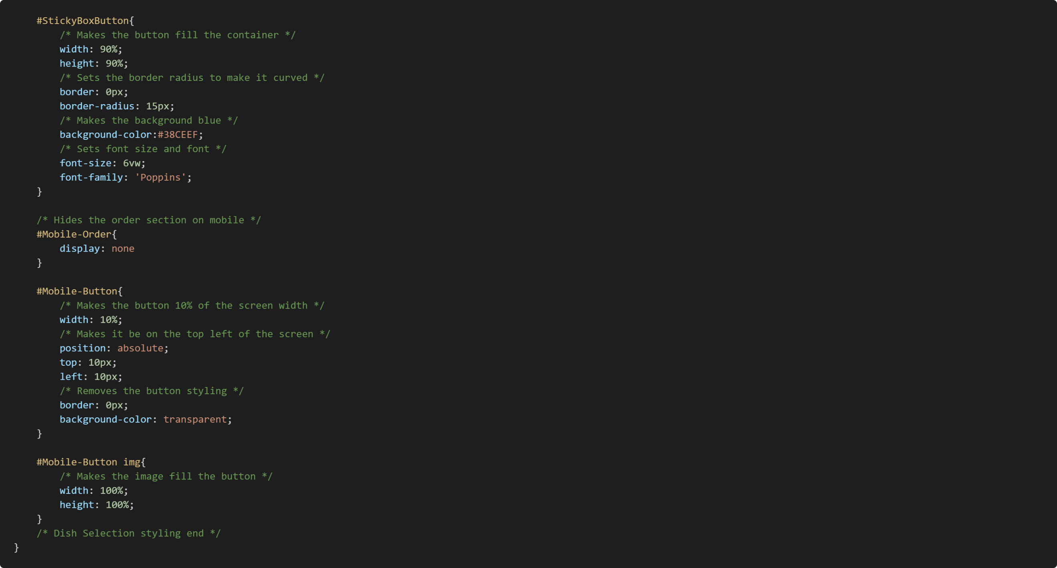

#### Pay

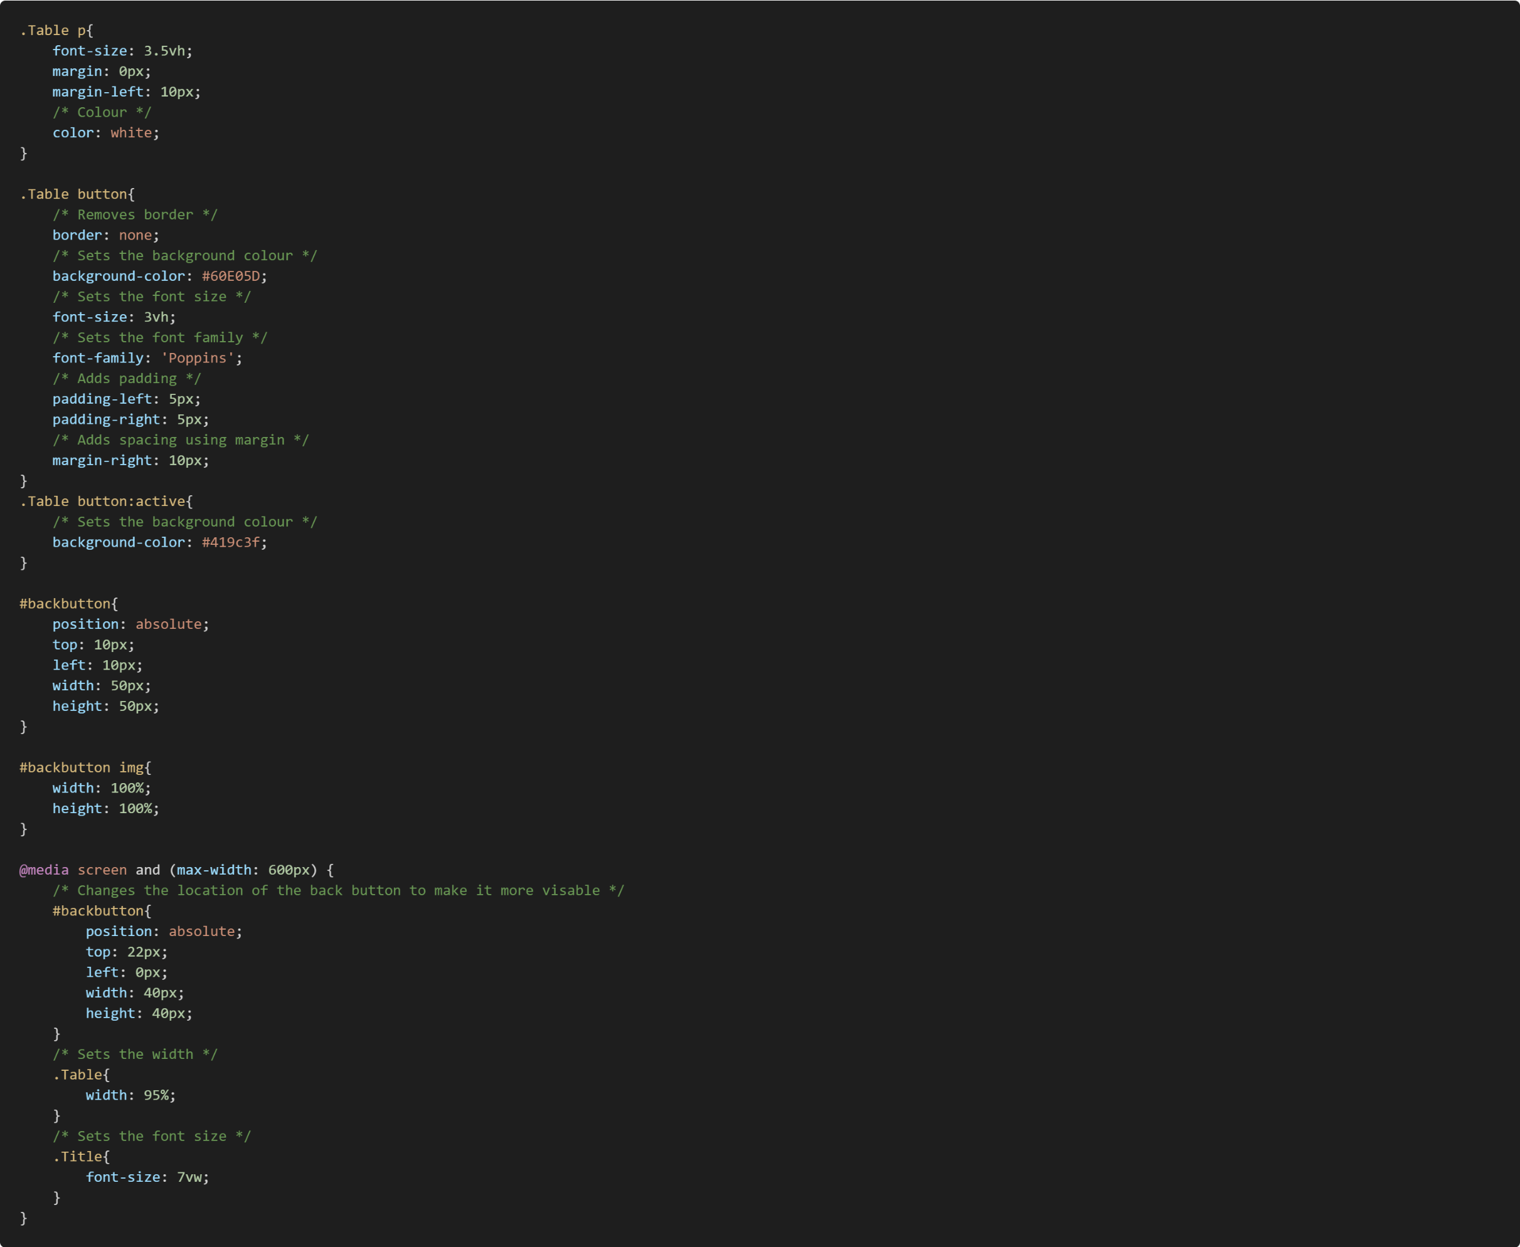

#### Ready Dish

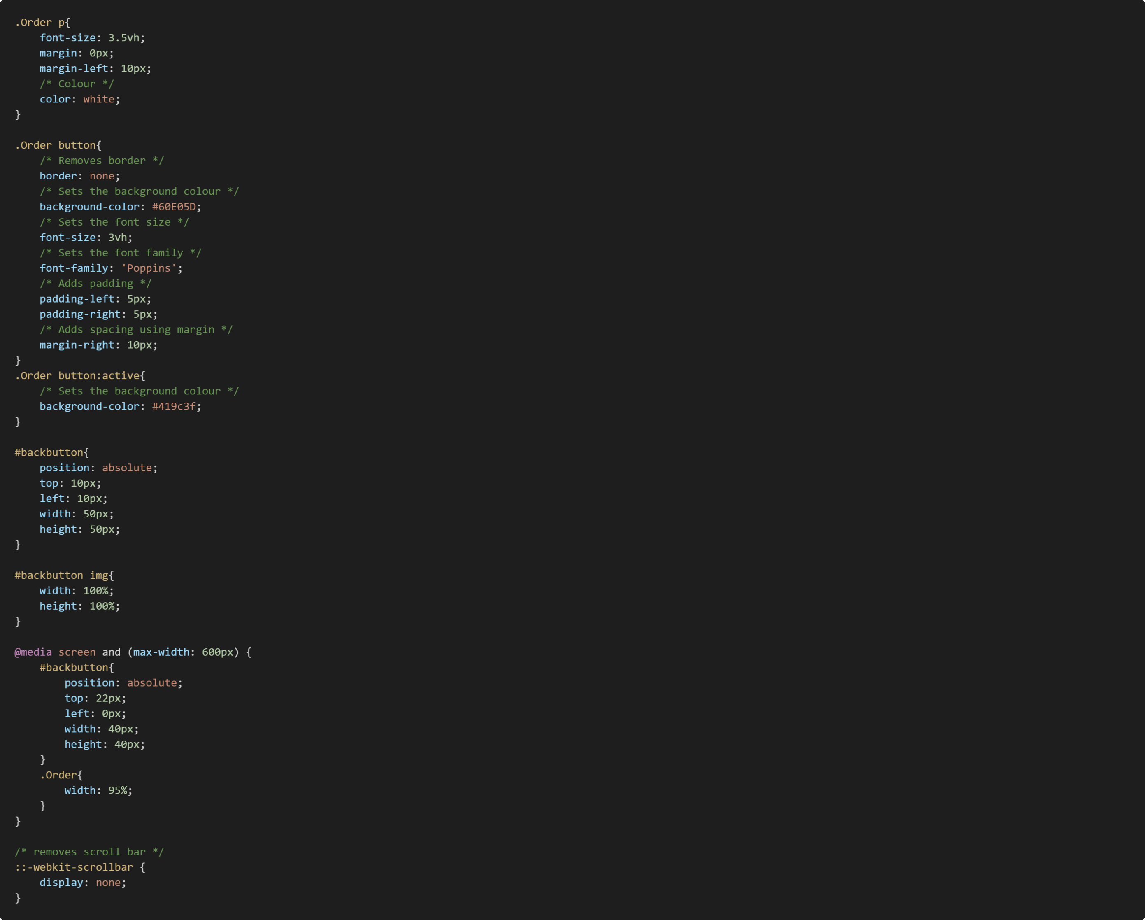

#### Selection

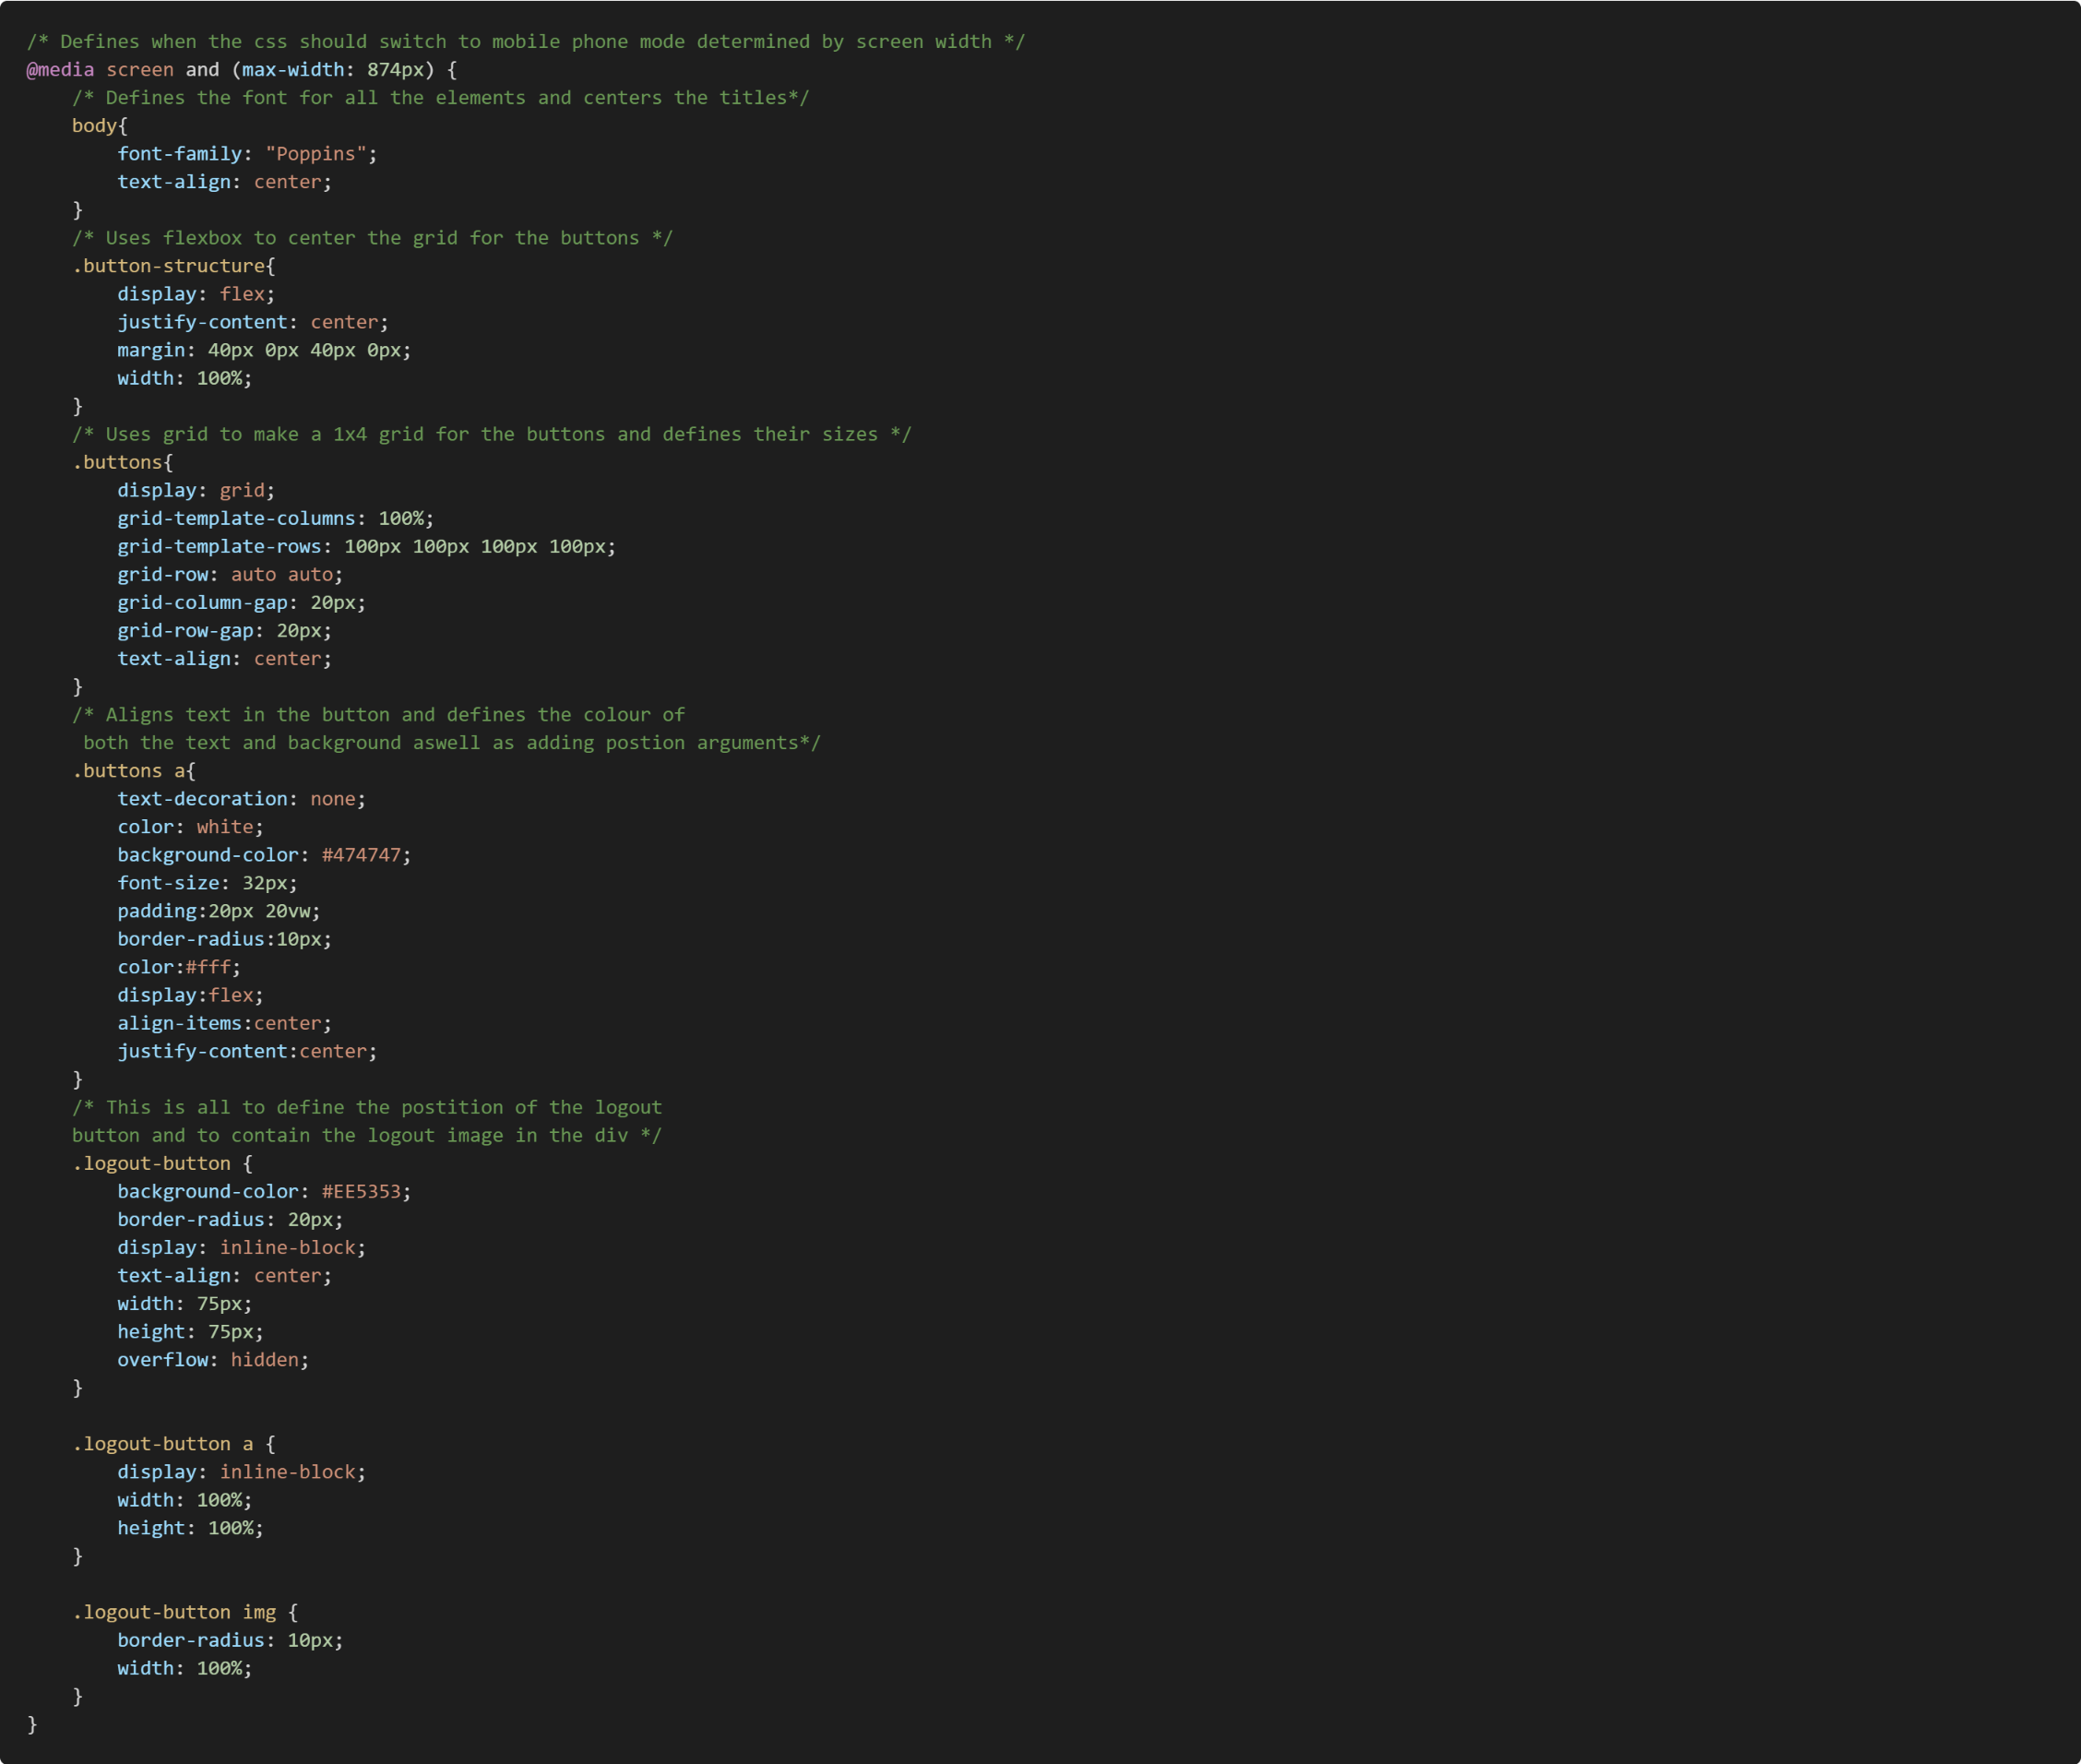

#### Table Status

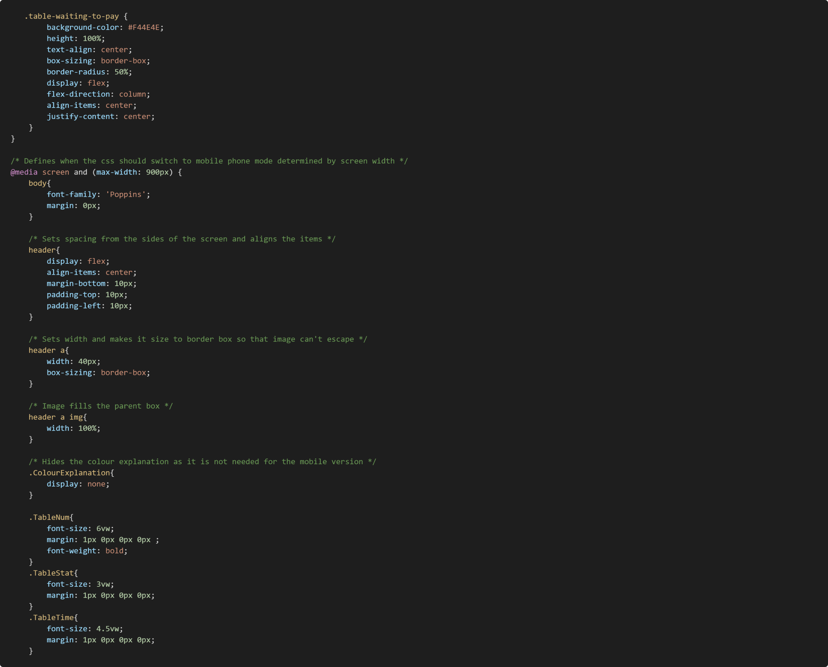

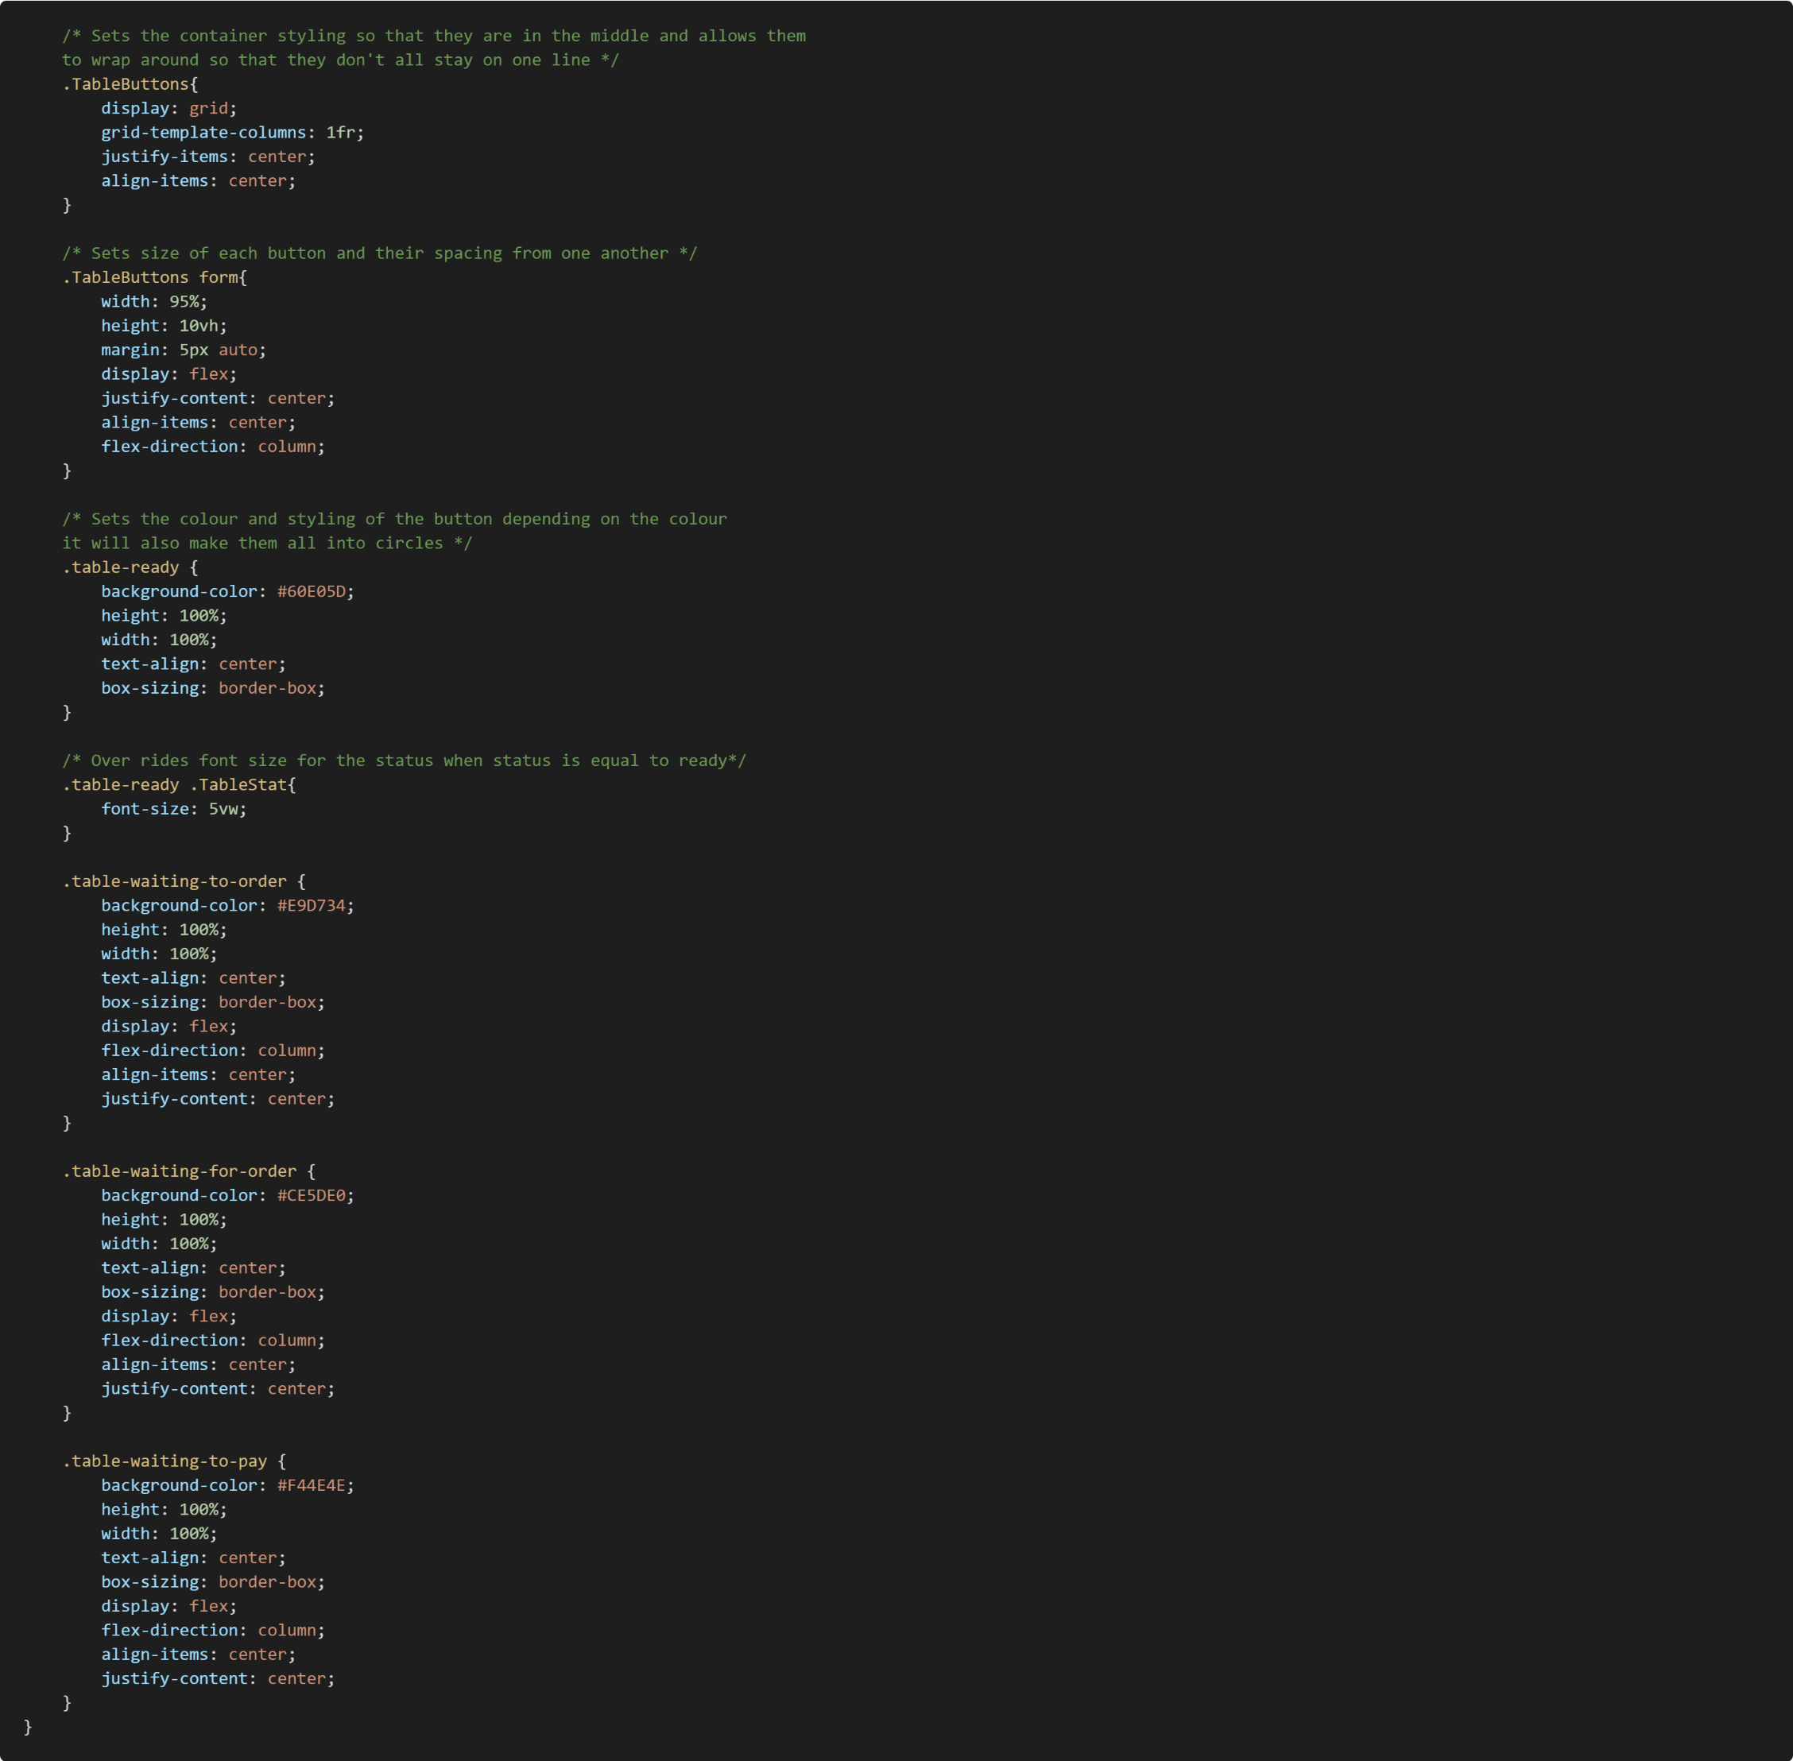

### JavaScript

#### Order Taking

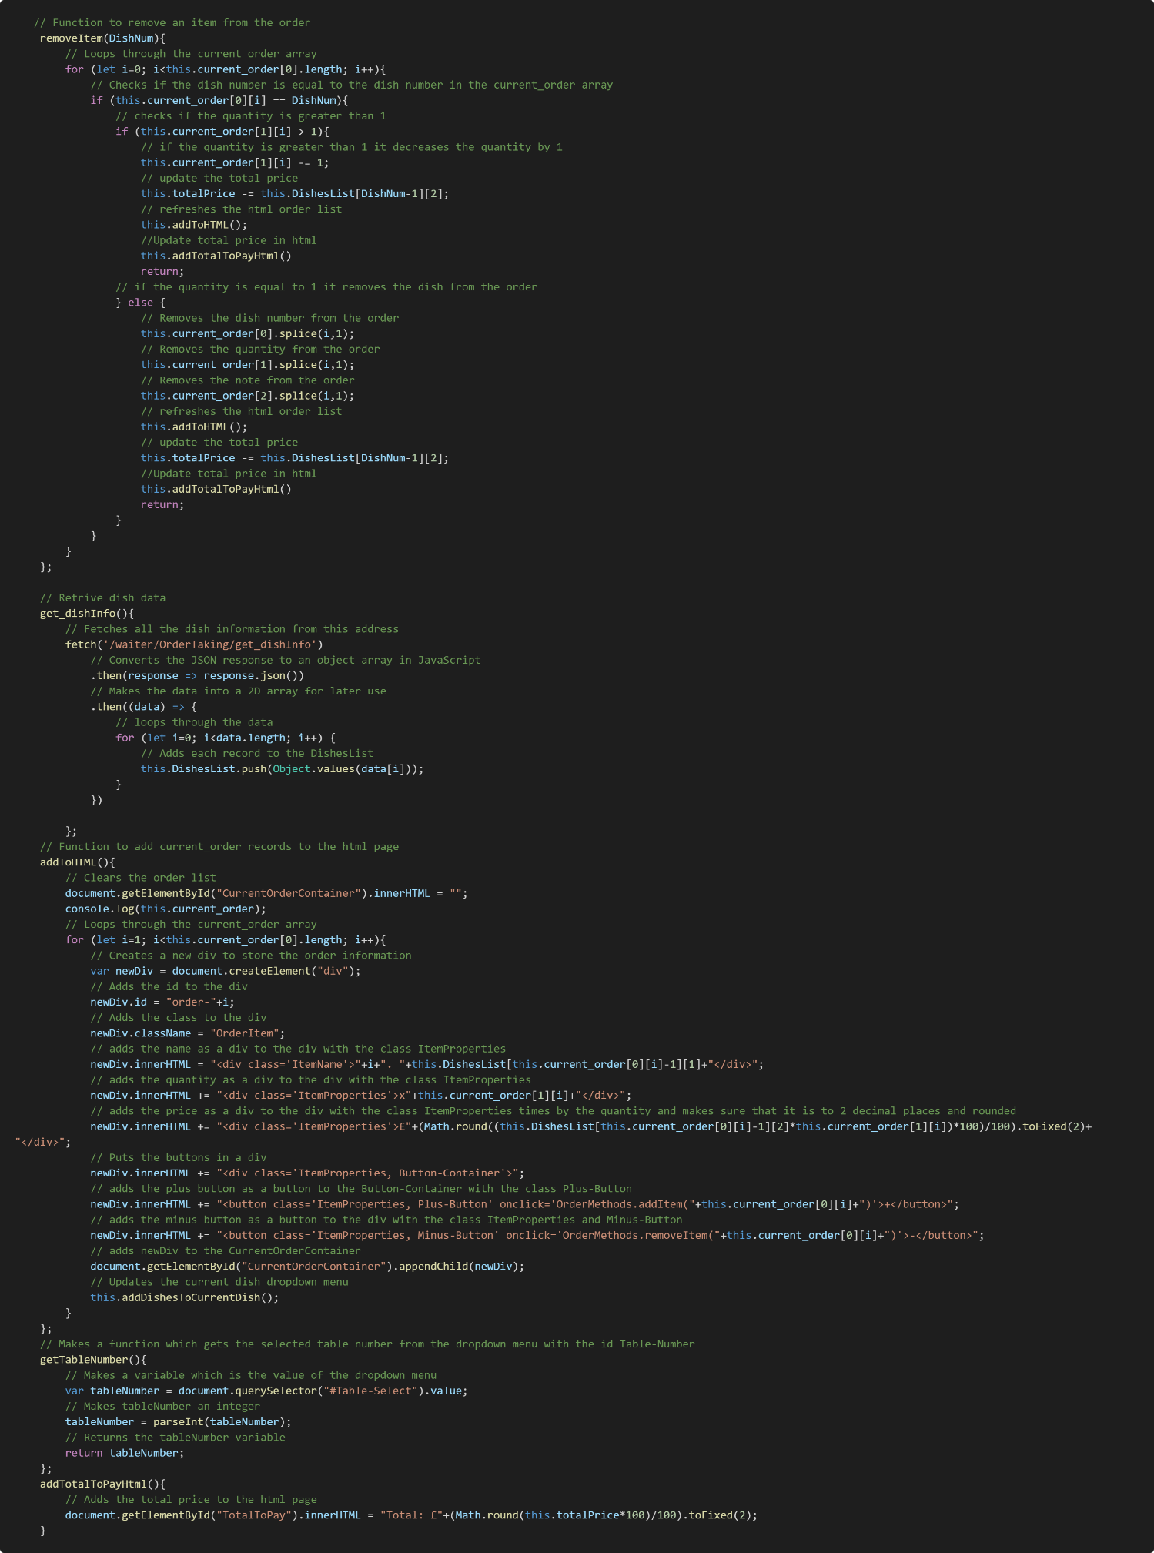

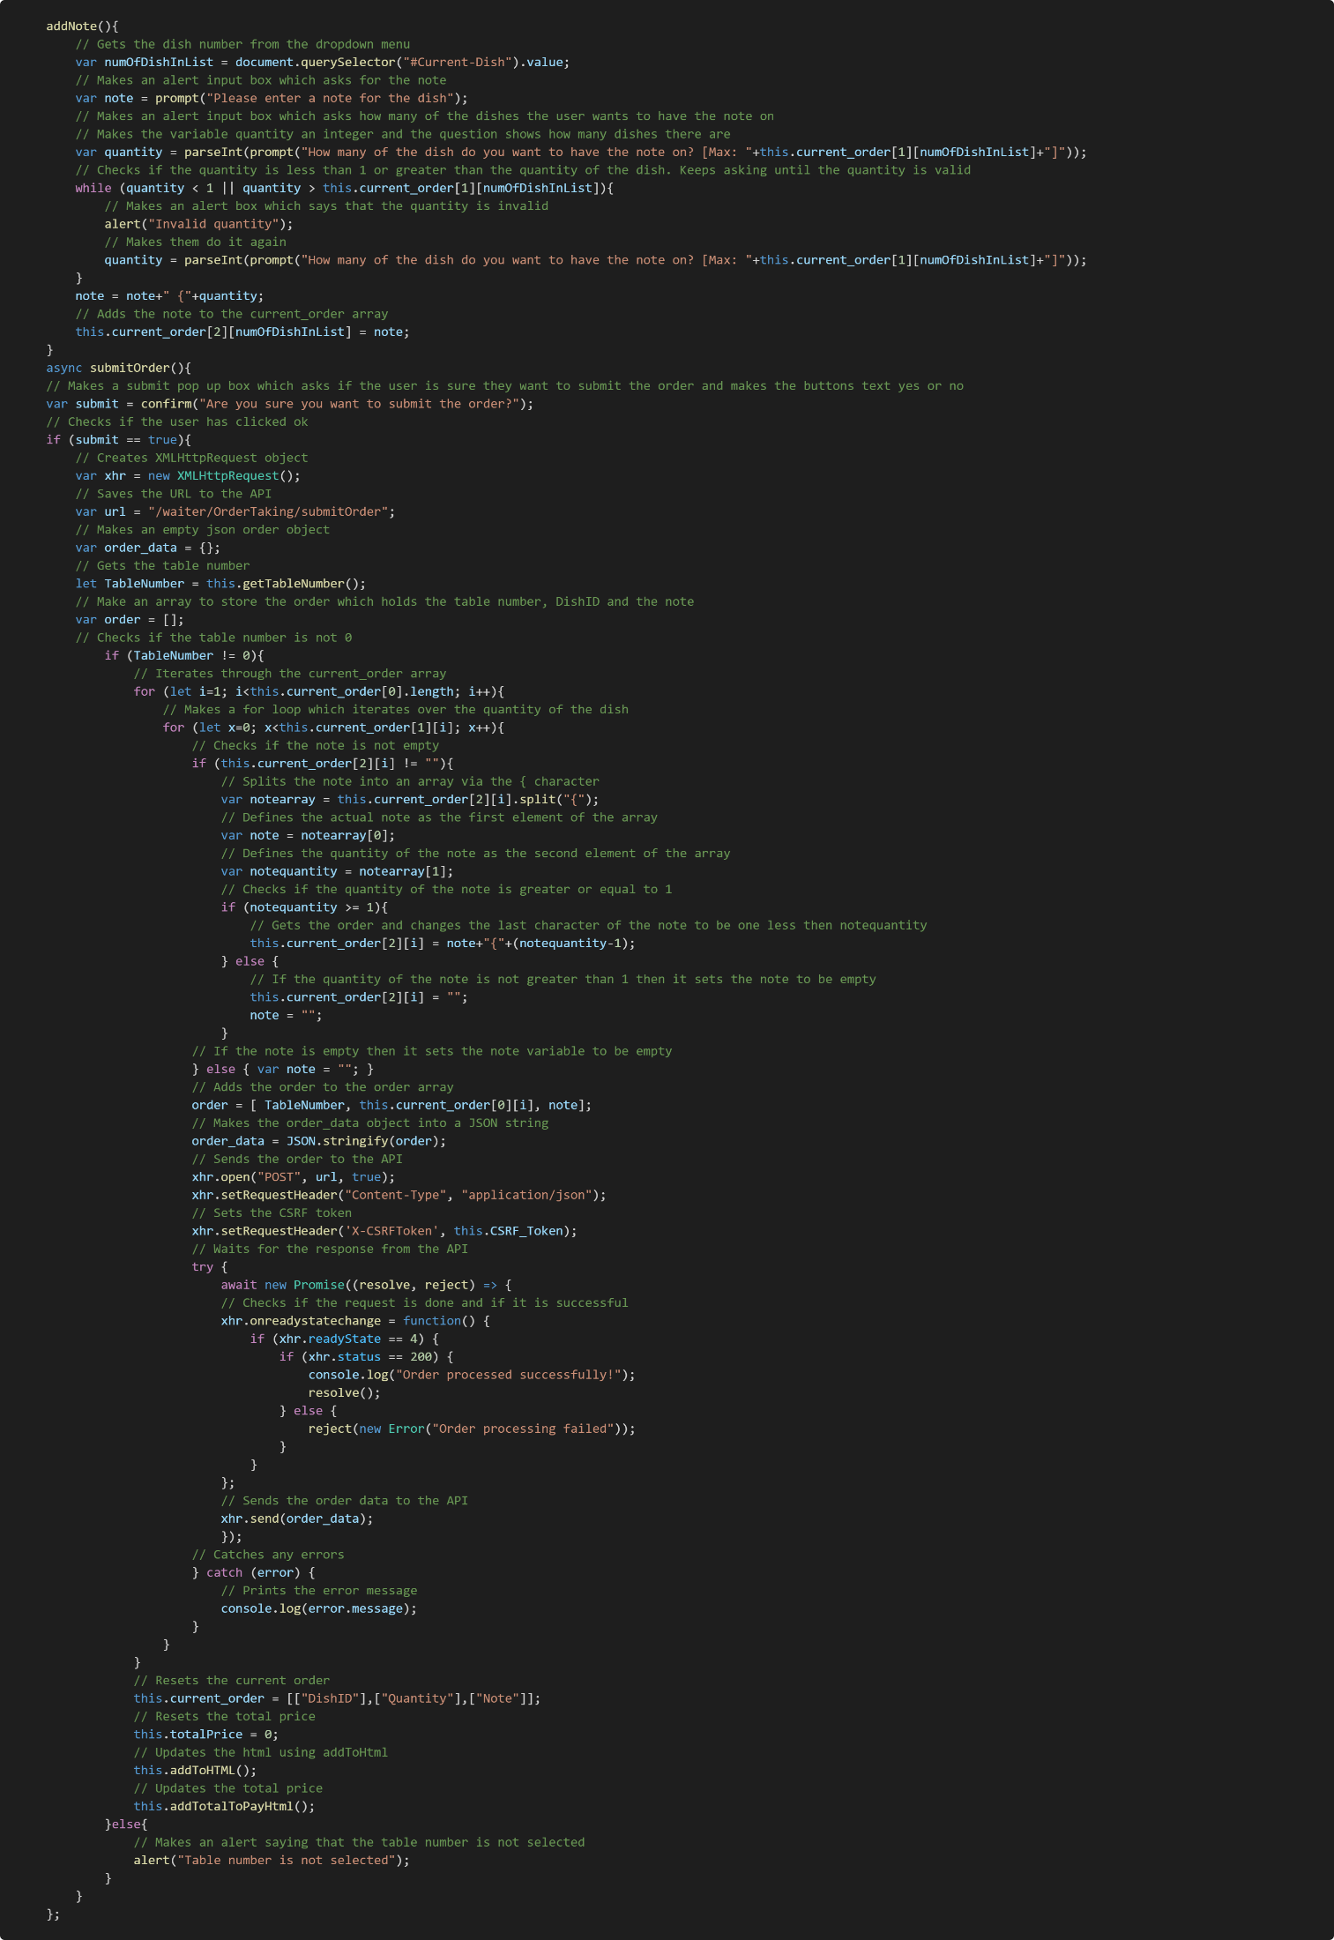

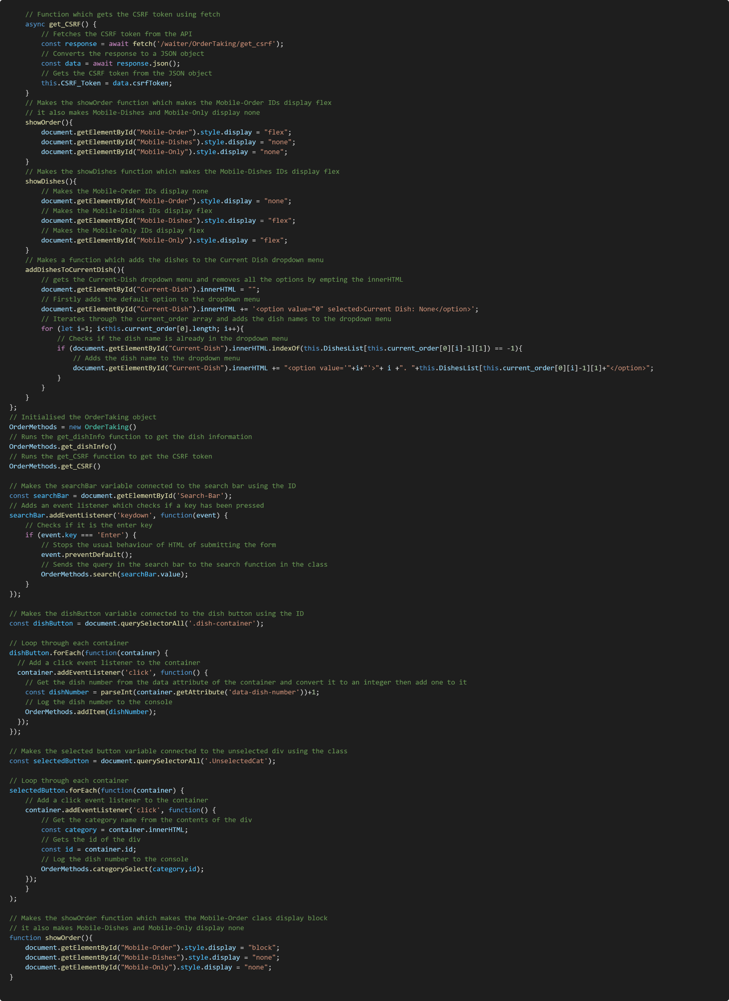

#### Pay

#### Ready Dishes

#### Table Status

## References

Bouncepad, 2022. *How many restaurants are using an iPad POS system?.* [Online]   
Available at: https://bouncepad.com/blogs/news/how-many-restaurants-are-using-an-ipad-pos-system  
[Accessed 3 November 2022].

eatPOS, 2019. *About Us.* [Online]   
Available at: https://www.eatpos.co.uk/about-us/  
[Accessed 7 October 2022].

Pro software, 2018. *Top 10 POS Systems UK - eatPOS.* [Online]   
Available at: https://www.pos-software.co.uk/eatpos/  
[Accessed 7 October 2022].

Square, 2022. *Square for Restaurants.* [Online]   
Available at: https://squareup.com/gb/en/point-of-sale/restaurants  
[Accessed 30 October 2022].

Toast, 2017. *Restaurant Technology in 2017.* [Online]   
Available at: https://pos.toasttab.com/resources/restaurant-technology-industry-report  
[Accessed 3 November 2022].